Our Shiny app comprises three major sections: the corporate structure, network graph, and influence graph. Each section includes similar components for filtering, visualization, and a nodes-edges table.

## Corporate Structure

Step 1: Click Corporate Structure Tab.

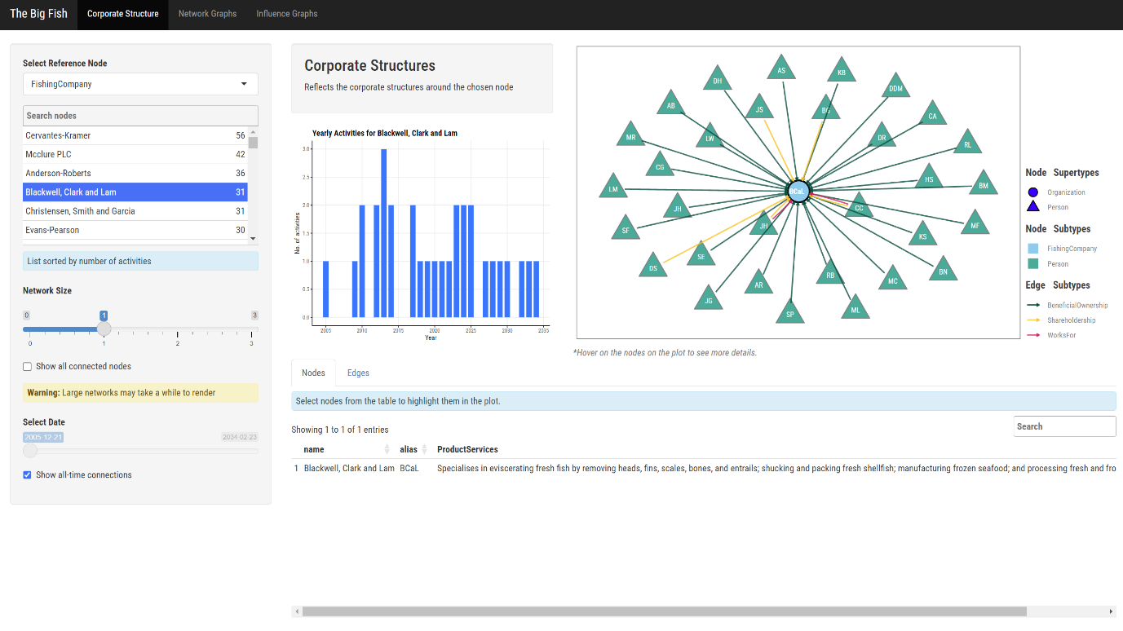

Step2: Select the company type and search for the company you want to investigate.

Step 3: Select the network depth and date. For the corporate structure, a smaller depth number is preferred. A larger depth number is typically used for network investigations.

Step 4: Examine the temporal patterns and the current corporate structure.

Step 5: Analyze the details of the nodes and edges.

## Network Graph

Step 1: Click Network Graph Tab.

Step 2: Perform similar filtering and visualization actions as in the corporate structure. However, users can also switch to a power plot instead of the default relationship network.A screenshot of a computer

## Influence Graph

Step1: Click Influence Graph tab.

Step 2: Perform similar filtering and visualization actions as in the corporate and network graphs. Hover over the nodes to view the page rank score.

Step 3: Switch to Power Brokers. Hover over the nodes to view the betweenness centrality score.