实验一：

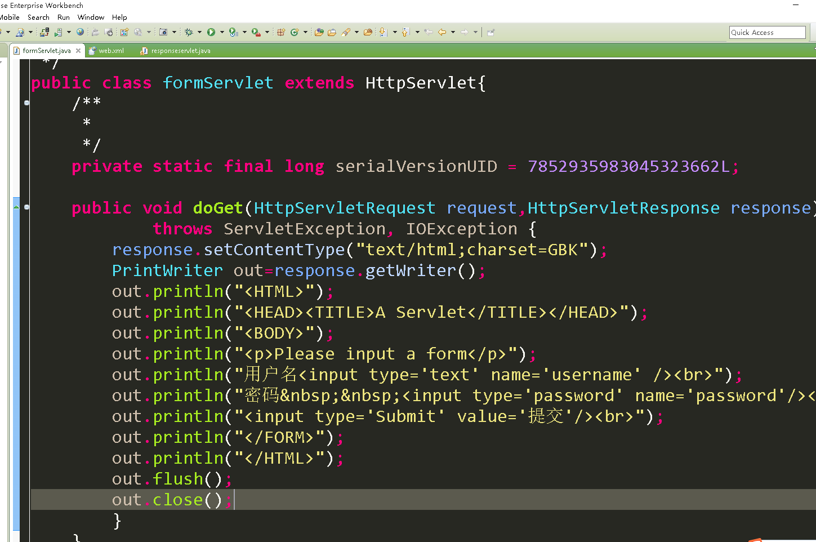

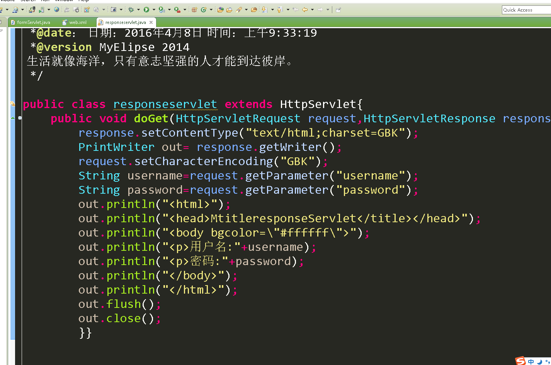

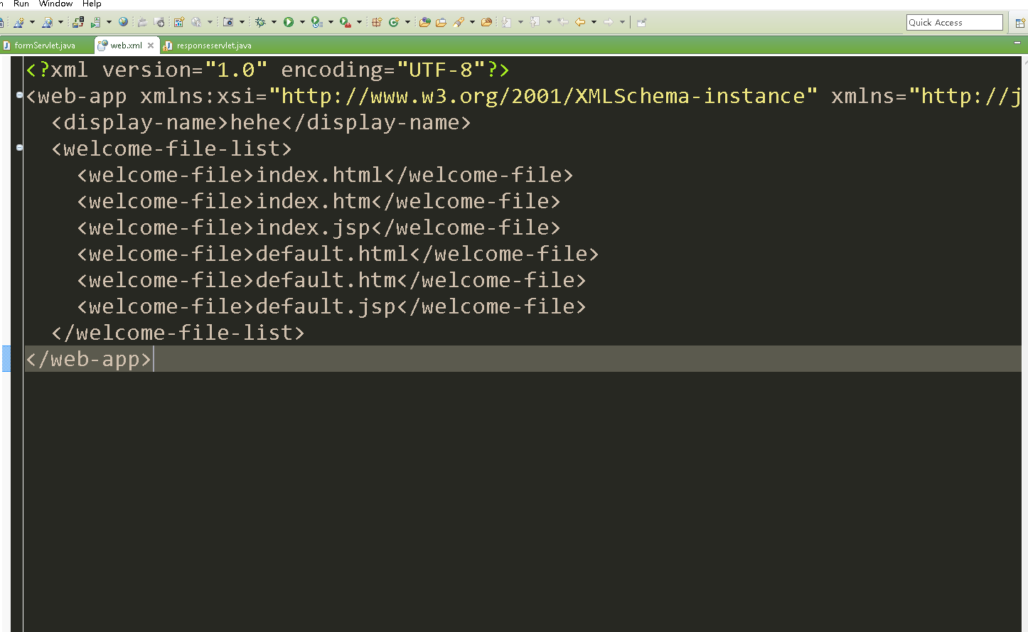

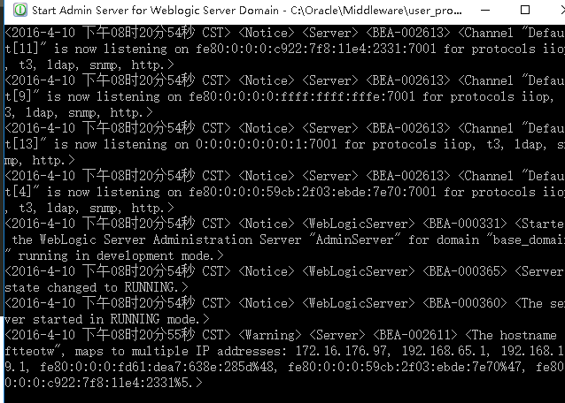

实验二：
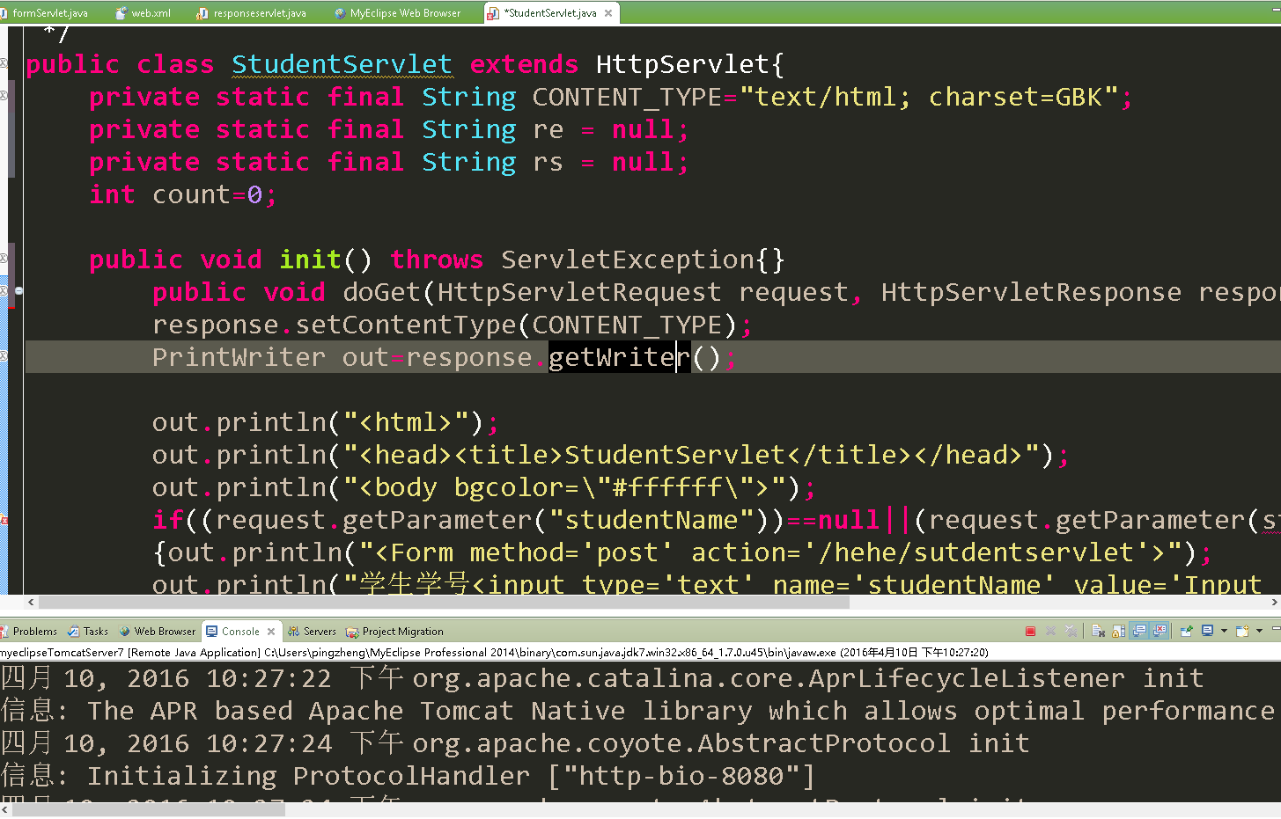

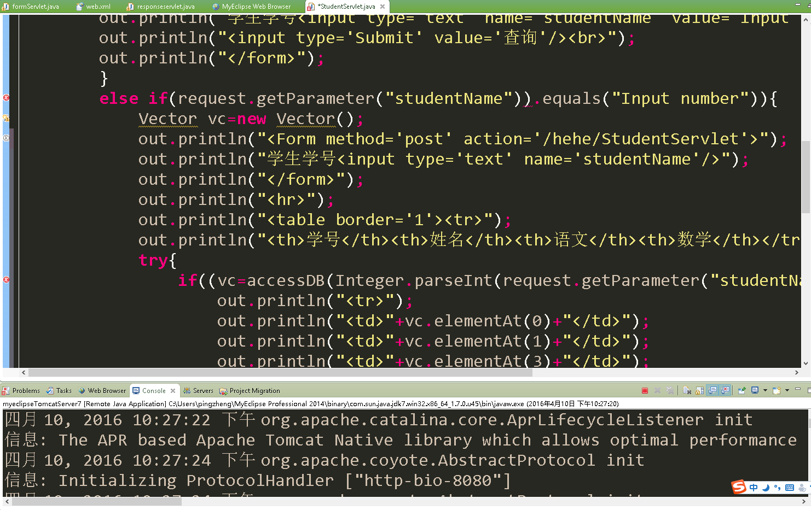

很明显，Weblogic12c这个版本的容器是足够没脑的，凡是与微软搭边的东西都很不正常.

附上实验源码：

/**
*
*/
package hehe;

import java.io.IOException;
import java.io.PrintWriter;
import java.util.Vector;

import javax.servlet.ServletException;
import javax.servlet.http.HttpServlet;
import javax.servlet.http.HttpServletRequest;
import javax.servlet.http.HttpServletResponse;

/**
*类描述：
*@author: pingzhengpingzheng
*@date： 日期：2016年4月10日 时间：下午11:12:06
*@version MyElipse 2014
生活就像海洋，只有意志坚强的人才能到达彼岸。
*/
public class StudentServlet extends HttpServlet{
private static final String CONTENT_TYPE="text/html; charset=GBK";
private static final String re = null;
private static final String rs = null;
int count=0;

public void init() throws ServletException{}
public void doGet(HttpServletRequest request, HttpServletResponse response) throws ServletException,IOException{
response.setContentType(CONTENT_TYPE);
PrintWriter out=response.getWriter();

out.println("<html>");
out.println("<head><title>StudentServlet</title></head>");
out.println("<body bgcolor=\"#ffffff\">");
if((request.getParameter("studentName"))==null||(request.getParameter(studentName)).equal("Input number"))
{out.println("<Form method='post' action='/hehe/sutdentservlet'>");
out.println("学生学号<input type='text' name='studentName' value='Input number'/>");
out.println("<input type='Submit' value='查询'/><br>");
out.println("</form>");
}
else if(request.getParameter("studentName")).equals("Input number")){
Vector vc=new Vector();
out.println("<Form method='post' action='/hehe/StudentServlet'>");
out.println("学生学号<input type='text' name='studentName'/>");
out.println("</form>");
out.println("<hr>");
out.println("<table border='1'><tr>");
out.println("<th>学号</th><th>姓名</th><th>语文</th><th>数学</th></tr>");
try{
if((vc=accessDB(Integer.parseInt(request.getParameter("studentName"))))!null){
out.println("<tr>");
out.println("<td>"+vc.elementAt(0)+"</td>");
out.println("<td>"+vc.elementAt(1)+"</td>");
out.println("<td>"+vc.elementAt(3)+"</td>");
out.println("</tr>");
}
else{
out.println("<tr>");
out.println("<td>没有记录</td>");
out.println("</tr>");
while(re.next()){
vc.add(Integer.toString(rs.getInt("sno")));
vc.add(rs.getString("sname"));
vc.add(Integer.toString(rs.getInt("chinese")));
vc.add(Integer.toString(rs.getInt("math")));
}
rs.close();
stmt.close();
conn.close();
return vc;
}
catch(Exception e){
e.printStackTrace();}
}
return null;
}
}
/**
* @param parseInt
* @return
*/
private Vector accessDB(int parseInt) {
// TODO Auto-generated method stub
return null;
}
}

}

import java.io.IOException;
import java.io.PrintWriter;

import javax.servlet.ServletException;
import javax.servlet.http.HttpServlet;
import javax.servlet.http.HttpServletRequest;
import javax.servlet.http.HttpServletResponse;

/**
*
*/

/**
*类描述：
*@author: pingzhengpingzheng
*@date： 日期：2016年4月8日 时间：上午9:33:19
*@version MyElipse 2014
生活就像海洋，只有意志坚强的人才能到达彼岸。
*/

public class responseservlet extends HttpServlet{
public void doGet(HttpServletRequest request,HttpServletResponse response)throws ServletException,IOException{
response.setContentType("text/html;charset=GBK");
PrintWriter out= response.getWriter();
request.setCharacterEncoding("GBK");
String username=request.getParameter("username");
String password=request.getParameter("password");
out.println("<html>");
out.println("<head><title>responseServlet</title></head>");
out.println("<body bgcolor=\"#ffffff\">");
out.println("<p>用户名:"+username);
out.println("<p>密码:"+password);
out.println("</body>");
out.println("</html>");
out.flush();
out.close();
}
public void doPost(HttpServletRequest request,HttpServletResponse response)
throws ServletException,IOException{
doGet(request,response);
}
}

import java.io.*;
import javax.servlet.*;
import javax.servlet.http.*;

/**
*
*/

/**
*类描述：
*@author: pingzhengpingzheng
*@date： 日期：2016年4月6日 时间：下午12:44:41
*@version MyElipse 2014
生活就像海洋，只有意志坚强的人才能到达彼岸。
*/
public class formServlet extends HttpServlet{

public void doGet(HttpServletRequest request,HttpServletResponse response)
throws ServletException, IOException {
response.setContentType("text/html;charset=GBK");
PrintWriter out=response.getWriter();
out.println("<HTML>");
out.println("<HEAD><TITLE>A Servlet</TITLE></HEAD>");
out.println("<BODY>");
out.println("<p>Please input a form</p>");
out.println("<Form method='POST' action='/hehe/servlet/responseservlet'>");
out.println("用户名<input type='text' name='username' /><br>");
out.println("密码&nbsp;&nbsp;<input type='password' name='password'/><br>");
out.println("<input type='Submit' value='提交'/><br>");
out.println("</FORM>");
out.println("</HTML>");
out.flush();
out.close();
}
public void doPost(HttpServletRequest request,HttpServletResponse response)
throws ServletException,IOException{
doGet(request,response);
}

}

<?xml version="1.0" encoding="UTF-8"?>
<web-app version="2.5"
xmlns="http://java.sun.com/xml/ns/javaee"
xmlns:xsi="http://www.w3/org/2001/XMLSchema-instance"
xsi:schemaLocation="http://java.sun.com/xml/ns/javaee http://java.sun.com/xml/ns/javaee/web-app_2_5.xsd">

<servlet>
<servlet-name>myFirstServlet</servlet-name>
<servlet-class>com.my.formServlet</servlet-class>
</servlet>
<servlet-mapping>
<servlet-name>myFirstServlet</servlet-name>
<url-pattern>/servlet/formServlet</url-pattern>
</servlet-mapping>

<servlet>
<servlet-name>responseservlet</servlet-name>
<servlet-class>com.my.responseservlet</servlet-class>
</servlet>

<servlet-mapping>
<servlet-name>responservlet</servlet-name>
<url-pattern>/servlet/responseservlet</url-pattern>
</servlet-mapping>

<welcome-file-list>
<welcome-file>index.jsp</welcome-file>
</welcome-file-list>
</web-app>

