B11118009蕭富池

const n =5

for(let i =1; i <=n;i++){

console.log("(OwO)")

}

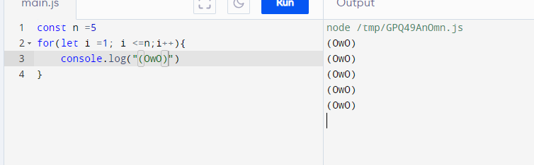

B11118013沈俊憲

//program to display text 5 times

const coumter = 5;

//loop from i = 1 to

for (let i = 1;i <=coumter; i++){

console.log("^=.=^");

}

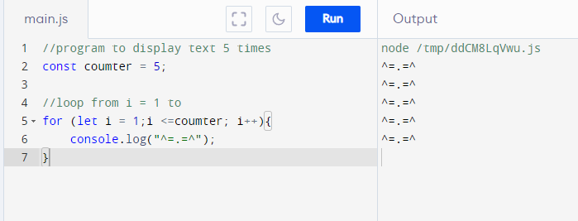

B11118016陳衍廷

// program to display text 5 times

const n = 5;

// looping from i = 1 to 5

for (let i = 1; i <= n; i++) {

console.log(`^=.=^`);

}

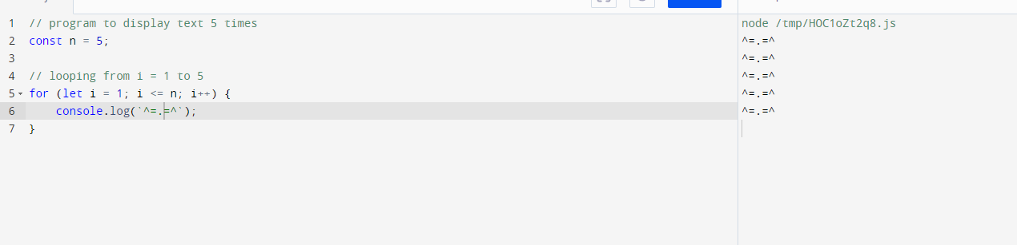

B11118017鄭安凱

// program to display text 5 times

const n = 5;

// looping from i = 1 to 5

for (let i = 1; i <= n; i++) {

console.log(`^=.=^`);

}

