Kris Duda
CSD 325: Advanced Python
Professor Woods

Module 10.2 Assignment: GUI ToDo

Here is the output of the initial To-Do program with a couple of tasks added:

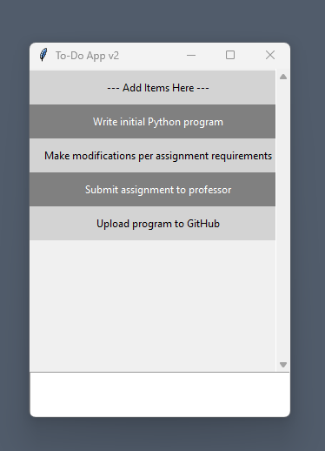

Here is the output of the program after the assignment modifications:

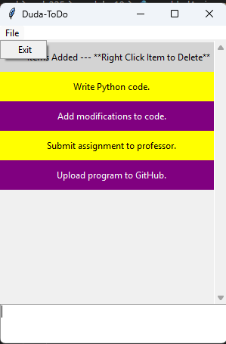

This is the same program with the last task deleted:

