Kris Duda
CSD 325: Advanced Python
Professor Woods

Module 11.2 Assignment: Django

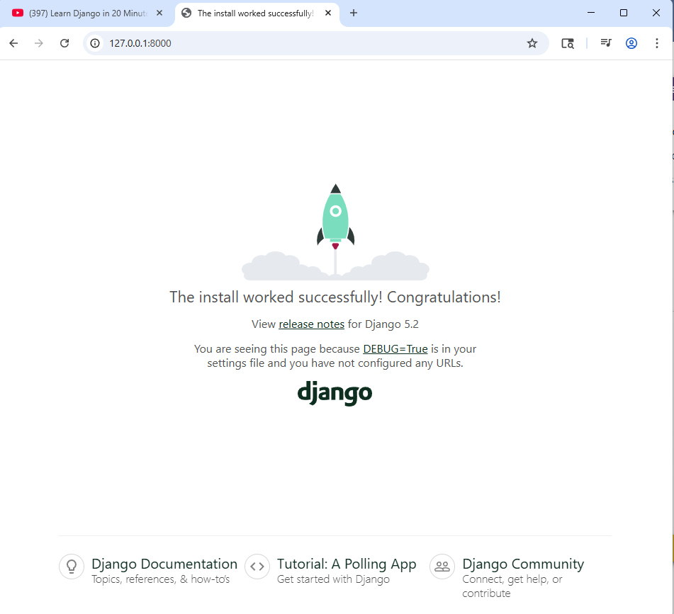

After making the required modifications to the files and directories, when I ran the server again, I ended up with the above screen again rather than the “Duda say Hello!” text that I associated with HttpResponse. I double checked to make sure that I was making the correct modifications to the correct files/directories, so I am at a loss as to why the correct output was not being generated. Below are screenshots of the relevant code, just to show that I was making the requisite modifications. I will accept any point deductions for not producing the desired output after the modifications were made.
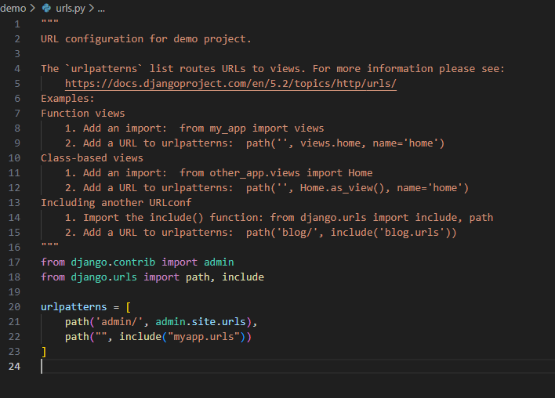

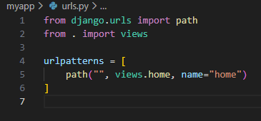

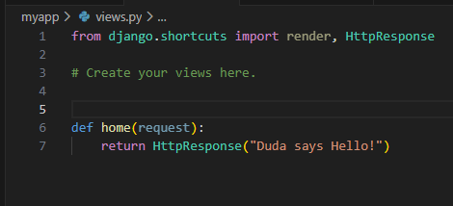
For the following program, the only modification was the addition of line 40, so I am only pasting the snippet of that part here:
