Kris Duda
CSD 325: Advanced Python
Professor Woods

Module 9.2 Assignment: JSON and APIs

This was the block of code used to test the connection to the astronaut API:

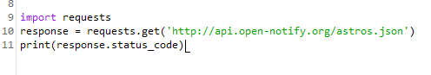
This was the resulting output. The ‘200’ indicates that the resource returned successfully:

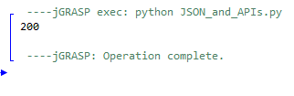
Here is the Python code used to extract information from the API and format the output:

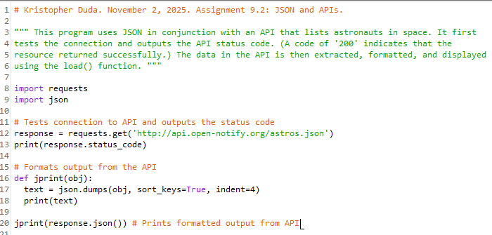

On the next page is the formatted output itself:

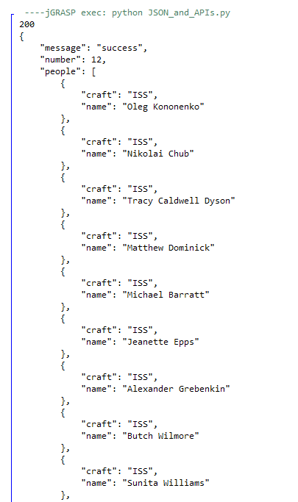
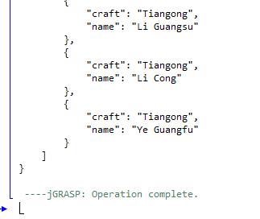
The next API I found is the “Bored API”. For each response, it returns data on a random activity that the user can do to combat boredom. As with the last program, the connection is tested at the beginning with the resulting status code given as output.
Here is the output of the response with no formatting. (Need to zoom in to see – sorry!):
Here is the output when the response is formatted:
