Kris Duda
CSD 325: Advanced Python
Professor Woods

Module 7.2 Assignment: Test Cases

The initial program:

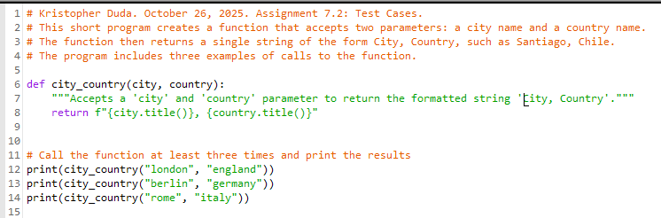

Output of the initial program:

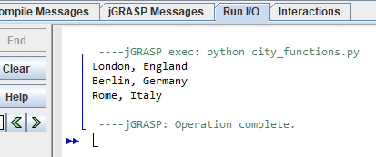

The test_cities.py file that tests the city_country() function in the previous program:

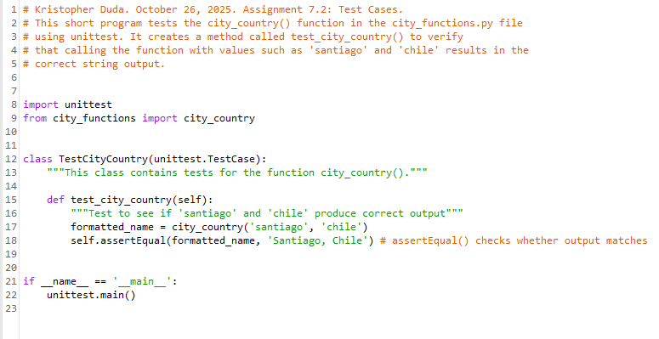

Output from running the above test_cities.py program:

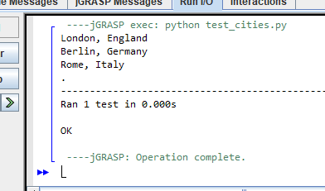

Revised version of the ‘city_functions.py’ program, to include a population parameter:

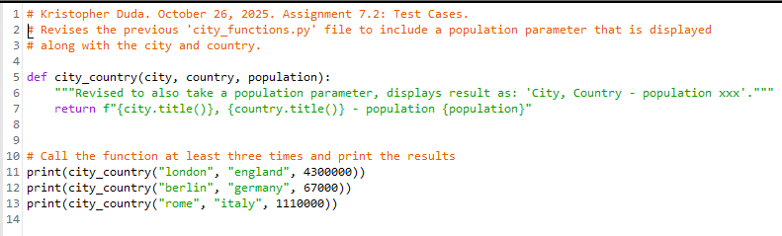

Failed test result of above program:

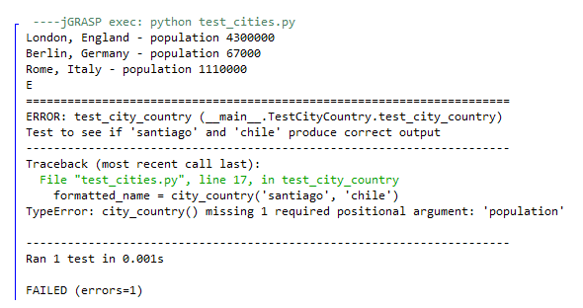

Modification of ‘city_functions.py’ program to make population parameter optional:

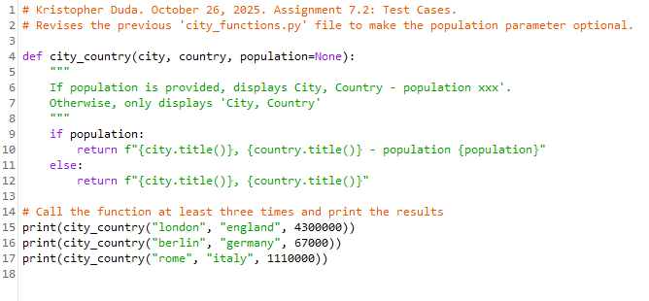
Now we see that this version of the program passes the test:

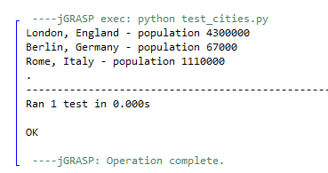

Modification of ‘city_functions.py’ to add a fourth parameter: language.
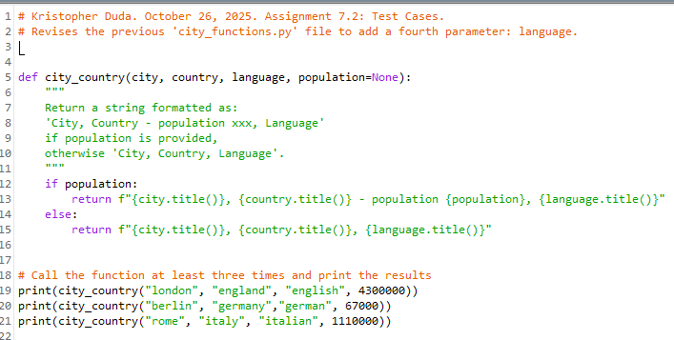

Failed (as expected) result after running ‘test_cities.py’ on above program:

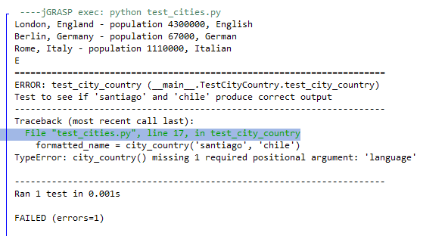

Modification of city_country() function in city_functions.py so that the language argument is optional:
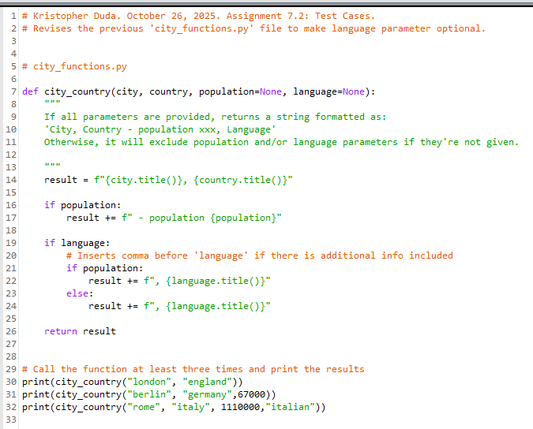

Test result is a pass (as expected):
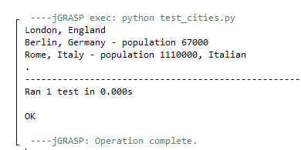
Result when ‘city_functions.py’ is run, calling the function three times using:
a City, Country for one
a City, Country, population for the next
a City, Country, population, and language for the last

