Kris Duda
CSD 325: Advanced Python
Professor Woods

Module 8.2 Assignment: JSON Practice

Run your program and take a screenshot of the results:

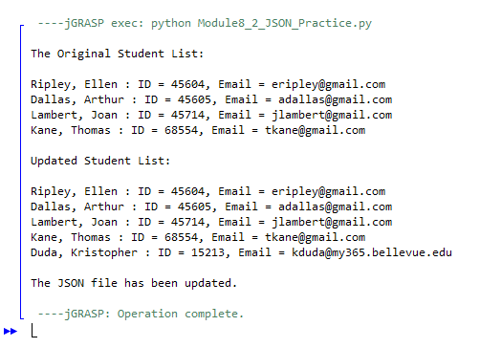

Once the program runs, you should also see a notification that the student.json file has changed, with a choice to save or not. Take a screen shot of the notification and paste into your Word document.

{I did not receive any notification that the json file had changed.)

Open the .json file and copy the contents, then paste that into your Word document:
