Kris Duda

CSD 325: Advanced Python

Professor Woods

Module 1.2 Assignment: GitHub Repository Setup

Link to GitHub repository:

[kjduda/csd-325: Advanced Python class materials](https://github.com/kjduda/csd-325)

Screenshot of local directory:

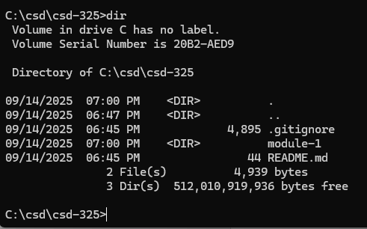

Screenshot of GitHub repository:

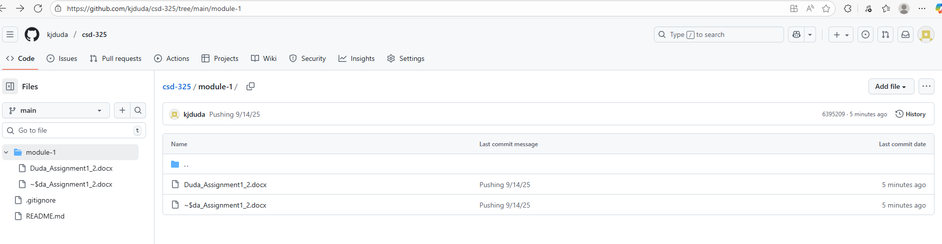

Note: When I originally created the “module-1” subdirectory, I accidentally made it only a subdirectory within the general csd folder (csd\module-1) instead of as a subdirectory of the csd-325 directory (csd\csd-325\module-1). After I identified this error, I created the subdirectory in the proper location and saved the assignment file to it. However, before I found and fixed the error, I had already saved a copy of the assignment file to the other ‘module-1’ directory as well. After the push, I believe that both copies of the assignment file were pushed to my repository, with one of the file names slightly altered so as not to have identical file names. The contents of the files are identical. I will delete the redundant file from the repository this week. I did not do it for this assignment since I am not super confident about how to do that yet and didn’t want to create any additional problems now that the assignment file was already successfully pushed to the GitHub repository.