Kris Duda

CSD 325: Advanced Python

Professor Woods

Module 2.2 Assignment: Documented Debugging

Link to GitHub repository:

[kjduda/csd-325: Advanced Python class materials](https://github.com/kjduda/csd-325)

Screenshot of start of debugging process using VS Code. Break point is created on line 17:

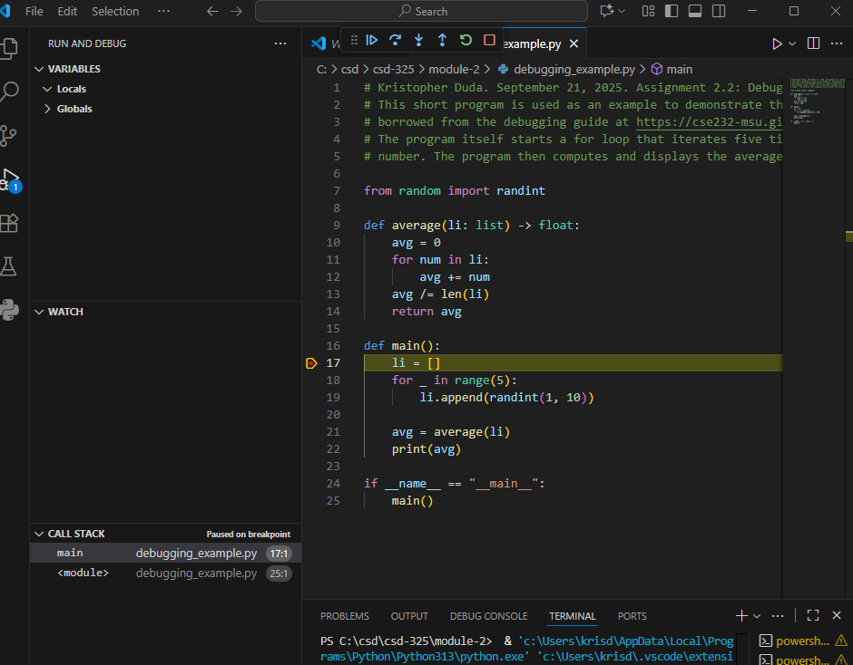

We then hit “Step Over” through the iterations of the loop. Note that the left panel shows how, with each step, ‘li’ expanded with a new random integer (for a total of 5 integers):

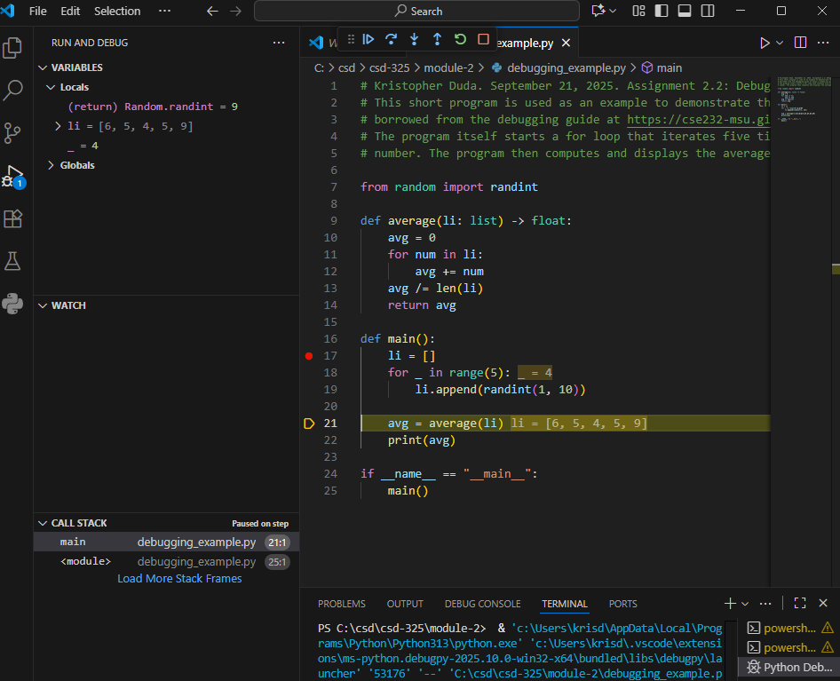

When we reach line 21, we Step Into the average() function, taking us to line 10, which is where the function starts:

