Darwinet Help

Welcome
Than you for using Darwinet!
This help file will describe to you how to get the most out of your Darwinet collaboration.

What is Darwinet?
Darwinet is a peer-2-peer network in which Darwinet applications may share data in Darwinet domains.
The Darwinet ramework provides applications and data in the Darwinet network to evolve in a similar way species may evolve in the nature.
Evolution of applications and data in the Darwinet network is promoted by providing an incremental mechanism of data change. When data is changed by one user at a Darwinet node, the change is reported to the other nodes of the user domain in which data is shared. The reported change is then merged at the receiver node.
This mechanism of incremental data exchange makes it possible to work off-line and still synchronize with other nodes when going on-line again.
- No server is required. All nodes are mirror nodes in a peer-2-peer network.
- Applications, data model, data instances and data contents may change in run-time and are automatically synchronized at each Darwinet node.
- More…

Darwinet generation 1

Overview of generation 1
This generation is for development testing only.
Darwinet nodes of this first generation tests concepts of the Darwinte network to evaluate what works and what solution to use and migrate to the next generation.

Darwinet generation 1 GUI
The GUI of generation 1 supports testing of synchronization of data of the same user between two Darwinet nodes on the same or on different machines.
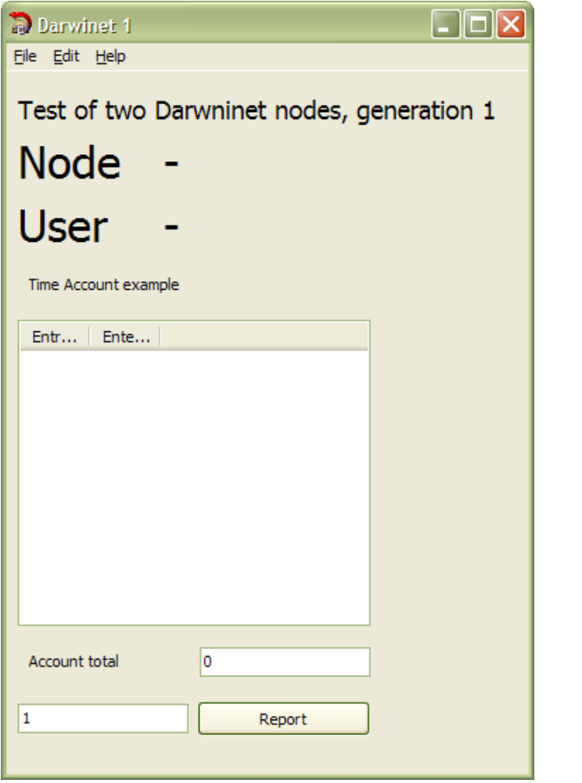
The GUI shows the user and the Node of which data is administrated.
The GUI simulates a time account of the user.
Reported changes to the account are shown in the list in the center of the GUI.
At the bottom of the account list a total filed is shown.
At the very bottom new reports to the account may be made.

Darwinet generation 1 configuration
This application uses hard coded configuration as follows.
- Node N1 reads changes reports from e-mail adress n1.darwinet@koh-innovation.se and reports changes to e-mail n2.darwinet@koh-innovation.se.
- Node N1 reads changes reports from e-mail adress n2.darwinet@koh-innovation.se and reports changes to e-mail n1.darwinet@koh-innovation.se.

