**Software Used:**

Minecraft: https://minecraft.net/en-us/

PiskelApp: https://www.piskelapp.com/p/agxzfnBpc2tlbC1hcHByEwsSBlBpc2tlbBiAgICPzaqgCAw/edit

NovaSkin: https://minecraft.novaskin.me/resourcepacks

BlockBench: http://blockbench.net/

Image to Map: https://www.minecraftforum.net/forums/mapping-and-modding-java-edition/minecraft-tools/1261738-linux-windows-imagetomap-in-game-text-and-images

SecureNET: The Grey Hat Origins

**YOUR STORY**

You are the newest agent at the SecureNET Cybersecurity Agency. A company renowned for its groundbreaking security services for many high-profile clients. You are here because you were caught. You were a former script kiddie and self-taught password cracker who got caught and were given an ultimatum. You either learn to use your skills to become a security agent or face the legal consequences. It is your first day on the job. You are being shown around the facility by the head security Agent S. Curity when an alarm sounds. Someone has attempted to break into the company’s systems. While Agent S. Curity goes to handle the situation, you must learn about various malware and cyberattacks using the UN-1-VAC simulator. There are five simulations: The Morris Worm, MafiaBoy DDoS, The Melissa Virus, WannaCry, and Mirai Botnet Attack. Once completed Agent S. Curity returns. They managed to stop the attack for now, but the damage was done, and they fear another attack is imminent. You are tasked to enter the computer system and using what you learned prepare and defend the system against the next attack. After defending the system, you have one last thing to do. Unmask the attacker based on what you learned from defending and repairing the system. Complete all this and you become an office SecureNET Agent.

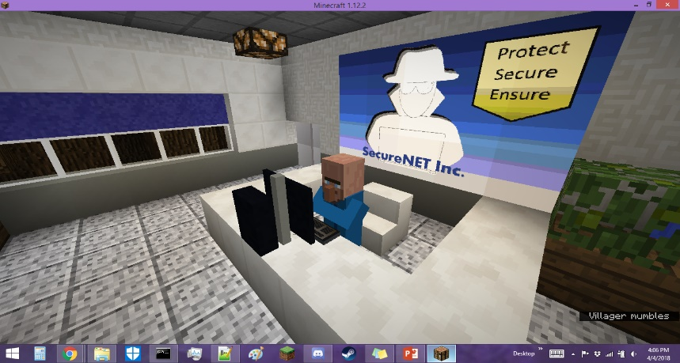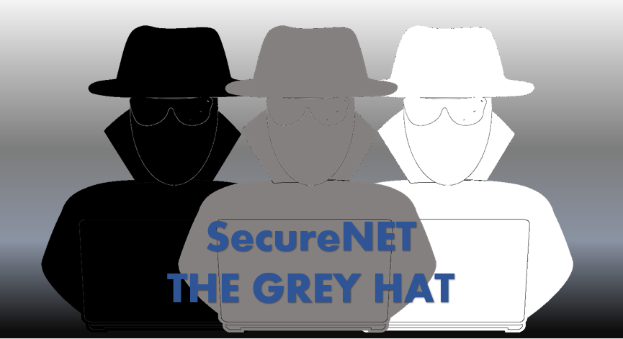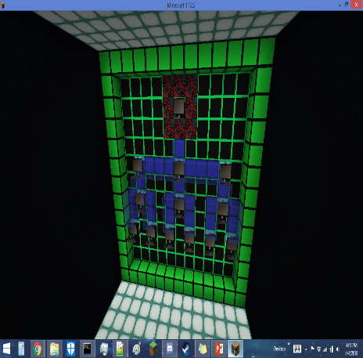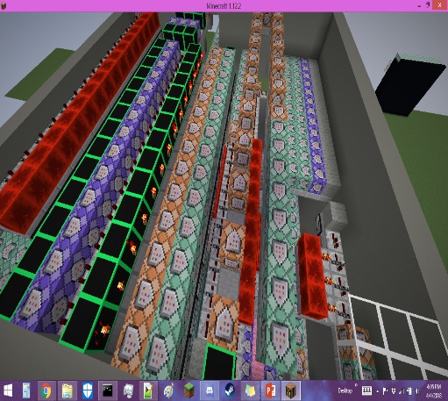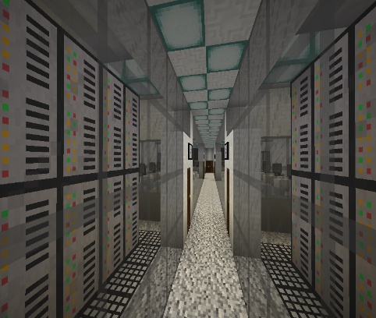

**Project Concept:**

Cyber Security is a growing concern in our world today. With the rise of the internet of things, everything is interconnected. You have smart phones, smart watches, smart TVs, and even smart refrigerators. The issue with this is now instead of just computers to worry about we have devices that can act as access points for cyber-attacks. This is something many people may not know or understand fully. One major way to help prevent these devices from becoming access points for attacks is the education of the people who use them about security. To do this one can use the concept of gamification, or learning through play, to create an interesting and more engaging way for people to understand just what can happen in the cyberworld. In order to get an insight into how much the player learned through my map I also created a survey using google forms that they could complete if they so choose after playing the game. I then took the feedback from this form to gauge if the players felt they learned something.

**Requirements/Game Settings:**

1. Play on Minecraft Version 1.12.2
2. Play on Norma Difficulty
3. Play in Adventure Mode
4. Particles & Sound ON
5. Auto-Jump OFF
6. Check Texture Pack
7. To advance text click >>>
8. Have fun!

|  |  |  |
| --- | --- | --- |
| On a scale from 1 to 10, 1 being you know very little to 10 being an expert how much do you know about Cyber Security overall? | | |
|  | Before | After |
| Below Average (1-4) | 35.71% | 11.90% |
| Average (5&6) | 35.71% | 26.19% |
| Above Average (7-10) | 28.57% | 61.90% |
| On a scale from 1 to 10, 1 being you know very little to 10 being an expert how much do you know about Cyber-Attacks? | | |
|  | Before | After |
| Below Average (1-4) | 38.10% | 16.67% |
| Average (5&6) | 26.19% | 19.05% |
| Above Average (7-10) | 35.71% | 64.29% |
| On a scale from 1 to 10, 1 being you know very little to 10 being an expert how much do you know about Malware? | | |
|  | Before | After |
| Below Average (1-4) | 42.86% | 21.43% |
| Average (5&6) | 19.05% | 21.43% |
| Above Average (7-10) | 38.10% | 57.14% |

**Game Download:** http://www.minecraftmaps.com/adventure-maps/securenet-the-grey-hat-origins

**Playthrough:** https://www.youtube.com/watch?v=pEbPRxPGZAo&t=371s

**Results Analysis**

At the time of writing this, the game has 1000+ downloads, however these downloads did not translate to many survey responses. I only received 42 survey responses. The results are as followed.

Based on these results it can be clearly seen that overall after playing the game there was an increase in understanding in regard to cyber-security, cyber-attacks, and malware. It should be noted for the sake of clarity that below average was deemed to be 0 to 4, average 5 or 6, and above average 7 to 10.

For cyber security knowledge before playing there was a fairly even distribution of below, average, and above with a tie for the major in below and at average with 35.71% each. After playing the game the majority fell to the above average range with a total of 61.90% of players falling in this category.

For cyber-attack knowledge before playing again there was a relatively close distribution but more polarized. The majority felt they were below average, 38.10%. This was only a slight majority as the second most was above average, 35.71%. After playing however players leaned once again towards being more knowledgeable with above average coming in at 64.29%.

In malware understanding it was a fairly even split. The majority either felt above or below average, with below coming in at 42.86% and above coming slight behind at 38.10%. After playing however there is again a shift with more people now feeling they better understand malware. Average and below average both ended with 21.43% and above average ending with 57.14%.

In all cases after playing the game the trend shows an improvement in understanding. This trend takes into account both good and bad reviews of the game of which there were both.

Want to Play or Watch?

Survey Results