Image-Text to Text based Multimodal AI using FLORENCE-2 for Remote Sensing Application

Kunal Jindal
Dept. of Computer Science Engineering
Amity University
Noida, India
0009-0005-6693-4812
Aditi Saxena
Dept. of Computer Science Engineering
Amity University
Noida, India
aditi.saxena2@s.amity.edu
Garima Aggarwal
Dept. of Computer Science Engineering
Amity University
Noida, India
gmehta@amity.edu
Ayush Singh Rajput
Amity Centre for Artificial Intelligence
Amity University
Noida, India
asrajput@amity.edu
Malay Kishore Dutta
Amity Centre for Artificial Intelligence
Amity University
Noida, India
malaykishoredutta@gmail.com

Abstract— Visual Question Answering (VQA) in remote sensing represents a critical advancement at the intersection of computer vision and natural language processing, facilitating context-aware interpretation of satellite and aerial imagery without human involvement. This study advances the domain by fine-tuning Microsoft’s FLORENCE-2, a lightweight multi-modal vision language model, for high-resolution remote sensing images. The model is fine-tuned on the RSVQA-HR dataset to bridge the gap between textual queries and complex geospatial imagery, addressing challenges such as spectral variability, occlusion, and scale diversity. The architecture integrates DaViT-based hierarchical vision encoding, enabling multi-scale feature extraction across spatial dimensions (128, 256, 512, and 1024), while a transformer-based decoder with cross-modal attention mechanisms ensures effective alignment of image embeddings with linguistic representations. Final Results demonstrate a higher accuracy and interpretability of satellite image-based VQA tasks by using the fine-tuned model. This research underscores the potential of large language vision models in enhancing geospatial intelligence, extending Artificial Intelligence (AI) application to environmental monitoring, disaster management, and urban planning.
Keywords—Visual Question Answering (VQA), Remote Sensing, Deep Learning, Multi-Modal Vision-Language Models, Satellite Image Interpretation, FLORENCE-2 Model

INTRODUCTION
Remote Sensing is a technology that is widely used in many fields such as environmental monitoring, disaster management and agriculture. The technology involves collecting information about an area or object using satellites, drones and various other sources using sensors and HD Cameras. It helps Geologists, Meteorologists, Agronomists, Govt. Agencies, Military, etc, to answer various complex questions about land use, infrastructure and vegetation. With the recent advancements in both Hardware and Software tools and technologies, the need for trained and technically sound professionals has increased greatly. And despite these new tools, analysis of such data requires a lot of manual work [1]. Though remote sensing has been practised for a long time, multiple studies have been conducted to review the advancements and challenges faced in this industry [2], [3].
In recent years, Visual Question Answering has emerged as a popular AI-based technique for interpreting images. It uses an AI model to generate responses for questions based on a given image. Several new large-scale models have been introduced to enhance the multi-modal reasoning in Visual Question Answering (VQA). Examples of such models include EVEv2 (2.5B parameters) [4] that uses Transformer-VLP to improve text and image fusion more effectively. Minicpm (2.4B parameters) [5] is another transformer based model that generates better responses in VQA. Qwen2-VL (72B parameters) [6] is a very large AI model based on Vit(Vision Transformer) and Transformer which uses a technique known as M-Rope to assist in improving image and text. ViLT (2B parameters) [7] used transformers to eliminates the use of traditional CNN's (commonly used in image processing) to process images and text. In addition, models such as Flamingo (80B parameters), CoCa (2.1B parameters), BLIP-2 (7.8B parameters), and PaLI (17B parameters) [8] raised the VQA performance above the first architectures. Unlike the old traditional methods for Visual Question Answering which relied on different image processing networks(such as CNNS) and language models, these next-generation AI models use transformer-based architecture such as Vision Transformers (ViTs) and Large Language Models (LLMs), to understand both images and text at the same time and effectively. These advanced AI models are trained on a massive dataset using self-supervised learning, which helps them improve their accuracy in answering questions about images, making the VQA model more powerful.
Recently, the use of AI in remote sensing is on the rise, thus opening doors to extend the use of Visual Question Answering in Remote sensing to interpret data involving remote sensing images. This technology is easily accessible and user-friendly as it allows users with limited technical understanding to interact with remote sensing data using natural language [9]. Since the most common way for humans to communicate is language, it becomes important to integrate natural language processing algorithms along with other algorithms to make machines understand remote sensing data effectively. The fusion of vision and language is increasingly popular among researchers and is being utilised in remote sensing applications. A few of them are describing the content of remote sensing images through image captioning [10]–[12], querying images by text query [13], and, more recently, visual question answering (VQA [14]–[17]. Earlier works that have used the RSVQA-HR dataset for visual question answering in remote sensing include RSGPT [18], GeoChat [19], SkyEyeGPT [20], LHRS-Bot [21], LHRS-Bot-Nova [22]. In this era of advanced technology, the Visual Question Answering model is also suggested to be integrated with various other existing models in different domains including healthcare [23], [24], [25], Autonomous driving [26], Reliable AI system [27], Remote Sensing and Image Classification [28], and various others.
However, using these models for Visual Question Answering in Remote Sensing still presents certain difficulties. Firstly, the images collected through satellites differ from the images of regular photo datasets as they contain special details such as spectral bands, complex geographical structures and various resolutions. Secondly, the different remote sensing tasks such as identifying land-cover types, environmental changes and various others, require specialised knowledge that these Large Language Vision Models (LLVMs) lack [1]
The FLORENCE-2-Base Vision Language model is developed by Microsoft and has high computing efficiency and low resource usage in comparison with other famous VQA models, making it suitable for this proposed work. It has only 0.23B parameters, making it easy to perform vision language tasks such as Image Caption generation, VQA, etc [29]. Fine-tuning the model not only improves the performance of the model on remote sensing Visual Question Answering tasks, but allows for better interpretation of land use, infrastructure, and environmental processes. But, it also bridges the gap between LLVMs and remote sensing tasks by reducing the dependency of images on human experts for interpretation. Fine-tuning FLORENCE-2 for domain-specific data increases its accuracy, making it more reliable for question-answering tasks assisted by remote sensing. Moreover, the fine-tuned model supports real-world applications in disaster management, climate change monitoring, and city planning, where processing remote sensing data is important.
Since earlier studies have proven the effectiveness of the FLORENCE-2 [29] model in understanding natural images [30], but their application for remote sensing tasks is still a challenge due to structural differences in images, spectral bands, and domain-dependent requirements. In order to overcome these challenges, this study proposes fine-tuning of the FLORENCE-2 model on the remote Sensing dataset. Thus, allowing it to process and respond to remote sensing image-related questions more effectively. Key contributions of this paper are:
- Task-Specific Adaptation of FLORENCE-2 for Remote Sensing VQA - This study extends the capabilities of FLORENCE-2 by fine-tuning it for Visual Question Answering (VQA) in high-resolution remote sensing imagery, demonstrating its adaptability to domain-specific challenges such as occlusion, spectral variability, and object-scale diversity in satellite data.
- Cross-Modality Alignment through Transformer-Based Multi-Stage Attention Mechanisms - The integration of self-attention, cross-attention, and feed-forward networks (FFN) within a 6-layer transformer decoder facilitates enhanced cross-modal learning, ensuring optimal fusion of textual and visual embeddings for contextual answer generation.
- Hierarchical Multi-Scale Representation Learning via DaViT Encoding - By leveraging DaViT-based hierarchical vision encoding, this research enables multi-scale feature extraction at granular spatial resolutions (128, 256, 512, and 1024), thereby enriching the model’s representational power and improving semantic understanding for remote sensing VQA tasks.
Section 2 contains information about the dataset, model used and the fine tuning process. Section 3 contains the results of the finetuned model. Section 4 concludes the work done in this study and shows some gaps that can be solved in future.

METHODOLOGY

Dataset Description
RSVQA-HR dataset [14] contains image-question-answer triplets generated using geo-localized information from OpenStreetMap (OSM). The dataset is divided into two sections based on image resolution.
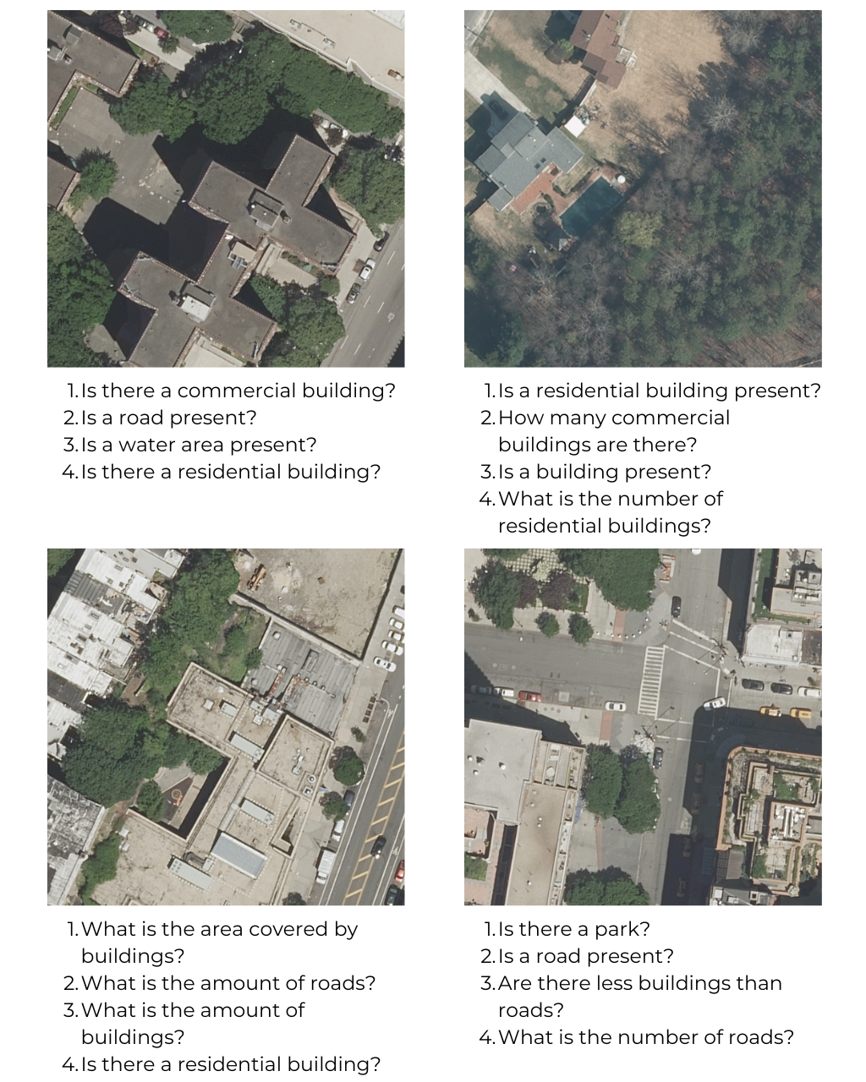
- The Low-Resolution (LR) dataset: The LR dataset is constructed using Sentinel-2 satellite images with a 10m resolution. It comprises 772 images of size 256×256 pixels and contains 77,232 question-answer pairs related to object presence, counting, area estimation, and comparison.
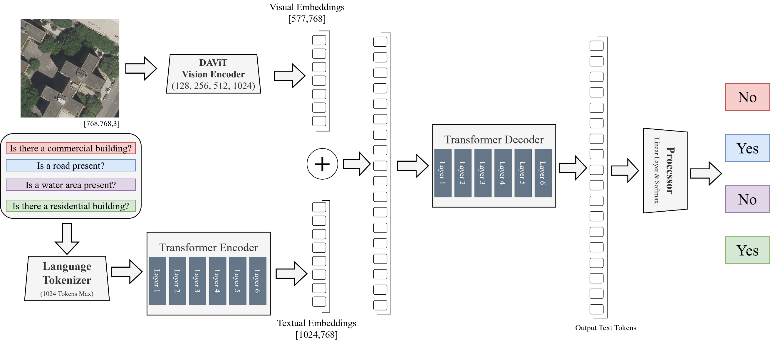
- The High-Resolution (HR) dataset: The HR dataset is built from 15cm aerial imagery provided by the USGS High-Resolution Orthoimagery (HRO) dataset, covering urban areas such as New York City, Philadelphia, and Portland. It includes 10,659 images of size 512×512 pixels, each covering 5898m², and contains 9,55,664 question-answer pairs. AI models trained on these datasets can be used for vision-related tasks such as object recognition, segmentation, precise area calculations, etc., with high accuracy for remote sensing applications.
The figure 1 shows some sample input images and a few example questions associated with the respective images.

Model Architecture
FLORENCE-2 is an advanced model that follows a multi-modal encoder-decoder architecture, and can handle several computer vision and vision-language tasks single-handedly by using a prompt-based framework. Unlike traditional models that require different architectures for each task, FLORENCE-2 is capable of image captioning, object detection, visual grounding, and segmentation with a sequence to sequence approach. This approach increases the model's adaptability, thus allowing it to learn and accomplish multiple tasks without intense training for each task [29].At its core, it consists of two main components, which are the Vision Encoder and the Transformer Encoder-Decoder, which fuse vision and textual inputs and generate responses.
Input images are first resized to 768 X 768 pixels, normalised and finally partitioned to non-overlapping patches. These patches are then given as input to a DAViT [31] based Vision Encoder. This encoder extracts spatial and semantic representations of the image at four scales: 128, 256, 512, and 1024 dimensions. The Final Output of the vision encoder are the Visual embeddings of 577 tokens each of size 768. Equation (1) shows the formation of initial patch embedding, where X is input Image, W_{E} is the projection matrix and b_{E} is the bias term.
For Processing Questions, a BART style tokenizer and encoder is being used. Input Text is tokenized and mapped to an embedding space of dimension 768 and augmented with positional encodings to preserve the word order. Model has a maximum limit of 1024 input tokens and a vocabulary of 51289 tokens, thus ensuring is ability to process long-form textual queries efficiently. These tokens are then passed on to a 6 Layer Transformer Encoder to generate Textual Embeddings, where each layer consists of Multi-head self-attention with 12 attention heads (each of size 64), FFN(Feed Forward Network) of dimension 3072.
The embeddings generated by the transformer encoder and the vision encoder are given as input to a 6-layer transformer decoder, where each layer consists of a Self Attention mechanism, a Cross Attention Mechanism and an FFN. Cross attention mechanism gives the model its multi-modal capabilities by aligning image features to the textual information. Equation (2) shows the cross attention mechanism being used, where K_{image}, V_{image} come from DaViT.
Finally, the output of the decoder is projected into a 51,289-dimensional vocabulary space, representing possible answers. A softmax layer then calculates probabilities for each token, and the most likely sequence is selected as the model’s response. This model has a total of 230M parameters out of which, approximately 90M parameters are of the vision encoder, and the rest 140M parameters are of the Transformer Encoder-Decoder. The figure 2 shows the FLORENCE-2 model architecture for Visual Question Answering on remote sensing images.

Fine Tuning Process
Table 1 shows the parameters used for fine-tuning the model. A batch size of 9 and a small learning rate of 1e-6 were used to prevent the model from over-fitting. Cross-entropy loss shown in (3), where $θ$ are the network parameters and $|y|$ is the number of target tokens, was used for all the tasks. AdamW optimizer was used because the decoupled weight decay helps achieve better generalization and stable convergence on high complexity data. Mixed-precision training was also enabled during the training process to make the process more efficient.
- TUNING CONFIGURATIONS FOR FLORENCE-2 ON RSVQA-HR
Parameter | Value
Optimizer | AdamW
Learning Rate | 1 × 10−6
Scheduler | Linear Decay
Warm-up Steps | 0
Number of Epochs | 10
Batch Size | 9
Number of Workers | 0
Early Stopping | Disabled

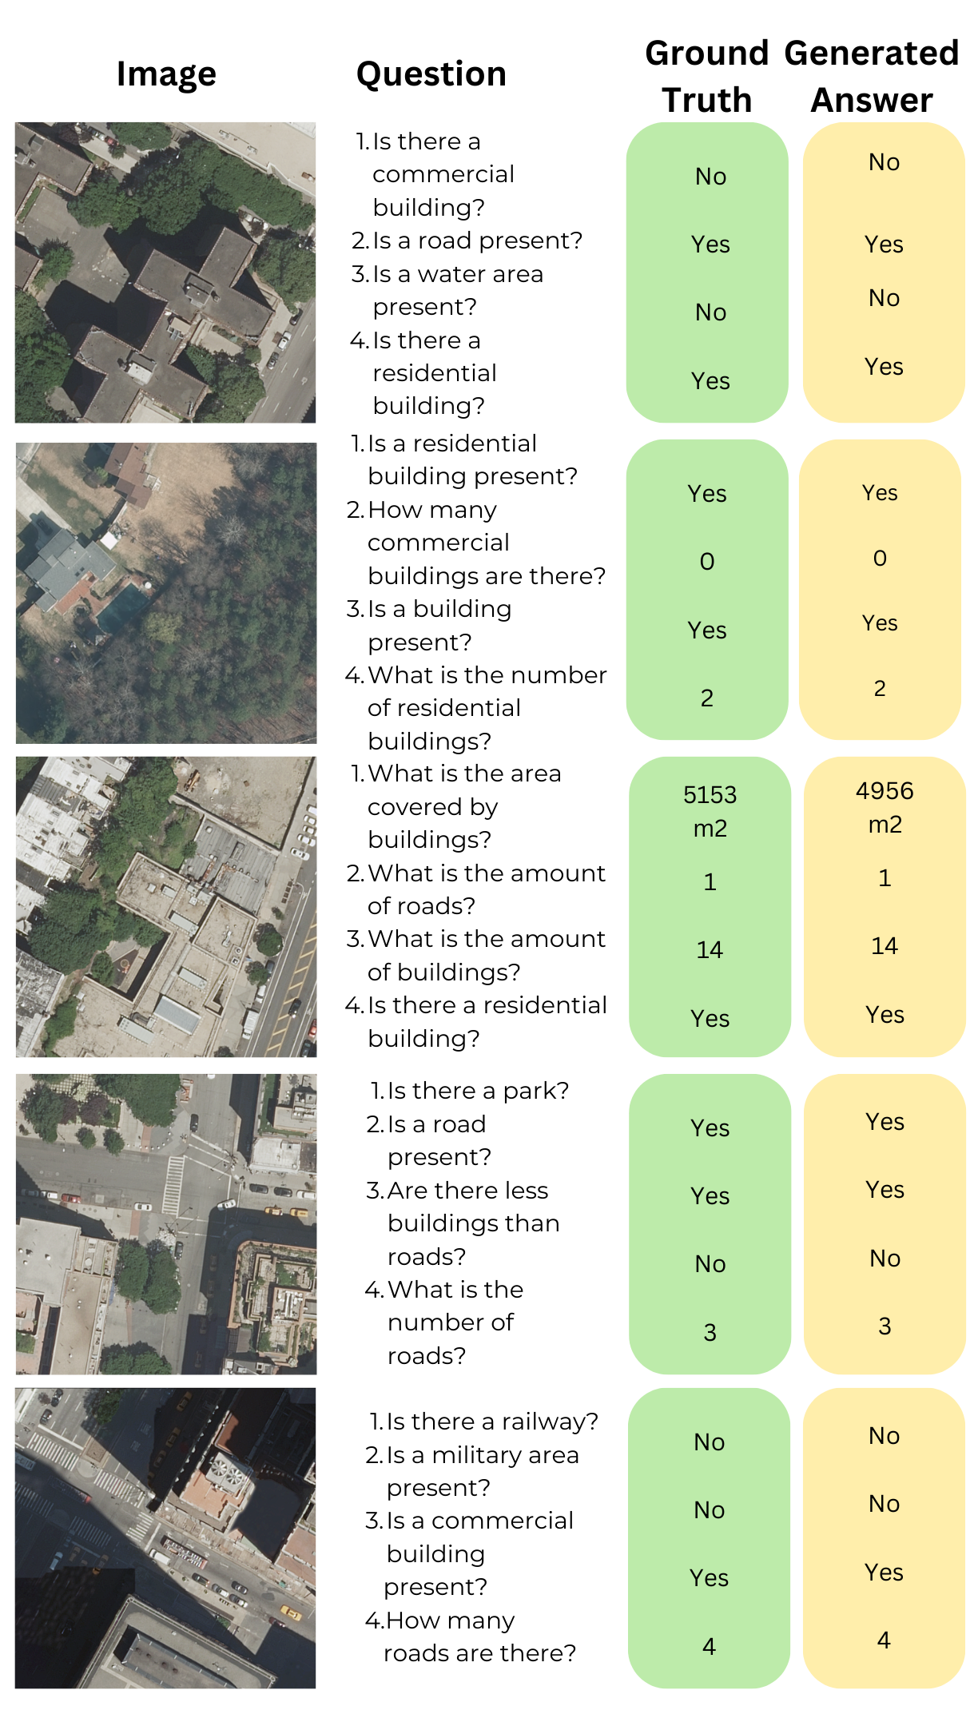
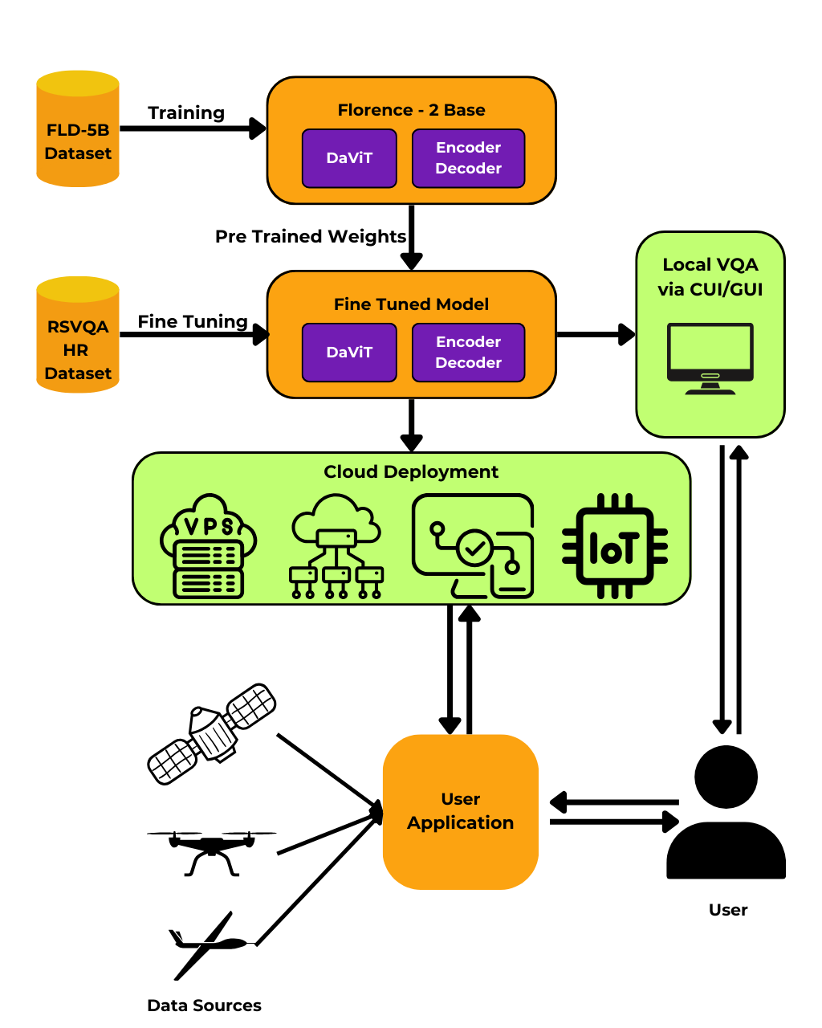
As shown in Figure 3, the fine-tuning of FLORENCE-2 for Visual Question Answering on Remote Sensing images initialized by loading and processing the pre-trained FLORENCE-2 Base model with the help of Hugging Face Transformers library.
As training continued, the model learned to link images and questions to the correct answers. After each epoch, Validation Loss was calculated to track the model's performance. When an improvement was observed, the model was saved for creating a backup and later use.

Experimental Training Setup
For the purpose of this study, the model was fine-tuned on an NVIDIA A100 GPU with 40GB RAM. This GPU is primarily used for deep learning and AI development due to its high efficiency. This configuration ensured a smooth and fine-tuning of the model at a very high speed. Further, the model was evaluated on an NVIDIA A40 GPU with 20 GB of RAM due to fewer resource requirements.

FINE TUNING RESULT
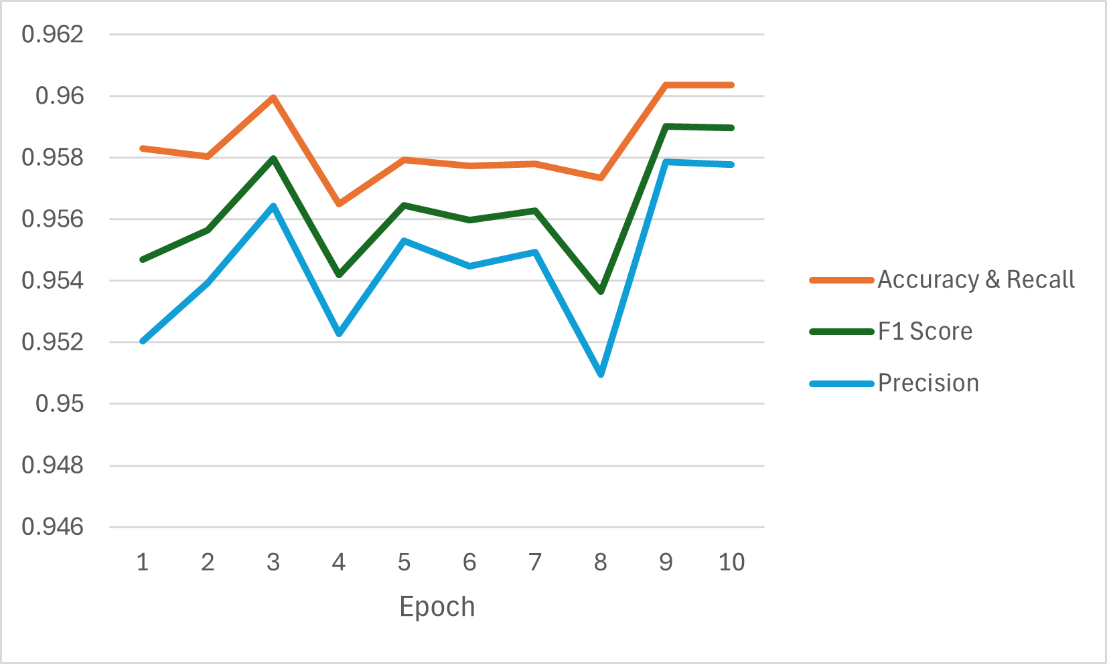
After each epoch, the model was tested using various primary performance indicators, namely Accuracy, Recall, Precision and F1 Score. Figure 4 shows the model performance after each epoch.
Figure 5 shows the answers generated by the model after fine-tuning. The values enclosed in the Green Box are the Correct Answers, while the values in the Yellow Box are the Generated Answers.
- Accuracy of different VQA Models on RSVQA – HR Dataset
Model | Accuracy (%)
RSGPT | 90.47
GeoChat | 70.82
SkyEyeGPT | 82.56
LHRS-Bot | 92.55
LHRS-Bot-Nova | 92.06
Finetuned Florence-2 (Ours) | 96.04

Table II presents a comparison of different VQA models evaluated on the RSVQA-HR dataset. Our fine-tuned Florence-2 model achieves the highest accuracy among all, demonstrating its superior performance. The results highlight the effectiveness of domain-specific fine-tuning over existing state-of-the-art approaches.
Table III shows the performance comparison between our fine-tuned model and the Florence-2-base model. The above results show a significant improvement in all key metrics, which are F1 score, precision, and recall. This demonstrates the impact of fine-tuning on task-specific data for enhancing overall model performance.
- BASE MODEL COMPARISON
Metric | Florence-2-Base | Florence-2-Base-Finetuned (Ours)
Accuracy | 0.4027 | 0.9604
F1 Score | 0.3145 | 0.9590
Precision | 0.3232 | 0.9579
Recall | 0.4027 | 0.9604
IoU | 1.0000 | 1.0000

After evaluating these results, it was observed that Epoch 9 delivered results with the highest accuracy and didn't observe further improvement after that from Epoch 10 onwards. Both epochs had an accuracy of 0.9604, indicating that the model can accurately interpret and answer visual questions. Table IV contains the results produced by the model after the 9th Epoch. As a result of this study, the FLORENCE-2 model was fine-tuned on the RSVQA-HR dataset for visual question answering using remote sensing images.
- BASE MODEL COMPARISON
Metric | Accuracy | F1 Score | Precision | Recall
Value | 0.9604 | 0.9590 | 0.9579 | 0.9604

CONCLUSION AND FUTURE WORK
In this study, the application of Visual Question Answering using Florence-2 is extended to Remote Sensing. This research addresses one of the key challenges faced in Remote Sensing, i.e. Technical Understanding of Tools, Data and Manual Analysis of Images. The obtained results demonstrate that after fine-tuning for 9 epochs using the RSVQA-HR dataset, the Florence-2 Base model achieved an accuracy of 96.04%.
Overall, this research highlights the fine-tuning process for the FLORENCE-2 model to implement Visual Question Answering in Remote Sensing. The analysis shows that in addition to the model’s high computational efficiency due to a smaller number of parameters and Transformer-based architecture, the model produces reliable and accurate results when handling complex questions regarding satellite images effectively. And, thus making its usage possible in environments/systems with limited resources.
Building upon this, some enhancements in terms of the model’s size, model’s architecture, training and deployment can be done to further improve the model and make it more suitable for large-scale usage. Firstly, the model size can be reduced while maintaining its ability to correctly answer questions based on the Images so that it can be deployed on Iot hardware such as Raspberry Pi and NVIDIA Jetson for real-time execution. Additionally, creating a Continuous training and deployment pipeline can streamline model updates and enhance its flexibility while making sure the Model is well-versed with the new data. Increasing the model's resilience to process varied satellite images from multiple sensors and geographic locations will also enhance its generalizability. Another potential improvement which can be introduced is to modify the model architecture to use data sources like weather forecasts, sensor readings, and geographical data to further increase the Model's scope and the variety of questions it can answer such as questions related to water level, quality of Air, solar capacity, etc to make the model useful for multiple applications. These enhancements will increase the relevance and usage of the work done in this study and make it more applicable to disaster management, agriculture, environmental monitoring, and urban planning.

Data Availability Statement
The RSVQA-HR dataset[14], utilised in this study for finetuning and evaluating the fine-tuned FLORENCE-2 model, contains high-resolution satellite imagery along with the corresponding question-answer pairs for Visual Question Answering (VQA) tasks. This dataset is publicly accessible and serves as a benchmark for remote sensing VQA research. Details regarding dataset access and structure can be found at [https://rsvqa.sylvainlobry.com/].

References
- S. Siripong, A. Chaiyapan, and T. Phonchai, “Large vision-language models for remote sensing visual question answering,” 2024.
- W. Han, X. Zhang, Y. Wang, L. Wang, X. Huang, J. Li, S. Wang, W. Chen, X. Li, R. Feng, et al., “A survey of machine learning and deep learning in remote sensing of geological environment: Challenges, advances, and opportunities,” ISPRS Journal of Photogrammetry and Remote Sensing, vol. 202, pp. 87–113, 2023.
- B. Zhu, L. Zhou, S. Pu, J. Fan, and Y. Ye, “Advances and challenges in multimodal remote sensing image registration,” IEEE Journal on Miniaturization for Air and Space Systems, vol. 4, no. 2, pp. 165–174, 2023.
- H. Diao, X. Li, Y. Cui, Y. Wang, H. Deng, T. Pan, W. Wang, H. Lu, and X. Wang, “Evev2: Improved baselines for encoder-free vision-language models,” 2025.
- S. Hu, Y. Tu, X. Han, C. He, G. Cui, X. Long, Z. Zheng, Y. Fang, Y. Huang, W. Zhao, X. Zhang, Z. L. Thai, K. Zhang, C. Wang, Y. Yao, C. Zhao, J. Zhou, J. Cai, Z. Zhai, N. Ding, C. Jia, G. Zeng, D. Li, Z. Liu, and M. Sun, “Minicpm: Unveiling the potential of small language models with scalable training strategies,” 2024.
- P. Wang, S. Bai, S. Tan, S. Wang, Z. Fan, J. Bai, K. Chen, X. Liu, J. Wang, W. Ge, Y. Fan, K. Dang, M. Du, X. Ren, R. Men, D. Liu, C. Zhou, J. Zhou, and J. Lin, “Qwen2-vl: Enhancing vision-language model’s perception of the world at any resolution,” 2024.
- W. Kim, B. Son, and I. Kim, “Vilt: Vision-and-language transformer without convolution or region supervision,” 2021.
- N. D. Huynh, M. R. Bouadjenek, S. Aryal, I. Razzak, and H. Hacid, “Visual question answering: from early developments to recent advances – a survey,” 2025.
- D. Huang, X. Tang, X. Zhang, F. Liu, J. Ma, C. Zhu, and L. Jiao, “A cross-modal semantic mapping enhancement model for remote sensing visual question answering,” in IGARSS 2024 - 2024 IEEE International Geoscience and Remote Sensing Symposium, pp. 7292–7295, 2024.
- K. Fu, Y. Li, W. Zhang, H. Yu, and X. Sun, “Boosting memory with a persistent memory mechanism for remote sensing image captioning,” Remote Sensing, vol. 12, no. 11, 2020.
- G. Sumbul, S. Nayak, and B. Demir, “Sd-rsic: Summarization-driven deep remote sensing image captioning,” IEEE Transactions on Geoscience and Remote Sensing, vol. 59, p. 6922–6934, Aug. 2021.
- Z. Yuan, X. Li, and Q. Wang, “Exploring multi-level attention and semantic relationship for remote sensing image captioning,” IEEE Access, vol. 8, pp. 2608–2620, 2020.
- T. Abdullah, Y. Bazi, M. Al Rahhal, M. Mekhalfi, L. Rangarajan, and M. Zuair, “Textrs: Deep bidirectional triplet network for matching text to remote sensing images,” Remote Sensing, vol. 12, p. 405, 01 2020.
- S. Lobry, D. Marcos, J. Murray, and D. Tuia, “Rsvqa: Visual question answering for remote sensing data,” IEEE Transactions on Geoscience and Remote Sensing, vol. 58, p. 8555–8566, Dec. 2020.
- Z. Yuan, L. Mou, Z. Xiong, and X. X. Zhu, “Change detection meets visual question answering,” IEEE Transactions on Geoscience and Remote Sensing, vol. 60, p. 1–13, 2022.
- X. Zheng, B. Wang, X. Du, and X. Lu, “Mutual attention inception network for remote sensing visual question answering,” IEEE Transactions on Geoscience and Remote Sensing, vol. 60, pp. 1–14, 2022.
- L. Bashmal, Y. Bazi, F. Melgani, R. Ricci, M. Al Rahhal, and M. Zuair, “Visual question generation from remote sensing images,” IEEE Journal of Selected Topics in Applied Earth Observations and Remote Sensing, vol. PP, pp. 1–15, 01 2023.
- Y. Hu, J. Yuan, C. Wen, X. Lu, and X. Li, “Rsgpt: A remote sensing vision language model and benchmark,” 2023.
- K. Kuckreja, M. S. Danish, M. Naseer, A. Das, S. Khan, and F. S. Khan, “Geochat: Grounded large vision-language model for remote sensing,” 2023.
- Y. Zhan, Z. Xiong, and Y. Yuan, “Skyeyegpt: Unifying remote sensing vision-language tasks via instruction tuning with large language model,” 2024.
- D. Muhtar, Z. Li, F. Gu, X. Zhang, and P. Xiao, “Lhrs-bot: Empowering remote sensing with vgi-enhanced large multimodal language model,” 2024.
- Z. Li, D. Muhtar, F. Gu, X. Zhang, P. Xiao, G. He, and X. Zhu, “Lhrsbot-nova: Improved multimodal large language model for remote sensing vision-language interpretation,” 2024.
- L. Canepa, S. Singh, and A. Sowmya, “Visual question answering in the medical domain,” 2023.
- L. Seenivasan, M. Islam, A. K. Krishna, and H. Ren, “Surgical-vqa: Visual question answering in surgical scenes using transformer,” 2022.
- X. Zhang, C. Wu, Z. Zhao, W. Lin, Y. Zhang, Y. Wang, and W. Xie, “Pmc-vqa: Visual instruction tuning for medical visual question answering,” 2024.
- C. Sima, K. Renz, K. Chitta, L. Chen, H. Zhang, C. Xie, J. Beißwenger, P. Luo, A. Geiger, and H. Li, “Drivelm: Driving with graph visual question answering,” 2025.
- S. Whitehead, S. Petryk, V. Shakib, J. Gonzalez, T. Darrell, A. Rohrbach, and M. Rohrbach, “Reliable visual question answering: Abstain rather than answer incorrectly,” 2022.
- H. Aghababaei and A. Stein, “Visual question answering for wishart h-alpha classification of polarimetric sar images,” in IGARSS 2024 2024 IEEE International Geoscience and Remote Sensing Symposium, pp. 11231–11234, 2024.
- B. Xiao, H. Wu, W. Xu, X. Dai, H. Hu, Y. Lu, M. Zeng, C. Liu, and L. Yuan, “Florence-2: Advancing a unified representation for a variety of vision tasks,” 2023.
- M. H. Abbas, Z. Xinyou, M. Manzoor, S. Tabraiz, and I. Hassan, “Visionxplore: Florence-2 for robust targeted object detection,” in 2024 21st International Computer Conference on Wavelet Active Media Technology and Information Processing (ICCWAMTIP), pp. 1–4, 2024.
- M. Ding, B. Xiao, N. Codella, P. Luo, J. Wang, and L. Yuan, “Davit:
Dual attention vision transformers,” 2022.

