下载链接

<https://www.eclipse.org/windowbuilder/download.php>

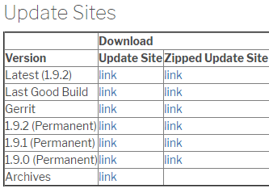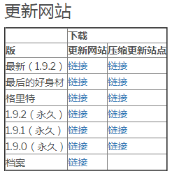

主题下载

<http://www.eclipsecolorthemes.org/>

