# CentOS配置本地yum源/阿里云yum源/163yuan源，并配置yum源的优先级

# 一、用Centos镜像搭建本地yum源

## 1.安装Centos后默认的yum源如下

**# ll /etc/yum.repos.d/**

## 2.把默认yum源备份(可选)

**# cp** CentOS-Base.repo CentOS-Base-cp.repo

## 3.在虚拟机上挂载CentOS镜像文件

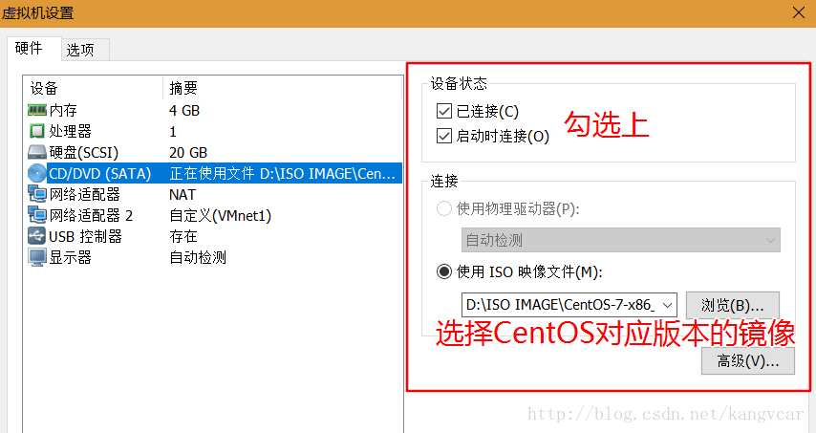

**# (1) mount -t iso9660 /dev/sr0 /opt/centos**

**# (2) mount /dev/cdrom /mnt/cdrom**

**4.编写repo文件并指向镜像的挂载目录**

**# cd /etc/yum.repos.d/**

**# vi local.repo //自定义配置文件名**

[local] **//标签**

name=local **//设置yum源名称**

baseurl=file:///opt/centos  **//挂载源**

enabled=1 **//可用性**

gpgcheck=0 **//校验**

## 5.清除缓存

**# yum clean all //全部消除缓存**

**# yum makecache //把yum源缓存到本地，加快软件的搜索好安装速度**

**# yum repolist //列出****个包**

# 二、把默认的CentOS yum源修改成国内的aliyun yum源

## 1.安装Centos后默认的yum源如下

**# ll /etc/yum.repos.d/**

## 2.把默认yum源备份(可选)

**# cp CentOS-Base.repo CentOS-Base-cp.repo**

## 3.下载ailiyun的yum源配置文件到/etc/yum.repos.d/

CentOS7

]# wget -O /etc/yum.repos.d/CentOS-Base.repo <http://mirrors.aliyun.com/repo/Centos-7.repo>

wget -O /etc/yum.repos.d/CentOS-Base.repo http://mirrors.aliyun.com/repo/Centos-7.repo

CentOS6

]# wget -O /etc/yum.repos.d/CentOS-Base.repo http://mirrors.aliyun.com/repo/Centos-6.repo

CentOS5

]# wget -O /etc/yum.repos.d/CentOS-Base.repo http://mirrors.aliyun.com/repo/Centos-5.repo

**# cat /etc/redhat-release //查看系统的版本**

**下载方法二：**

**下载wget**

**yum install wget -y**

**echo 备份当前的yum源：**

**mv /etc/yum.repos.d /etc/yum.repos.d.backup4comex**

**echo 新建空的yum源设置目录：**

**mkdir /etc/yum.repos.d**

**echo 下载阿里云的yum源配置：**

**wget -O /etc/yum.repos.d/CentOS-Base.repo http://mirrors.aliyun.com/repo/Centos-7.repo**

CentOS Linux release 7.2.1511 (Core)

**1# 开始下载**

wget -O /etc/yum.repos.d/CentOS-Base.repo <http://mirrors.aliyun.com/repo/Centos-7.repo>

Saving to: ‘/etc/yum.repos.d/CentOS-Base.repo’100%[=======================================================================================================>] 2,573 --.-K/s in 0s 2017-06-20 06:43:08 (118 MB/s) - ‘/etc/yum.repos.d/CentOS-Base.repo’ saved [2573/2573]

## 4.清除缓存

**1# yum clean all 清除全部缓存**

**1# yum makecache //把yum源缓存到本地，加快软件的搜索好安装速度**

**1# yum -y update //更新yum库存**

**1# yum repolist //总共列出了9954个包**

# 三、把默认的CentOS yum源修改成国内的163源

## 1.安装Centos后默认的yum源如下

1**# ll /etc/yum.repos.d/**

## 2.把默认yum源备份(可选)

**# cp CentOS-Base.repo CentOS-Base-cp.repo**

## 3.下载163 yum源repo文件

#各系统版本repo文件对应的下载操作

CentOS 5

wget <http://mirrors.163.com/.help/CentOS5-Base-163.repo>

CentOS 6

wget <http://mirrors.163.com/.help/CentOS6-Base-163.repo>

CentOS 7

 wget <http://mirrors.163.com/.help/CentOS7-Base-163.repo>

**1# cat /etc/redhat-release //查看系统的版本**

CentOS Linux release 7.2.1511 (Core)

**1# wget -O /etc/yum.repos.d/CentOS7-Base-163.repo 这里是一个空格http://mirrors.163.com/.help/CentOS7-Base-163.repo**

Saving to: ‘/etc/yum.repos.d/CentOS7-Base-163.repo’100%[=======================================================================================================>] 1,572 --.-K/s in 0s 2017-06-20 06:29:47 (293 MB/s) - ‘/etc/yum.repos.d/CentOS7-Base-163.repo’ saved [1572/1572]

## 4.清除缓存

**1# yum clean all 清除全部缓存**

**1# yum makecache //把yum源缓存到本地，加快软件的搜索好安装速度**

**1# yum -y update //更新yum库存**

**1# yum repolist //总共列出了9954个包**

# 四、修改yum源的优先级

## 1.查看系统是否安装了优先级的插件

**1# rpm -qa | grep yum-plugin-**

yum-plugin-fastestmirror-1.1.31-34.el7.noarch

//这里看到没有安装yum-plugin-priorities.noarch这个插件

**1# yum search yum-plugin-priorities**

//用search查看是否有此插件可用

Loaded plugins: fastestmirror

Loading mirror speeds from cached hostfile

* base: mirrors.aliyun.com

* extras: mirrors.aliyun.com

* updates: mirrors.aliyun.com

====================================================== N/S matched: yum-plugin-priorities =======================================================

yum-plugin-priorities.noarch : plugin to give priorities to packages from different repos

## 2.安装yum-plugin-priorities.noarch插件

**1# yum -y install yum-plugin-priorities.noarch**

## 3.查看插件是否启用

**1# cat /etc/yum/pluginconf.d/priorities.conf**

[main]

enabled = 1//1为启用；0为禁用

## 4.修改本地yum源优先使用

**1# ll /etc/yum.repos.d/**

total 8

-rw-r--r--. 1 root root 2573 May 15 2015 CentOS-Base.repo

-rw-r--r--. 1 root root 67 Jun 20 06:04 local.repo//有两个repo文件

**1# vi /etc/yum.repos.d/local.repo**

[local]

name=local

baseurl=file:///opt/centos

enabled=1

gpgcheck=0

priority=1//在原基础上加入priority=1 ；数字越小优先级越高//可以继续修改其他源的priority值，经测试仅配置本地源的优先级为priority=1就会优先使用本地源了

## 5.测试

配置优先级前：(使用阿里云yum源)

**1# yum -y install vimDependencies Resolved**

=================================================================================================================================================Package Arch Version Repository Size

=================================================================================================================================================

Installing:

vim-enhanced x86_64 2:7.4.160-1.el7_3.1 updates 1.0 M

Updating for dependencies:

vim-common x86_64 2:7.4.160-1.el7_3.1 updates 5.9 M

省略···

* 11

配置优先级后：(使用本地yum源)

**1# yum -y install vimDependencies Resolved**

=================================================================================================================================================Package Arch Version Repository Size

=================================================================================================================================================

Installing:

vim-enhanced x86_64 2:7.4.160-1.el7 local 1.0 M

Installing for dependencies:

gpm-libs x86_64 1.20.7-5.el7 local 32 k

perl x86_64 4:5.16.3-286.el7 local 8.0 M

perl-Carp noarch 1.26-244.el7 local 19 k

perl-Encode x86_64 2.51-7.el7 local 1.5 M

perl-Exporter noarch 5.68-3.el7 local 28 k

perl-File-Path noarch 2.09-2.el7 local 26 k

perl-File-Temp noarch 0.23.01-3.el7 local 56 k

省略···