1. **Performance Measures Using F-1 Scores**

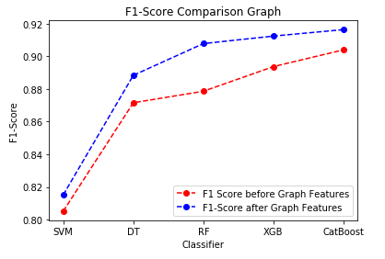

1. **Performance Measures – Accuracy**

