Class04.R

kjj01

2023-04-13

x <- 1:50  
plot(x,sin(x))

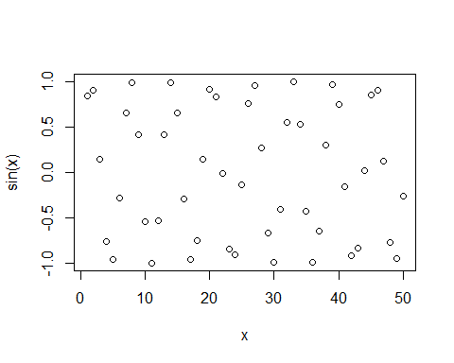

plot(x,sin(x),typ="l",col="blue",lwd=3,xlab="Hello")

