Github is a graphic interface for using the git version control. It was created in April 2008 by Tom Preston-Werner, Chris Wanstrath, and PJ Hyett. The goal was to make sharing code easier and simpler. There are many alternatives to Github such as SourceForge, Bitbucket, and Launchpad. Each of these alternatives have their own advantages and disadvantages. I would consider using these alternatives depending on what the project requires.

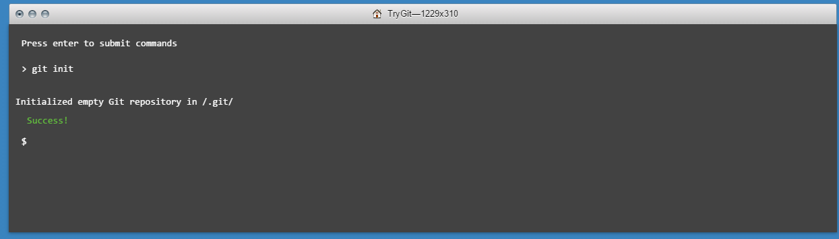

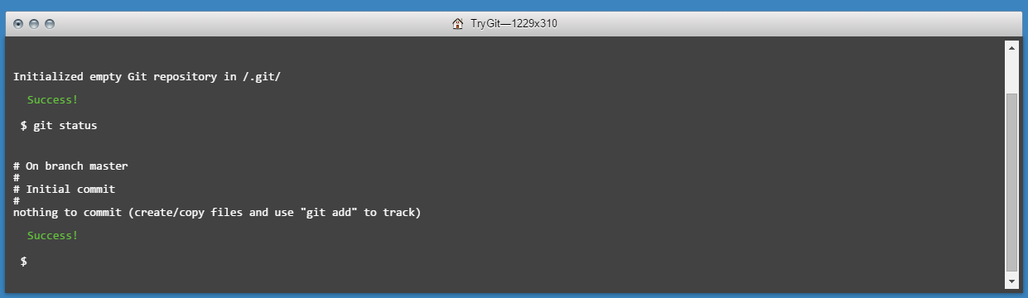

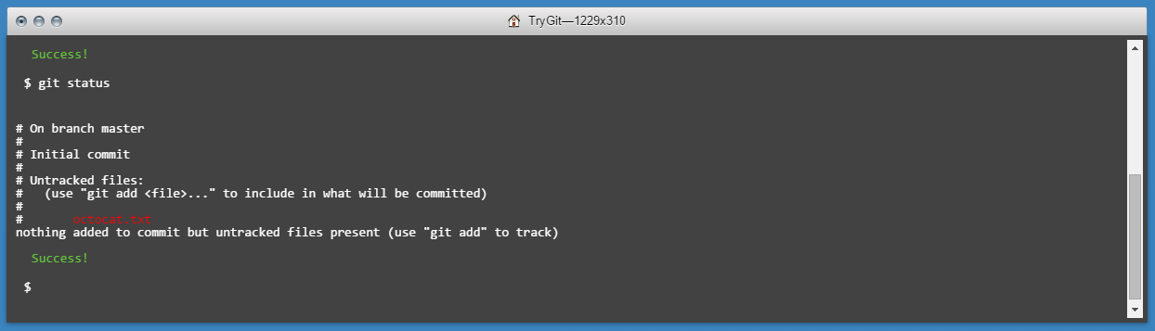

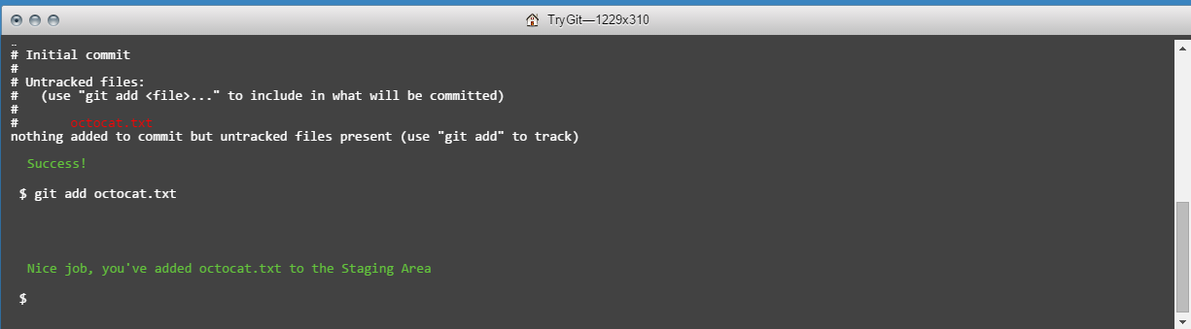

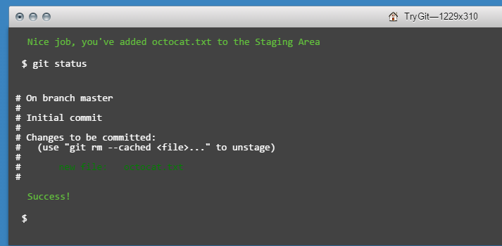

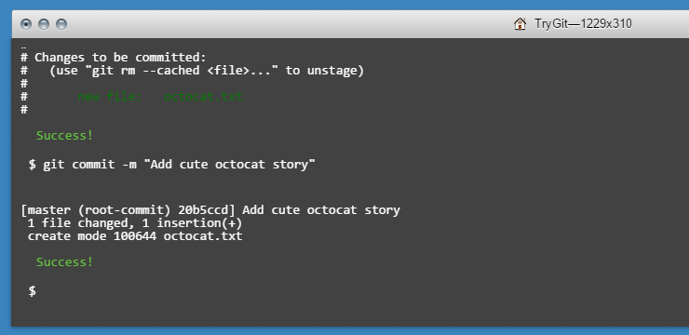

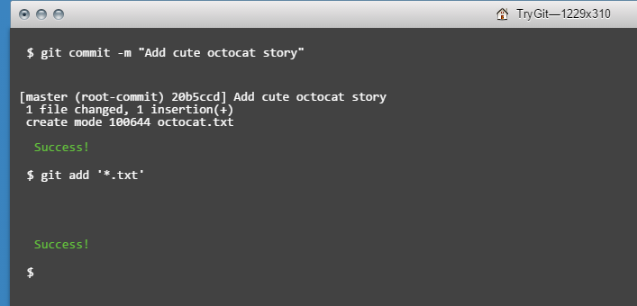

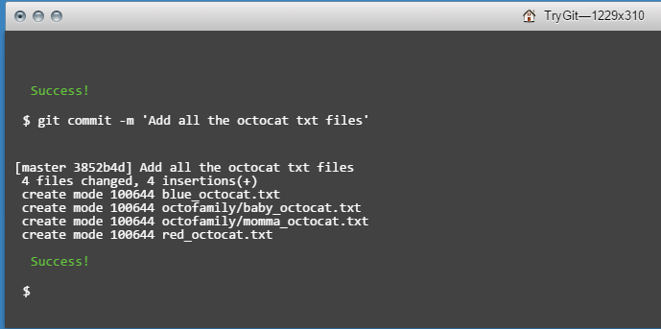

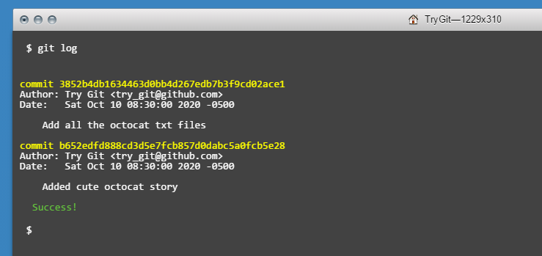

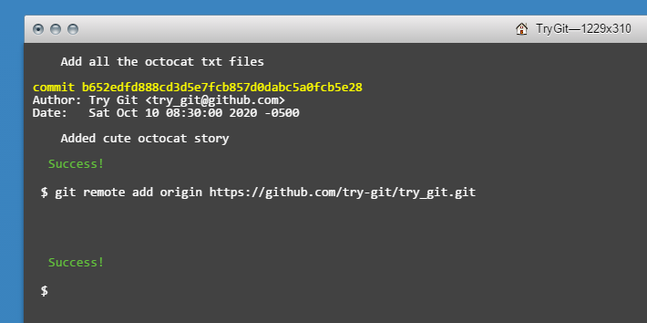

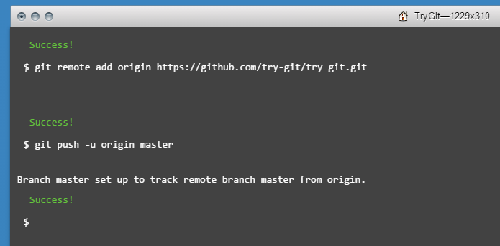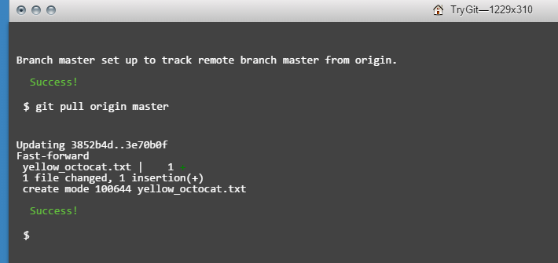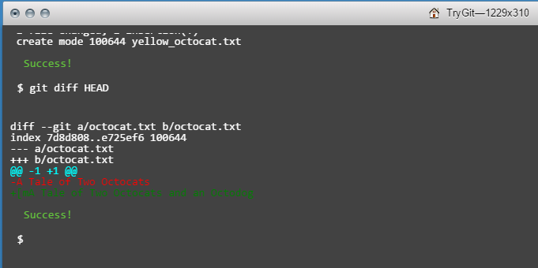

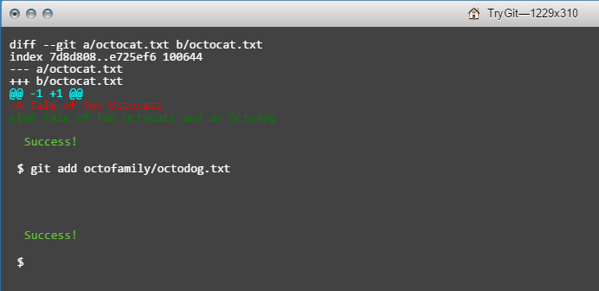

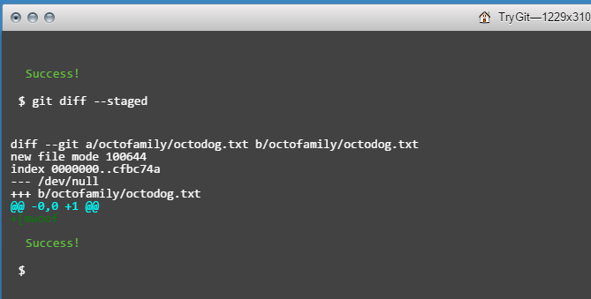

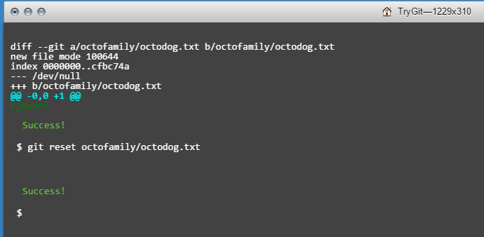

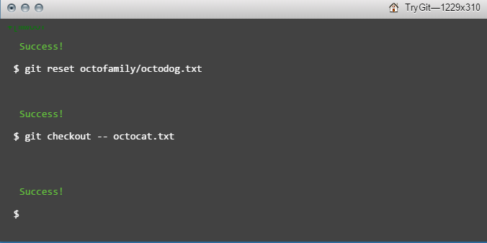

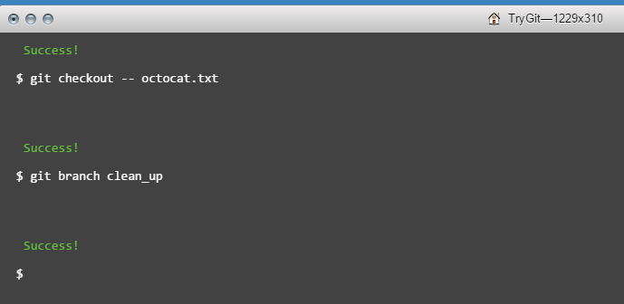

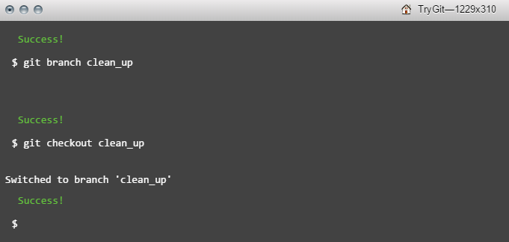

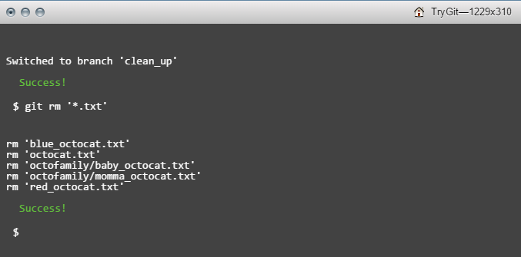

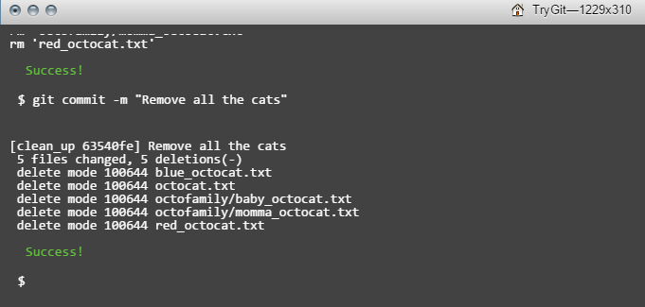

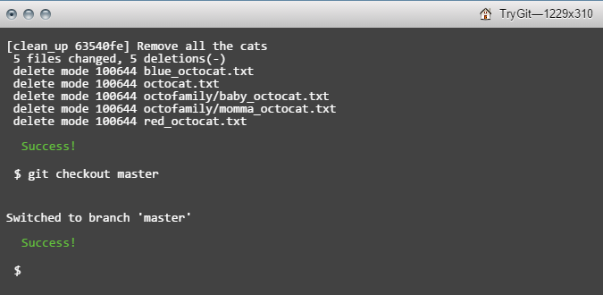

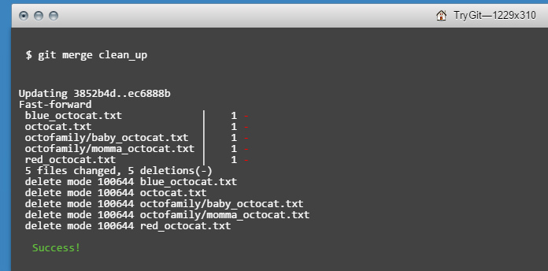

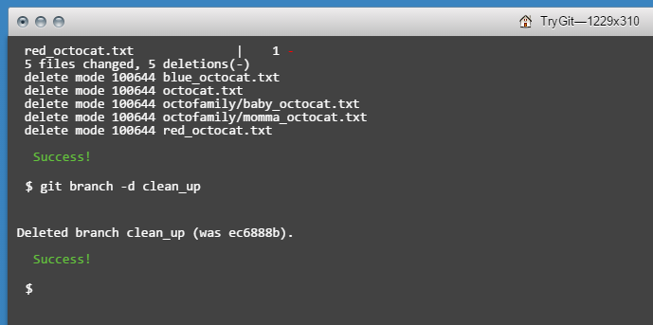

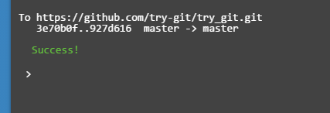

Definitions:

Repository: Where a project and all its branches is stored.

Commit: A commit is updating the local repository with new files, modified files, or deleted files. A comment can also be added to describe what changes were made.

Push: Places the latest commit of a branch to the branch that is shared with everyone.

Fork: To create a copy of a repository that is under your account in order for you to push changes to your code and submit pull requests.

Merge: To include changes made on one branch to the other.

Clone: To make copy of a repository on your local machine, all changes will be pushed to the same branch the repository was closed from.

Pull: To update the repository on the local machine from the shared repository.

Pull Request: A notification that notifies the other members of a project when someone has new changes to a branch.

Part 6: To do part 6 of the exercise, I had to fork the repository and then clone a copy of the repository from my account. Then I made the necessary changes to the file and pushed them to the forked repository on my account. Then I had to create a pull request on the original repository and waited for my changes to be accepted by the project manager.

Part 10: My previous experience with Github has been using it as an online resume of my programming work. I would say about half of the code I have is from tutorials that I have found and different ways I have experimented with Github. Some of the other work is from programming challenges I have had to do as part of interviews and projects I have had to do for work.