CS 3853 Computer Architecture

Project Report

May 2, 2019 7:30 p.m.

Team 03

Group Members

1. Richard Azille

2. Keegan Knisely

3. Sabrina Mosher

By signing this report, I affirm that I know and agree with the contents.

Signatures:

1. ________________________________

2. ________________________________

3. ________________________________

**Objectives:**

1. Comprehend how a cache implementation works
   1. Learned how overhead is calculated and purpose of the overhead data
   2. Learned how dynamic sizing works for the structure of the cache
   3. Gained knowledge of where a cache stores data and has to replace data blocks when invalid information is there
2. Determine the performance benefits based on cache configuration
   1. Block size plays an important factor to performance. Bigger blocks cause less misses and subsequent content switching
   2. Replacement algorithms had minimal impact on performance except a slight decrease in conflict misses with Least Recently Used.
   3. Performance increases diminished as sizes increased making larger configuration not provide a return on size increase investment.
3. Learn to work in a small group
   1. Learned the benefits of working with efficient team members that each carried equal weight over the course of the project.
   2. Divided tasks fairly and equally and played off each other’s strengths and specific areas of knowledge/expertise
   3. Improved understanding in the benefits of schedule coordination and online version control for collaboration and code sharing

**Algorithm**

For every valid combination of cache size, block size, and associativity, our simulator would construct a virtual cache based on the specifications. The primary cache structure (implemented via a typedef struct, “Cache”) was used to record all pertinent cache information and characteristics. The algorithm used to actually configure the cache would first calculate additional cache values based on the initial command line specifications and then dynamically allocate memory to support an array of Index structs based on the number of indexes calculated, each with a dynamically allocated array of Block structs based on the cache associativity.

Our algorithm for determining a cache hit was relatively simple. For each address read in from the trace file, we parsed the address into its tag, index, and offset values first. Then we used the index value to access the corresponding cache row. For each block in the index’s array of blocks, if the block was valid and the tag matched that of the current address being handled, we declared a hit. Otherwise, if the tag could not be found in the index, a miss was recorded, and a replacement would be performed according to the policy in place.

In order to implement our round robin replacement algorithm, each index of the cache tracks a “replacement block index” which is the index of the next block to be replaced in that specific index’s array of blocks. With each replacement, this value is incremented by one within the range of [0, associativity - 1] with modulo math in place to prevent an index outside of the valid range of the row (ex. Associativity = 4, replacement block index = 3; after replacement, replacement block index = 0).

Our random replacement algorithm simply generates a random value within the range of [0, associativity - 1] and replaces the block at the randomly generated index value.

Our LRU algorithm was achieved by utilizing timestamps and associating each block with the time that it was last accessed. This allowed for a simple algorithm in which we could quickly identify the block with the highest time value (least recently used) and designate it to be replaced. After replacing the block with the new tag value, the block’s clock time is then updated to the current time, making it the most recently used and the least likely to be replaced in that specific index.

**Analysis**

For the analysis, we ran every cache size, block size, associativity and replacement against every trace file. This provided us with a complete understanding of which factor had significant impact on conflict miss rates. We realized conflict miss rates were where the most time was wasted. Compulsory misses were acceptable to an extent until the cache blocks were full. There was however a point when the cache size was so big, no conflict misses occurred and not all blocks were full, wasting resources.

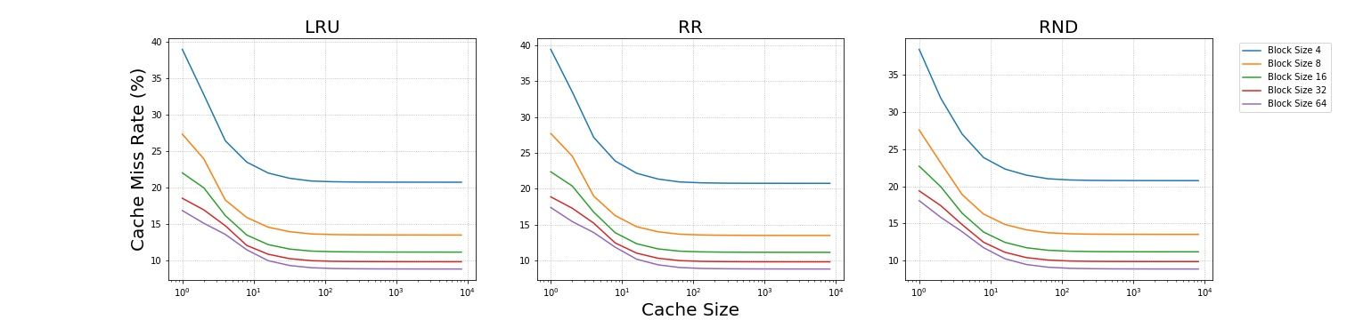

When the cache size grew to greater than 512 KB, there were no conflict misses, wasting space. When the cache size was 64K, total misses was about at the minimum number of misses, across all cache sizes, about half of which were conflict. 128K cut conflict misses in half but total misses were about the same. 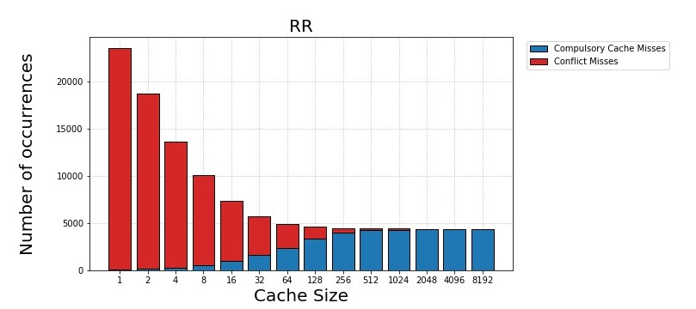

Associativity played little affect on performance. Direct mapped had an increase in misses by 15 percent but each increase in associativity didn’t cut down on misses very much. The problem with increasing associativity is the tag size increases raising total overhead cost.

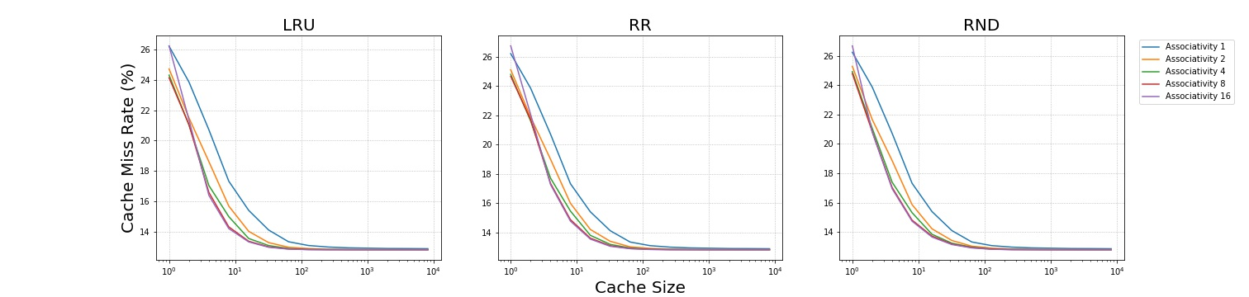

The Replacement algorithm also had a surprisingly small impact on conflict miss rates. Least Recently Used lowered conflict miss rates some. Probably due to loops and reusing memory. It may not be enough of an improvement since the was an additional over head cost to track the LRU. RR had a slight overhead in tracking which index to use but was relatively insignificant especially with increase index associativity. RND was about the same as RR in terms of performance and overhead but random seeding can be an issue.

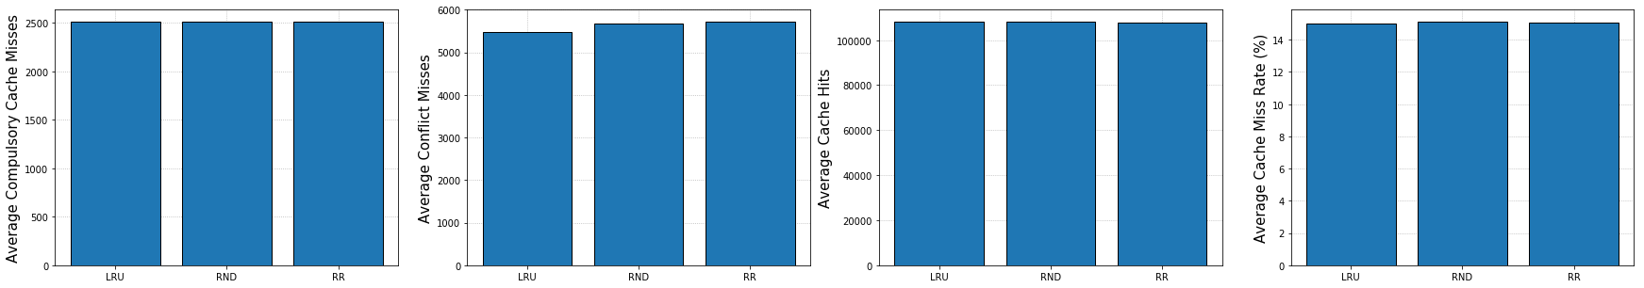

The biggest factor on performance no matter the other specifications is block size. There is a massive difference in performance between each size. Having a block size of made the miss rate and especially conflict miss rate extremely high at about 35%. Each time we ran a bigger block size, the miss rate was nearly cut in half from the previous improvement. 4 to 8-byte block cut the misses by 6000. 8 to 16 cut the miss rate by 3000, 16 to 32 cut misses by 1500 and so on.

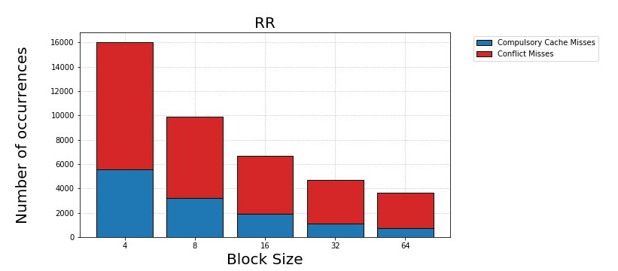

**Technical Issues**

The most challenging technical aspect of completing this project was coming up with an effective design for the cache itself. In order to accomplish this task, we first had to identify all of the requirements that a virtual cache implementation would need to satisfy. One such requirement was the ability of the cache to maintain a collection of indexes (rows) each with up to 16 cache blocks depending on the cache’s associativity. Also, the cache needed to be capable of taking on variable configurations based on several unique combinations of cache size, block size, and associativity. After identifying each of the critical requirements of the virtual cache, we found our ideal solution by creating three unique typedef structs to support the implementation: Cache, Index, and Block. With these data structures in place, we were able to dynamically allocate the components to build any valid cache configuration that our simulator could be tasked with.

We did have one technical issue with one cache setup. With a block size of 64 and cache size of 1K. this makes only 16 blocks. 16 blocks and 16-way associativity made the cache fully associative and we had not set the program to account for fully associative. Handle this by passing it. With 975 simulations per trace file, we felt 1 result would not make a major impact on our understanding.

**Group Member Contributions**

Each member of our team played a consistent and active role in contributing to the progress of this project over the course of the semester. Overall, the responsibilities of coding, testing, and troubleshooting the cache simulator were shared equally among all members. Specific tasks completed by each team member are listed below.

1. Richard
   1. Implementation of cache data structures and cache configuration and deconstruction functions
   2. Implementation of round robin and random replacement algorithms
   3. Fair contributions in final project report
2. Keegan
   1. Implementation of command line input processing and validation
   2. Implementation of address to tag, index, and offset logic
   3. Ran final testing, error checking/debugging and compilations for submissions
   4. Fair contributions in final project report
3. Sabrina
   1. Implementation of file-tracing and address-parsing logic
   2. Implementation of LRU algorithm
   3. Developed script for plotting simulation outputs and compiled all results into charts and graphs for post-experiment analysis. Script ran every combination of cache size, block size, associativity, and replacement against every trace file.
   4. Fair contributions in final project report

**Group Issues and Resolutions**

Absolutely None.

**Conclusion**

Overall, this project was a valuable hands-on effort that provided a greater understanding of cache implementations, operations, and performance. The work load was very manageable and not overwhelming, especially with a solid team to share the responsibilities with. One of the most enjoyable aspects of this project was that it forced us to to figure out how to convert our preexisting knowledge of caches into actual implementation and code to produce an accurate simulator.