Context:

Assuming Customer is environmental friendly and is above 40. He prefers luxury but with speed. Power but with mileage.

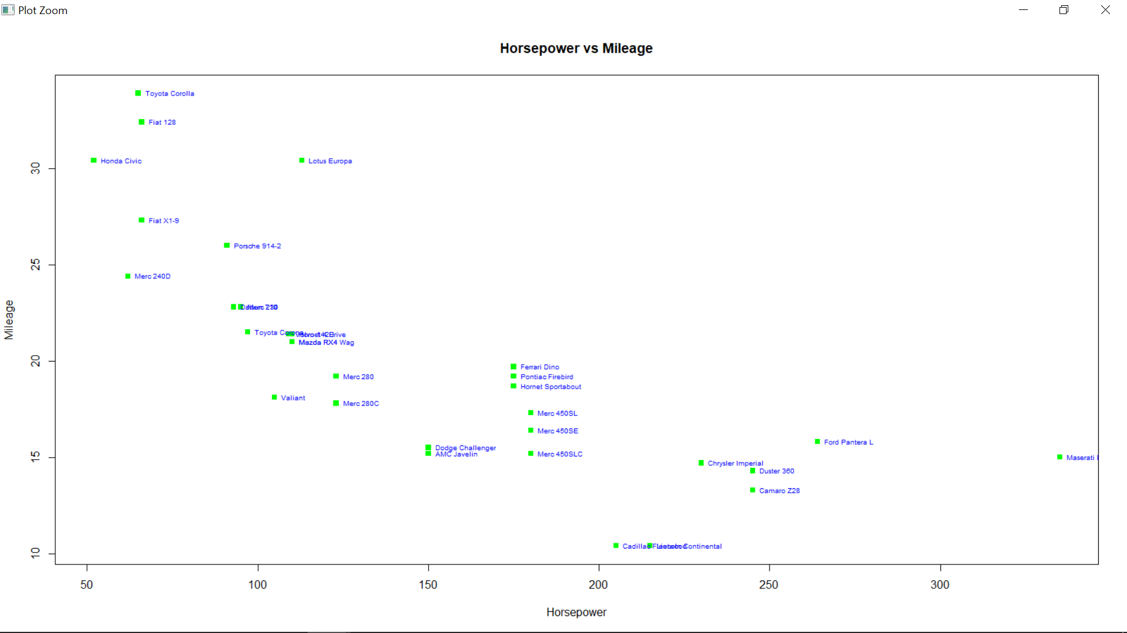

plot(hp, mpg, main = "Horsepower vs Mileage", xlab = "Horsepower", ylab = "Mileage", pch = 15, col = "green")

text(hp, mpg, row.names(mtcars), cex = 0.6, pos = 4, col = "blue")

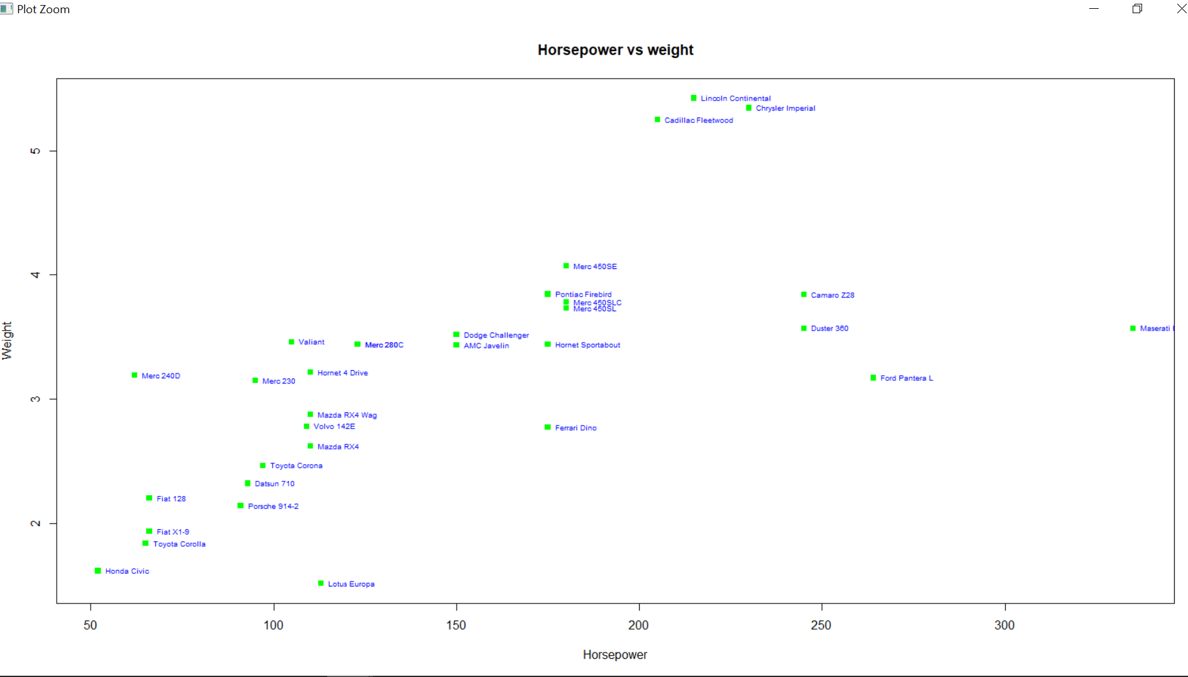

plot(hp, wt, main = "Horsepower vs weight", xlab = "Horsepower", ylab = "Weight",

+ pch = 15, col = "green")

> text(hp, wt, row.names(mtcars), cex = 0.6, pos = 4, col = "blue")

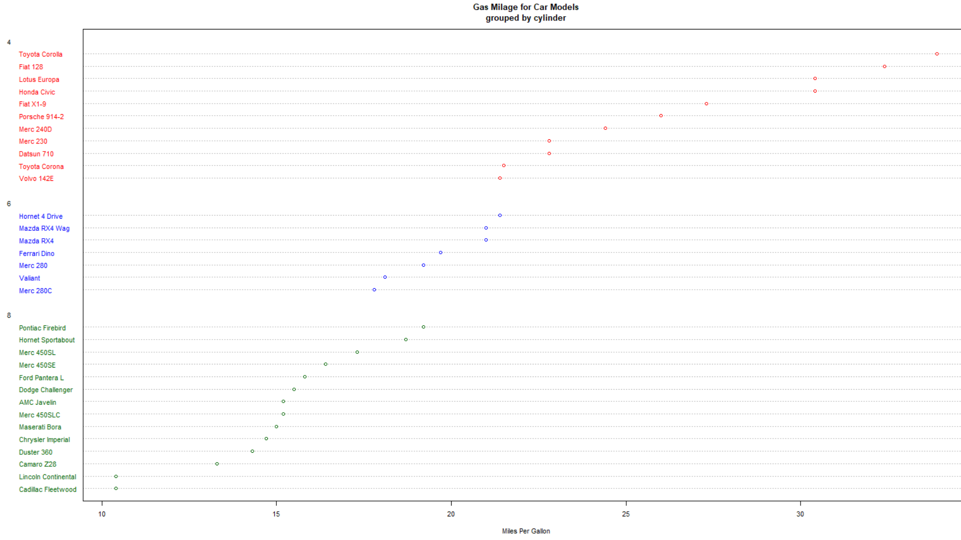

|  |
| --- |
| # Dotplot: Grouped Sorted and Colored  > # Sort by mpg, group and color by cylinder  > x <- mtcars[order(mtcars$mpg),] # sort by mpg  > x$cyl <- factor(x$cyl) # it must be a factor  > x$color[x$cyl==4] <- "red"  > x$color[x$cyl==6] <- "blue"  > x$color[x$cyl==8] <- "darkgreen"  > dotchart(x$mpg,labels=row.names(x),cex=.7,groups= x$cyl,  + main="Gas Milage for Car Models\ngrouped by cylinder",  + xlab="Miles Per Gallon", gcolor="black", color=x$color) |
|  |
| |  | | --- | | > | |