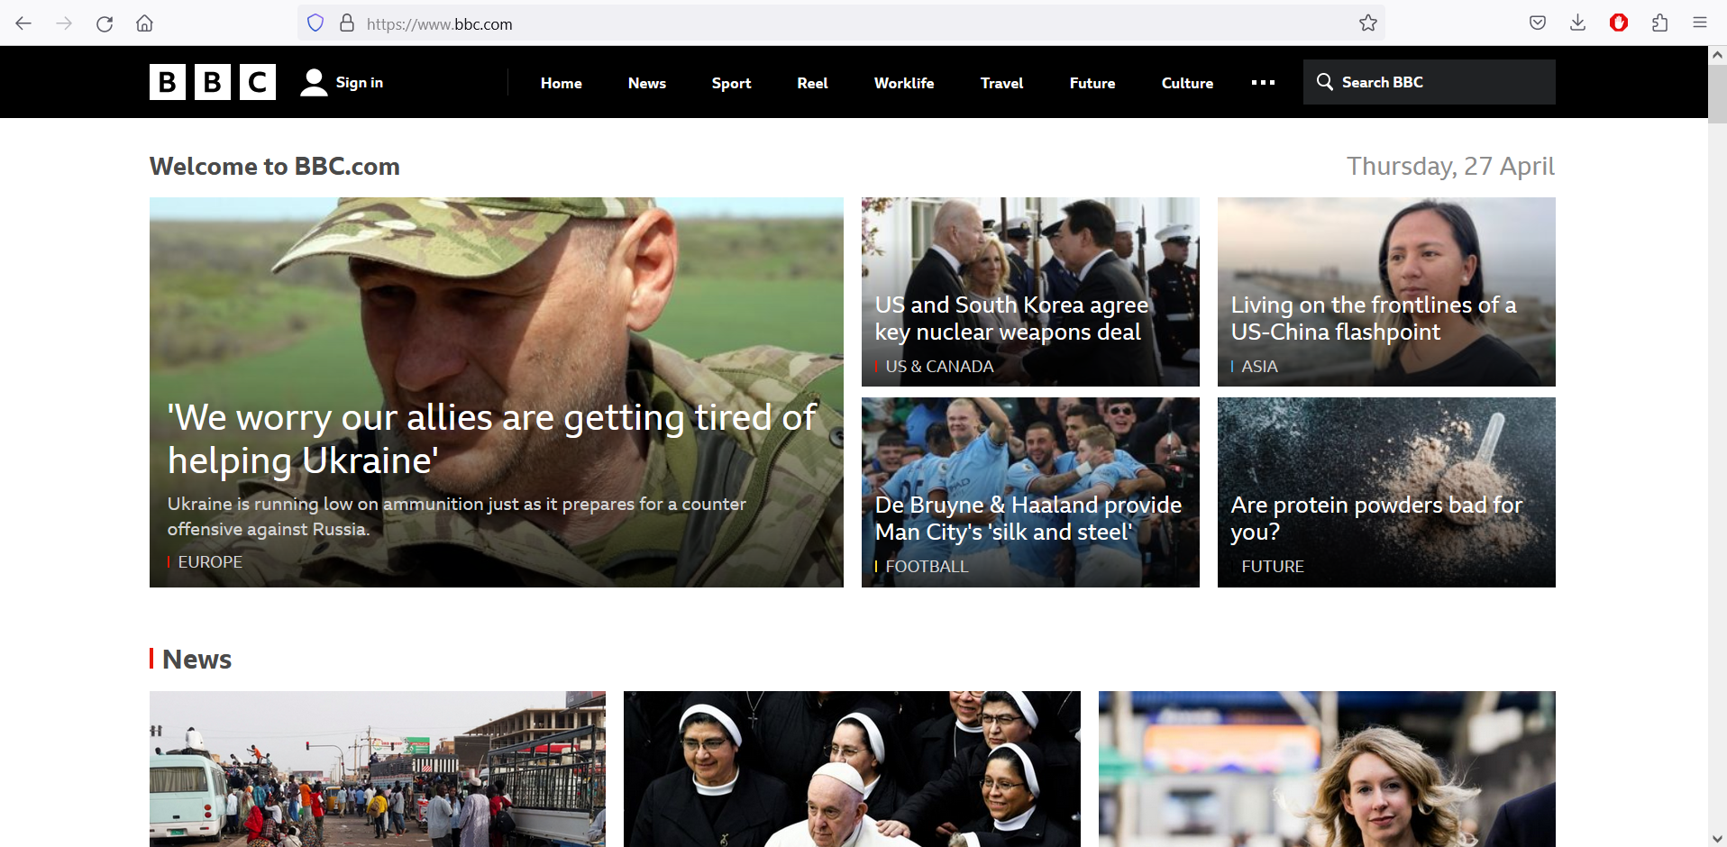

Bbc.com

One of the most popular news site. I like it for its minimalist colour scheme that allows all the focus on the news and content which is the main purpose of this website

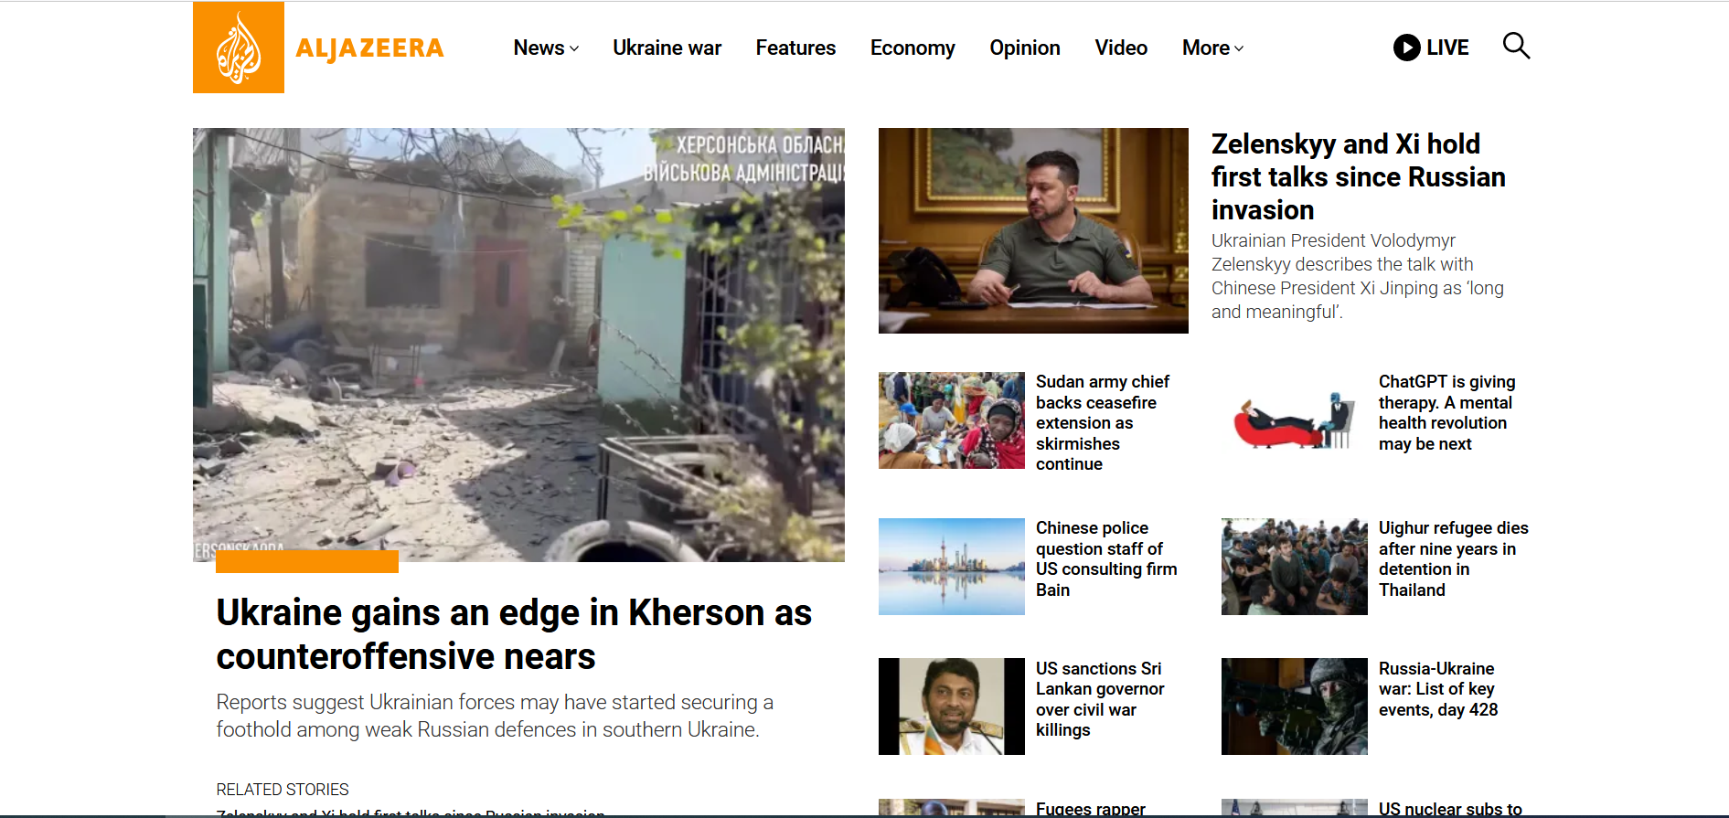

Another news website that also has a minimal colour scheme which helps focus on news and content. I like how the headline text isn’t appearing over photos unlike in BBC which helps in the headline to be instantly recognizable.