## SiteChart

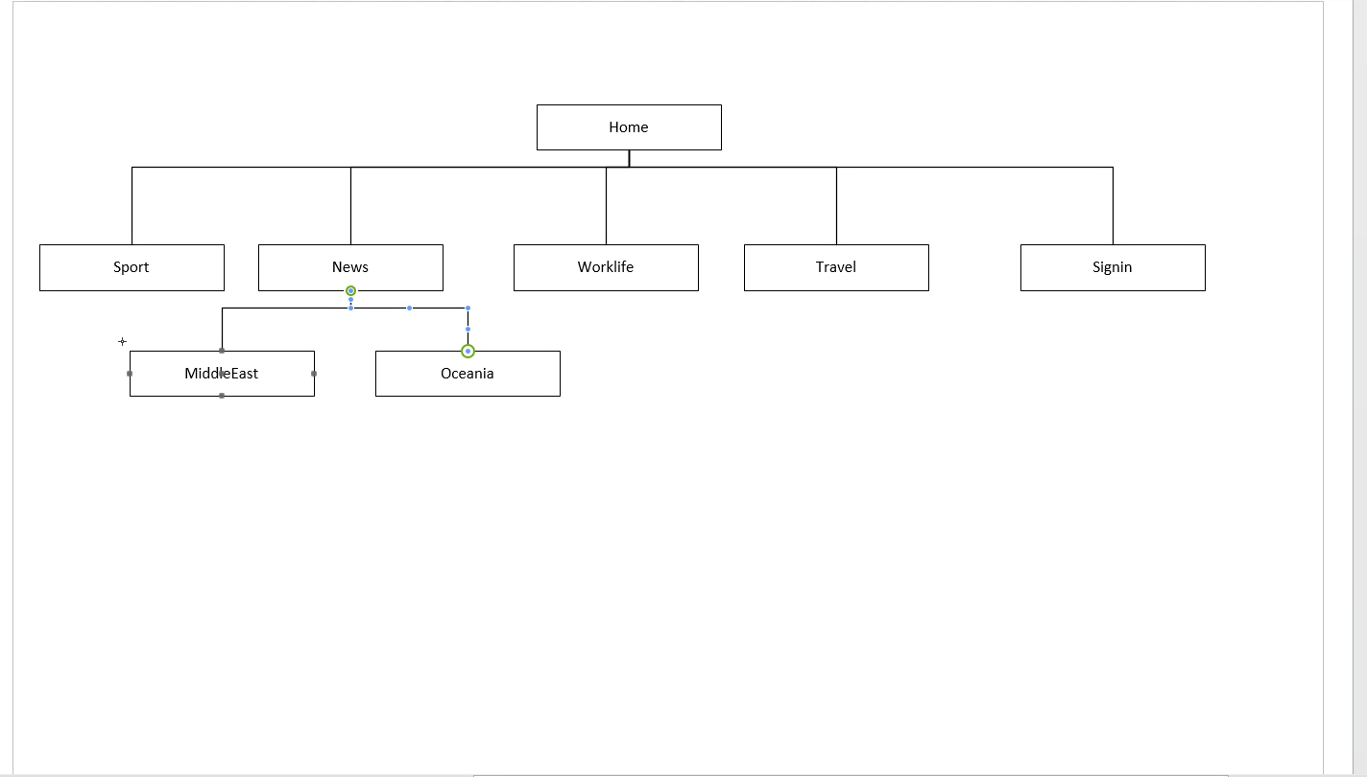

## Home

## Sport

## Worklife

## Signin

## News

## MiddleEast

## Oceania

