IBM Security Verify Governance

Identity Manager

Example installation of Identity Manager with an external LDAP user registry

Table of Contents
1 Overview 3
1.1 Software requirements 3
1.2 Summary of configuration steps 3
1.2.1 Before the Identity Manager installation 3
1.2.2 During the Identity Manager Installation 4
1.2.3 After the Identity Manager Installation 4
2 Before the Identity Manager installation 5
2.1 Configuring IBM Tivoli Directory Server LDAP user registry 5
2.2 Collecting LDAP server information 5
2.3 Adding required users for Identity Manager 6
2.4 Configuring WebSphere Security Domain with a standalone LDAP registry 12
3 During the Identity Manager installation 23
3.1 Using the predefined WebSphere security domain 23
3.2 Supplying the Identity Manager system user and password 24
4 After the Identity Manager installation 25
4.1 Disabling the password change attribute for the default administrator account 25
4.2 Configuring the default administrator 27
4.3 Verifying access for the administrator account 28
5 Appendix: LDAP User registry configuration 29
5.1 Creating a new suffix 29
5.2 Creating a domain 34
5.3 Adding a user template 41
5.4 Adding a user realm 48

Document date: March12 2012

Overview

Identity Manager introduces support for authentication through an external user registry. You can configure Identity Manager to use any external user registry that is supported by IBM WebSphere Application Server.
This document provides an example of how to configure an LDAP server and a WebSphere Application Server so that Identity Manager can use the LDAP registry as a user registry for authentication.

Software requirements
This document describes an Identity Manager deployment that uses the following IBM software. The instructions in this document apply only to the following versions:
- WebSphere Application Server version 7 single server with fix pack 21. (WebSphere)
- IBM DB2 version 9.7 with fix pack 5 (DB2)
- IBM Tivoli Directory Server version 6.3 fix pack 10 with Web Administration tool (ITDS)
Note: The step by step procedures are specific to Version 6.3. The procedures might differ with other versions.
- Identity Manager

Summary of configuration steps

This section summarizes the configuration instructions that are presented in the rest of this document. The configuration is divided into steps to complete before, during, and after the Identity Manager installation.

Before the Identity Manager installation

- Configure an ITDS LDAP user registry
This step is required only if you do not already have an LDAP user registry configured. Since this step is optional, the configuration steps are added as an appendix. See Appendix A.
- Collect information needed for setting up the LDAP service after the Identity Manager is installed.
- Create the required users for Identity Manager
1. The default Identity Manager administrator user
2. The Identity Manager system user
- Configure a WebSphere security domain with a standalone ITDS LDAP user repository.

During the Identity Manager Installation
When running the Identity Manager installation program:
- Specify the predefined WebSphere security domain with the LDAP user repository.
- Provide the Identity Manager system user name and the password that you created in LDAP user repository during the pre-installation steps.

After the Identity Manager Installation
- Optional: Disable the Change password at next logon attribute for the default Identity Manager administrator account.
- Optional: If using an Identity Manager administrator account ID other than ITIM Manager, rename the ITIM Manager erSystemUser in the Identity Manager LDAP data store.
- Verify access for the administrator account.

Before the Identity Manager installation

Complete the instructions in each of the following sections.

Configuring IBM Tivoli Directory Server LDAP user registry

This step is needed only if you do not already have a configured LDAP user registry. If you have not yet installed an LDAP user registry, complete the instructions in Appendix: LDAP User registry configuration

Collecting LDAP server information

Collect the following information in order to configure the WebSphere security domain with the LDAP user repository.
- LDAP server host IP address.
- LDAP server port address.
- The bind user name and the password. For example: cn=root / secret
- The base DN of user repository. For example: dc=mycorp
- The object class name for the user. For example: InetOrgPerson
- The relative naming attribute for the user. For example: uid
- The object class names for groups. For example: groupOfNames and groupOfUniqueNames
- The attribute names for group membership. For example: member and uniqueMember

Adding required users for Identity Manager

This section describes how to use the IBM Tivoli Directory Server administration tool to add the required users. Alternatively, you can create an ldapadd command, or use LDIF files.
The required users are:
Account type | Account name
Default administrative user | ITIM Manager
Default system user | isimsystem

- Open the IBM Tivoli Directory Server Web administration tool.
- Go to the Users and groups --> Manage users page.
- Select the realm and click View users.
- Click Add... to create the required users.

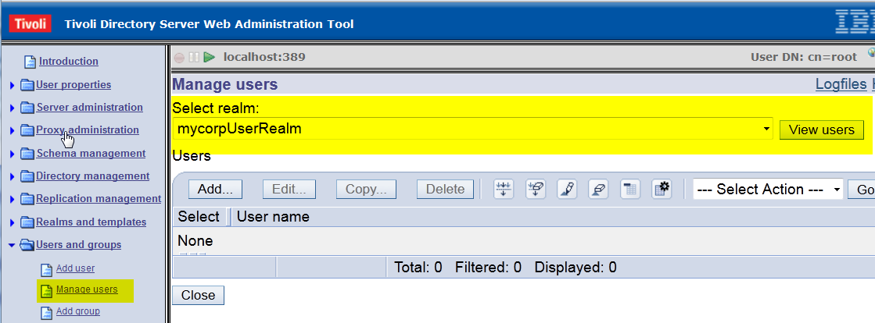

- Select the correct realm and click on Next button.
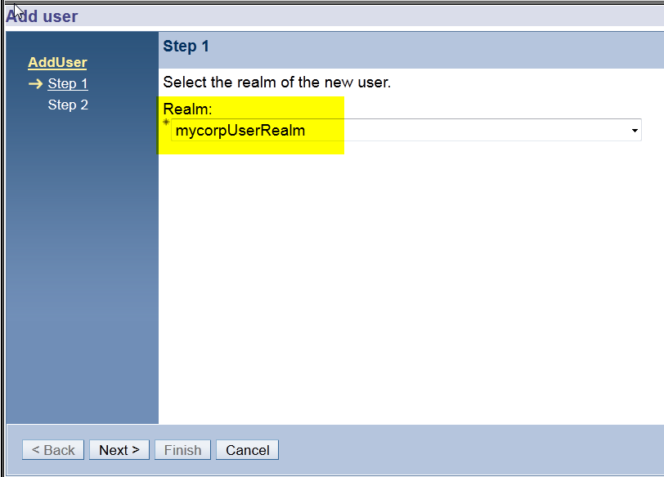

- On the Add User page, provide the required attributes and click Finish.
The default password for the ITIM Manager account is secret. This document uses the default Identity Manager administrator user id, ITIM Manager, but you can use a different user ID if you want. If you used a different user ID (other than ITIM Manager), follow the additional configuration steps after the Identity Manager installation completes. These steps are described in section After you install Identity Manager.
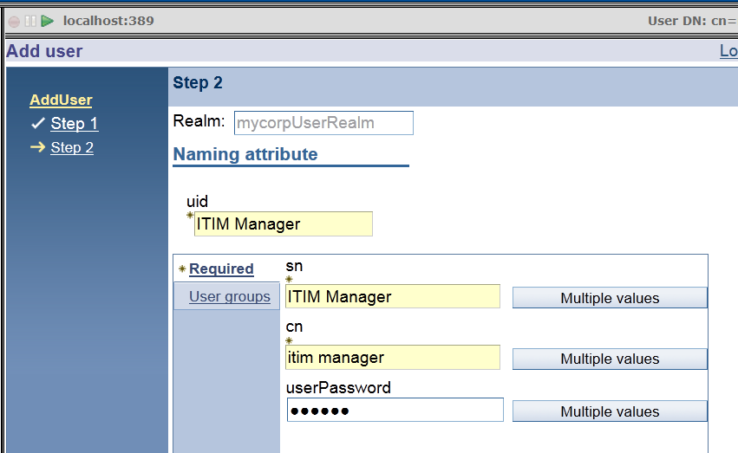

7. From the Manage users page, verify that the ITIM Manager is created. Click on the Add... button to create the isimsystem user.
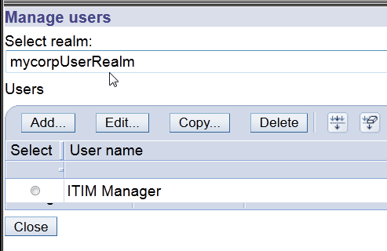
8. Select the correct realm and click Next.
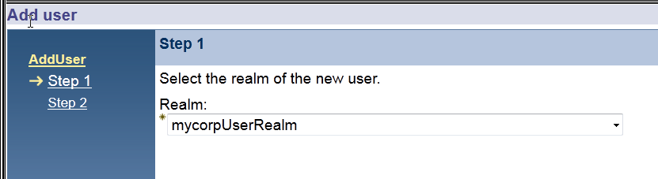

9. Provide the required attributes and click Finish. You can set the password to anything you want. This document uses the default password secret. This document uses the default Identity Manager system user id, isimsystem, but you can use a different user ID if you want.
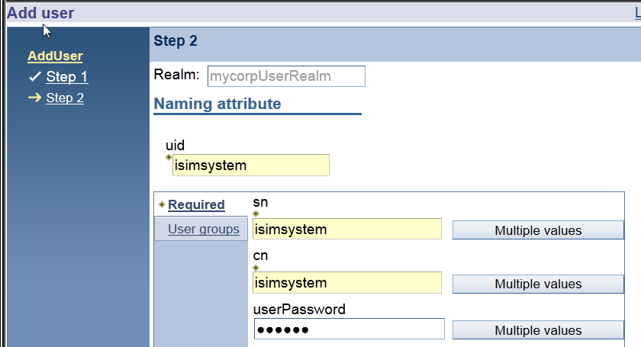

10. On the Manage users page, verify that both the ITIM Manager and isimsystem users are listed.
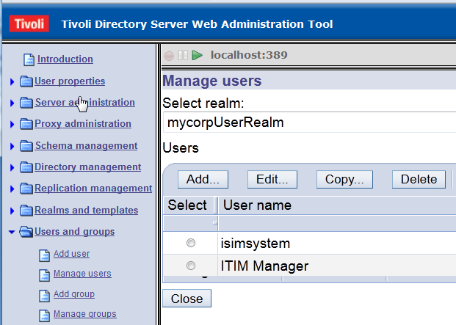
11. You have completed the configuration of the ITDS v6.3 LDAP server with the required Identity Manager users. Continue with the next section to configure the WebSphere security domain with this LDAP user registry.

Configuring WebSphere Security Domain with a standalone LDAP registry

1. Login to the WebSphere administration console as an administrator.

2. Go to Security > Security domains. Click New to create a new security domain for Identity Manager.

3. Enter a name you want in the Name field. Click OK and save the changes.

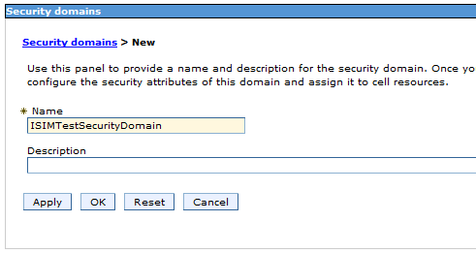
4. After the new security domain is created, click the security domain name to configure the security attributes for the domain.
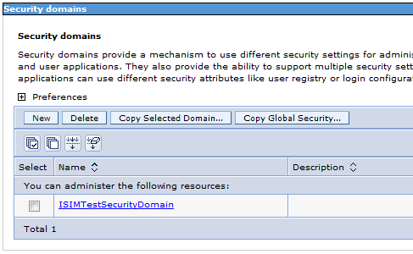
5. When you click the security domain name, the following page is shown. You must configure a number of settings, as described in the following steps.
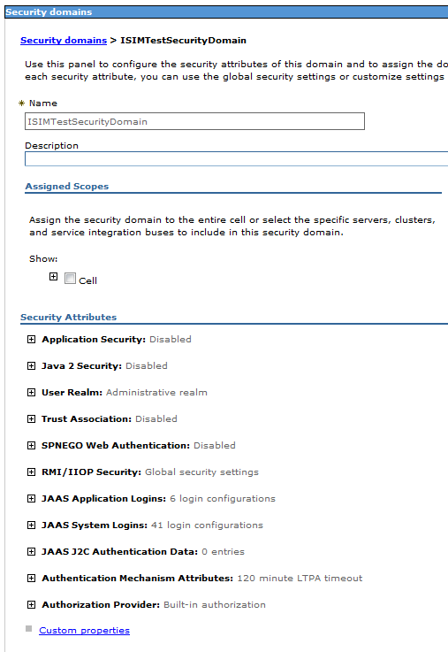

6. In the Assigned Scopes section, select the WebSphere application server where Identity manager will be installed.
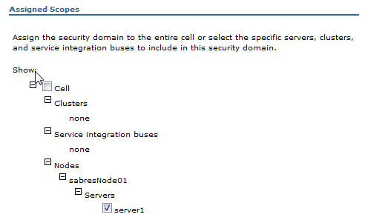
7. In the Security Attributes section, select and specify the following settings.

- Application Security: Click Enable application security.

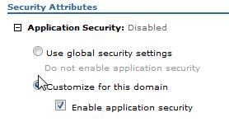
- Java 2 Security: For best performance, leave this disabled.

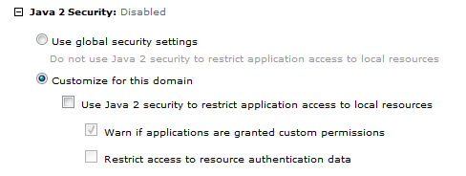
- User Realm: Select Standalone LDAP registry and click Configure...
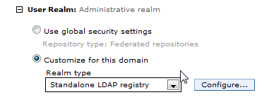
- Configure Standalone LDAP registry. See the table after the screen capture.

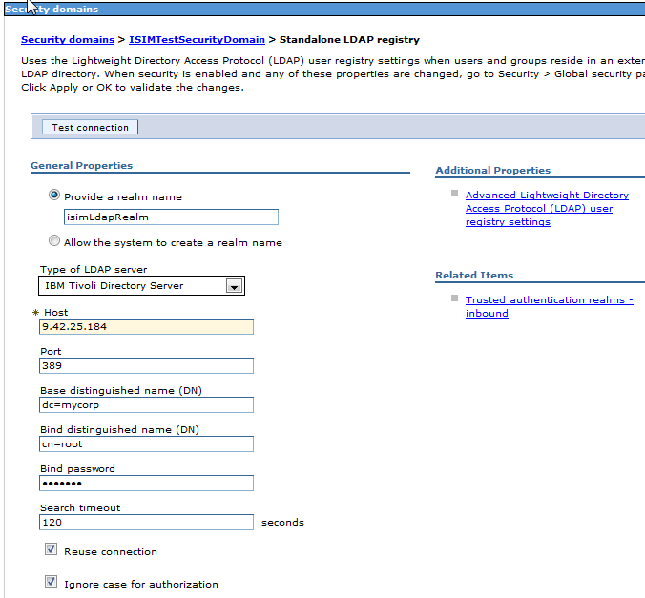

Field | Description
Realm name | Provide the realm name as whatever you want.
Type of LDAP server: | IBM Tivoli Directory Server is used for this document.
Host | The ITDS host name or IP address
Port | The LDAP server port for ITDS
Base DN | The base DN of the LDAP registry
Bind DN | The user DN that will be bound to the LDAP registry.
Bind password | The password of bind user.

8. Click Test connection button to ensure that WebSphere can communicate with the LDAP registry.

9. After the connection test is successful, click OK and Save the changes.

10. After the user realm's basic security attributes are configured, you still need to set some
advanced LDAP settings for this user realm.
a. Click on the security domain name
b. Click the Configure button next to the realm name
c. Select Set Advanced Lightweight Directory Access Protocal (LDAP) user registry setting link on the Standalone LDAP registry attribute setting page.

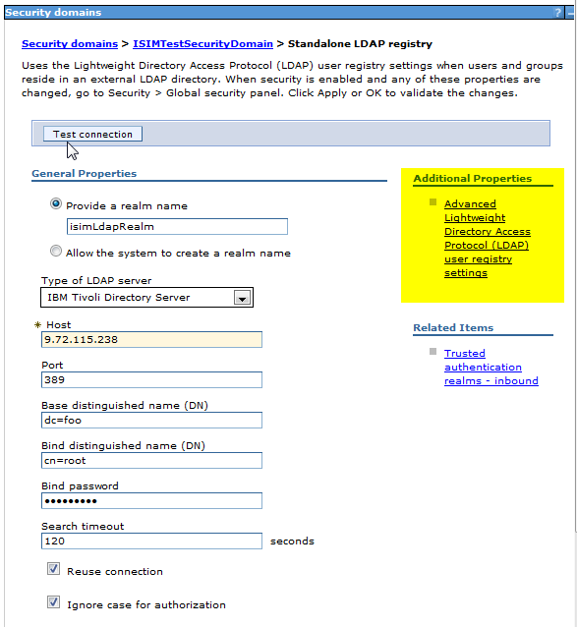

12. Ensure that the correct object class is used for the user filter. By default the objectclass is set to ePerson. If you are not using ePerson as an object class for the LDAP user, update this setting to use the correct object class for the LDAP user. In this document, the object class for the user is inetOrgPerson.
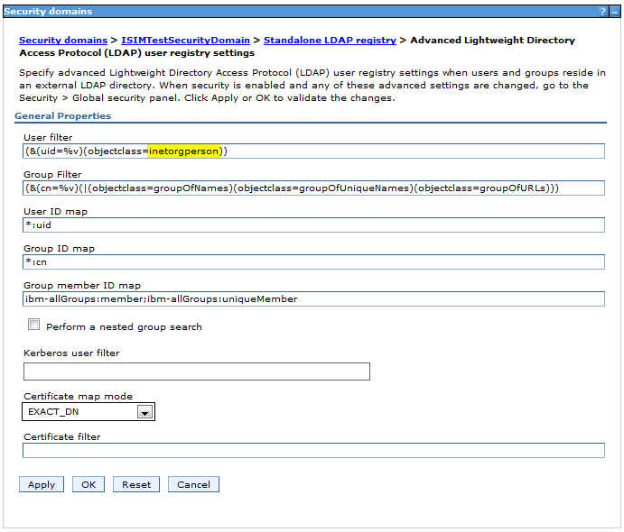

13. Click OK and Save the changes. From the Standalone LDAP registry page, click OK and Save the changes.

Note: If you set an incorrect object class for the user filter, the following error message displays after you click OK.
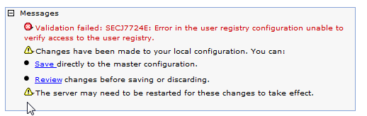
14. When you Save the changes, you are redirected to the domain list page. Select the domain name in order to continue configuring the remaining security attributes for this domain.

See the screen captures on the following three pages

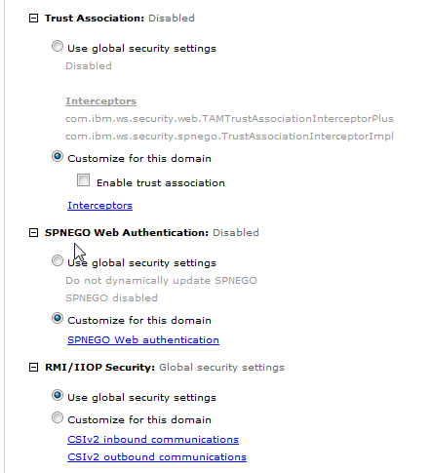
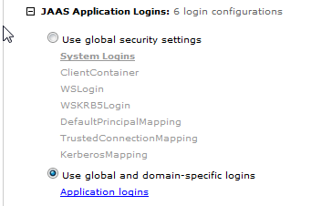

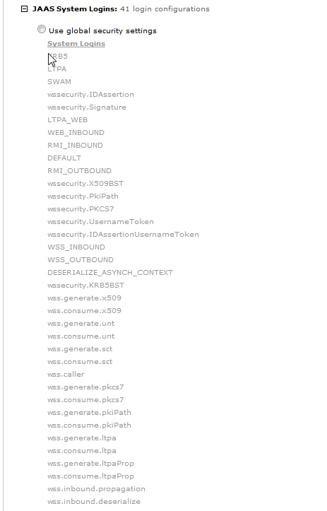


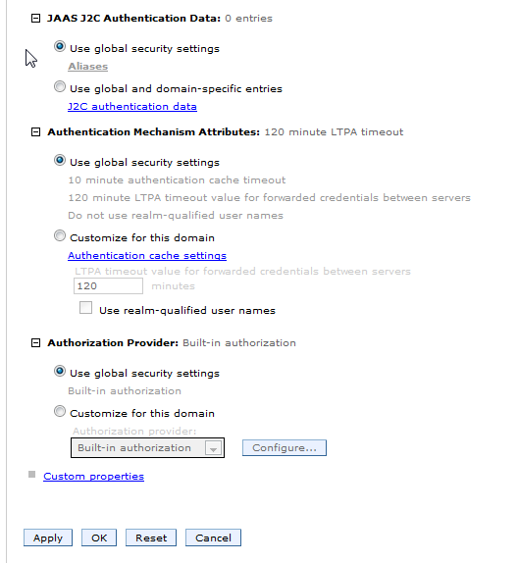
15. Click OK and Save the changes.

16. Restart WebSphere Application Server.

You have completed the WebSphere configuration. Continue with the next section to install Identity Manager.

During the Identity Manager installation

This section does not describe the entire Identity Manager installation. Instead it describes the configuration settings necessary for this example deployment.

Using the predefined WebSphere security domain

During the Identity Manager installation, tell the installer to use the security domain you just created with the LDAP standalone registry. Select No on the panel Choose to use Identity Manager Custom Registry or not.

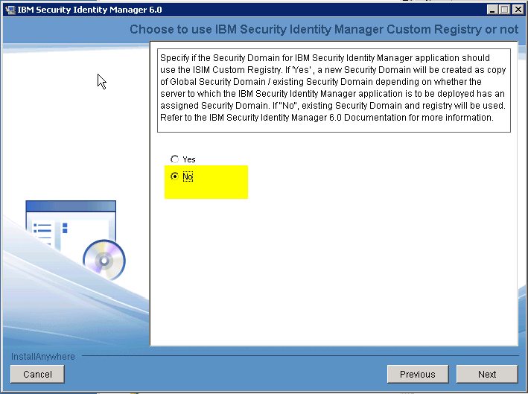

Supplying the Identity Manager system user and password

On the Identity Manager security credentials panel, you must supply a system user id and password.
The Identity Manager System User is the user who belongs to the ISIM_SYSTEM security role. This user is the Identity Manager run-as user for the managed beans. Provide the user name and the password. In this example documentation, the user name is isimsystem and the password is secret.

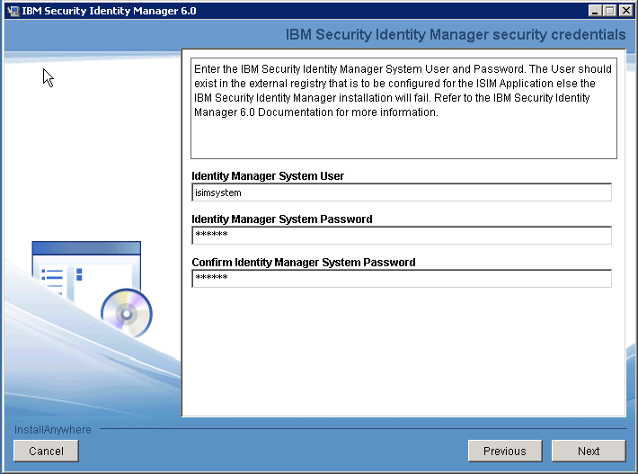

3. Complete the Identity Manager installation as directed by the installation utility.
4. When the Identity Manager installation completes, continue with the instructions in the next section.

After the Identity Manager installation

After the installation completes, modify an attribute and verify the installation, as described in the following sections.

Disabling the password change attribute for the default administrator account

Modify the configuration so that the Change password at next logon attribute is disabled. Set the erChangePswdRequired attribute of ITIM Manager to false, so that you don't need to change the password once you login to the Identity Manager console.
This documentation shows use IBM Tivoli Directory Server Web administration Tool to modify the configuration, but you can alternatively use an ldapadd command or LDAP editor.

1. Login to the Tivoli Directory Server Web Administration Tool as the administrator. Go to Directory management > Manage entries, and find the ITIM Manager (default administrator) entry.

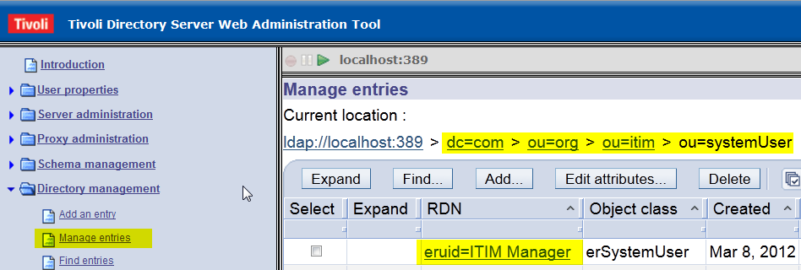
2. Click eruid=ITIM Manager and click Next.
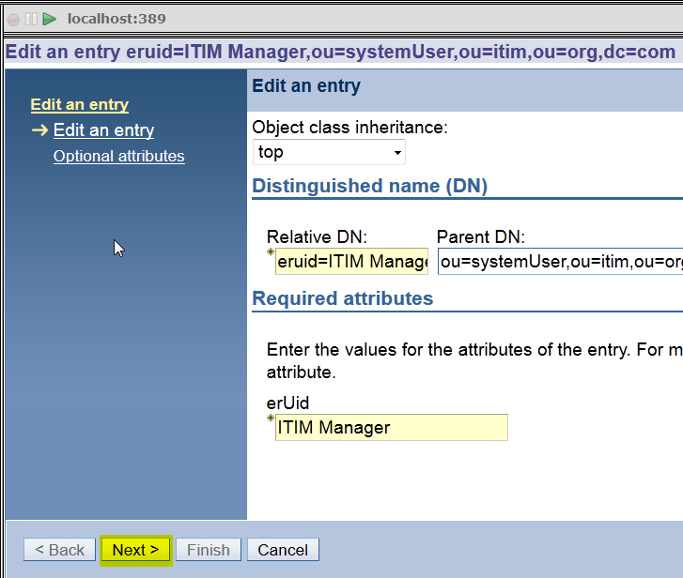
3. From the Optional attributes page, scroll down to the erChangePswdRequired attribute and change the value to False. Click Finish to save the changes.
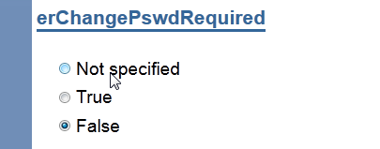

Configuring the default administrator

If you set the default Identity Manager administrator ID to be an ID other than ITIM Manager, you must configure the default administrator account. In this documentation, and ldapmodify command is used to modify the eruid attribute of ITIM Manager account.

Complete the following steps:

1. Create a file with the following contents.
dn: eruid=ITIM Manager,ou=systemUser,ou=itim,ou=org,dc=com
changetype: modrdn
newrdn: eruid=itimManager
deleteoldrdn: 1

2. Run the ldapmodify command as below.
ldapmodify -h <hostIP> -D <adminDN> -w <adminPassword> -i <filePath>

Entry | Description
ldapmodify | This command is located in TDS_HOME/bin directory. For example, on Windows:  C:\Program Files\LDAP\V6.3\bin
hostIP | The IP address of the Tivoli Directory Server where the Identity Manager LDAP data is stored.
adminDN | The administrator DN. For example, cn=root
adminPassword | The administrator password.
filePath | The path to the file you created in Step 1.

3. Update the ITVG_HOME/data/enRole.properties file with the new default administrator ID.
enrole.defaultadmin.id=itimManager
4. Restart the WebSphere application server, to load the updated values from the property file.

Verifying access for the administrator account

Verify that the administrator account is configured correctly. Log in to Identity Manager administration console as the default administrator.
- Go to http://hostIP:9080/itim/console
- User ID: ITIM Manager or the default admin user ID you configured.
- Password: The password you set for this user. In this document, secret is used.
If you can login successfully by supplying the password you used for the default administrator user that you created in the LDAP registry, then you have successfully configured the LDAP user registry as an external authentication user registry for Identity Manager.
Note: Best practice is to continue with the instructions to the document Using Identity Manager with an external user registry. These instructions describe additional configuration tasks for using Identity Manager in this scenario. Tasks include disabling Identity Manager account passwords, configuring an LDAP service for the user repository, and enabling forgotten password management.
The document Using Identity Manager with an external user registry is located in the extensions directory on your Identity Manager software installation.

Appendix: LDAP User registry configuration

Note: These instructions are needed only if you have not previously configured the LDAP user registry that you want to use for authentication by Identity Manager accounts.

Summary: We will use ITDS Version 6.3 to create a new suffix dc=mycorp and a domain dc=mycorp. We then create the user template and the user realm in dc=mycorp domain. The ITIM Manager and isimsystem users should be created in this realm. Identity Manager requires these users.
Complete the instructions in each of the following sections.

Creating a new suffix

1. Start the IBM Tivoli Directory Server Instance Administration tool.
2. In the Instance Administration tool, select the instance and click Start/Stop... to stop the server. The server must be stopped in order to create a new suffix.
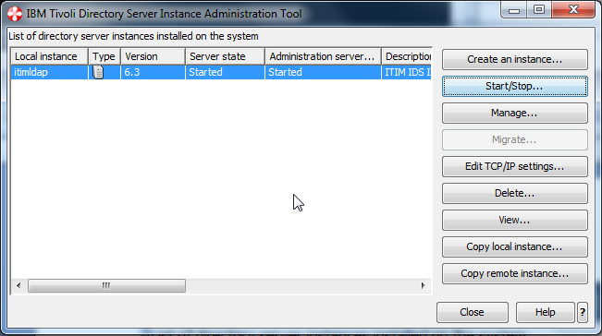

3. Click Stop server to stop the server. Click Close to close the Manage server state window.
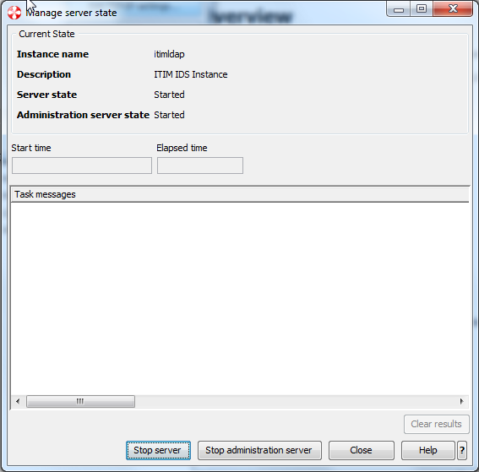

4. In the Instance Administration tool, click Manage....

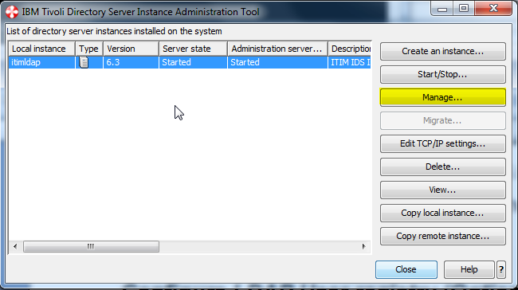

5. In the ITDS Configuration tool, go to Manage suffixes. Enter the suffix name dc=mycorp, click Add and click OK.
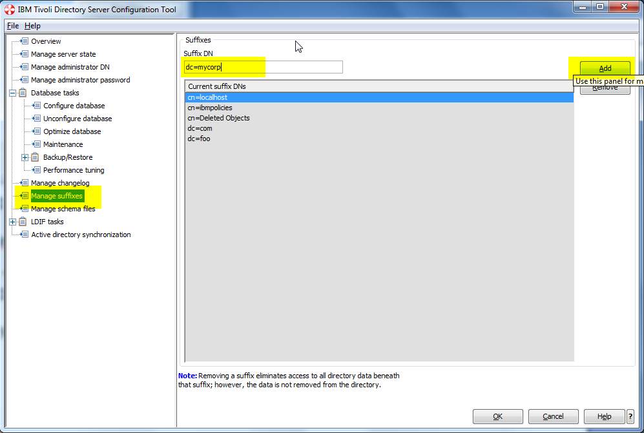

6. When the dc=mycorp suffix is added, start the ITDS server, and continue with the instructions in the next section.
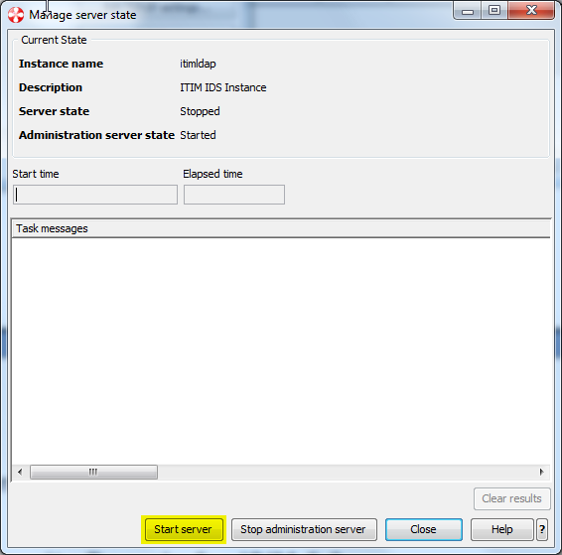

Creating a domain

These instructions describe how to use the IBM Tivoli Directory Server Web administration tool to create a domain. Alternatively, you can use an ldapadd command.

1. Start the ITDS Web Administration Tool and log in to your LDAP server as an administrator.
The Web Administration tool might not have been installed when you installed ITDS V.6.3. If so, see the ITDS documentation for instructions on how to install the Web Administration tool manually after the ITDS installation. Access the ITDS infocenter at:
http://publib.boulder.ibm.com/infocenter/tivihelp/v2r1/index.jsp?topic=%2Fcom.ibm.IBMDS.doc%2Fwelcome.htm

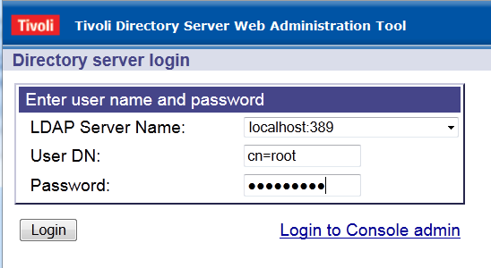

2. Go to the Directory management --> Manage entries page, and click Add... to crate a new domain.
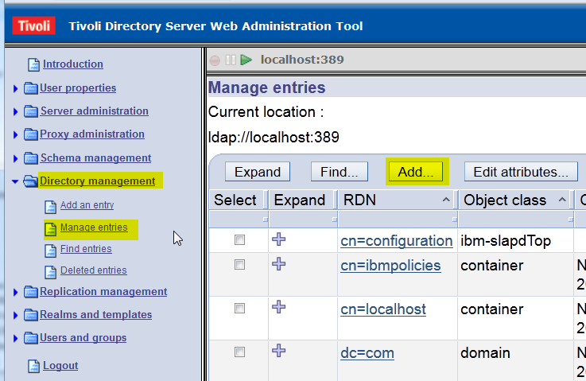

3. Select domain as a structural object class and click Next.
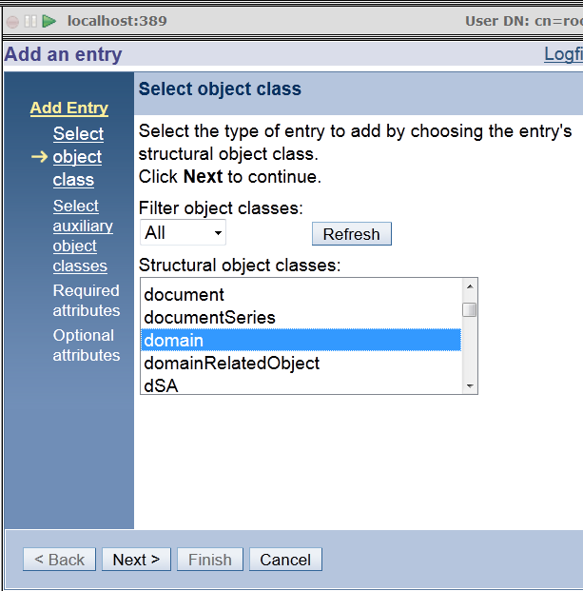

4. You don't need to set the auxiliary class. Just click Next.
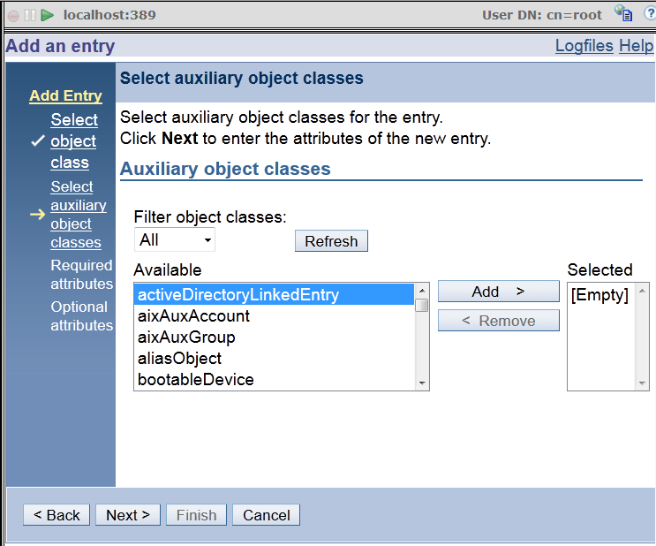

5. On the Required Attributes panel, set the relative DN and the required attribute. Then click Next.
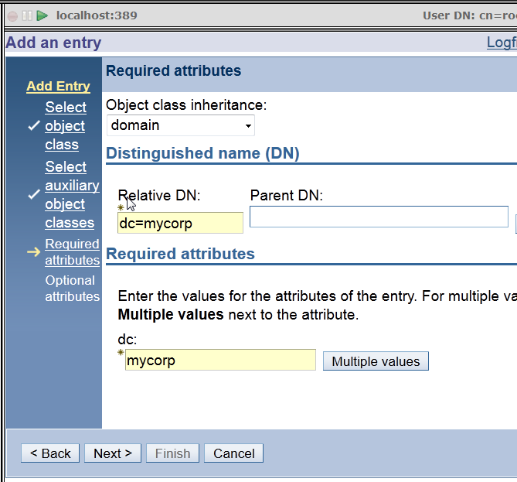
6. You do not need to set any values on the Optional attributes page. Scroll to the bottom and click Finish.

7. You will see the confirmation page as below. Click No to go back to the Manage entries page.
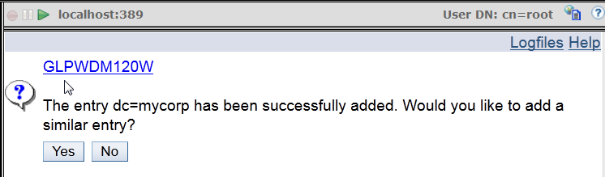

8. Ensure that dc=mycorp domain is created and listed on the Manage entries page. Continue with the instructions in the next section.
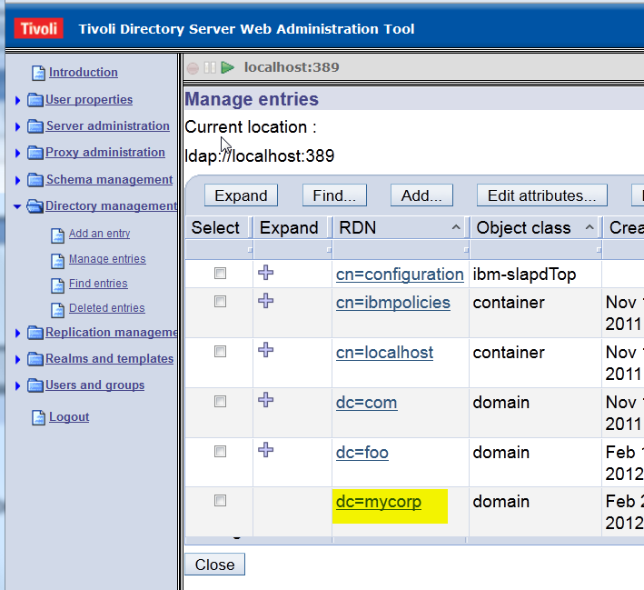

Adding a user template

This step is optional.
1. Continuing in the Web Administration Tool, go to the Realms and templates --> Manage user templates page and click Add... to create a new user template.
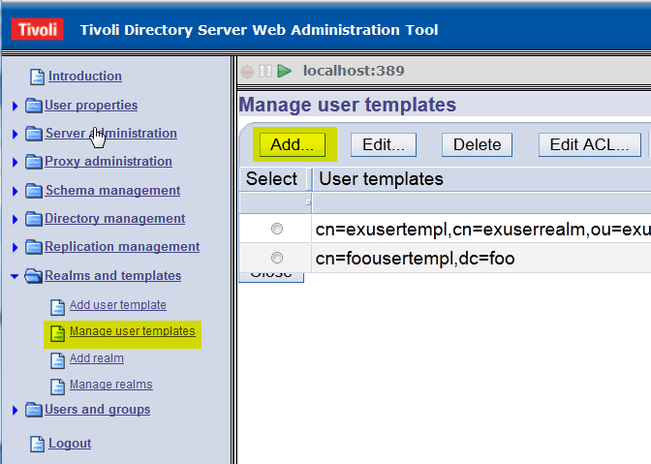

2. Enter the user realm name and the parent DN. Click Next.
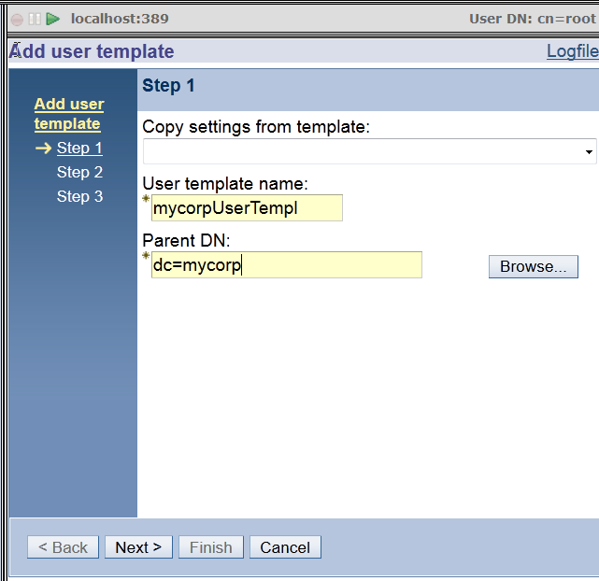

3. Select the object class for this user template. The class inetOrgPerson is used for this document. Click Next.
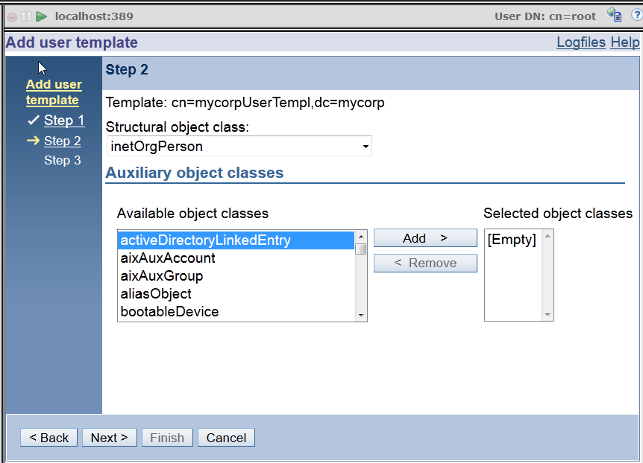

4. Set the Naming attribute. The Naming attribute uid is used in this document. Click Edit... to add the password field to the required attributes tab.

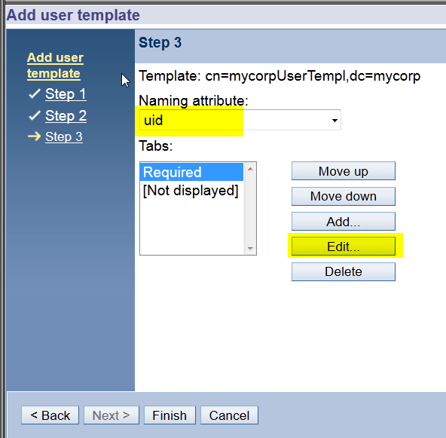

5. Add the userPassword attribute to the Required tab.
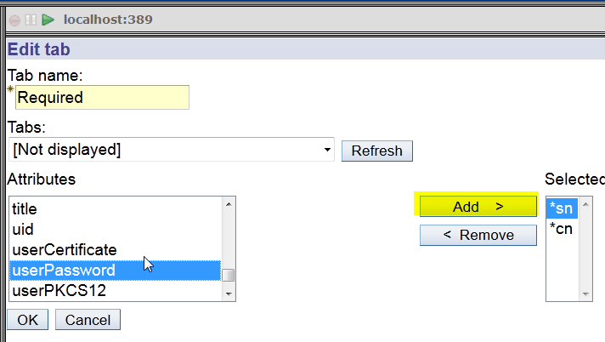
6. When userPassword is added, move it down to the bottom and click OK.
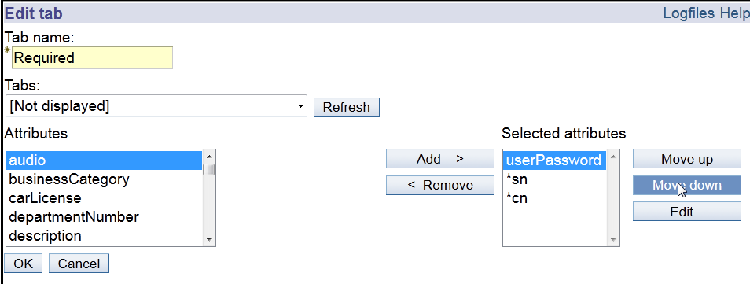

7. Click Finish to create a user template.
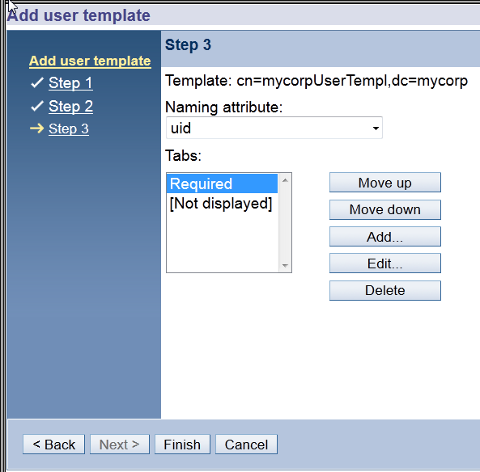

8. Verify that the user template mycorpUserTempl is created. Continue with the instructions in the next section.
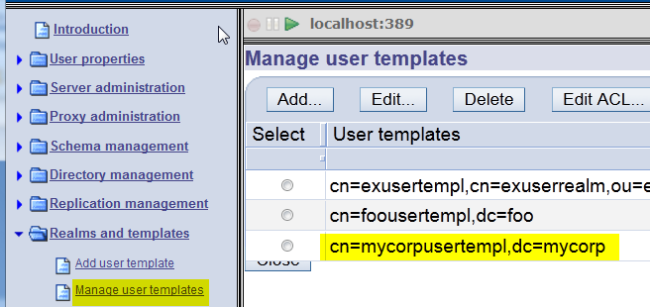

Adding a user realm

1. Continuing in the Web Administration tool, on the Realms and templates --> Manage realms page, click Add... to create a user realm for the user template that you just created.
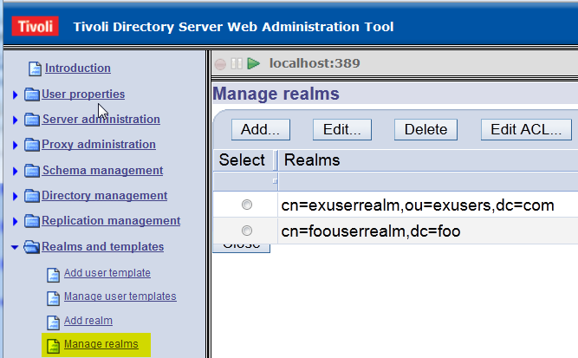

2. Enter values in the Realm name field and the Parent DN field, and click Next.
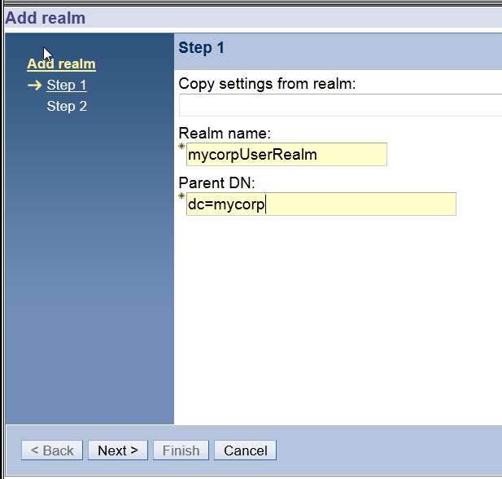

3. From the User template menu, select the user template that you created. Click the Edit... button next to the User search filter field.
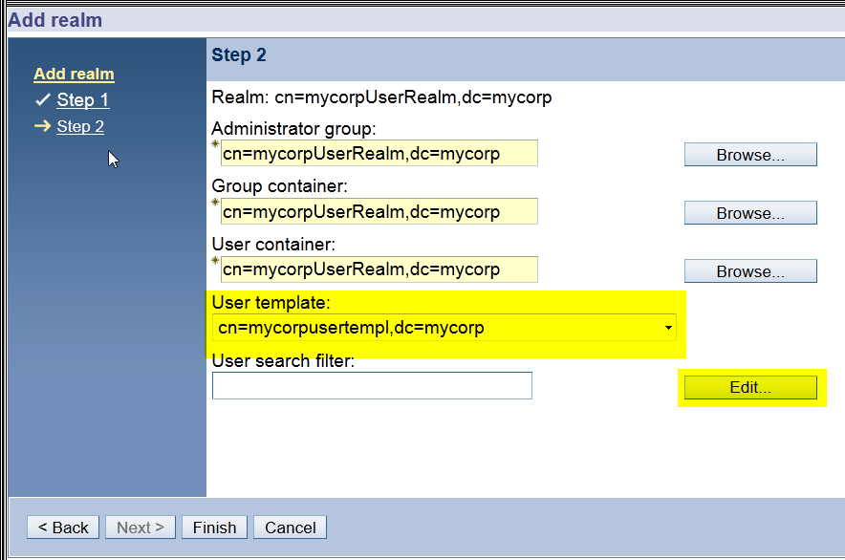

4. Accept the default settings and click OK.
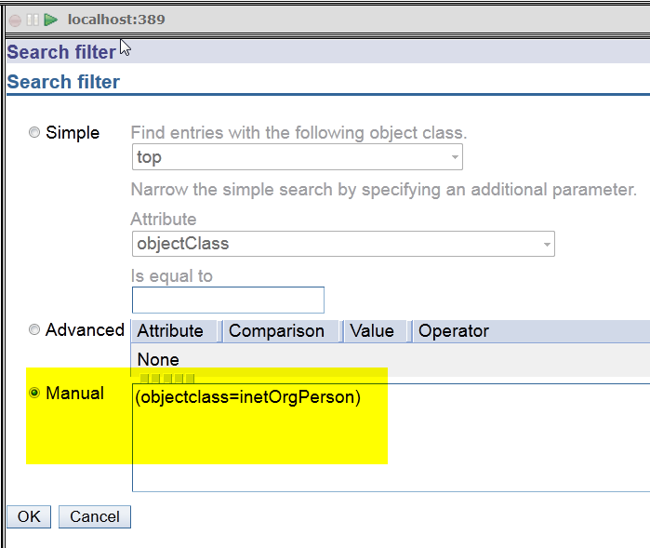

5. Click Finish to complete the creation of a user realm.
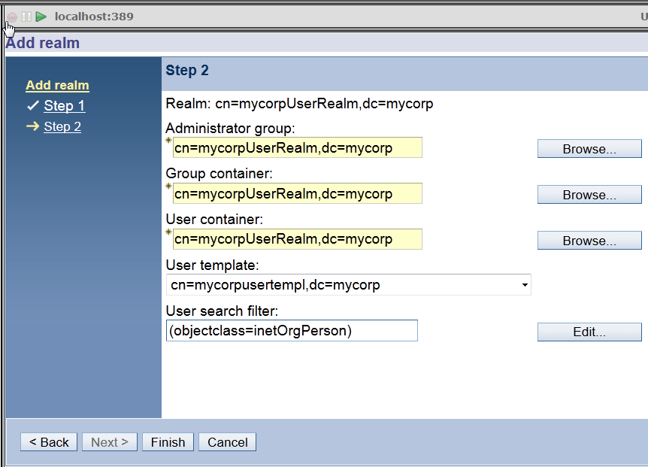
Make sure the new realm is created from the Manage realms page.

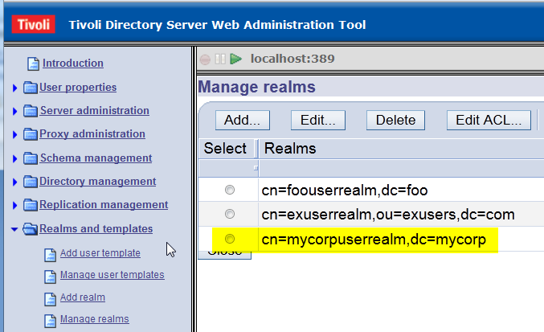
This concludes the appendix on configuring the LDAP User Registry.

