IBM Security Verify Governance

Identity Manager
Version 10.0.0

Example reconfiguration of Identity Manager to use an external LDAP user registry

Table of Contents
1 Overview 3
1.1 Initial installation with the default custom registry 4
1.2 Summary of the reconfiguration steps 5
1.3 Authorization when an external user registry is used 5
2 Adding the required users to the user registry 6
3 Configuring a WebSphere security domain 12
4 Updating the Identity Manager properties file 16
5 Mapping the Identity Manager application users in WebSphere 17
5.1 Unmapping the existing UserRunAs Roles 17
5.2 Unmapping the security role to user/group mapping 19
5.3 Mapping the security role to user/group for the isimsystem user 24
5.4 Mapping the User RunAs Roles for the isimsystem user 31
6 Remapping the service bus user role for the system user 34

Document date: 5/28/12

Overview

In this scenario, you have deployed an enterprise LDAP directory as the center of your information technology infrastructure. This LDAP directory is the principal identity source for your Identity Manager installation (HR Feed). The LDAP directory is also used to authenticate users to applications, through an existing WebSphere security domain. You also have configured an LDAP Service for this directory, allowing account and password management. Now you would like to use this LDAP directory as the authentication source for Identity Manager logins.

Initial installation with the default custom registry
Identity Manager supports several options for using a user registry for authentication. Identity Manager provides a custom registry that is preconfigured with the necessary administration and system accounts. During Identity Manager installation, you can choose to use this custom registry as the authentication registry for the WebSphere security domain. This is the default configuration. This configuration is used when you select Yes on the Installation panel Choose to use the Identity Manager Custom Registry or not.

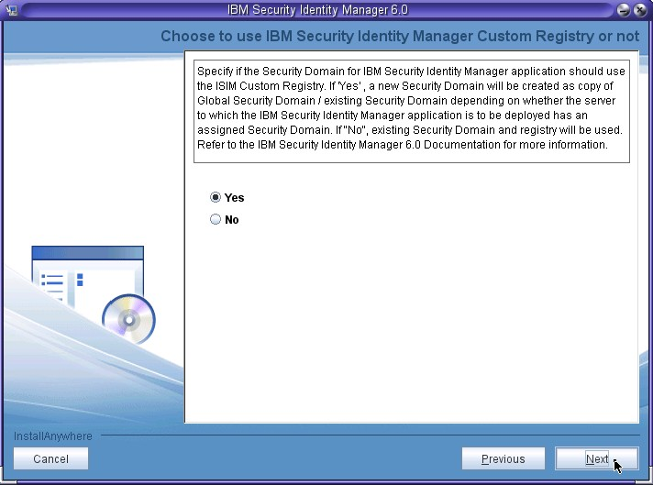

This document assumes that you selected Yes at the installation menu, and then later decided that you want to use an external user registry instead of the custom registry.

This document describes how to change the configuration from custom registry to external user registry, after initial installation of Identity Manager has completed.

Summary of the reconfiguration steps
The reconfiguration steps are:
- Add the required the Identity Manager users to the user registry
- Create or configure a WebSphere security domain
- Updating the Identity Manager properties file
- Map the Identity Manager application users
- Re-map the service bus user

To change the configuration, you must modify the WebSphere security domain configuration for the user realm type. For customized realms, WebSphere supports four different types of users realms.

- The default Identity Manager installation program configures a customized realm of type Standalone custom registry.
- After initial installation, you can modify the customized realm type to either Standalone LDAP registry or Global federated repositories.

The instructions in this guide describe both Standalone LDAP registry and global federated repository. Decide which realm type you want to deploy, and use the applicable instructions.

Authorization when an external user registry is used

While authentication is focused on the LDAP directory, authorization (determining the read/write and other operation and attribute access of the user through ACI controls) remains governed by the user's Identity Manager account and that account's ITIM group memberships. These ITIM group memberships also continue to solely define the user's interface views in the Identity Manager console and self service user interface. For a user to successfully log in to Identity Manager, they require both a valid LDAP login and password as well as a matching Identity Manager account.

Adding the required users to the user registry
You must add the required users for for Identity Manager to the LDAP registry that you want to use an external user registry for authentication.
This task describes how to use the IBM Tivoli Directory Server (ITDS) administration tool to add the users. You can also accomplish the task by using ldapadd or by creating and using LDIF files.
The required users are:
Account type | Account name
Default administrative user | ITIM Manager
Default system user | isimsystem

- Open the ITDS Web administration tool.
- Go to the Users and groups --> Manage users page.
- Select the realm and click View users.
- Click Add... to create the required users.

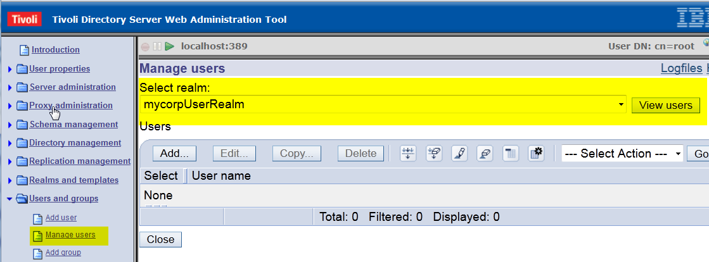

- Select the correct realm and click Next.
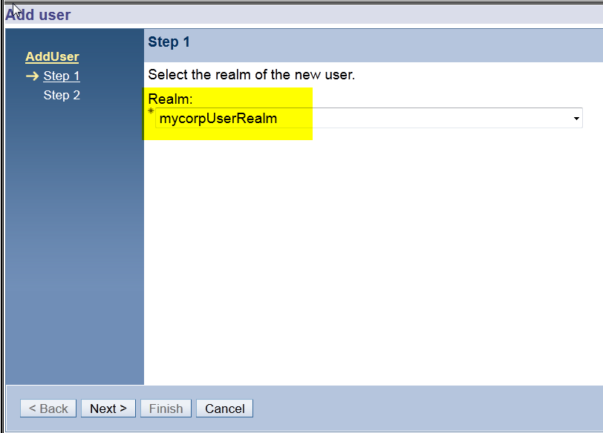

- On the Add User page, provide the required attributes and click Finish.
The default password for the ITIM Manager account is secret. This document uses the default Identity Manager administrator user id, ITIM Manager, but you can use a different user ID if you want.

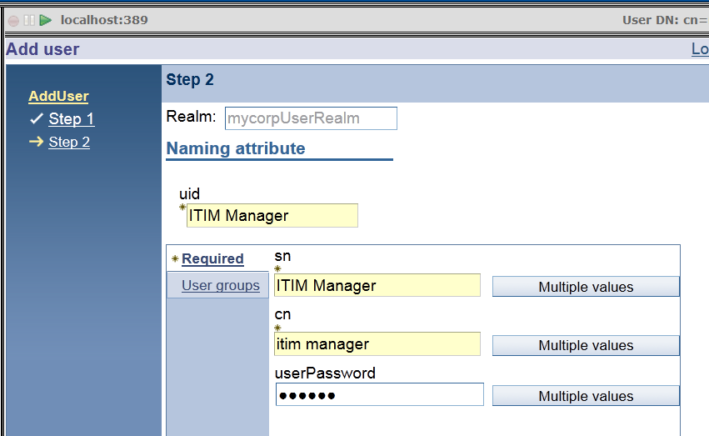

7. From the Manage users page, verify that ITIM Manager is created. Click Add... to create the isimsystem user.
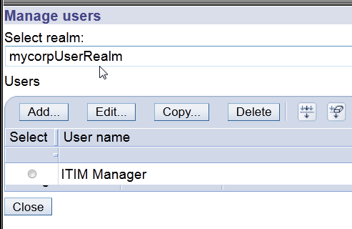
8. Select the correct realm and click Next.
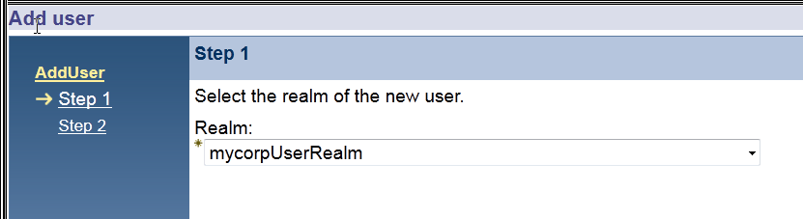

9. Provide the required attributes and click Finish. You can set the password to anything you want. This document uses the default password secret. This document also uses the default Identity Manager system user id, isimsystem, but you can use a different user ID if you want.
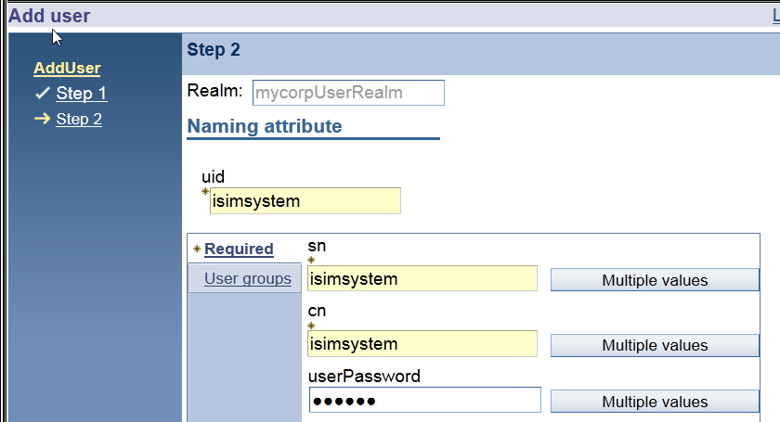

10. On the Manage users page, verify that both the ITIM Manager and isimsystem users are listed.
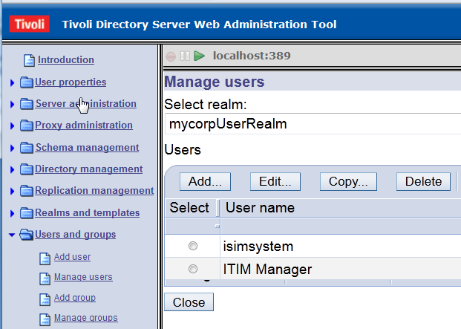
11. You have completed the configuration of the ITDS v6.3 LDAP server with the required Identity Manager users. Continue with the next section to configure the WebSphere security domain with this LDAP user registry.

Configuring a WebSphere security domain

This section describes how to change configuration of a default security domain for Identity Manager from a default Identity Manager Custom Registry to a standalone LDAP registry.

The Identity Manager installer creates a security domain in the WebSphere environment. The default security domain created by the install is ISIMSecurityDomain

For this task, you must edit the configuration settings for ISIMSecurityDomain.

1. Log in to the WebSphere administration console.

2. Stop the ISIM enterprise application.

3. Select Security > Security domains

4. Click ISIMSecurityDomain.

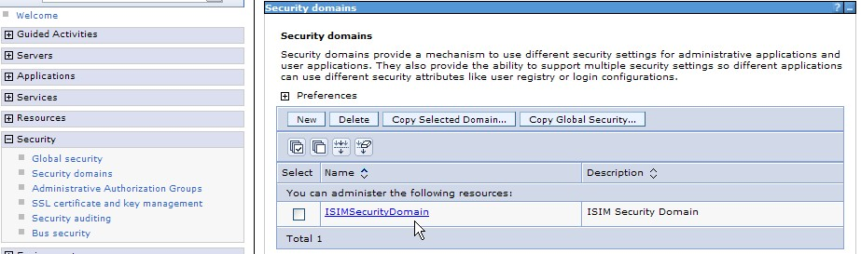

5. On the ISIMSecurityDomain page, in the Security Attributes section, expand the User Realm option. In the Realm type field, use the drop down list to select Standalone LDAP registry.

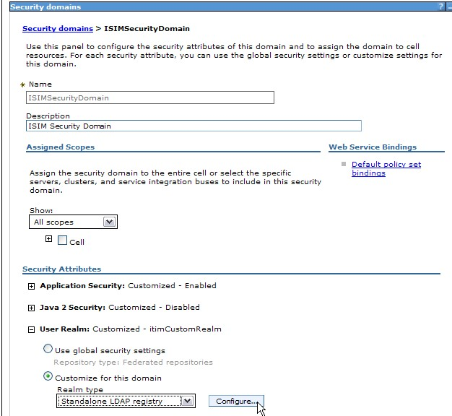

6. On the Standalone LDAP registry page, provide the necessary configuration values for your deployments.

For the following steps, see the screen capture on the next page

a. Select Provide a realm name. Enter a name. For example: newRealm

b. For Type of LDAP server, use the drop down list to select IBM Tivoli Directory Server

c. Provide values for the remaining fields, as shown in the following table:

Configuration Field | Example value
Host | your_host_name
Port | 389
Base distinguished name (DN) | c=us
Bind distinguished name (DN) | cn=root
Bind password | your current password

d. If necessary, provide SSL settings.

7. Click Test Connection to verify that the connection information provided is valid.

8. Click OK to save your changes. Click Save to save the changes.

9. If necessary (if there is a change in login or password), update the J2C global alias definition for the isimsystem user

10. Stop the WebSphere server.
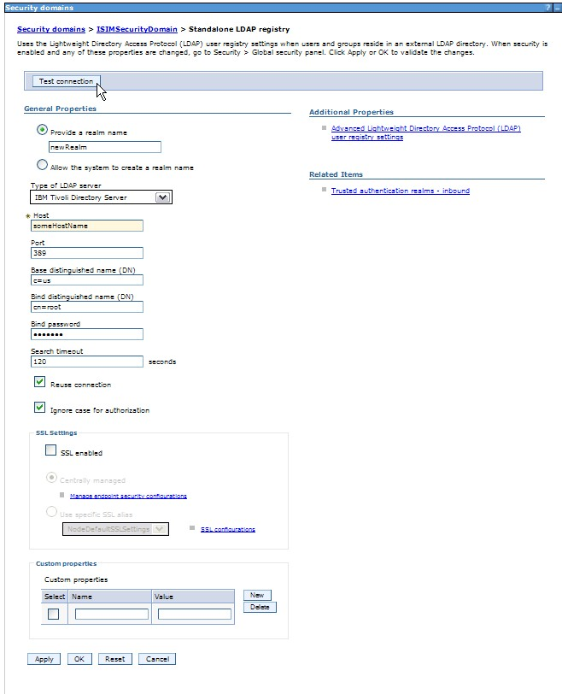

Updating the Identity Manager properties file

1. If there is a change in login or password, update the “isimsystem” user login and password. Use runConfig to set the new login and password. Ignore the runConfig warning that WebSphere could not be contacted. The warning is expected, since WebSphere is stopped.

2. Edit the /opt/IBM/isim/data/enRole.properties file in your Identity Manager environment. Reset the default realm name to match the realm name you provided for the standalone LDAP registry.

Old setting | enrole.appServer.realm=itimCustomRealm
New setting | enrole.appServer.realm=your_realm_name  For example:  enrole.appServer.realm=newRealm

3. Save the file.

4. Start the WebSphere server.

Mapping the Identity Manager application users in WebSphere

Unmapping the existing UserRunAs Roles

Unmap the existing setting. In a later section you will re-map the setting for the user isimsystem so that the attribute is synched with the new registry.

1. Log in to the WebSphere administration console.

2. Go to Applications > Application Types > WebSphere Enterprise Applications > ITIM

3. In the Detail Properties section, click User RunAs roles.

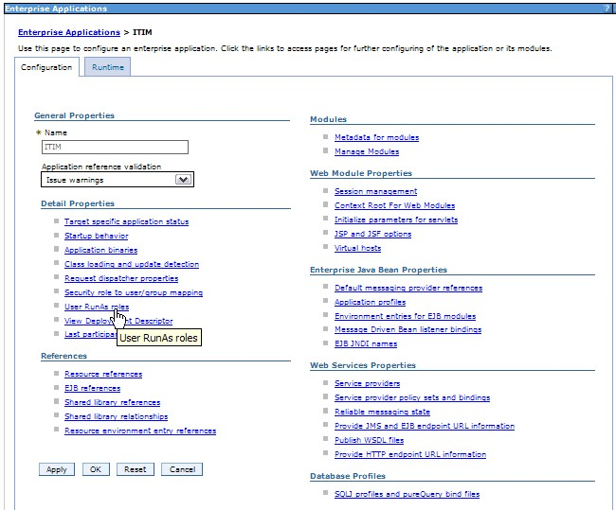

4. On the User RunAs roles page, select the check box for ITIM_SYSTEM. Click Remove to remove the User name isimsystem from the ITIM_SYSTEM role.

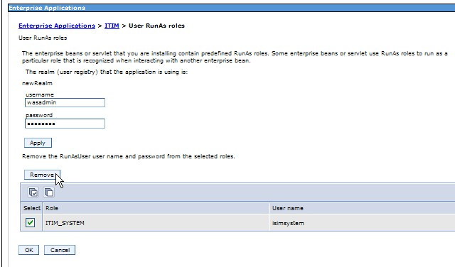

5. Click OK and click Save.

6. Continue with the instructions in the next section.

Unmapping the security role to user/group mapping

1. Continuing in the WebSphere administration console, return to
Applications > Application Types > WebSphere Enterprise Applications > ITIM

2. On the Configuration tab, click Security role to user/group mapping

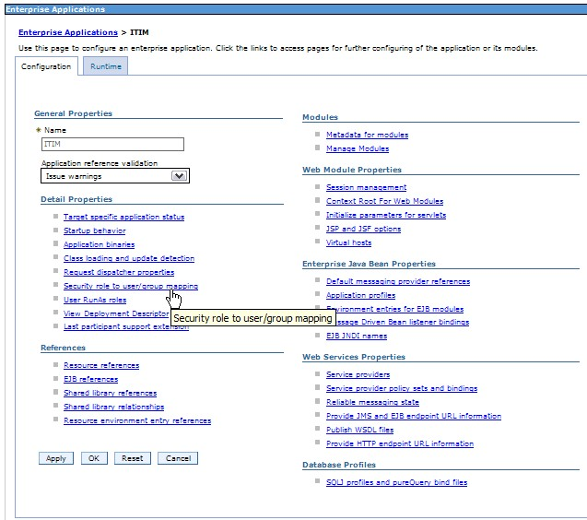

3. On the Security role to user/group mapping page, check the check box next to ITIM_SYSTEM. Click Map Users.

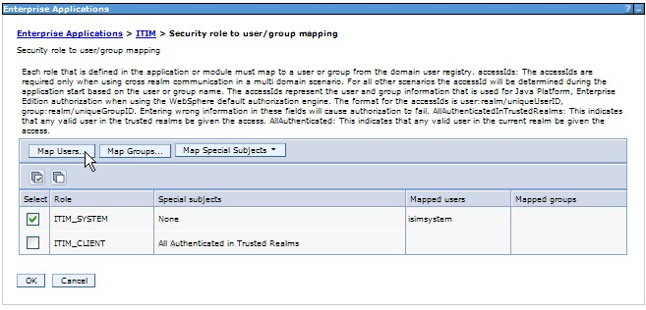

4. On the Map users/groups page, go to the list of Selected users, click isimsystem and click the arrow button to remove isimsystem from the Selected users and into the Available users list.

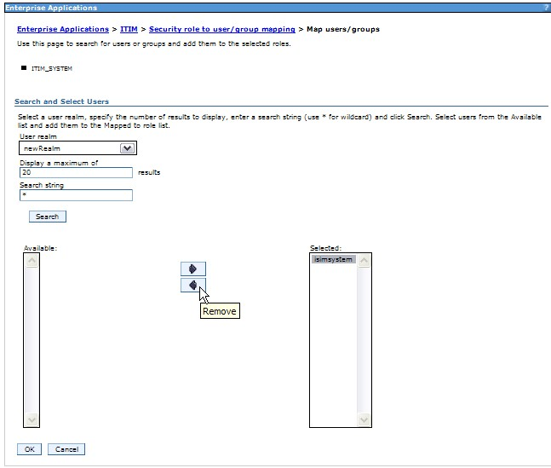

5. When isimsystem is displayed under the Available list, click OK.

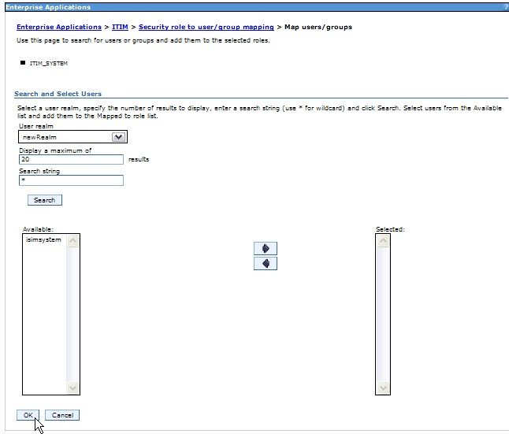

6. On the Security role to user/group mapping page, click OK and then click Save to save the changed.

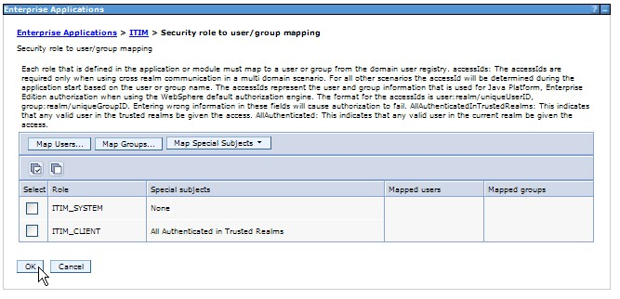

7. Continue with the instructions in the next section.

Mapping the security role to user/group for the isimsystem user

1. Continuing in the WebSphere administration console, return to
Applications > Application Types > WebSphere Enterprise Applications > ITIM

2. On the Configuration tab, click Security role to user/group mapping

3. On the Security role to user/group mapping page, check the check box next to ITIM_SYSTEM. Click Map Users.

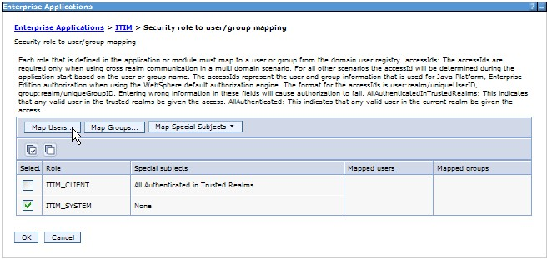

4. On the Map users/groups page, go to the Search string field, and enter: *isimsystem*

5. Click Search.

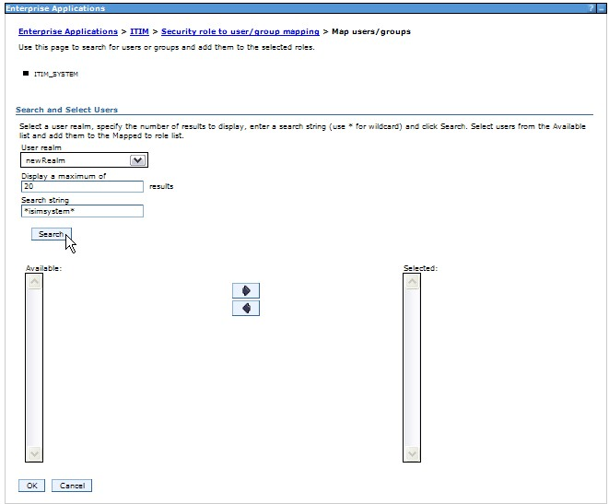

6. Verify that the results of your search query match the syntax of the isimsystem user entry/dn in your Standalone LDAP registry.

In this example, this syntax is: cn=isimsystem,c=us

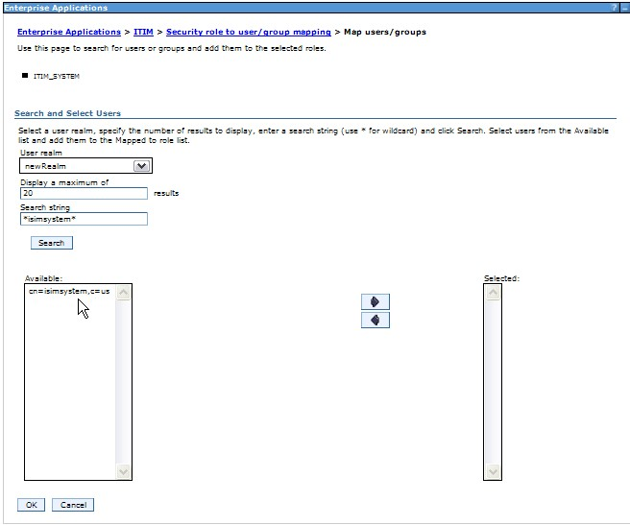

7. In the Search and Select users section, highlight the user in the Available list, and click the Add arrow to move the user into the Selected list.

In this example, this available user is: cn=isimsystem,c=us

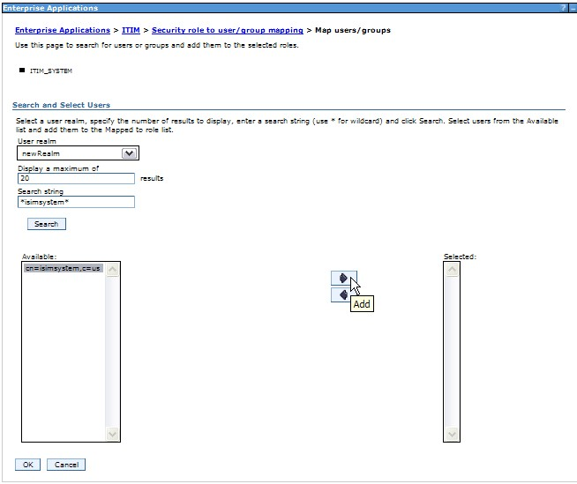

8. When the user is displayed in the Selected list, click OK.

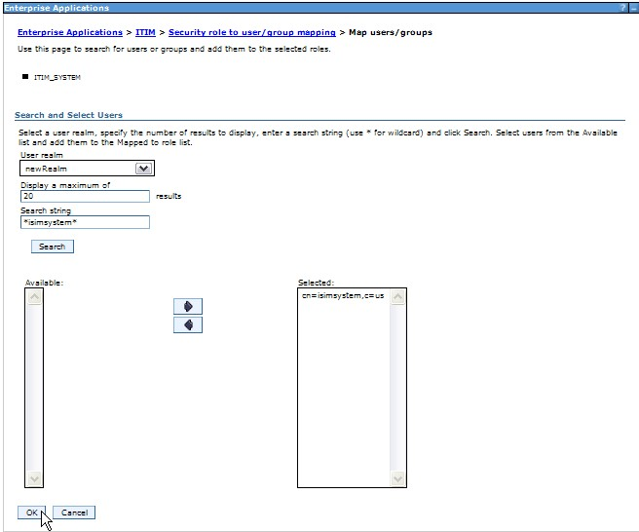

9. On the Security role to user/group mapping page, click OK and click Save to save the changes.

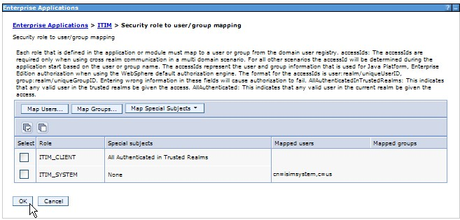

10. Continue with the instructions in the next section.

Mapping the User RunAs Roles for the isimsystem user

1. Continuing in the WebSphere administration console, return to
Applications > Application Types > WebSphere Enterprise Applications > ITIM

2. On the Configuration tab, click User RunAs Roles.

3. On the User RunAs roles page, provide values for the isimsystem user in the username field and password field. In the table, select the check box for ITIM_SYSTEM, and click Apply.

Note: The user id must be the shortname of what you used in the previous step Mapping security role to user/group. For example, these instructions used cn=isimsystem,c=us for the previous step Mapping security role to user/group. This means that the username for this step is: isimsystem

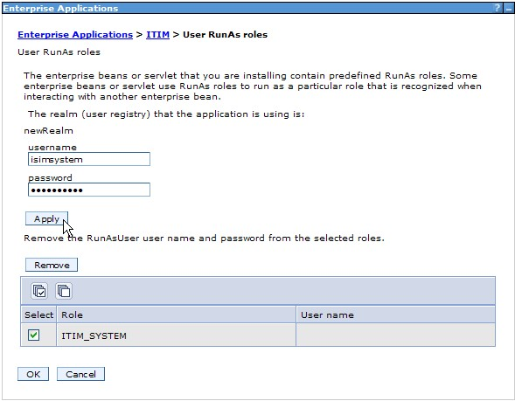

4. Verify that the user isimsystem is now listed in the User name column in the table entry for the Role for ITIM_SYSTEM.

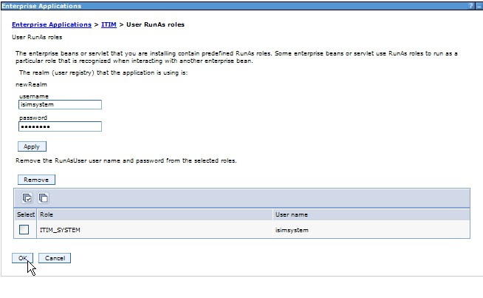

5. Click OK and click Save to save the changes.

6. Continue with the instructions in the next section.

Remapping the service bus user role for the system user

1. Under Service Integration > Buses click the Enabled link under the Security column for the itim_bus resource.

2. On the Security for bus itim_bus page, under Authorization Policy , click Users and groups in the bus connector role.

3. On the Users and groups in the bus connector role page, remove the system user. For example, isimsystem.

4. On the same page, click New and add the system user (for example, isimsystem) from your external user registry repository.

5. In the SIB Security Resource wizard:

a. On the Search for Users or Groups page, in the Search pattern field, enter an asterisk "*", and click Next.

b. On the Select Users and Groups page, select your system user. For example, isimsystem. Click Next.

c. On the Summary page, review the configuration and click Finish.

6. Return to Security for bus itim_bus, and under Authorization Policy click Manage default access roles.

7. On the Default access roles page, expand Default access, select the system user ( isimsystem), and click Remove.

8. On the Security for bus itim_bus page, click Add.

9. Add the system user from the external user registry repository. In the SIB Security Resource wizard:

a. On the Search for Users or Groups page, in the Search pattern field, enter an asterisk "*", and click Next.

b. On the Select Users and Groups page, select your system user. For example, isimsystem. Click Next.

c. On the Select Role Types page, select Sender, Browser, Receiver, and Creator.

d. On the Summary page, review the configuration and click Finish.

10. Set the Identity Manager application target deployment status back to start.

11. Save changes.

12. Start the Identity Manager application.

END OF DOCUMENT

