IBM Security Verify Governance

Identity Manager

Version 10.0.0

Configuring and using Identity Manager with an external user registry

Table of Contents
1 Overview 3
2 Example deployment steps 5
2.1 Prerequisite requirements 5
2.2 Summary of deployment steps 5
2.3 Collecting LDAP user repository information 6
2.4 Populating LDAP users with ITIM account through InetOrgPerson Identity Feed 7
2.5 Create LDAP service and populate LDAP accounts 13
2.6 Updating the WebSphere account repository attribute of ITIM Service 18
3 Management tasks 20
3.1 User management 20
3.2 Password Management 20
3.3 Account Management 20

Document date: March 12, 2012

Overview

In Identity Manager, you can optionally use an external user repository as an authentication user repository. After Identity Manager is installed with the external user repository, you must complete some configuration steps to ensure that the product successfully uses the authentication user repository.
Identity Manager provides a service to manage the supported external user registries.
- You can optionally use the service to manage the external user registry, if the registry is supported.
- If Identity Manager does not provide a service for your external user repository, you cannot manage the repository through the Identity Manager administration console.

The default service that manages user repositories is ITIM Service. When Identity Manager is installed, ITIM Service is set as a default value for WebSphere user repository.
If you are using an external user repository, you must set the WebSphere user repository attribute of ITIM Service correctly.
- If you want to use an Identity Manager service to manage the external user repository, create a service instance for the user repository and set that service instance as a WebSphere user repository.
- If you do not want to use an Identity Manager service to manage the external user repository, use the Identity Manager administration console to clear (remove all values) from the WebSphere user repository field of ITIM Service.
When the WebSphere user repository field is configured with an Identity Manager manageable service, Identity Manager supports the features shown in the following table. When the WebSphere user repository field is set to empty (no value), the features are not supported.

Configuration setting | Supported Features
WebSphere user repository field is set to an Identity Manager manageable service. For example, ITIM Service | - Forgotten password with password reset feature.  - Provisioning and managing of the users in the user repository.  - Password management of the users in the user repository.
WebSphere user repository field is set to empty (no value) | none

Note:
- You must set the field to empty if the external user repository is not a supported service.
- You can optionally set the field to empty if the external user repository is a supported service, but you choose not to manage the user repository through Identity Manager

The following sections in this document provide a step-by-step example on how to configure Identity Manager with external LDAP user repository as a WebSphere user repository.

Example deployment steps

The example is provided to show how to populate the LDAP users and accounts to the Identity Manager and describes the implications on the configurations.

Prerequisite requirements

- The LDAP user repository already has the Identity manager system user isimsystem and the default administrator user ITIM Manager. (Alternatively, you define a different system user and administrator user.)
- Identity Manager is installed with the security domain configured with external LDAP user repository.

Summary of deployment steps

The sections in the remainder of this document describe the following configuration tasks:
- Collect LDAP user repository information.
- Populate LDAP users with ITIM account through inetOrgPerson Identity feed.
- Create a service instance for the external LDAP user repository with the manual provisioning policy, and run the reconciliation function to populate LDAP accounts.
- Update the ITIM Service WebSphere account repository field with the LDAP service.

Collecting LDAP user repository information

From the Tivoli Directory Server Web Administration Tool, collect the LDAP user repository information.
- Go to Realms and templates > Manage realms page.
- Select the realm name to view and collect the user repository information as shown in the following screen capture.
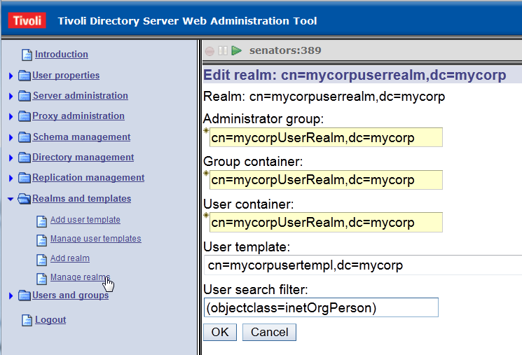
- Continue with the instructions in the next section.

Populating LDAP users with ITIM account through InetOrgPerson Identity Feed

The most base entities are the users in Identity Manager. You must have a user (person or business partner) to manage the accounts. After the users are added, you can provision accounts for the services, based on the provisioning policies. The provisioning policy entitles the users to access specific services.
This step describes how to feed the users from the LDAP user repository to the identity manager system.
1. Log in to Identity Manager console as the Identity Manager administrator (for example, ITIM Manager) and click Manage Services.
2. Click Create button to create a new INetOrgPerson identity feed service.
3. Set the Business unit in which to create this service. Select INetOrgPerson identity feed for the Service Type, and click Next.
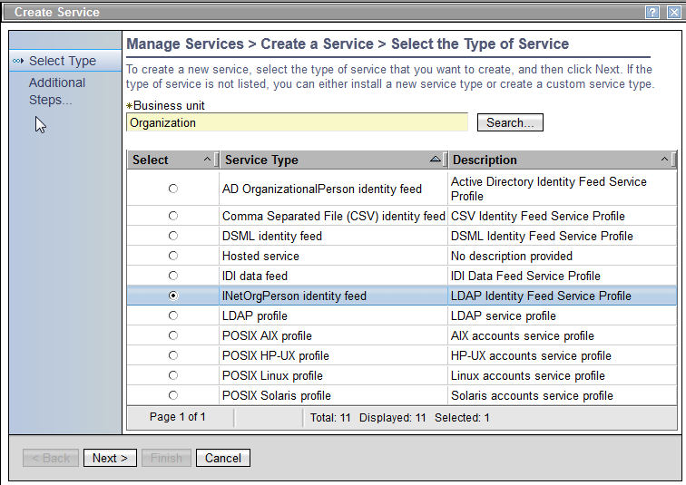

4. Fill out the service information as specified in the table below, and click Test Connection .
See the example Service Information screen on the following page

Field | Description
Service name | The name of the service
URL | The LDAP URL where directory server is running.
User ID | The DN of bind user.
Password | The password of bind user.
Naming Context | The base DN of users
Use workflow | When this check box is selected, the provisioning policy will be evaluated. Select this option to automatically provision an ITIM account after the user is created.
Person profile name | Person or Business partner person. Select Person.
Name attribute | The naming attribute for this person. This example uses the attribute uid.  NOTE:  This attribute is used to check to see if there is already a matching person exists in Identity Manager system. If there is a person already exists with the same uid value as LDAP user, then that person will be updated with additional attribute values instead of creating a new person. For example, if System Administrator person has same uid value as ITIM Manager LDAP user, then ID feed will just update System Administrator person instead of creating a new person called ITIM Manager. Because of this reason, you might want to update uid value of System Administrator person to ITIM Manager to avoid creating ITIM Manager person. If you used the uid other then ITIM Manager for the Identity Manager default administrator user in LDAP user registry, then you need to use that uid value for System Administrator's uid value. To avoid updating the cn (full name) and sn (last name) of System Administrator person, update the cn and sn attribute of ITIM Manager LDAP user to have the same cn and sn values as System Administrator person.

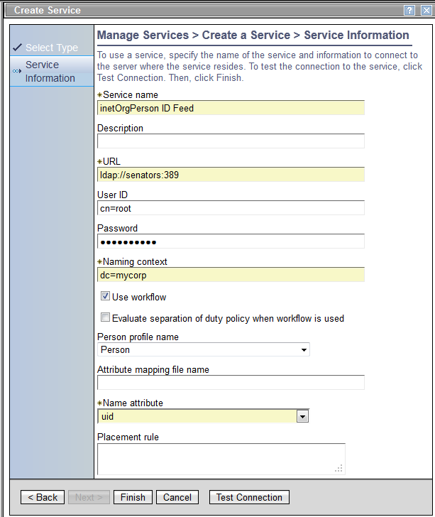

5. The following message displays when the connection succeeds. Click Finish.
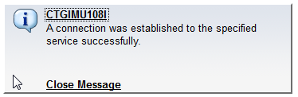
6. After the InetOrgPerson Identity Feed service is created you need to run the reconciliation to feed in the LDAP users to the Identity Manager system. Right click the service name and select Reconcile Now.
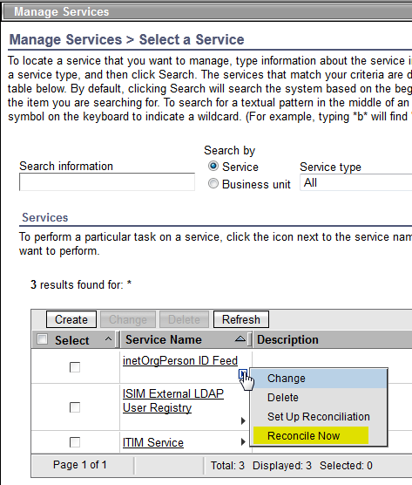

7. The success page displays when the request is successfully submitted. You can check to see if the request is completed by clicking the link View my request.
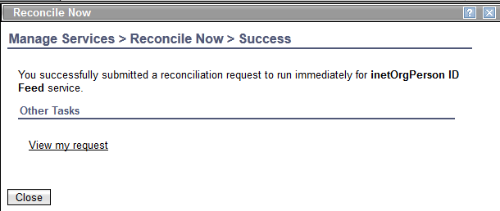
8. After the reconciliation is completed, you will see all the users from LDAP user repository are populated into Identity Manager system. Go to Manage Users and click Search to list all the users.
- Since you selected “Use workflow” option on the INetOrgPerson identity feed service, and since you used uid as a naming attribute, the ITIM account would be automatically provisioned for each user with the same LDAP account ID. If the ITIM account is not created with the same user ID, then you need to create the ITIM account manually with the same LDAP user id.
- When the external user repository is used for the authentication user repository. you must have the same user ID between the external user ID and the ITIM account user ID. After the user is authenticated to the Identity Manager, Identity Manager system uses the mapped ITIM account for the ACI checking and the view controls. The default IDMapper assumes that one to one mapping exists between the external user and the ITIM account with the same ID. If it is not possible to have the same ID, then you must implement the custom IDMapper to address the mapping from the external user to the ITIM account. See the Identity Manager information center and the API documentation for instructions on how to implement a custom IDMapper.
- When the INetOrgPerson identity feed completes, you might see an isimsystem person with isimsystem ITIM account, and an ITIM Manager person with an ITIM Manager1 ITIM account. ITIM Manager and isimsystem users are required users in LDAP user registry before you run the Identity Manager installer. They are created as people in Identity Manager system by the Identity feed.
- The isimsystem person is a special internal user that is used only by the Identity Manager system. Leave this person as is.
- The ITIM Manager person is a duplicate person for the System Administrator person. You can choose to delete the ITIM Manager person (with the ITIM Manager1 account), since you already have the System Administrator person with an ITIM Manager account.
- If you delete the ITIM Manager person with the ITIM Manager1 account, you must update the ITIM Manager LDAP user cn and sn attribute in the LDAP user registry with the same cn and sn value as the System Admnistrator person. You also must update uid attribute of System Administrator person to ITIM Manager . You must complete this update in order to prevent the creation of the same duplicate user (ITIM Manager person) when you run the same Identity Feed later. For example, you might run the Identity Feed again when more users are added to the LDAP user registry.

Create LDAP service and populate LDAP accounts

If you want to manage the external LDAP user repository through Identity Manager, you can create a service instance for the LDAP user repository. This section describes how to create an LDAP service instance for the external user repository and also how to configure the ITIM Service WebSphere account repository. The effects of using this setting are also described.

To create a LDAP service with the external user repository, complete the following steps:

1. Login to the Identity Manager administration console.
2. Go to Manage Services and click Create.
3. Select the Business unit in which this service is created and select LDAP profile as a service type.
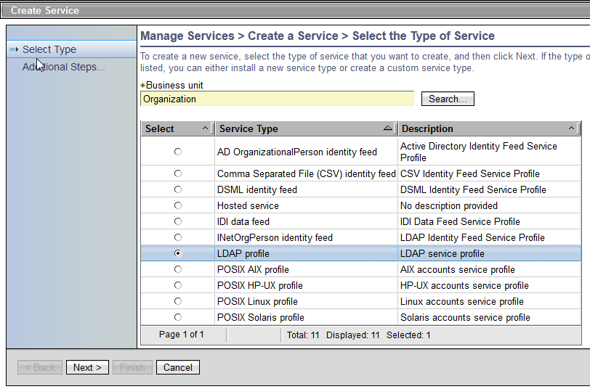

4. Provide all the required attributes for the LDAP service, and click Test Connection.
- Service name: your choice of name.
- Tivoli Directory integrator location: The RMI URL to Tivoli Directory Integrator. The default port is 1099.
- Administrator name: The LDAP bind user.
- Password: The LDAP bind user password.
- Directory server name: IBM Directory Server is used in this documentation.

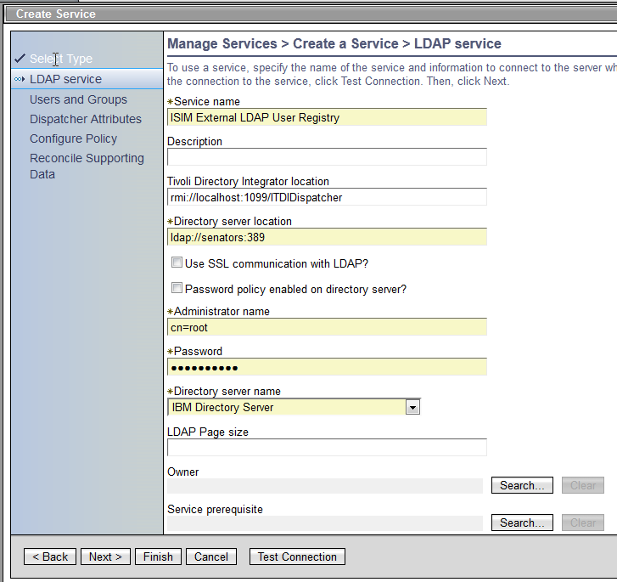

5. When the connection test to the LDAP server is successful, the following message is displayed. Click Next.
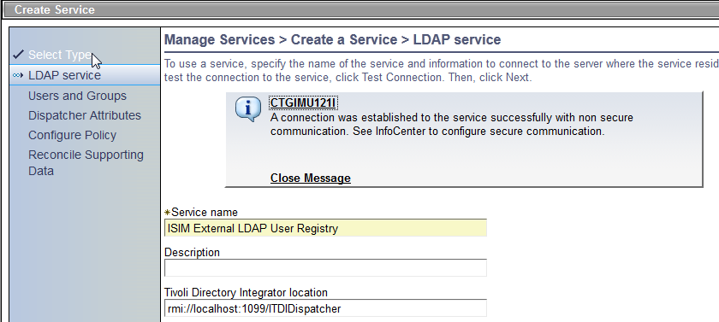

6. Enter information for Users and Groups. You already collected this information earlier in this document, during the Collect LDAP user repository information section.
- User base DN: The base DN for the users.
- User RDN Attribute: The relative DN attribute for the user.
- Group base DN: The base DN for the user group.
- Group RDN Attribute: The relative DN attribute for the user groups

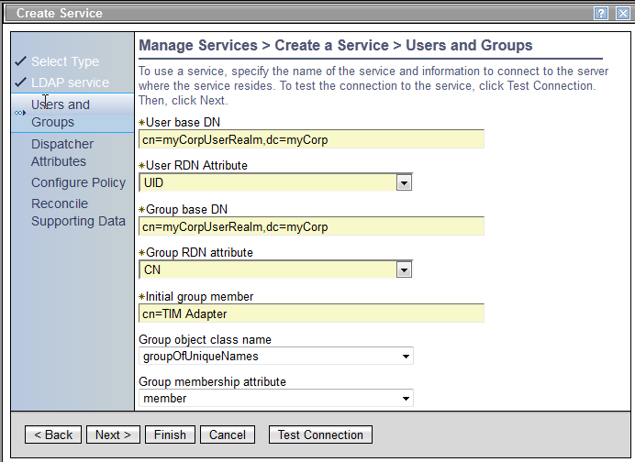

7. Click Next until the Configure Policy page is shown. Select Yes, create a policy for manually requesting accounts, and click Next.

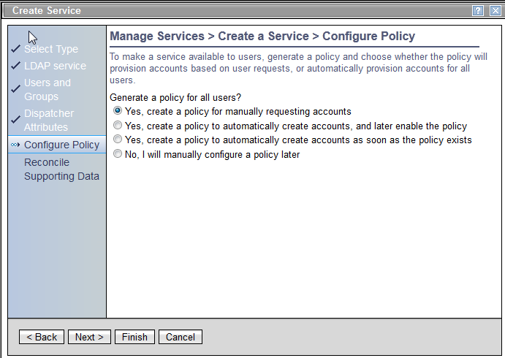
8. From the Reconcile supporting data section, select Never and click Finish. The reconciliation setting can be configured to a different setting later, once the service is created. For this documentation, Never is used so that the reconciliation can be run manually.
Once the service is created, you can run the reconciliation to populate the LDAP accounts to the Identity Manager system. During the reconciliation, if there is no adoption policy defined for this service or service type, then the global adoption policy is used. The default global adoption policy assigns the account to the user who has the same uid value as the account user ID. Since the users are populated with the INetOrgPerson identity feed, the uid attribute should already have the user ID of the LDAP account. In other words, after the reconciliation is done, all the accounts are assigned to the correct user. For some reason, if the user does not have the UID set differently then you need to either: 1) update the adoption policy before you run the reconciliation or 2) assign the account to the correct user after the reconciliation is done.

Updating the WebSphere account repository attribute of ITIM Service

The WebSphere account repository attribute of ITIM Service is used to tell the Identity Manager system which authentication user registry is used.
When the external user registry is configured to be an authentication user registry for Identity Manager, you should update the WebSphere account repository attribute of ITIM Service. By default, ITIM Service is set for this attribute. You need to clear the value or set the service instance of an external user registry as a value.
- If the external user registry is not manageable by Identity Manager, then the blank value needs to be set for this attribute.
- If you already have created the service for the external user registry, and you want to use the forgotten password with password reset feature, then you need to set WebSphere account repository with the service that represents the external user registry.
- If the blank value or the service instance other than ITIM Service is set for this attribute, the password of ITIM account becomes meaningless since the authentication is done though the external user registry. For this case, you cannot change the ITIM account password, and the ITIM account is used only for authorization and the view control. After the authentication is done through the external user registry, Identity Manager system gets the mapped ITIM account for the external user registry user and applies the ACI and the View access. The Identity Manager comes with the default IDMapper to map the external authenticated user to ITIM account by using the same user ID. If you want to map the external user to an ITIM account with a different user ID, you must implement a custom IDMapper. See the Identity Manager information center and the API documentation for more information.

To set the WebSphere account repository attribute, follow these instructions.

1. Log into Identity Manager console UI and go to Manage Services.
2. Click on the ITIM Service name to update the attribute values for ITIM Service.
3. Update the WebSphere account repository field. For this example, set it to the LDAP service instance that is already created for the external authentication user registry.

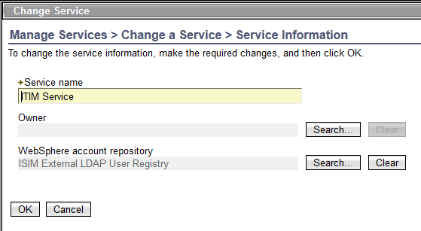
You have now completed all the steps to populate all the users (people) from the LDAP external user registry and also the Identity Manager account and the LDAP account for each user. In this example, the users and the LDAP accounts are reconciled from the same LDAP repository to demonstrate how to feed in the users and assign the account to the correct user with the default adoption policy.

Your Identity Manager system is ready to use with the external LDAP user registry users.

Management tasks

User management
You can manually create a user though the Identity Manager console UI or you can use the INetOrgPerson Identity feed to populate the new user that is added to the LDAP server directly.

Password Management
Once the WebSphere account repository is updated for the external user registry, your ITIM account password is never used, since the user from the external registry is used for the authentication. For that reason, the Identity Manager system treats the ITIM Service accounts the same way as it treats other accounts that do not have a password attribute. This means that you can not change the password of ITIM Service accounts.
The password expiration and the maximum number incorrect login attempts settings are also never used if the WebSphere account repository is set to blank or external user registry service.
The forgotten password with password reset feature is only supported when the WebSphere account repository is set with ITIM Service or any other service that Identity Manager manages. After the challenge response questions are answered, the password of underlying authentication user will be reset or changed.

Account Management

If the external user registry is configured as an authentication user registry, there should be an one-to-one mapping between the authentication user and the ITIM Service account. After the authentication is done, the Identity Manager uses the default IDMapper to find the mapped ITIM Service account. The ITIM Service account is required to enforce the access control and the view control. Identity Manager comes with a default mapper that maps the authentication user to the ITIM Service account with the same ID. If the authentication user ID is different from the ITIM account user ID, then you must implement a custom IDMapper. See the Identity Manager information center and the API documentation for more information.
To use the default IDMapper without implementing a custom IDMapper, you must have the same user ID between the external authentication user and the ITIM Service account user. For example, if you change the user ID of authentication user, then you need to also change the ITIM Service account user ID.
ITIM account suspension also affects the Identity Manager system behavior. Once it is suspended, you can not access the Identity Manager system even though the external user registry is configured as an authentication user registry. You can suspend the ITIM Service account to prevent access to the Identity Manager system.

