DESIGN AND ANALYSIS OF ALGORITHMS
Name: K. Jnanendra
Roll no: ch.sc.u4cse24217

HUFFMAN CODING:
#include <stdio.h>
#include <stdlib.h>
#include <string.h>

#define MAX_CHAR 256
#define MAX_CODE 100

typedef struct Node {
char ch;
int freq;
struct Node *left, *right;
} Node;

typedef struct {
Node *data[MAX_CHAR];
int size;
} MinHeap;

Node *newNode(char ch, int freq) {
Node *node = (Node *)malloc(sizeof(Node));
node->ch = ch;
node->freq = freq;
node->left = node->right = NULL;
return node;
}

void heapify(MinHeap *h, int i) {
int smallest = i;
int left = 2 * i + 1;
int right = 2 * i + 2;
if (left < h->size && h->data[left]->freq < h->data[smallest]->freq)
smallest = left;
if (right < h->size && h->data[right]->freq < h->data[smallest]->freq)
smallest = right;
if (smallest != i) {
Node *temp = h->data[i];
h->data[i] = h->data[smallest];
h->data[smallest] = temp;
heapify(h, smallest);
}
}

void insert(MinHeap *h, Node *node) {
h->data[h->size] = node;
int i = h->size++;
while (i && h->data[i]->freq < h->data[(i - 1) / 2]->freq) {
Node *temp = h->data[i];
h->data[i] = h->data[(i - 1) / 2];
h->data[(i - 1) / 2] = temp;
i = (i - 1) / 2;
}
}

Node *extractMin(MinHeap *h) {
Node *min = h->data[0];
h->data[0] = h->data[--h->size];
heapify(h, 0);
return min;
}

Node *buildHuffmanTree(char chars[], int freq[], int n) {
MinHeap h;
h.size = 0;
for (int i = 0; i < n; i++)
insert(&h, newNode(chars[i], freq[i]));

while (h.size > 1) {
Node *left = extractMin(&h);
Node *right = extractMin(&h);
Node *merged = newNode('$', left->freq + right->freq);
merged->left = left;
merged->right = right;
insert(&h, merged);
}
return extractMin(&h);
}

void generateCodes(Node *root, char code[], int depth, char codes[][MAX_CODE], char chars[], int n) {
if (!root) return;
if (!root->left && !root->right) {
code[depth] = '\0';
for (int i = 0; i < n; i++)
if (chars[i] == root->ch)
strcpy(codes[i], code);
return;
}
code[depth] = '0';
generateCodes(root->left, code, depth + 1, codes, chars, n);
code[depth] = '1';
generateCodes(root->right, code, depth + 1, codes, chars, n);
}

int main() {
char *text = "AMRITA VISHWA VIDYAPEETHAM CHENNAI CAMPUS";
int freq[MAX_CHAR] = {0};

for (int i = 0; text[i]; i++)
freq[(int)text[i]]++;

char chars[MAX_CHAR];
int freqs[MAX_CHAR];
int n = 0;

for (int i = 0; i < MAX_CHAR; i++) {
if (freq[i] > 0) {
chars[n] = (char)i;
freqs[n] = freq[i];
n++;
}
}

printf("Huffman Coding\n");
printf("==============\n");
printf("Input: %s\n\n", text);

printf("Character Frequencies:\n");
printf("Char\tFrequency\n");
for (int i = 0; i < n; i++) {
if (chars[i] == ' ')
printf("SPACE\t%d\n", freqs[i]);
else
printf("%c\t%d\n", chars[i], freqs[i]);
}

Node *root = buildHuffmanTree(chars, freqs, n);

char codes[MAX_CHAR][MAX_CODE];
char code[MAX_CODE];
generateCodes(root, code, 0, codes, chars, n);

printf("\nHuffman Codes:\n");
printf("Char\tFreq\tCode\t\tBits\n");
int totalBits = 0, fixedBits = 0;
for (int i = 0; i < n; i++) {
if (chars[i] == ' ')
printf("SPACE\t%d\t%s\t\t%d\n", freqs[i], codes[i], (int)strlen(codes[i]));
else
printf("%c\t%d\t%s\t\t%d\n", chars[i], freqs[i], codes[i], (int)strlen(codes[i]));
totalBits += freqs[i] * strlen(codes[i]);
fixedBits += freqs[i] * 8;
}

printf("\nTotal characters: %d\n", (int)strlen(text));
printf("Unique characters: %d\n", n);
printf("Bits with Huffman encoding: %d\n", totalBits);
printf("Bits with fixed 8-bit encoding: %d\n", fixedBits);
printf("Compression ratio: %.2f%%\n", (1.0 - (double)totalBits / fixedBits) * 100);

return 0;
}

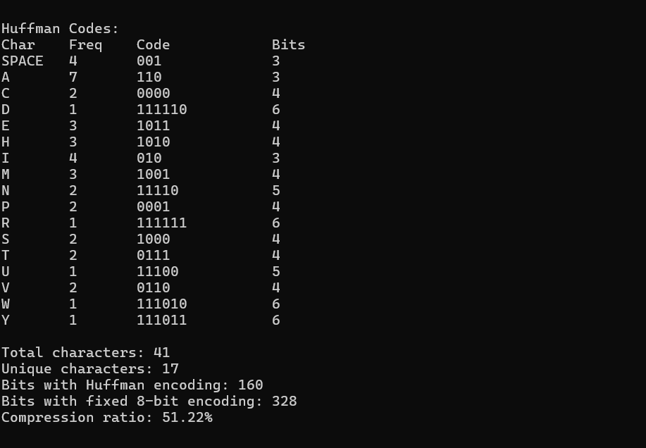

JOB SEQUENCE
#include <stdio.h>
#include <string.h>

#define MAX 100

typedef struct {
int id, profit, deadline;
} Job;

void swap(Job *a, Job *b) {
Job temp = *a;
*a = *b;
*b = temp;
}

void sortByProfit(Job jobs[], int n) {
for (int i = 0; i < n - 1; i++)
for (int j = 0; j < n - i - 1; j++)
if (jobs[j].profit < jobs[j + 1].profit)
swap(&jobs[j], &jobs[j + 1]);
}

void jobSequencing(Job jobs[], int n) {
sortByProfit(jobs, n);

int maxDeadline = 0;
for (int i = 0; i < n; i++)
if (jobs[i].deadline > maxDeadline)
maxDeadline = jobs[i].deadline;

int slot[MAX];
int result[MAX];
memset(slot, -1, sizeof(slot));

int totalProfit = 0, count = 0;

for (int i = 0; i < n; i++) {
for (int j = jobs[i].deadline - 1; j >= 0; j--) {
if (slot[j] == -1) {
slot[j] = i;
result[count++] = jobs[i].id;
totalProfit += jobs[i].profit;
break;
}
}
}

printf("Selected Jobs (in slot order):\n");
printf("Slot\tJob ID\tProfit\n");
for (int i = 0; i < maxDeadline; i++) {
if (slot[i] != -1)
printf("%d\tJ%d\t%d\n", i + 1, jobs[slot[i]].id, jobs[slot[i]].profit);
}
printf("\nTotal Profit: %d\n", totalProfit);
printf("Number of Jobs Scheduled: %d\n", count);
}

int main() {
Job jobs[] = {
{1, 36, 5},
{2, 21, 8},
{3, 28, 3},
{4, 19, 4},
{5, 21, 4},
{6, 13, 9},
{7, 28, 12},
{8, 25, 14},
{9, 18, 2},
{10, 20, 7},
{11, 27, 5},
{12, 22, 1},
{13, 14, 6},
{14, 26, 3}
};
int n = 14;

printf("Job Sequencing with Deadlines\n");
printf("==============================\n");
printf("Job\tProfit\tDeadline\n");
for (int i = 0; i < n; i++)
printf("J%d\t%d\t%d\n", jobs[i].id, jobs[i].profit, jobs[i].deadline);
printf("\n");

jobSequencing(jobs, n);

return 0;
}

