DESIGN AND ANALYSIS OF ALGORITHMS
Name: K. Jnanendra
Roll no: ch.sc.u4cse24217

- AVL TREES
#include <stdio.h>
#include <stdlib.h>

typedef struct Node {
int key;
struct Node *left, *right;
int height;
} Node;

int height(Node *n) {
return n ? n->height : 0;
}

int max(int a, int b) {
return a > b ? a : b;
}

int getBalance(Node *n) {
return n ? height(n->left) - height(n->right) : 0;
}

Node *newNode(int key) {
Node *node = (Node *)malloc(sizeof(Node));
node->key = key;
node->left = node->right = NULL;
node->height = 1;
return node;
}

Node *rotateRight(Node *y) {
Node *x = y->left;
Node *T2 = x->right;
x->right = y;
y->left = T2;
y->height = 1 + max(height(y->left), height(y->right));
x->height = 1 + max(height(x->left), height(x->right));
return x;
}

Node *rotateLeft(Node *x) {
Node *y = x->right;
Node *T2 = y->left;
y->left = x;
x->right = T2;
x->height = 1 + max(height(x->left), height(x->right));
y->height = 1 + max(height(y->left), height(y->right));
return y;
}

Node *insert(Node *node, int key) {
if (!node) return newNode(key);
if (key < node->key)
node->left = insert(node->left, key);
else if (key > node->key)
node->right = insert(node->right, key);
else
return node;

node->height = 1 + max(height(node->left), height(node->right));
int balance = getBalance(node);

if (balance > 1 && key < node->left->key)
return rotateRight(node);
if (balance < -1 && key > node->right->key)
return rotateLeft(node);
if (balance > 1 && key > node->left->key) {
node->left = rotateLeft(node->left);
return rotateRight(node);
}
if (balance < -1 && key < node->right->key) {
node->right = rotateRight(node->right);
return rotateLeft(node);
}
return node;
}

Node *minValueNode(Node *node) {
Node *current = node;
while (current->left)
current = current->left;
return current;
}

Node *deleteNode(Node *root, int key) {
if (!root) return root;
if (key < root->key)
root->left = deleteNode(root->left, key);
else if (key > root->key)
root->right = deleteNode(root->right, key);
else {
if (!root->left || !root->right) {
Node *temp = root->left ? root->left : root->right;
if (!temp) {
temp = root;
root = NULL;
} else
*root = *temp;
free(temp);
} else {
Node *temp = minValueNode(root->right);
root->key = temp->key;
root->right = deleteNode(root->right, temp->key);
}
}
if (!root) return root;

root->height = 1 + max(height(root->left), height(root->right));
int balance = getBalance(root);

if (balance > 1 && getBalance(root->left) >= 0)
return rotateRight(root);
if (balance > 1 && getBalance(root->left) < 0) {
root->left = rotateLeft(root->left);
return rotateRight(root);
}
if (balance < -1 && getBalance(root->right) <= 0)
return rotateLeft(root);
if (balance < -1 && getBalance(root->right) > 0) {
root->right = rotateRight(root->right);
return rotateLeft(root);
}
return root;
}

Node *search(Node *root, int key) {
if (!root || root->key == key) return root;
if (key < root->key) return search(root->left, key);
return search(root->right, key);
}

void inorder(Node *root) {
if (root) {
inorder(root->left);
printf("%d ", root->key);
inorder(root->right);
}
}

int main() {
Node *root = NULL;
int choice, key;

while (1) {
printf("\n1. Insert\n2. Delete\n3. Search\n4. Display (Inorder)\n5. Exit\nChoice: ");
scanf("%d", &choice);
switch (choice) {
case 1:
printf("Enter key: ");
scanf("%d", &key);
root = insert(root, key);
printf("Inserted %d\n", key);
break;
case 2:
printf("Enter key: ");
scanf("%d", &key);
root = deleteNode(root, key);
printf("Deleted %d\n", key);
break;
case 3:
printf("Enter key: ");
scanf("%d", &key);
printf(search(root, key) ? "Found %d\n" : "%d not found\n", key);
break;
case 4:
printf("Inorder: ");
inorder(root);
printf("\n");
break;
case 5:
exit(0);
}
}
return 0;
}

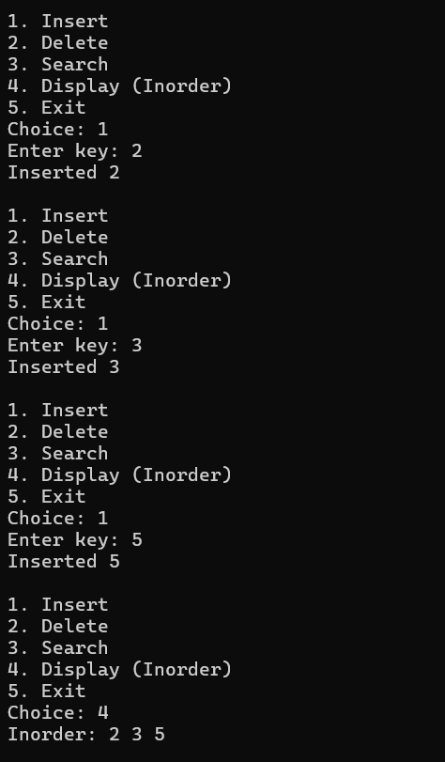

RED BLACK TREE
#include <stdio.h>
#include <stdlib.h>

#define RED 0
#define BLACK 1

typedef struct Node {
int key, color;
struct Node *left, *right, *parent;
} Node;

Node *NIL;

void initNIL() {
NIL = (Node *)malloc(sizeof(Node));
NIL->color = BLACK;
NIL->left = NIL->right = NIL->parent = NULL;
}

Node *newNode(int key) {
Node *node = (Node *)malloc(sizeof(Node));
node->key = key;
node->color = RED;
node->left = node->right = node->parent = NIL;
return node;
}

void rotateLeft(Node **root, Node *x) {
Node *y = x->right;
x->right = y->left;
if (y->left != NIL) y->left->parent = x;
y->parent = x->parent;
if (x->parent == NIL) *root = y;
else if (x == x->parent->left) x->parent->left = y;
else x->parent->right = y;
y->left = x;
x->parent = y;
}

void rotateRight(Node **root, Node *x) {
Node *y = x->left;
x->left = y->right;
if (y->right != NIL) y->right->parent = x;
y->parent = x->parent;
if (x->parent == NIL) *root = y;
else if (x == x->parent->right) x->parent->right = y;
else x->parent->left = y;
y->right = x;
x->parent = y;
}

void insertFix(Node **root, Node *z) {
while (z->parent->color == RED) {
if (z->parent == z->parent->parent->left) {
Node *y = z->parent->parent->right;
if (y->color == RED) {
z->parent->color = BLACK;
y->color = BLACK;
z->parent->parent->color = RED;
z = z->parent->parent;
} else {
if (z == z->parent->right) {
z = z->parent;
rotateLeft(root, z);
}
z->parent->color = BLACK;
z->parent->parent->color = RED;
rotateRight(root, z->parent->parent);
}
} else {
Node *y = z->parent->parent->left;
if (y->color == RED) {
z->parent->color = BLACK;
y->color = BLACK;
z->parent->parent->color = RED;
z = z->parent->parent;
} else {
if (z == z->parent->left) {
z = z->parent;
rotateRight(root, z);
}
z->parent->color = BLACK;
z->parent->parent->color = RED;
rotateLeft(root, z->parent->parent);
}
}
}
(*root)->color = BLACK;
}

void insert(Node **root, int key) {
Node *z = newNode(key);
Node *y = NIL, *x = *root;
while (x != NIL) {
y = x;
if (z->key < x->key) x = x->left;
else if (z->key > x->key) x = x->right;
else { free(z); return; }
}
z->parent = y;
if (y == NIL) *root = z;
else if (z->key < y->key) y->left = z;
else y->right = z;
insertFix(root, z);
}

void transplant(Node **root, Node *u, Node *v) {
if (u->parent == NIL) *root = v;
else if (u == u->parent->left) u->parent->left = v;
else u->parent->right = v;
v->parent = u->parent;
}

Node *minimum(Node *x) {
while (x->left != NIL) x = x->left;
return x;
}

void deleteFix(Node **root, Node *x) {
while (x != *root && x->color == BLACK) {
if (x == x->parent->left) {
Node *w = x->parent->right;
if (w->color == RED) {
w->color = BLACK;
x->parent->color = RED;
rotateLeft(root, x->parent);
w = x->parent->right;
}
if (w->left->color == BLACK && w->right->color == BLACK) {
w->color = RED;
x = x->parent;
} else {
if (w->right->color == BLACK) {
w->left->color = BLACK;
w->color = RED;
rotateRight(root, w);
w = x->parent->right;
}
w->color = x->parent->color;
x->parent->color = BLACK;
w->right->color = BLACK;
rotateLeft(root, x->parent);
x = *root;
}
} else {
Node *w = x->parent->left;
if (w->color == RED) {
w->color = BLACK;
x->parent->color = RED;
rotateRight(root, x->parent);
w = x->parent->left;
}
if (w->right->color == BLACK && w->left->color == BLACK) {
w->color = RED;
x = x->parent;
} else {
if (w->left->color == BLACK) {
w->right->color = BLACK;
w->color = RED;
rotateLeft(root, w);
w = x->parent->left;
}
w->color = x->parent->color;
x->parent->color = BLACK;
w->left->color = BLACK;
rotateRight(root, x->parent);
x = *root;
}
}
}
x->color = BLACK;
}

void deleteNode(Node **root, int key) {
Node *z = *root;
while (z != NIL) {
if (key == z->key) break;
else if (key < z->key) z = z->left;
else z = z->right;
}
if (z == NIL) { printf("%d not found\n", key); return; }

Node *y = z, *x;
int yOrigColor = y->color;
if (z->left == NIL) {
x = z->right;
transplant(root, z, z->right);
} else if (z->right == NIL) {
x = z->left;
transplant(root, z, z->left);
} else {
y = minimum(z->right);
yOrigColor = y->color;
x = y->right;
if (y->parent == z) x->parent = y;
else {
transplant(root, y, y->right);
y->right = z->right;
y->right->parent = y;
}
transplant(root, z, y);
y->left = z->left;
y->left->parent = y;
y->color = z->color;
}
free(z);
if (yOrigColor == BLACK) deleteFix(root, x);
}

Node *search(Node *root, int key) {
if (root == NIL || root->key == key) return root;
if (key < root->key) return search(root->left, key);
return search(root->right, key);
}

void inorder(Node *root) {
if (root != NIL) {
inorder(root->left);
printf("%d(%s) ", root->key, root->color == RED ? "R" : "B");
inorder(root->right);
}
}

int main() {
initNIL();
Node *root = NIL;
int choice, key;

while (1) {
printf("\n1. Insert\n2. Delete\n3. Search\n4. Display (Inorder)\n5. Exit\nChoice: ");
scanf("%d", &choice);
switch (choice) {
case 1:
printf("Enter key: ");
scanf("%d", &key);
insert(&root, key);
printf("Inserted %d\n", key);
break;
case 2:
printf("Enter key: ");
scanf("%d", &key);
deleteNode(&root, key);
break;
case 3:
printf("Enter key: ");
scanf("%d", &key);
printf(search(root, key) != NIL ? "Found %d\n" : "%d not found\n", key);
break;
case 4:
printf("Inorder: ");
inorder(root);
printf("\n");
break;
case 5:
exit(0);
}
}
return 0;
}

