DAA LAB ASSIGNMENT
WEEK-1
NAME: K. JNANENDRA
ROLL NO: CH.SC.U4CSE24217

- SUM OF FIRST N NATURAL NUMBERS

CODE:
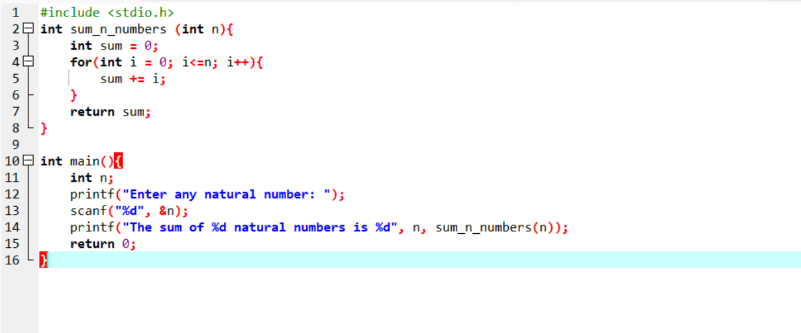

OUTPUT:
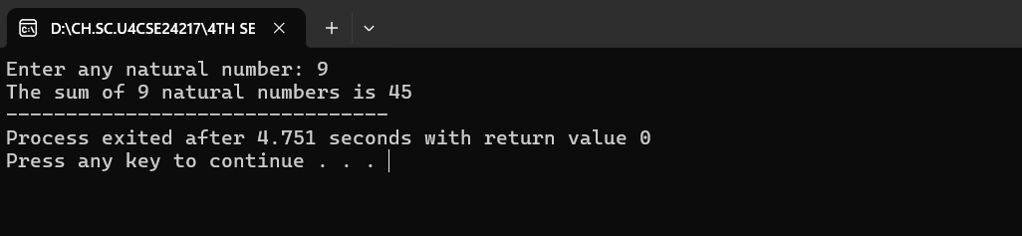

Interpretation: I declared a variable sum initialized to 0. Then I used a for loop from 1 to n adding i to sum each iteration. This directly computes the desired total.

Time complexity: O(n) — single loop over n elements.
Space complexity: O(1).
- SUM OF SQUARES OF FIRST N NATURAL NUMBERS

CODE:
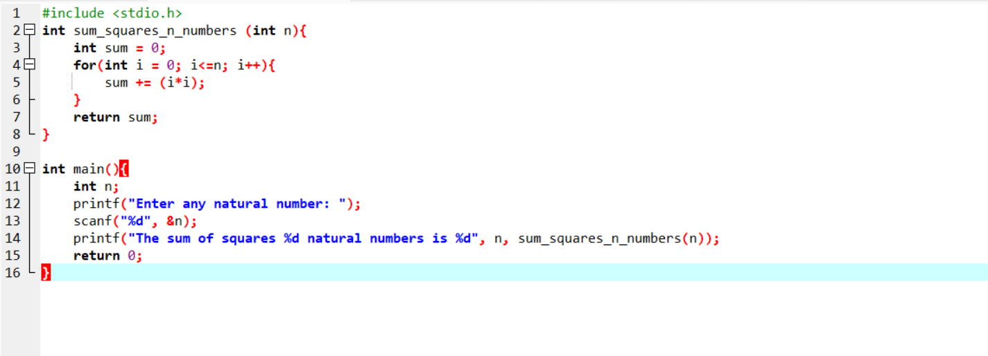
OUTPUT:
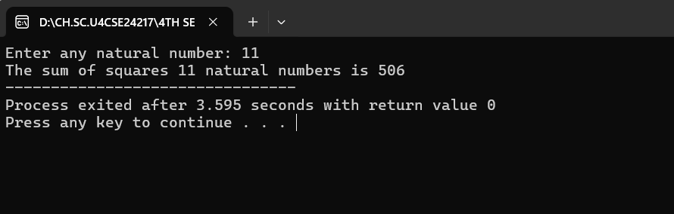

Interpretation: Similar to the previous problem, but this time I used a loop and added i*i each iteration into sum.

Time complexity: O(n).
Space complexity: O(1).

- SUM OF CUBES OF FIRST N NATURAL NUMBERS

CODE:
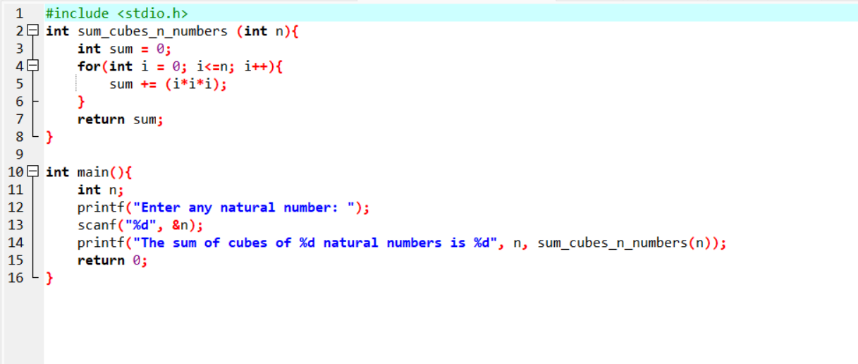

OUTPUT:

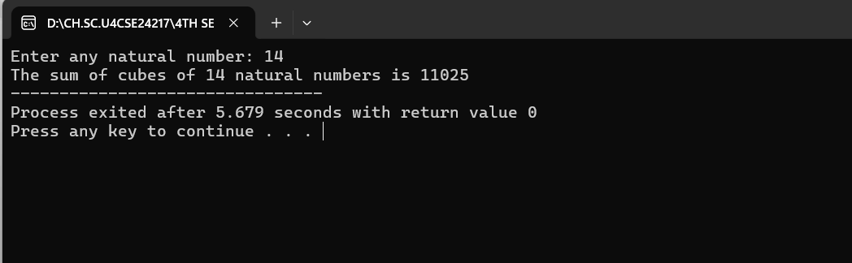

Interpretation: Same approach as previous problems but adding i*i*i.

Time complexity : O(n).
Space complexity: O(1).

- FACTORIAL OF A NUMBER USING RECURSION

CODE:
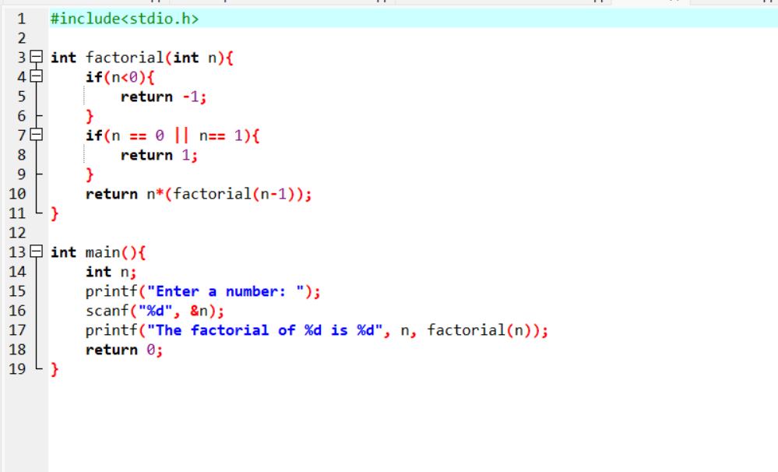
OUTPUT:
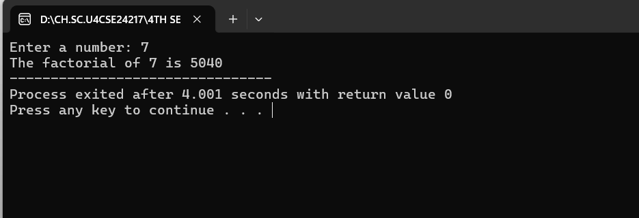

Interpretation: The recursive function factorial returns 1 for n <= 1 (base case) and otherwise returns n * factorial(n-1).

Time complexity: O(n)

Space complexity: O(n)

- TRANSPOSE OF A MATRIX

CODE:
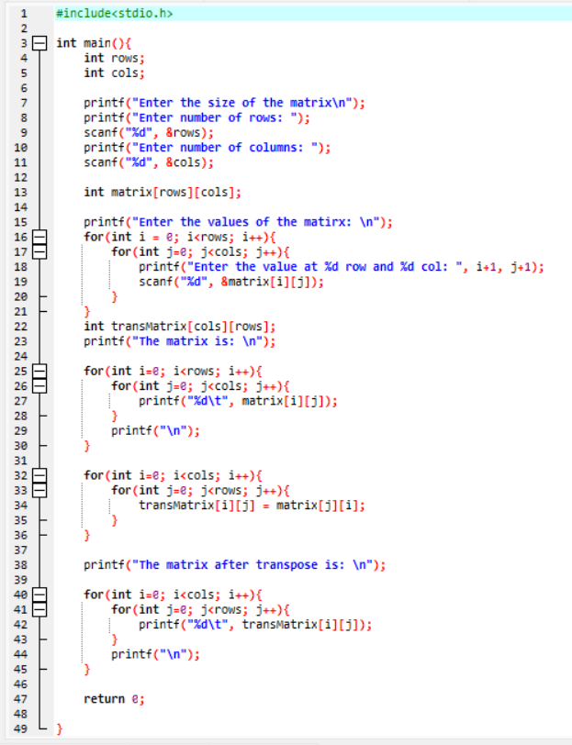

OUTPUT:
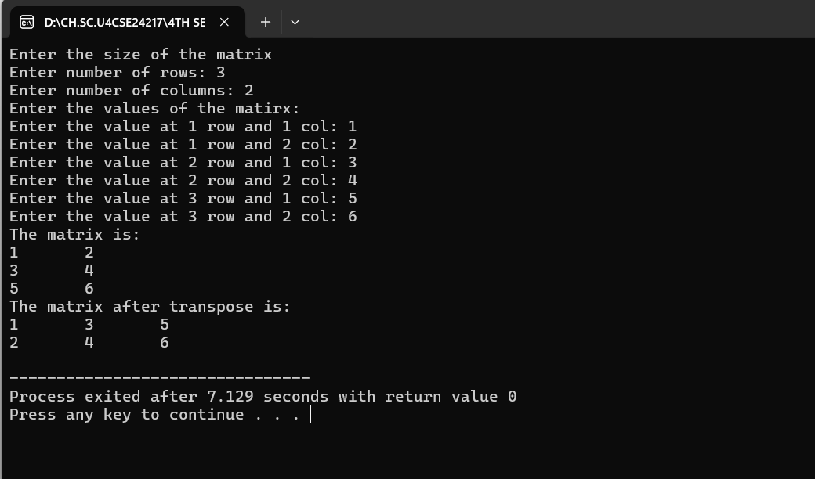

Interpretation: First we read the number oof rows and colums for the matrix and also read the values for it, and then create another matrix with the opposite dimensions, and add values to it as a[i][j] -> b[j][i]
using nested loops

Time Complexity: O(mn). Where m = no of rows, n= no of columns

Space Complexity: O(mn).

- FIBONACCI SERIES UPTO A GIVEN NUMBER

CODE:
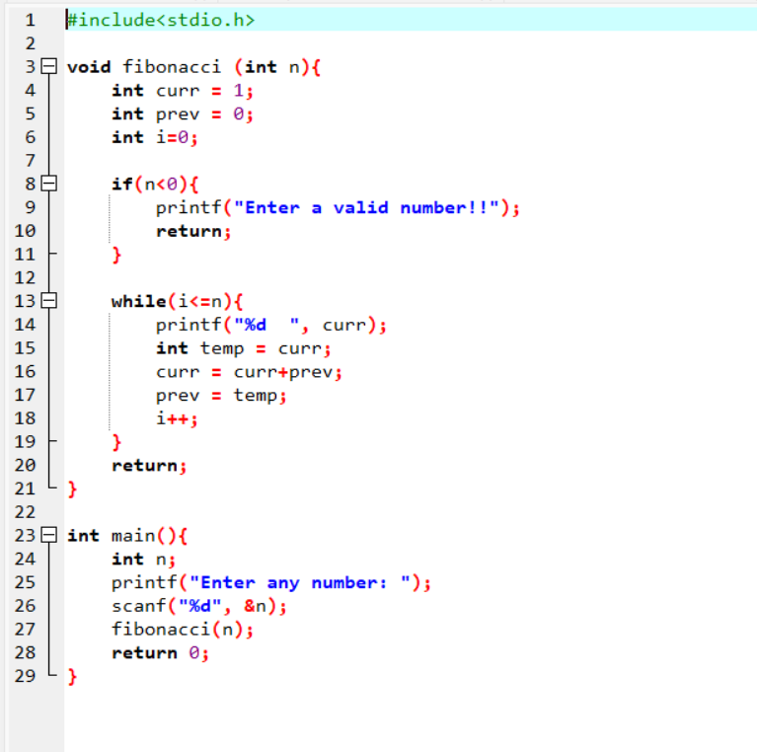
OUTPUT:
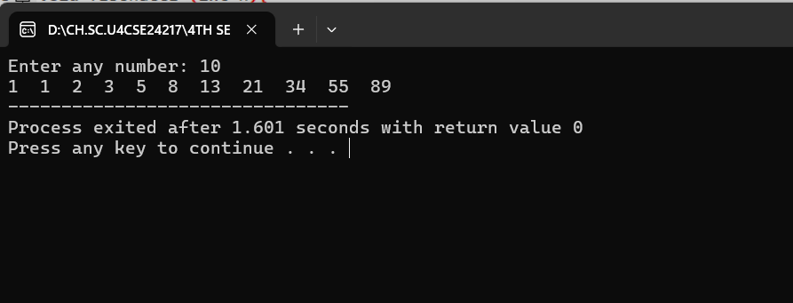

Interpretation: Start with prev = 0, and curr = 1 when i=0, and print the number while updating the previous and current variables as curr = curr + prev, and prev = curr.
Time Complexity: O(n) Space Complexity: O(1)

