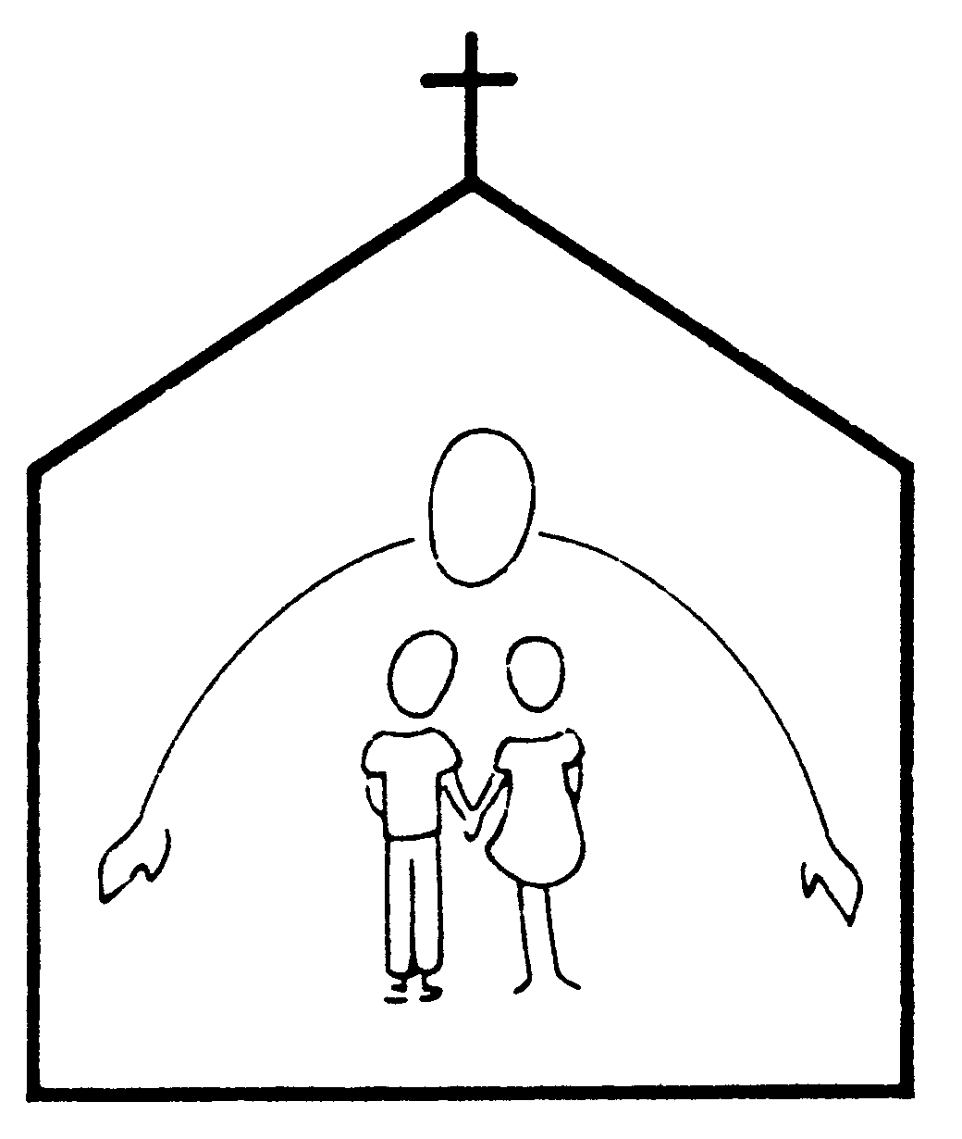
ELP Enrollment Information 2013-2014
Child's Full Name |  |  |  |  |  |  |  |  |  |  |  |  | (please circle)
Child's Full Name |  |  |  |  |  |  |  |  |  |  |  |  | Boy |  | Girl
Name to be called in class: |  |  |  |  |  |  |  |  |  | Date of Birth:
 | (please circle)
Child speaks English: | fluently |  |  |  |  | a little |  | not at all |  | Language(s) at home:
Mailing Address:
Mother’s Name: |  |  |  |  |  |  |  |  | Home Phone:
Address: |  |  |  |  |  |  |  |  | Cell Phone:
Same as above |  |  |  |  |  |  |  |  | Work Phone:
Employer: |  |  |  |  |  |  |  |  | e-mail:
*Work addresses must be supplied per licensing requirements.
Father’s Name: |  |  |  |  |  |  |  |  | Home Phone:
Address: |  |  |  |  |  |  |  |  | Cell Phone:
Same as above |  |  |  |  |  |  |  |  | Work Phone:
Employer: |  |  |  |  |  |  |  |  | e-mail:
Other children in the family or other persons living in the household (names and ages):
 |  | (please circle)
Diagnosed Allergies: |  | Yes |  |  |  | No |  | Type
If yes, additional paperwork is required. Please see the office.
Response Required: |  | None |  |  |  | Epi-Pen |  | Other
Pertinent Developmental/ Chronic Physical Information (e.g., premature birth, health concerns, vision, ADHD, etc.)
 |  |  | (please circle)
Does child have an IEP? |  |  | Yes |  |  | No | If yes, please provide the office with a copy
Special accommodations we should be aware of:
Previous or current child daycare programs or schools attended:
If any information changes, please notify the office immediately
Please complete and sign other side*

CHILD'S NAME: ________________________________________________________

The registration fee must be returned with Registration Form and Application for Enrollment. Without exception, if offered a place in the school the registration, activity fee and first tuition payment are nonrefundable. The activity fee and first (September) tuition payment are due March 1, 2013 for families new to Emmanuel. For returning families (a child is current enrolled at ELP), the activity fee and first (September) tuition payment are due May 1, 2013. Tuition received after the 5th of that month will be deemed late and will incur a $20 late fee. If your first payment is not received by the 15th, we will not be able to hold the place for your child. The next monthly tuition payment is due September 1. As long as the child is enrolled, tuition must be paid whether or not the child is in attendance. Tuition refunds for other months must be requested through the Emmanuel Lutheran Preschool Board at a regularly scheduled meeting. They may be granted only if the space is filled with no loss in revenue to the school. The Health Form, Emergency Authorization Form, and proof of identity shown to the registrar (birth certificate or passport) are required by the Commonwealth of Virginia and Fairfax County. Your child will not be able to begin school without the completed forms. The Health form should be updated should your child receive additional vaccines. It is understood that EMMANUEL LUTHERAN PRESCHOOL will not be responsible for any illness that the child named on the Registration Form may contract. The preschool will notify the parent as soon as possible if the child becomes ill. It is also understood that parents will notify the preschool when any member of the household is sick with a contagious illness as this is a Virginia State Licensing requirement.

I hereby give my consent to EMMANUEL LUTHERAN PRESCHOOL or anyone on its behalf to secure and provide any medical or other attention that is necessary or urgent, and I further agree to pay for any medical or any other expenses incurred on behalf of the above named child. EMMANUEL LUTHERAN PRESCHOOL is insured with Brotherhood Mutual Insurance Co. of National Church Group Insurance Agency, Inc.; P.O. Box 4480; Leesburg, VA 22075.

We agree to abide by all rules and guidelines set out in the ELP Parent Handbook. It is understood that each child must be completely toilet-trained for the 3- and 4-year-old classes. It is also agreed that if it is found that the child fails to cooperate satisfactorily with the school program, or if tuition payments fall two (2) months in arrears, said child's name will be withdrawn from ELP enrollment. EMMANUEL LUTHERAN PRESCHOOL does not discriminate on the basis of race, color, religion, national or ethnic origin. It is also agreed that all applications for enrollment in EMMANUEL LUTHERAN PRESCHOOL are subject to the approval of the ELP Board.
Release of Information: |  |  |  |  |  |  | (Please circle)
Permission to photograph my child during school activities |  |  |  |  |  |  | Yes |  |  |  | No
Permission to share photographs with class/school |  |  |  |  |  |  | Yes |  |  |  | No
Permission to share mailing address with other parents |  |  |  |  |  |  | Yes |  |  |  | No
Permission to share home (or cell when no home) number with other parents |  |  |  |  |  |  | Yes |  |  |  | No
We understand our total financial commitment for the 2013-2014 school year is: |  |  |  |  | (Please complete this section)
Monthly Tuition* | $ |  |  | X9 months |  | $
Registration Fee |  |  |  |  |  | $
*$30 per month discount for each  additional student |  |  | One-Time Activity Fee |  |  | $
 |  |  | Total Yearly Financial Commitment |  |  | $
➔Parent Signature |  |  |  |  |  |  |  |  | Date
*******************************************************************************************************
OFFICE USE ONLY
Identity Verification
(as required by VA Dept of Social Services, Div of Licensing)
Proof of the child's identity and age may include a certified copy of the child's birth certificate, birth registration card, notification of birth (hospital, physician or midwife record), passport, copy of the placement agreement or other proof of the child's identity from a child placing agency, record from a public school in Virginia, or certification by a principal or his designee of a public school in the U.S. that a certified copy of the child's birth record was previously presented. While programs are not required to keep the proof of the child's identity, documentation of viewing this information must be maintained for each child.
Birth Certificate Number # |  | Child’s Full Name
Date of Birth |  | Boy | Girl
Place of Birth |  | Date Filed/ Issued:

Last updated 11/27/12

