**ELP Enrollment Information 2014-2015**

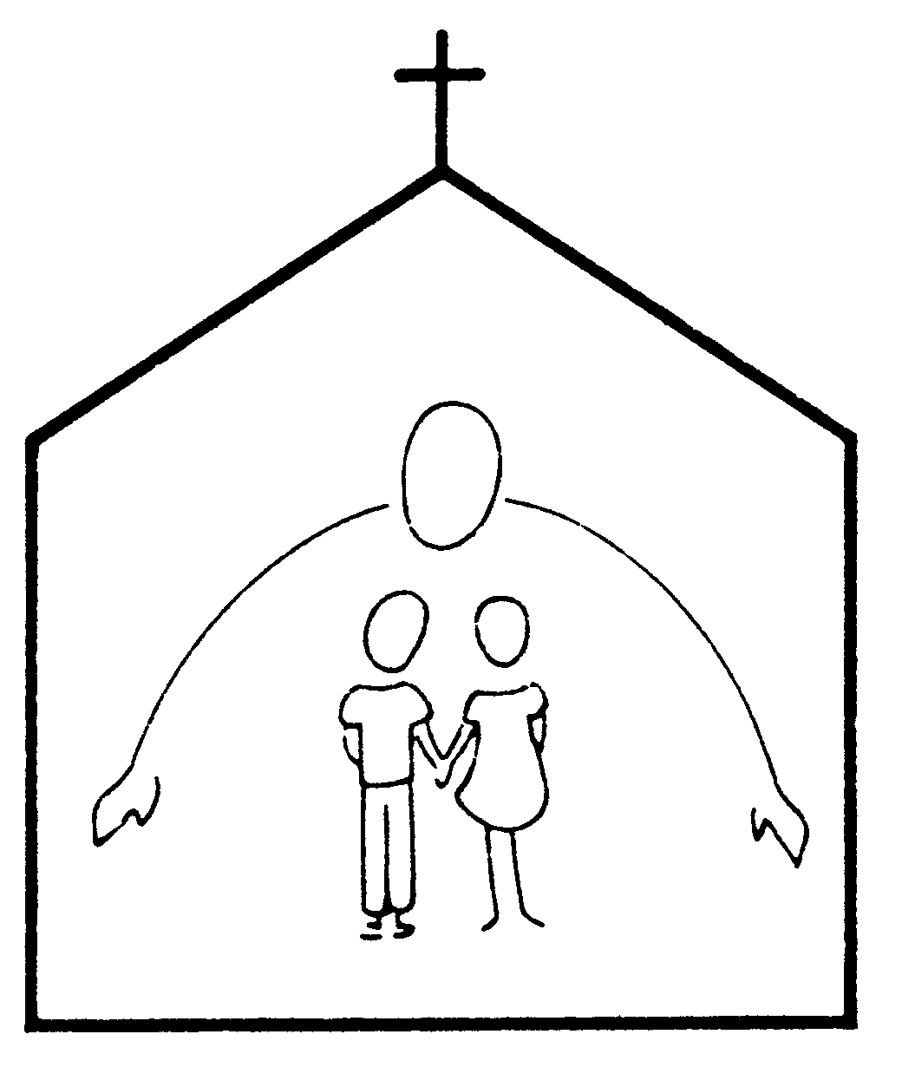

|  |  |  |  |  |  |  |  |  |  |  |  |  |  |  |  |
| --- | --- | --- | --- | --- | --- | --- | --- | --- | --- | --- | --- | --- | --- | --- | --- |
| Child's Full Name |  | | | | | | | | | | | | (please circle) | | |
| Boy | | Girl |
| Name to be used in preschool: | | | |  | | | | | | Date of Birth: | | |  | | |
|  |  | | | | | | | | |  | | | |  | |
|  | (please circle) | | | | | | | | |  | | | |  | |
| Child speaks English: | fluently | | | | | a little | | not at all | | Language(s) at home: | | | |  | |
| Mailing Address: |  | | | | | | | | | | | | | | |
|  | | | | | | | | | | | | | | |
|  |  | | | | | | | | |  | | | |  | |
|  |  | | | | | | | |  | | | | | | |
| **Mother’s** Name: |  | | | | | | | | Home Phone: | | |  | | | |
| Address: |  | | | | | | | | Cell Phone: | | |  | | | |
| Same as above |  | | | | | | | | Work Phone: | | |  | | | |
| Employer: |  | | | | | | | | e-mail: | | |  | | | |
|  |  | | | | | | | |  | | |  | | | |
|  |  | | | | | | | |  | | |  | | | |
| **\*Work addresses must be supplied per licensing requirements.** |  | | | | | | | |  | | |  | | | |
| **Father’s** Name: |  | | | | | | | | Home Phone: | | |  | | | |
| Address: |  | | | | | | | | Cell Phone: | | |  | | | |
| Same as above |  | | | | | | | | Work Phone: | | |  | | | |
| Employer: |  | | | | | | | | e-mail: | | |  | | | |
|  |  | | | | | | | |  | | |  | | | |
| Other children in the family or other persons living in the household (names and ages): | | | | | | | |  | | | | | | | |
|  | | | | | | | |  | | | | | | | |
|  | | (please circle) | | | | | |  | | | | | | | |
| Diagnosed Allergies: | | Yes | | | | No | | Type | | |  | | | | |
| If yes, additional paperwork from physician is required. Please see the office. | | | | | | | | | | | | | | | |
| Response Required: | | None | | | | Epi-Pen | | Other | | |  | | | | |
| Pertinent Developmental/ Chronic Physical Information (*e.g.*, premature birth, health concerns, vision, ADHD, etc.) | | | | |  | | | | | | | | | | |
|  | | | | | | | | | | |
|  | | | (please circle) | | | |  | | | | | | | | |
| Does child have an IEP? | | | Yes | | | No | If yes, please provide the office with a copy | | | | | | | | |
| Special accommodations we should be aware of: | | | | | | |  | | | | | | | | |
| Previous or current child daycare programs or schools attended: | | | | | | |  | | | | | | | | |
|  | | | | | | |  | | | | | | | | |

***If any information changes, please notify the office immediately***

Please complete and sign other side*

**CHILD'S NAME: ________________________________________________________**

The registration fee must be returned with Registration Form and Application for Enrollment. Our preschool tuition is divided into 9 equal monthly payments. **If accepted, a non-refundable deposit of one month’s tuition and your child’s activity fee must be received to hold your child’s spot in our program.** For families that are new to our school your tuition payment and activity fee is due by March 2014 and for currently enrolled families by May 2014. Your deposit will be credited in our tuition accounts as your child(rens) May 2015 tuition. Tuition is then paid monthly beginning September 1 for September, October 1, for October, and so on. Your final payment for the year will be April 1st for April. Tuition received after the 6th of the month will be deemed late and will incur a $40 late fee. Tuition received after the 10th will incur a $80 total late fee. If your first payment is not received by the 15th including all late fees, we will not be able to hold the place for your child. As long as the child is enrolled, tuition must be paid whether or not the child is in attendance. **The Health Form, Emergency Authorization Form, and proof of identity shown to the registrar (birth certificate or passport) are required by the Commonwealth of Virginia and Fairfax County.** Your child will not be able to begin school without the completed forms. The Health form should be updated should your child receive additional vaccines. It is understood that EMMANUEL LUTHERAN PRESCHOOL will not be responsible for any illness that the child named on the Registration Form may contract. The preschool will notify the parent as soon as possible if the child becomes ill. It is also understood that parents will notify the preschool when any member of the household is sick with a contagious illness as this is a Virginia State Licensing requirement. Without exception, if offered a place in the school the registration, activity fee and first tuition payment are nonrefundable. I hereby give my consent to EMMANUEL LUTHERAN PRESCHOOL or anyone on its behalf to secure and provide any medical or other attention that is necessary or urgent, and I further agree to pay for any medical or any other expenses incurred on behalf of the above named child. EMMANUEL LUTHERAN PRESCHOOL is insured with Brotherhood Mutual Insurance Co. of National Church Group Insurance Agency, Inc.; P.O. Box 4480; Leesburg, VA 22075.

We agree to abide by all rules and guidelines set out in the ELP Parent Handbook. It is understood that each child must be completely toilet-trained for the 3- and 4-year-old classes. It is also agreed that if it is found that the child fails to cooperate satisfactorily with the school program, or if tuition payments fall two (2) months in arrears, said child will be withdrawn from ELP enrollment. EMMANUEL LUTHERAN PRESCHOOL does not discriminate on the basis of race, color, religion, national or ethnic origin. It is also agreed that all applications for enrollment in EMMANUEL LUTHERAN PRESCHOOL are subject to the approval of the ELP Board.

|  |  |  |  |  |  |  |  |  |  |  |
| --- | --- | --- | --- | --- | --- | --- | --- | --- | --- | --- |
| **Release of Information:** | | | | | | (Please circle) | | | | |
| Permission to photograph my child during school activities | | | | | | Yes | | No | | |
| Permission to share photographs with class/school (including our closed Facebook group) | | | | | | Yes | | No | | |
| Permission to share mailing address with other parents | | | | | | Yes | | No | | |
| Permission to share home (or cell when no home) number with other parents | | | | | | Yes | | No | | |
|  | | | | | | | |  | | | |
| **We understand our total financial commitment for the 2014-2015 school year is:** | | | | | | **(Please complete this section)** | | | | | |
|  |  |  | |  | | |  |  | | |  |
| Monthly Tuition* | $ |  | | X9 months | | | $ |  | | |  |
| Registration Fee | | | | | | | $ |  | | |  |
| *$30 per month discount for each  additional student | | | One-Time Activity Fee | | | | $ |  | | |  |
| **Total Yearly Financial Commitment** | | | | $ |  | | |  |
|  | | | | | | | | |  | | |
| **🡺Parent Signature** | | | | | | | | | **Date** | | |

*******************************************************************************************************

**OFFICE USE ONLY**

**Identity Verification**

**(as required by VA Dept of Social Services, Div of Licensing)**

Proof of the child's identity and age may include a certified copy of the child's birth certificate, birth registration card, notification of birth (hospital, physician or midwife record), passport, copy of the placement agreement or other proof of the child's identity from a child placing agency, record from a public school in Virginia, or certification by a principal or his designee of a public school in the U.S. that a certified copy of the child's birth record was previously presented. While programs are not required to keep the proof of the child's identity, documentation of viewing this information must be maintained for each child.

|  |  |  |  |  |
| --- | --- | --- | --- | --- |
| Birth Certificate Number # |  | Child’s Full Name | |  |
| Date of Birth |  | Boy | Girl |  |
| Place of Birth |  | Date Filed/ Issued: | |  |