1. Innhold

Now I'm adding a LOT of text and a picture! 2

Now I'm adding a LOT of text and a picture! 2

Now I'm adding a LOT of text and a picture! 2

This is a GitHubtest!

Now I'm adding a LOT of text and a picture!

Now I'm adding a LOT of text and a picture!

# Now I'm adding a LOT of text and a picture!

Now I'm adding a LOT of text and a picture! Now I'm adding a LOT of text and a picture!

Now I'm adding a LOT of text and a picture!

Now I'm adding a LOT of text and a picture!

Now I'm adding a LOT of text and a picture!

Now I'm adding a LOT of text and a picture! Now I'm adding a LOT of text and a picture!

## Now I'm adding a LOT of text and a picture!

Now I'm adding a LOT of text and a picture!

### Now I'm adding a LOT of text and a picture!

Now I'm adding a LOT of text and a picture!

Now I'm adding a LOT of text and a picture!

Now I'm adding a LOT of text and a picture!

Now I'm adding a LOT of text and a picture!

Now I'm adding a LOT of text and a picture!

Now I'm adding a LOT of text and a picture! Now I'm adding a LOT of text and a picture!

Now I'm adding a LOT of text and a picture! Now I'm adding a LOT of text and a picture! Now I'm adding a LOT of text and a picture! Now I'm adding a LOT of text and a picture! Now I'm adding a LOT of text and a picture!

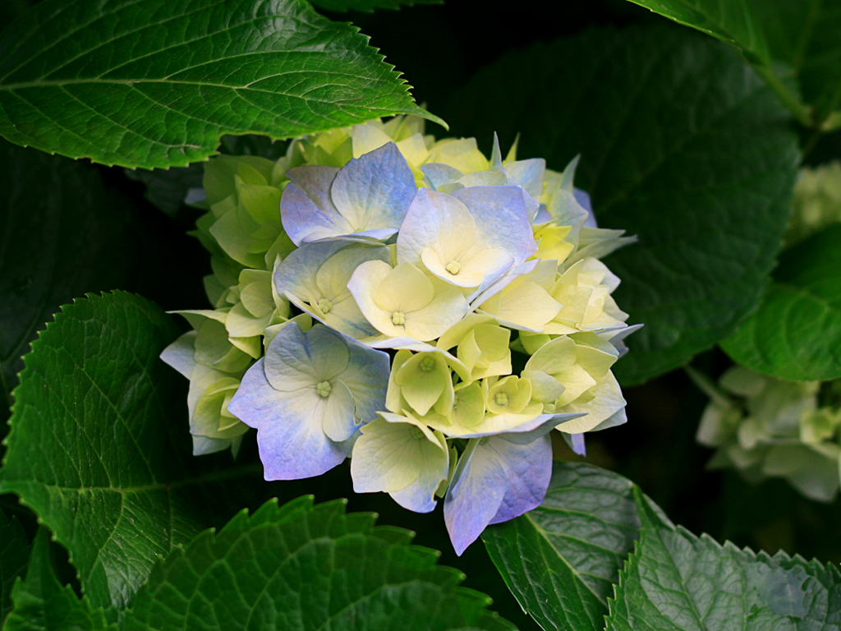

Figure 1: Picturetext

Text underneath picture!