Methods

Data

We downloaded phenology data from the National Ecological Observatory Network (NEON) Data Portal (data.neonscience.org) on March 19, 2018. Data consisted of 301,359 phenology observations of XXX individuals from 42 different sites in the continental U.S. between 2013 and 2018. [MAP] [Supplemental summary table]

NEON phenology data are collected according to a systematic protocol across all sites [REF] and consist of regular observations of individual plants by ground observers. Specified phenology states (e.g. open flowers, emerging needles) are recorded as present or absent, depending on the growth form of the species. For certain phenology states, a binned “status intensity” is also recorded; it describes the degree to which a phenology state is present and recorded. For example, a deciduous tree may have 5-24% of its canopy leaves remaining during one autumn observation.

We defined seven phenophase transition dates using the phenology states recorded in the NEON data (Table A). In particular, we differentiated between two regimes of phenology data collection, as specified in the NEON protocol: sites with an annual dormant season during which data collection ceases (“seasonal”) and sites that collect data year-round (“ongoing”). We assessed the collection regime at each site using data visualization, and treated sites that were unclear as seasonal sites (Table SA). At ongoing sites without a clear and regular dormant season, phenology states can carry over from one year to the next. To account for this, we considered a portion of the beginning of a year to be a continuation of the previous year for the definition of “All leaves shed.” The duration of each beginning-of-year portion was assessed visually on a site-by-site basis (Table SA).

Table A: Definitions of phenophase transition dates
Phenophase Transition | Definition
New growth start | Seasonal sites: The date of first ‘yes’ in a year for the earliest of “breaking buds”, “emerging needles”, “initial growth”, “increasing leaf size”, “young leaves” and “young needles”. This first ‘yes’ must be preceded by a ‘no’, otherwise new growth start is considered ‘missed’. If this first ‘yes’ is followed by three successive ‘no’s, it is ignored and the first ‘yes’ that is not followed by three successive ‘no’s is considered the date of new growth start.
 | Ongoing sites: Same as for seasonal sites, except the date of first ‘yes’ must be preceded by three successive ‘no’s instead of a single ‘no’.
New growth end | Seasonal sites: The date of last ‘yes’ in a year for the latest of “breaking buds”, “emerging needles”, “initial growth”, “increasing leaf size”, “young leaves” and “young needles”. This last ‘yes’ must be followed by a ‘no’, otherwise new growth end is considered ‘missed’. If this final ‘yes’ is preceded by three successive ‘no’s, it is ignored and the last ‘yes’ that is not preceded by three successive ‘no’s is considered the date of new growth end.
 | Ongoing sites: Same as for seasonal sites, except the date of last ‘yes’ must be followed by three successive ‘no’s instead of a single ‘no’.
First color | Seasonal sites: The date of first ‘yes’ in a year for “colored leaves” or “colored needles”. This first ‘yes’ must be preceded by a ‘no’, otherwise the start of new growth is considered ‘missed’. If this first ‘yes’ is followed by three successive ‘no’s, it is ignored and the first ‘yes’ that is not followed by three successive ‘no’s is considered the date of start of new growth.
 | Ongoing sites: Same as for seasonal sites, except the date of first ‘yes’ must be preceded by three successive ‘no’s instead of a single ‘no’.
Leaves shed end | Seasonal sites: The date of first ‘yes’ with an intensity of “<5%” or ‘no’ for “leaves” or “needles” such that all following observations in that year are also a ‘yes’ with intensity “<5%” or ‘no’. This date must be preceded by a ‘yes’ with an intensity other than “<5%”. If the last observation is a ‘yes’ with an intensity other than “<5%”, leaves shed end is considered missed.
 | Ongoing sites: Same as for seasonal sites, except that an additional period of time may be considered at the start of the following year. See Table SA
First flower | The date of first ‘yes’ in a year for “open flowers” or “open pollen cones.” This first ‘yes’ must be preceded by a ‘no’, otherwise first flower is considered ‘missed’.
Last flower | The date of last ‘yes’ in a year for “open flowers” or “open pollen cones.” This last ‘yes’ must be followed by a ‘no’, otherwise last flower is considered ‘missed’.
Peak flower | The median date of all recorded observations of “open flowers” or “open pollen cones” with the highest intensity value for the year. If the median is a half-day, it is rounded down to the nearest day.

In addition to phenology observations, the NEON data contained metadata for each of the observed individuals. These metadata included location, elevation, species identification, and growth form. Location was given relative to the 400 m square transect along which phenology measurements are made at each site. Specifically, the distance along the transect, the direction from the transect (left or right) and the distance from the transect were provided [REF protocol]. We converted these measurements into a GPS location for each individual, to the nearest meter. Growth forms in the dataset consisted of “Deciduous broadleaf,” “Drought deciduous broadleaf,” “Semi-evergreen broadleaf,” “Evergreen broadleaf,” “Evergreen conifer,” “Pine,” “Forb,” and “Graminoid.”

Uncertainty in phenophase transition dates due to observation regime

NEON phenology data are collected by ground observers on a regular basis, ranging from one observation every other week to multiple observations per week. Because the observations are not daily, the exact date that an individual plant transitioned from one phenophase to another is uncertain, but can be bounded by successive observation dates. For example, if a plant is observed to be not flowering on one day, but is flowering three days later, then we know that the plant flowered sometime between the two observation dates. In this case, we consider the uncertainty due to observation regime to be three days.

For each observed phenophase transition date, we calculated its uncertainty (Table B). Because the protocols specify that successive observations should occur no less frequently than every other week, we discarded as anomalous transition dates with uncertainties greater than 32 days (Monday to the Friday four weeks following) for “peak flower,” and greater than 18 days (Monday to the Friday two weeks following) for all other transitions. These transitions with very large uncertainties remained discarded for all analyses.

Table B: Definition of uncertainty for each type of phenophase transition
Phenophase Transition
New growth start | The difference in days between the date of new growth start and the preceding ‘no’
New growth end | The difference in days between the date of new growth end and the following ‘no’
First color | The difference in days between the date of first color and the preceding ‘no’
Leaves shed end | The difference in days between the date of leaves shed end and the preceding observation
First flower | The difference in days between the date of first flower and the preceding ‘no’
Last flower | The difference in days between the date of last flower and the following ‘no’
Peak flower | The difference in days between the observation date immediately preceding peak flower and the observation date immediately following peak flower

To get a sense of the overall uncertainty of individuals in the dataset, we constructed a hierarchical Bayesian model that we ran for each transition type. The model partially pools across groups of individuals of the same species at the same site (site-species). This partial pooling allows us to partition the model variance between variance in uncertainty due to individuals and variance in uncertainty due to the specifics of observation regime for particular site-species groups. If observations at specific sites or of specific species result in large uncertainties relative to others, the variance due to site-species will be large relative to variance due to individuals and would suggest further investigation to understand which sites and/or species have large uncertainties and why.

Mathematically, the model can be described as:
$$δ_{i}=μ+γ_{site-sp-yr\left(i\right)}+β_{i}$$
$$γ_{site-sp} \sim N(0,τ^{2})$$
$$β_{i} \sim N(0,σ^{2})$$
where δ_{i} is the uncertainty for individual i; µ is the overall estimated mean uncertainty across all individuals; and γ is a vector of differences between the mean uncertainty and the uncertainty of each site-species. β_{i} is the residual uncertainty associated with plant i. τ² is the variance in uncertainty due to site-species and σ² is the variance in uncertainty due to individuals.
The overall variance in uncertainty is defined by adding the variance components:
$$var\left(δ\right)=τ^{2}+σ^{2}$$

All models were run using Stan [REF] via R [REF]. Code is available as supplementary material.

Variability in phenophase transition dates within populations

We investigated the generalizability of variation in phenophase transition dates across all species in the NEON data set. Individuals of a given species at a single site in a single year experience very similar weather, but can progress through phenological phases at different times. For example, XXX [REF]. We expected that some site-species-year-transitions would show little variation and others would show larger variation. We built a hierarchical Bayesian model to describe this range in variation.

The model describes the transition dates for a set of site-species-year-transitions as a normal distribution, with independent means for each of the site-species-year-transition combinations. The standard deviation is modeled as a log-normally distributed variable for all site-species-year-transition combinations and is partially pooled by transition types. Mathematically:

$$y_{i}\sim N(μ_{j\left(i\right)},σ_{j(i)}^{2})$$
$$σ_{j}=e^{a_{j}}$$
$$a_{j}\sim N(ν_{k\left(i\right)},τ_{k(i)}^{2})$$
$$τ_{k}=e^{b_{k}}$$

where y_{i} is the transition date for individual i, j(i) is the site-species-year-transition group of i, and k(i) is the transition type of i. μ_{j(i)} is the independent mean for the site-species-year-transition of i, and σ_{j(i)} is its standard deviation. σ_{j(i)} is log-normally distributed; a_{j} describes the associated normal distribution with independent means ν_{k(j)} and standard deviations τ_{k(i)} – one for each phenophase transition type. The model is unpooled across transition types. The estimates of model parameters tell us what to expect for phenological variation within populations across all of NEON.

This initial model gives us separate estimates of the range of variation for each of the seven phenophase transition types. Following this first analysis, we used the same mathematical structure to incorporate growth form. This new model divides the data into transition type by growth form groups, such that k(i) is now the growth-form-transition of individual i. The result is separate estimates for each growth form by transition type group.

In fitting the model, we removed three growth-form-transition groups with very few individuals sampled that we believe to be observation or recording errors: “evergreen conifer, first color” (n=3), “evergreen conifer, leaves shed end” (n=1), and “graminoid, first color” (n=1).

Effects of observation sampling size on measured precision of phenology transitions

The NEON protocol states that in the first three years of sampling, 30 individuals of three species each are to be monitored at each site. After these initial years, more species are to be added, while reducing the number of individuals monitored per species, so that no more than 90 total individuals are monitored. Exactly how to balance number of species with number of individuals is unclear, especially across so many sites and different types of species. We performed an analysis to examine the effect monitoring fewer individuals (less effort) on the lost precision in the sample mean and variance of phenophase transition dates for populations of individuals.

We selected the site-species-year-transition combinations for which at least 25 individuals had been observed. Of the 664 such combinations, 55 had simultaneous transition dates for all individuals, so we excluded those. For each of the remaining 609 combinations, we randomly drew 5 individuals, with replacement, and calculated the mean and standard deviation. We repeated this drawing and calculating 1000 times. We repeated this process for draws of 6 individuals, 7 individuals, and so on, up to 30 individuals. At the end, we had 1000 means and standard deviations for each site-species-year-transition combination and each simulated sampling size from 5 to 30.

We visualized the change in standard deviation of site-species-year-transition combinations and calculated normalized and unnormalized quantiles across all combinations for sampling sizes of 5, 10, 15, 20, 25, and 30 individuals.

3. Characterize the dependence of phenology dates on previous phenology dates

Two phenology dates for the same individual are unlikely to be completely independent. For example, the date of end of new growth will likely depend on the date of beginning of new growth. To explore the relationship among phenology dates, I will employ structural equation modeling to identify the phenology dates that are most important for predicting later phenology events. Our model will be constructed as follows:

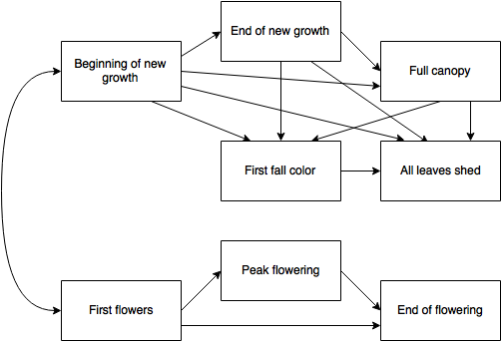

Because our focus is on the overall effects of earlier phenology dates at the scale of the individual, I will normalize phenology dates at the site-species level. Specifically, for each species at each site, I will normalize the distribution of each phenology date so that it has a mean of zero and a standard deviation of one. Doing so will satisfy the multi-normality assumption of structural equation modeling and will remove the idiosyncratic effects of species and site on the relationships among phenology dates.

4. Analyze the effects of local-scale environmental factors on phenology dates

The final analysis seeks to identify the local environmental factors that influence plant phenology. For each phenology date, I will model:

$$y_{i}=a_{i}+β_{i}X_{i}+ϵ$$
$$a_{i}=α_{site-sp-yr(i)}$$
$$β_{i} \sim N(γ_{site-sp\left(i\right)},τ_{site-sp\left(i\right)}^{2})$$
$$γ_{site-sp\left(i\right)} \sim N(μ,σ^{2})$$
Where:
$y_{i}$ is the phenology date for individual i.
a is a vector of site-species-year means, that as an intercept is meant to capture all site-level and year-level variation. In other words, it should remove the effects of climate, inter-species variation, and site variation.
$β$ is a matrix consisting of a vector of effects for each predictor, $β$. The values in each vector $β$ are normally distributed around an average site-species effect of $γ$ with a site-species-specific variation $τ$². $γ$ is normally distributed around some universal average $μ$ and some variance $σ$² for each predictor.
X is the data matrix for individual i.
$ϵ$ is unexplained variation; and particularly, it should be unexplained individual variation, normally distributed with some variance.

Environmental factors for which there is data:
- Elevation (meters above sea level)
- Slope (degrees from horizontal)
- Aspect (degrees clockwise from due north)
- Height of canopy (meters above ground)
- Plant height (meters)
- Canopy position (open grown, full sun, partially shaded, mostly shaded, full shade)

I will use the predictors:
- Elevation
- Slope
- North-south, derived from aspect, on [-1,1] such that 1 = north and -1 = south
- East-west, derived from aspect, on [-1,1] such that 1 = east and -1= west
- An interaction term between the north-sound and east-west aspects
Each aspect-derived predictor will be multiplied by slope in the model. The idea is that a strongly south-facing aspect has little meaning if the slope is close to zero.

Plus, there will be an additional one or two predictor terms that derive from height of canopy, plant height, and canopy position. These three factors are related, and it’s likely that both some measure of absolute plant height and an individual’s height relative to its neighbors matter for phenology. However, using all three measures as if they were independent would likely lead to collinearity issues in the model. I will conduct initial regression analyses to determine what independent predictor(s) explain the most variation in the data. In particular, I will analyze the predictors of: plant height, height of canopy, canopy position, and ratio of plant height to height of canopy.

Specifically, the first equation above can be expanded to read (with subscripts i dropped for readability):
$$y=a+β_{elev}∙x_{elev}+β_{slope}∙x_{slope}+β_{aspectNS}∙x_{aspectNS}∙x_{slope}+β_{aspectEW}∙x_{aspectEW}∙x_{slope}+β_{aspectNESW}∙x_{aspectNS}∙x_{aspectEW}∙x_{slope}+…+ ϵ$$

Correcting for changing variances
It’s possible that for a given site-species, the variance among individuals changes from year to year due to weather conditions. Such changes in variance would affect both model fit and interpretation of model results. I will analyze how variance changes between years within site-species using visualizations. If changing variance appears to be a problem, I will add unmodeled scaling factors $ξ∈[0,1]$ to the model for each $β$.
$$y=a+β_{elev}∙ξ_{site-spp-yr\left(i\right);elev}∙x_{elev}+…$$

Exploring the effect of predictors on growth form
It’s possible that various predictors affect the different growth forms differently. To investigate this possibility, I will modify the original model by replacing the equation for $γ$ with:
$$γ_{site-sp\left(i\right)} \sim N(δ_{fungrp(i)},σ_{fungrp(i)}^{2})$$
Where:
δ is a vector of the average effect of a predictor on phenology date by functional group
σ² is a vector of the variances by functional group

Results

We calculated 28,902 phenophase transition dates for 3,973 individuals of 100 species at 40 sites (137 unique site-species). All together, 333 site-species-years were represented. We discarded 813 transition dates because the uncertainty was too large (>32 days for “peak flower”, >18 days for all other transition types).

Uncertainty in phenophase transition dates due to observation regime

Uncertainty in phenophase transition dates was on the order of a week for most transition types (Table C). “New growth start” has smaller uncertainty, and “peak flower” had larger uncertainty, due to its definition of uncertainty. Model results for the uncertainty of site-species groups indicate that the range in uncertainty values is spread across site-species and phenophases without strong patterns as to particular sites or species driving overall uncertainty (Table SB). These differential uncertainties can be used to improve sampling regimes for targeted phenophases on a site-by-site basis. Additionally, because the variation in uncertainty due to site-species was smaller than that due to individuals, we did not investigate further the extent to which individual sites or species disproportionately drive overall uncertainty; the mean uncertainties for each phenophase can be taken as reasonable generalizations across the entire NEON network.

Table C: Mean uncertainty and variation in the dates of phenophase transitions due to sampling. The standard deviation attributable to differences among site-species is small compared with the standard deviation attributable to differences among individuals of a site-species at a site.
Phenophase Transition | Mean uncertainty (days) | Standard deviation due to site-species (days) | Standard deviation due to individuals (days)
New growth start | 4.96 | 1.82 | 2.46
New growth end | 7.17 | 2.00 | 2.82
First color | 6.12 | 1.43 | 3.04
Leaves shed end | 7.74 | 1.26 | 2.68
First flower | 6.11 | 2.46 | 2.90
Last flower | 10.11 | 3.91 | 5.07
Peak flower | 6.78 | 2.19 | 2.90

Variability in phenophase transition dates within populations

We found that the standard deviation for populations (site-species-year) across each phenophase transition type was rather skewed, with many populations having zero or very little variation in transition dates among individuals. The mode of the fitted log-normal distributions was between 1.5 and 3 days for all transition types, while the median ranged from 5 to 10 days, and the mean ranged from 9 to 18 days (Table D; Figure A). Of the 1475 populations used in the model, 115 of them (~8%) had a variance of zero.

Table D: Variation in the standard deviation of population phenophase transitions; mode, median, and mean are derived from the estimated parameters of a log-normal distribution across the populations (site-species-year) within each transition.
 | Variation in standard deviation  across Transitions (day) |  |  | Parameter values
Phenophase Transition | Mode | Median | Mean | Ν | τ
new growth start | 1.69 | 5.23 | 9.20 | 1.6536 | 1.0636
new growth end | 1.47 | 7.02 | 15.34 | 1.9484 | 1.2509
first color | 2.84 | 8.10 | 13.69 | 2.0919 | 1.0242
leaves shed end | 3.32 | 9.97 | 17.27 | 2.2997 | 1.0480
first flower | 2.53 | 8.46 | 15.49 | 2.1357 | 1.0994
peak flower | 2.34 | 8.26 | 15.53 | 2.1113 | 1.1237
last flower | 2.86 | 9.57 | 17.49 | 2.2582 | 1.0986

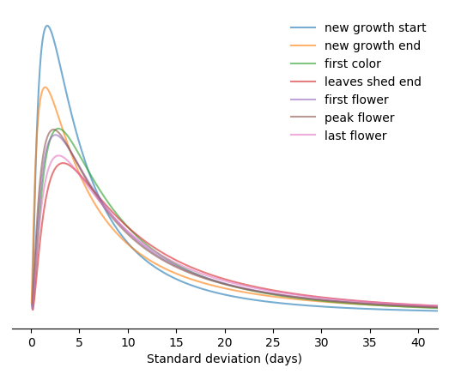
Figure A: Modeled probability distributions of the standard deviation in phenophase transitions across NEON populations (site-species-year combinations). Distributions are log-normal with high right skew and unit area under the curve; see Table D for distribution parameters and averages.

When we partially pooled by growth form as well as transition type, we found that some growth forms appear to have a more variability phenology (Figures B; Table SC). Deciduous broadleaf and evergreen conifer trees had relatively less variation in phenology among individuals than other types of trees (drought deciduous, semi-evergreen, and evergreen broadleaf trees and pines). Forbs and graminoids had a similar variability to one another. Their variability fell within the middle of that of the trees, but with leaves shed end being particularly variable among individuals. These patterns hold generally for the mode and mean of the distributions (Figures SA, SB), as well as the median, although evergreen trees (both broadleaf and conifer) have many more populations of simultaneous phenology transitions, as evidenced by low variation in the mode (Figure SA).

Figure B. Median standard deviation within populations (site-species-year) in phenophase transition dates for the eight growth forms in the NEON data set. The mode and mean of the modeled log-normal distributions show similar patterns; they can be found in SA and SB respectively.

Effects of observation sampling size on measured precision of phenology transitions

The effect of observing fewer individuals increases the standard deviation of sample means, when measured as repeated draws from the same population (site-species-year-transition). The relationship is quite consistent across populations on a normalized scale (Figure Ca). On average, reducing the sample size to 15 individuals increased the standard deviation of the mean by ~40% and reducing it to 10 individuals increased the standard deviation of the mean by ~75%. In unnormalized terms, a standard deviation of 1.2 days in the sample mean of 30 individuals from a population becomes 1.7 days with 15 individuals and 2.0 days with 10 individuals. For the worst case (a large spread in transition dates in the population), the standard deviation of 15.7 days in the sample mean with 30 individuals becomes 22.4 days with 15 individuals and 26.7 days with 10 individuals. However, for 75% of all populations, sampling just 10 individuals keeps the standard deviation of the mean to less than 4 days. See Tables SC-SF.

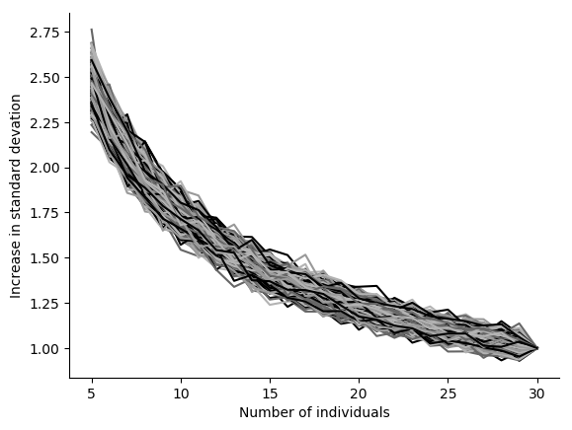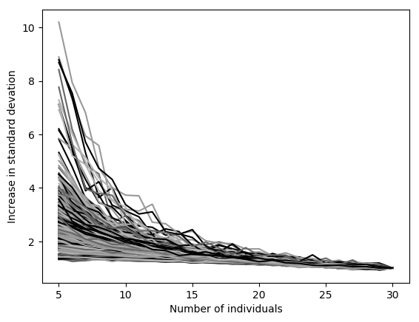
Figure C. Multiplicative increase in the calculated (a) mean and (b) standard deviation of phenophase transition dates as the number of sampled individuals decreases. Each line represents one site-species-year-transition combination; each point on the line is the standard deviation of 1000 independent draws with replacement from the 25+ individual transitions of that combination.

Unlike the mean, the effect of sampling fewer individuals on the standard deviation of populations was not consistent (Figure Cb). On average, decreasing the sample size from 30 to 15 individuals resulted in a ~45% or less increase in the standard deviation of the standard deviation of phenology transitions, and reducing it from 30 to 10 individuals resulted in a ~80% or less increase. This translates to increasing from 0.9 (or fewer) days standard deviation of the standard deviation when sampling 30 individuals to 1.3 days for 15 individuals and 1.6 days for 10 individuals. For the worst case, the standard deviation of 23.1 days in the standard deviation of phenology transitions with 30 individuals becomes 30.1 days for 15 individuals and 36.6 for 10 individuals. See Tables SC-SF.

