Influential Norwegians: From Vikings to Modern Icons
I. Pioneers of Exploration and Science
Norway’s history is defined by those who ventured into the unknown, starting with the seafaring Vikings and continuing into the modern scientific era.

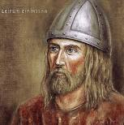

Leif Erikson
(c. 970 – c. 1020): Often cited as the first European to set foot on North American soil, nearly 500 years before Christopher Columbus. His voyages to "Vinland" (modern-day Newfoundland) are documented in the Icelandic sagas and confirmed by archaeological finds at L’Anse aux Meadows.

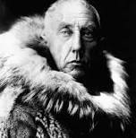

Roald Amundsen
(1872–1928): A legendary polar explorer, Amundsen led the first expedition to reach the South Pole in 1911. He was also the first to traverse the Northwest Passage and the first to definitively reach both the North and South Poles.

Fridtjof Nansen
(1861–1930): Beyond his famed Arctic expeditions on the ship Fram, Nansen was a Nobel Peace Prize laureate. He is celebrated for his humanitarian work with refugees following World War I, including the creation of the "Nansen Passport" for stateless persons.

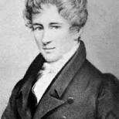

Niels Henrik Abel
(1802–1829): Despite his short life, Abel made monumental contributions to mathematics, particularly in the fields of algebra and analysis. The prestigious Abel Prize, often called the "Nobel of Mathematics," is named in his honor.
Wikipedia +7
II. Masters of Art and Literature
Norway’s cultural "Golden Age" in the late 19th century produced some of the world's most enduring artistic works.

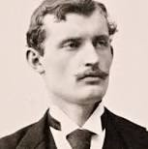

Edvard Munch
(1863–1944): One of the most significant painters in modern art, Munch is best known for "The Scream". His work was a cornerstone of Expressionism, focusing on raw human emotions like anxiety, love, and jealousy.

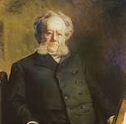

Henrik Ibsen
(1828–1906): Often called the "father of modern drama," Ibsen is the second most performed playwright in the world after Shakespeare. His plays, such as A Doll’s House and Peer Gynt, revolutionized theater by introducing social realism and challenging contemporary morals.

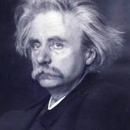

Edvard Grieg
(1843–1907): Norway's national composer, Grieg integrated Norwegian folk themes into classical music. His Peer Gynt Suite, featuring "In the Hall of the Mountain King," remains globally iconic.

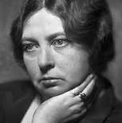

Sigrid Undset
(1882–1949): A Nobel Prize laureate in Literature (1928), Undset is famous for her historical trilogy Kristin Lavransdatter, which provided a vivid and deep look at life in medieval Scandinavia.
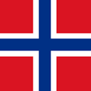Life in Norway +8
III. Modern Icons and Global Leaders
In recent years, Norwegians have continued to dominate the global stage in diplomacy, entertainment, and sports.

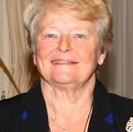

Gro Harlem Brundtland
(b. 1939): The first female Prime Minister of Norway and former Director-General of the World Health Organization. She is known as the "mother of sustainable development" for her work on the Brundtland Report.

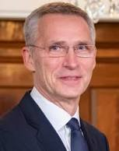

Jens Stoltenberg
(b. 1959): A former Prime Minister of Norway, he has served as the Secretary General of NATO during one of the most critical periods in modern European security.



Magnus Carlsen
(b. 1990): Widely considered the greatest chess player of all time, Carlsen held the World Chess Championship title for a decade and has achieved the highest FIDE rating in history.



Erling Haaland
(b. 2000): One of the most famous athletes in the world today, Haaland is a record-breaking striker for Manchester City and the Norwegian national football team, consistently appearing at the top of global popularity charts.
Life in Norway +4

Sources
- Wikipedia - List of Norwegians
- Life in Norway - Famous Norwegian People
- On This Day - Famous Norwegians in History
- Visit Norway -
Edvard Munch

- UpNorway - Famous Norwegian Explorers
- Patentstyret - Norwegian Inventors
- Evaneos - Travel Norway: Celebrities
- Britannica - Norway: People
- Wikipedia -
Henrik Ibsen
- Pantheon - Famous People from Norway

