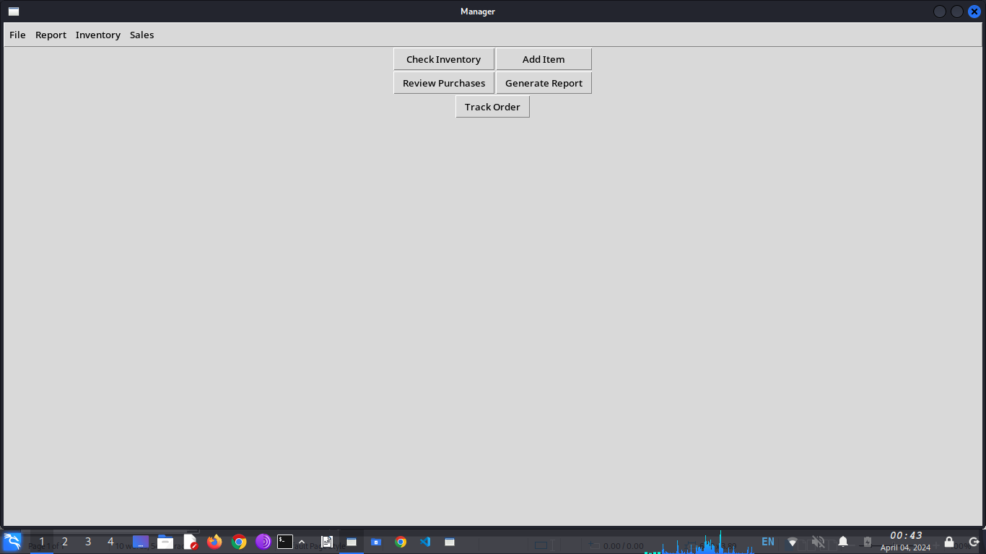
To update inventory:
Click the check inventory button
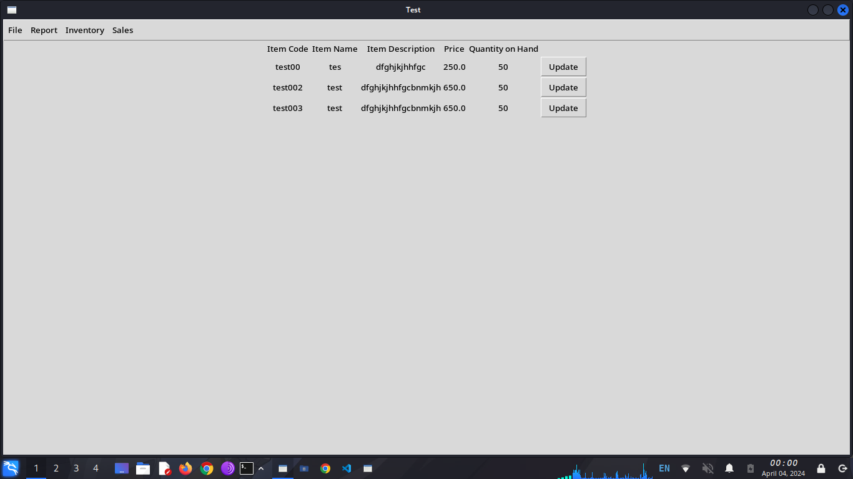
Find the Item that needs updating then click the update button

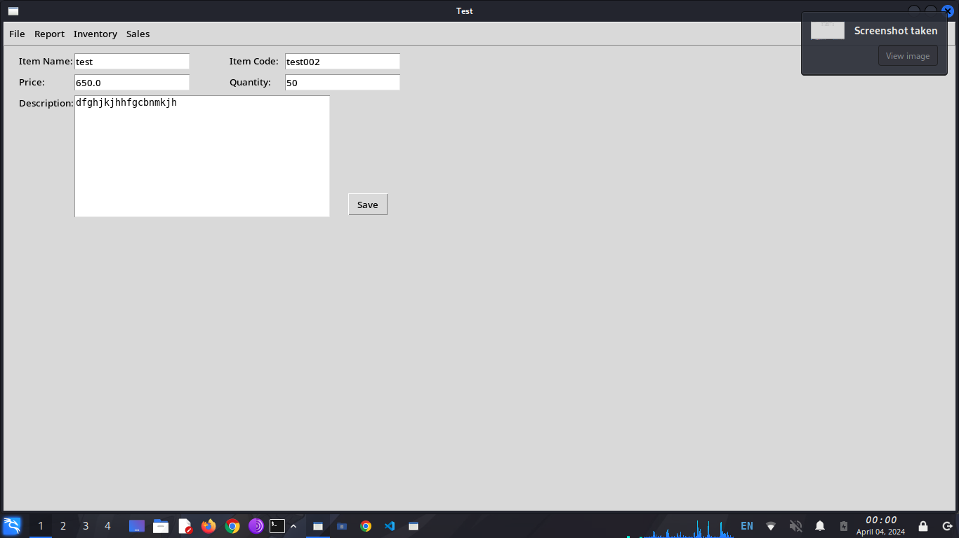
Make changes then click the save button
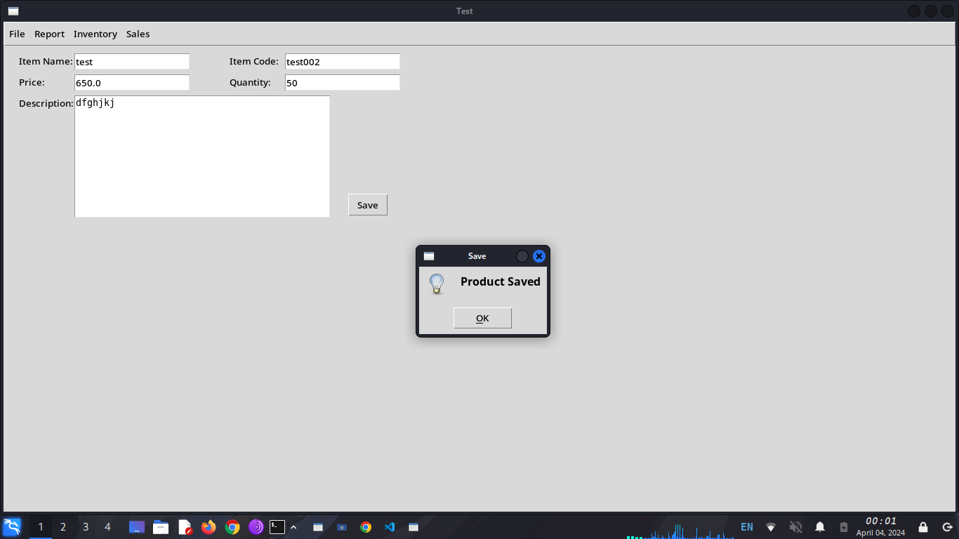
Click OK

To add new item to inventory:
Click the Add Item button

Fill in the boxes then click the save button
Click OK

To Refund Purchases:
Click the review purchases button
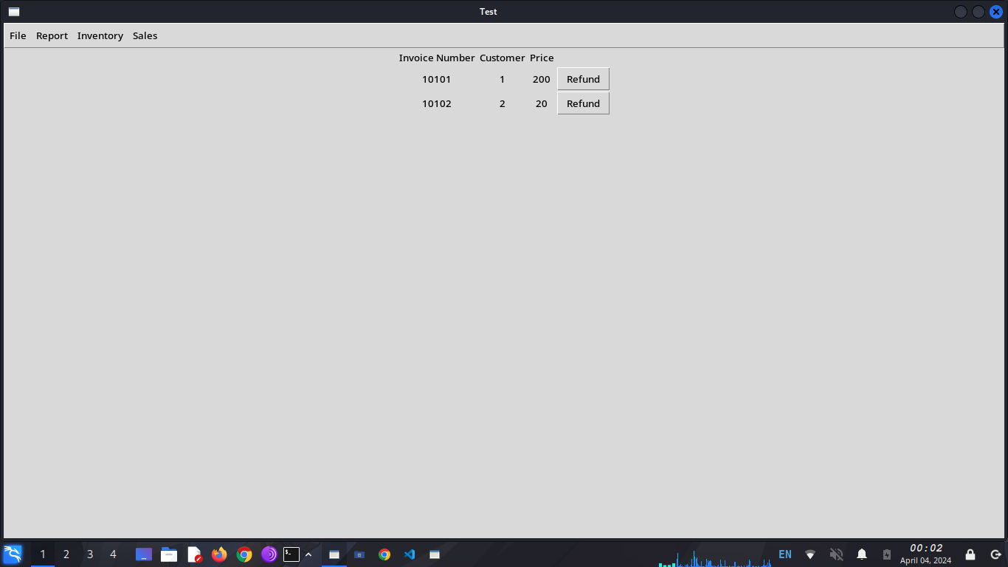
Find the purchase that needs to refunded and click the refund button

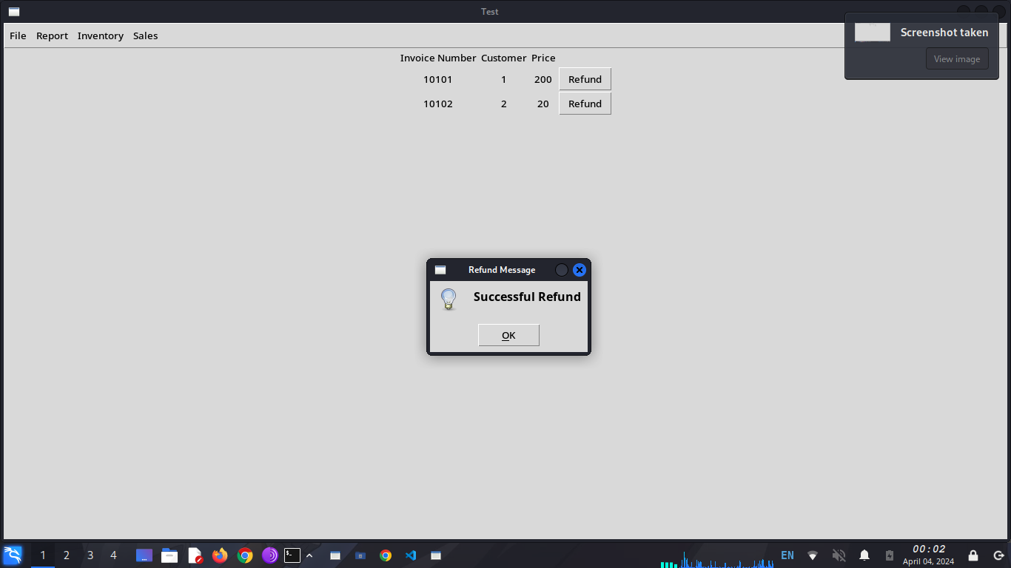
Click OK

To Generate Reports:
Click the generate report button
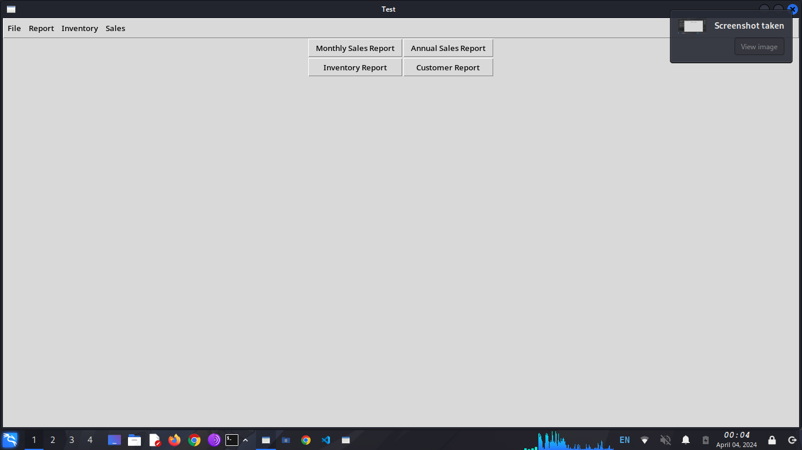
Select the type of report that needs to be generated

To Track Orders:
Click the track order button
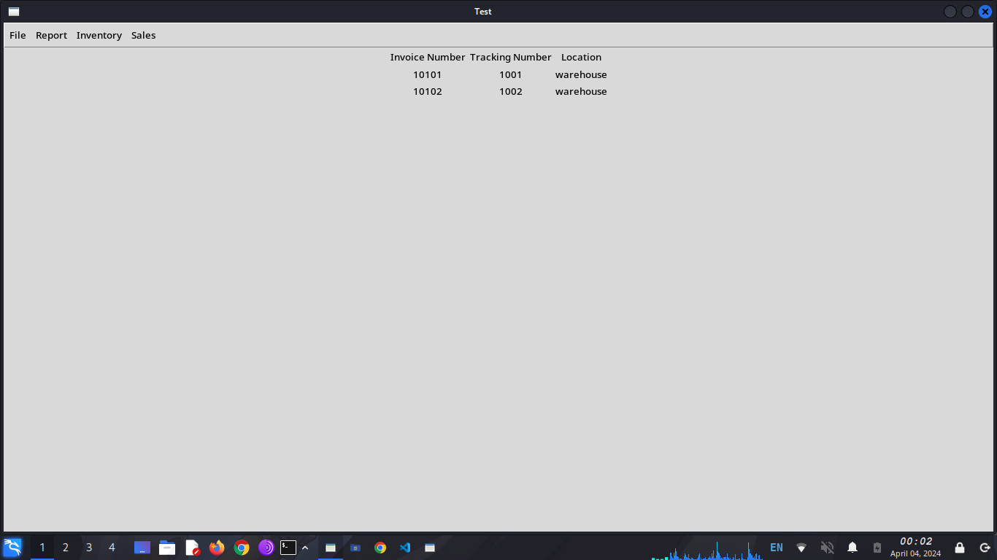
find the order that needs tracking

