Project #2
Names: / / .
Floating point versus exact arithmetic

Compute each of the following expressions following the same procedures as in Chapter 1.

Comments, especially with respect Expression CAL CAS the differences between the CAL result and the CAS result(s).
13!

14!

15!

16!

14!+1

15!+1

16!+1

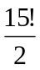
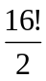
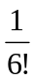
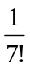
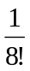
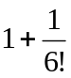
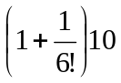
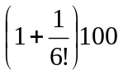
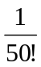
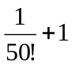
Exercise. Is there a difference between your CAL answer for 14! and for 15!? Why?

Exercise. Does your CAL answer for 14!+1 agree with your CAS answer? Does your CAL answer for 15!+1 agree with your CAS answer? Why is there a difference?

Exercise. Does your CAL answer for 15!/2 agree with your CAS answer? Does your CAL answer for 16!/2 agree with your CAS answer? Why is there a difference?

The Maple command convert(expression,fraction); converts the expression to fraction form. Try the following Maple sequence:
sqrt(2)=evalf(sqrt(2));sqrt(2)=convert(evalf(sqrt(2)),fraction); What is the result?

Why is this very misleading? What do you think is going on here?

Exercise. Consider the last 8 calculation problems. Can your calculator convert its decimal answers to the rational CAS results? (Hint: if your calculator has a >Frac command, try to obtain the CAS results.) Conversely, can you convert your CAS rational results to decimal answers that match your CAL answers? (Hint: in Maple consider the evalf command.) For which numbers does this work, for which does it not work? Why not?

CAL ans >Frac evalf(CAS ans)

1/6!

1/7!

1/8!

1+1/6!

(1+1/6!)10

(1+1/6!)100

1/50!

1/50!+1

Exercise. Explain the meaning of the term "floating point arithmetic."

Exercise. Experiment with different integers to see if you can determine which of the following expressions is "usually" the bigger. Show some of your calculations.

2(n!) or (2n)!

(n+m)! or n!+m!

(n!)² or (n²)!

n^{n} or n!

2^{n} or n!

Experiment with both machines to determine whether or not the conversion from decimal to fraction form is an exact operation in either machine. Hint: see if you can find two different decimals that convert to the same fraction.

Reflection: What are the main points/issues that you take away from the exercises in Project #2?

