Name: Final Exam-B Math 4371
Key

- Consider the polynomial:

- How many roots does the polynomial have?
2
2
0
2

- How many real roots does the polynomial have?

- How many complex roots does the polynomial have?

- How many x-intercepts does the polynomial have?

- Factor the polynomial completely into irreducible polynomials (over the reals):

- Copy a graph of the polynomial (from a CAS into the textbox below) which clearly shows the behavior of the polynomial near the roots (if any) and near any local minimums or maximums (if any).
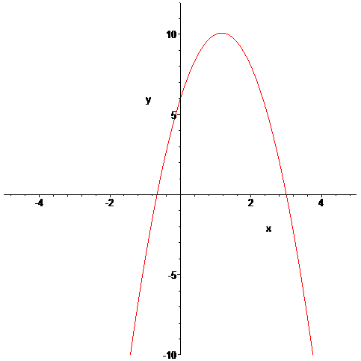

- Consider the polynomial:
0
3
3
3
- How many roots does the polynomial have?

- How many real roots does the polynomial have?

- How many complex roots does the polynomial have?

- How many x-intercepts does the polynomial have?

- Factor the polynomial completely into irreducible polynomials (over the reals):

- Copy a graph of the polynomial (from a CAS into the textbox below) which clearly shows the behavior of the polynomial near the roots (if any) and near any local minimums or maximums (if any).
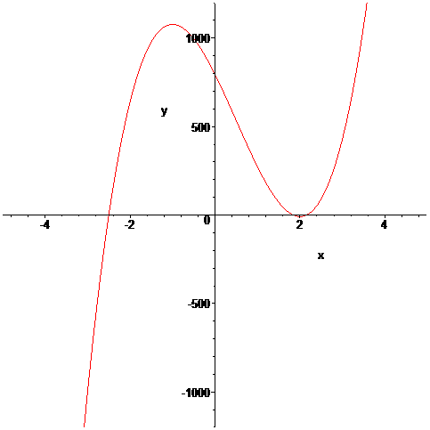

- Consider the polynomial:
2
2
2
4
- How many roots does the polynomial have?

- How many real roots does the polynomial have?

- How many complex roots does the polynomial have?

- How many x-intercepts does the polynomial have?

- Factor the polynomial completely into irreducible polynomials (over the reals):

- Copy a graph of the polynomial (from a CAS into the textbox below) which clearly shows the behavior of the polynomial near the roots (if any) and near any local minimums or maximums (if any).

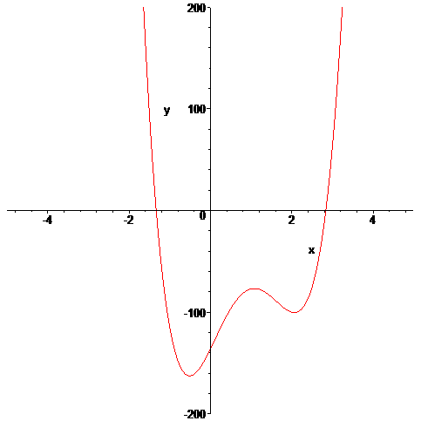
- Consider the set
- Find a polynomial whose roots are exactly the elements of the set . Write the polynomial out in expanded form:

2 distinct, 3 counting multiplicity
- How many x-intercepts does the polynomial have?

- Copy a graph of the polynomial (from a CAS into the textbox below) which clearly shows the behavior of the polynomial near the roots (if any) and near any local minimums or maximums (if any).

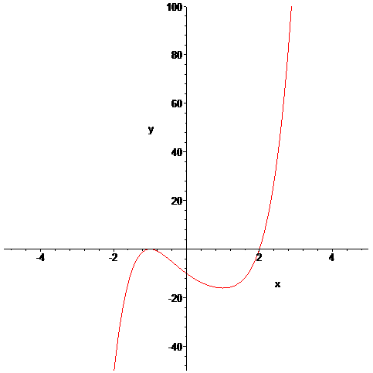
- Consider the following set of functions:
- Which of the five functions have only complex roots?
complex

complex
complex
y₁ y₂ y₃ y₄ y₅

- Estimate the minimum value of each function.
.5
-1.12
-1
.88
4.5
y₁ y₂ y₃ y₄ y₅

- Estimate the x-intercepts of those functions for which real roots exist.

-.73, .73

y₁ y₂ y₃

-1, .5
y₄ y₅

- Using a CAS, plot the graphs all five functions on the same coordinate axes. Copy the plot into the textbox below.
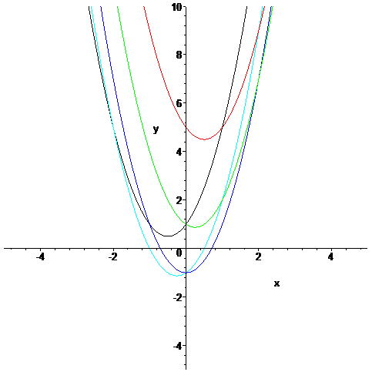
- Consider the rational function:

- Does the function have vertical asymptotes? If so, where?
x=-2, x=4
Yes
Yes/No Where?

- Does the function have a horizontal asymptote? If so, where?
y=2
Yes
Yes/No Where?

- Does the function have a slant asymptote?
No
Yes/No

- Copy a graph of the function (from a CAS into the textbox below) which clearly shows the behavior of the function near any intercepts (if any) and also shows the asymptotes (if any).
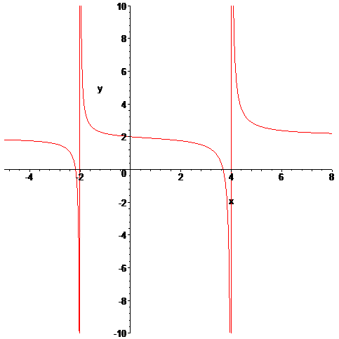

- Consider the rational function:

- Does the function have vertical asymptotes? If so, where?
x=-3/2
Yes
Yes/No Where?

- Does the function have a horizontal asymptote? If so, where?

No
Yes/No Where?

- Does the function have a slant asymptote?
Yes
Yes/No

- Copy a graph of the function (from a CAS into the textbox below) which clearly shows the behavior of the function near any intercepts (if any) and also shows the asymptotes (if any).
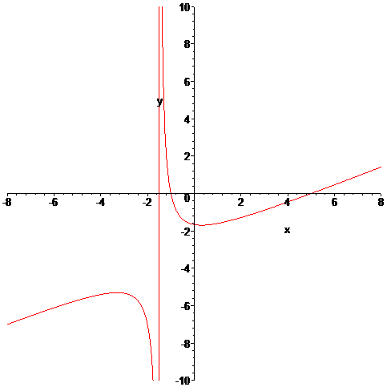
- Using a CAS construct an implicit plot of the equation . Copy the graph of the equation from the CAS into the textbox below.
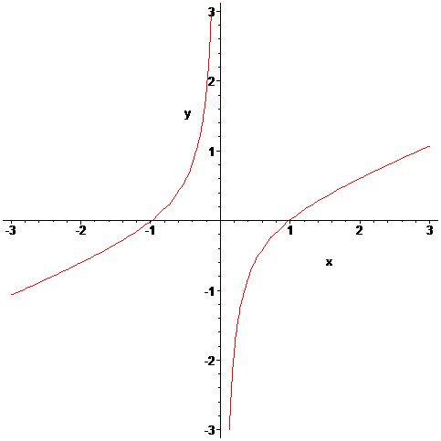

- Using a CAS construct an plot of the 3-d graph of the function Copy the graph of the function from the CAS into the textbox below.
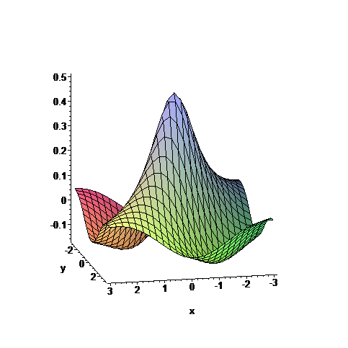

- For the following sequence identify the next two missing terms and describe the pattern that the terms in the sequence follow.
1
1
{0,1,1,0,1,1,1,1,0,1,1,1,1,1,1,0,1, , , . . . }

Pattern:
0 if n is perfect square, 1 is n is not perfect square

- For the following recursive sequence identify the next two missing terms and describe the pattern that the terms in the sequence follow.
239
577
{1, 1, 3, 7, 17, 41, 99, , , . . . }

Pattern:
A_{n} = A_{n-2} + 2*A_{n-1}

- For the following sequence S find the specified missing terms. S is an arithmetic sequence for which the 5th and 9th terms are 27 and 59, resp.
203
-5
Find the 1st term and the 27th term: ,

- For the following sequence S find an explicit functional formula for generating all of the terms of the sequence and find the 39th term of the sequence. S is the sequence given by

{1, 5, 14, 28, 47, . . . } where the second differences are constant.

A_{n} = 2 +(-7/2)*n + (5/2)*n²
3668
Formula: ,

- On the back of the instruction’s page for the exam, sketch on the same graph the derivative and the anti-derivative of function pictured below.

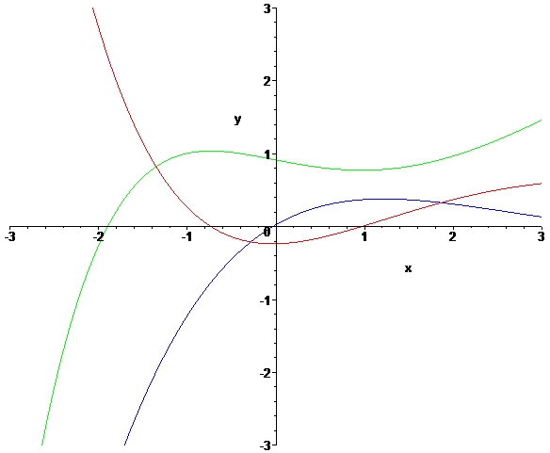

Function = Red Derivative = Blue Anti-Derivative = Green
- In the picture below the graphs of three functions are plotted on the same coordinate axes. Of the three graphs one is the graph of a function f , one is the graph of the derivative of f and one is the graph of an anti-derivative of f. Identify which graph is which:

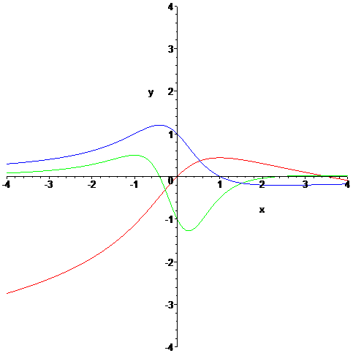

Red
Green
Function = Derivative = Anti-derivative =
Blue

