Name: Final Exam-B Math 4371

- Consider the polynomial:

- How many roots does the polynomial have?

- How many real roots does the polynomial have?

- How many complex roots does the polynomial have?

- How many x-intercepts does the polynomial have?

- Factor the polynomial completely into irreducible polynomials (over the reals):

- Copy a graph of the polynomial (from a CAS into the textbox below) which clearly shows the behavior of the polynomial near the roots (if any) and near any local minimums or maximums (if any).

- Consider the polynomial:

- How many roots does the polynomial have?

- How many real roots does the polynomial have?

- How many complex roots does the polynomial have?

- How many x-intercepts does the polynomial have?

- Factor the polynomial completely into irreducible polynomials (over the reals):

- Copy a graph of the polynomial (from a CAS into the textbox below) which clearly shows the behavior of the polynomial near the roots (if any) and near any local minimums or maximums (if any).

- Consider the polynomial:

- How many roots does the polynomial have?

- How many real roots does the polynomial have?

- How many complex roots does the polynomial have?

- How many x-intercepts does the polynomial have?

- Factor the polynomial completely into irreducible polynomials (over the reals):

- Copy a graph of the polynomial (from a CAS into the textbox below) which clearly shows the behavior of the polynomial near the roots (if any) and near any local minimums or maximums (if any).

- Consider the set
- Find a polynomial whose roots are exactly the elements of the set . Write the polynomial out in expanded form:

- How many x-intercepts does the polynomial have?

- Copy a graph of the polynomial (from a CAS into the textbox below) which clearly shows the behavior of the polynomial near the roots (if any) and near any local minimums or maximums (if any).

- Consider the following set of functions:
- Which of the five functions have only complex roots?

y₁ y₂ y₃ y₄ y₅

- Estimate the minimum value of each function.

y₁ y₂ y₃ y₄ y₅

- Estimate the x-intercepts of those functions for which real roots exist.

y₁ y₂ y₃

y₄ y₅

- Using a CAS, plot the graphs all five functions on the same coordinate axes. Copy the plot into the textbox below.

- Consider the rational function:

- Does the function have vertical asymptotes? If so, where?

Yes/No Where?

- Does the function have a horizontal asymptote? If so, where?

Yes/No Where?

- Does the function have a slant asymptote?

Yes/No

- Copy a graph of the function (from a CAS into the textbox below) which clearly shows the behavior of the function near any intercepts (if any) and also shows the asymptotes (if any).

- Consider the rational function:

- Does the function have vertical asymptotes? If so, where?

Yes/No Where?

- Does the function have a horizontal asymptote? If so, where?

Yes/No Where?

- Does the function have a slant asymptote?

Yes/No

- Copy a graph of the function (from a CAS into the textbox below) which clearly shows the behavior of the function near any intercepts (if any) and also shows the asymptotes (if any).

- Using a CAS construct an implicit plot of the equation . Copy the graph of the equation from the CAS into the textbox below.

- Using a CAS construct an plot of the 3-d graph of the function Copy the graph of the function from the CAS into the textbox below.

- For the following sequence identify the next two missing terms and describe the pattern that the terms in the sequence follow.

{0,1,1,0,1,1,1,1,0,1,1,1,1,1,1,0,1, , , . . . }

Pattern:

- For the following recursive sequence identify the next two missing terms and describe the pattern that the terms in the sequence follow.

{1, 1, 3, 7, 17, 41, 99, , , . . . }

Pattern:

- For the following sequence S find the specified missing terms. S is an arithmetic sequence for which the 5th and 9th terms are 27 and 59, resp.

Find the 1st term and the 27th term: ,

- For the following sequence S find an explicit functional formula for generating all of the terms of the sequence and find the 39th term of the sequence. S is the sequence given by

{1, 5, 14, 28, 47, . . . } where the second differences are constant.

Formula: ,

- On the back of the instruction’s page for the exam, sketch on the same graph the derivative and the anti-derivative of function pictured below.

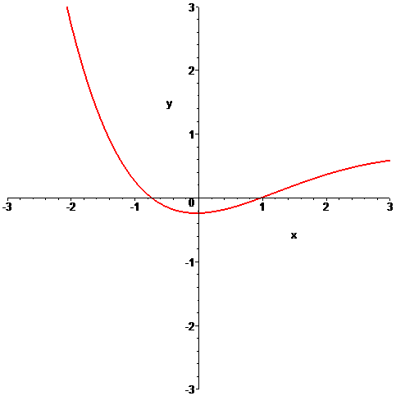

- In the picture below the graphs of three functions are plotted on the same coordinate axes. Of the three graphs one is the graph of a function f , one is the graph of the derivative of f and one is the graph of an anti-derivative of f. Identify which graph is which:

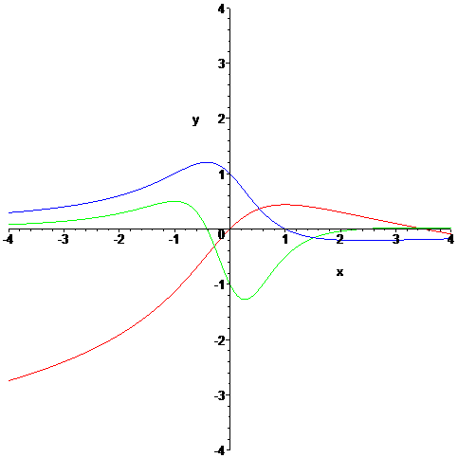

Function = Derivative = Anti-derivative =

