The Maple command for plotting a 2-dimensional graph of y = a function of x is
plot(function of x, x=xmin..xmax, optional stuff);

This command automatically chooses a y-range that it thinks is best. If you wish to specify the y-range then you must include it in the original command :
plot(function of x, x=xmin..xmax,y=ymin..ymax, more optional stuff);

WolframAlpha accepts the either the command
plot function of x
or
graph function of x

Note, WolframAlpha typically displays two plots: one close up and one further away.

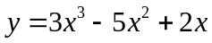

Maple Graph:

WolframAlpha Graph:

For purpose of demonstration it is nice to see all these graphs on the same axes. In WolframAlpha, you can list multiple functions to graph on the same axes:
plot first function of x, second function of x, etc.

Again, WolframAlpha will display two graphs with different range parameters.

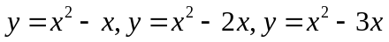

WolframAlpha Graph:

In Maple it seems to be a bit more of a challenge, so here goes. In Maple try the command

plot({first function of x, second function of x, etc.},x=-4..4,y=-10..10);

Maple Graph

Optional Parameter: title

Using the cursor/pointer in Maple, estimate points on a graph.
Asymptotes, Complete Graphs

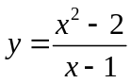
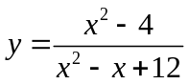
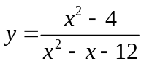
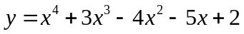

Implict plots are sketch of graphs of equations that are not functions. Such things are very common; for examples, ellipses, hyperbolas, and many parabolas are such. These are graphs of equations, not necessarily graphs of functions. To graph such things with Maple we must first invoke a special graphing package, to do this execute the command
with(plots);
Notice all the plotting commands contained in this package. Now change the semicolon to a colon and see what happens when you press enter. The implicit plot works just the same as plot did above except the command is

implicitplot(equation in x and y, x=a..b, y=c..d, title=’stuff’);

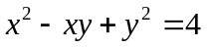

In WolframAlpha, one enters the command
implicit plot equation in x and y

Or the command
contour plot equation in x and y

The Maple command for plotting a 3-dimensional graph is
plot3d(function in x and y, x=xmin...xmax, y=ymin...ymax, optional stuff);

The WolframAlpha command is
plot function in x and y

