Project #1 Elementary Calculations

Names: / / .
Complete each of the following exercises by hand, using your brain, pencil and an eraser (HAND), a calculator (CAL), and Maple/WolframAlpha (CAS). In each case record your answers in the appropriate place.

 | HAND | CAL | CAS | Comments (good place to include notes on syntax)
a.
2+6
b.
2(6+5)
c.
(1+5)²+2
d.
2+3*5
e.
2*3^5
f.
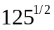
g.
2^3^4
h.
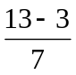
i.
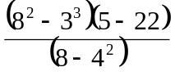
j.
4!+3!+2!+1!+0!

Note: ! stands for factorial

There is a formula you should recall from basic probability and statistics:

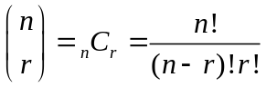

This is the number of combinations of n objects, choosing r at a time, and is sometimes verbalized as: n choose r. For example if you wanted to know how many possible different 3 student groups you could make from a class of 15 students, you would compute

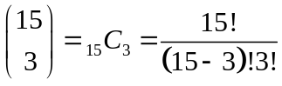.

Try computing this by hand, and then using your CAL and CAS. What is your answer?__________

 | HAND | CAL | CAS | Comments (good place to include notes on syntax
k.
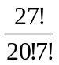
l.
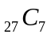
m.
binomial(27,10)

n.
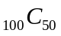
o.
binomial(100,50)

p.
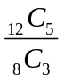
q.
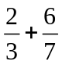
r.
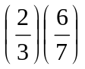
s.
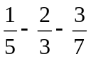
t.
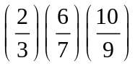
u.
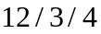
v.
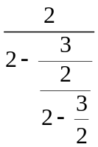
w.
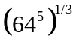
x.
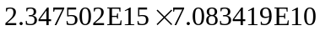
y.
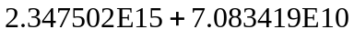

Reflection 1: Look back over the above exercises. Why do some of the CAL and CAS answers seem to differ? Can you convert the answers from one format to another? [CAL to CAS? CAS to CAL?] If you can convert the answers from one format to another, do you get the same results? If not, why not? If not, can you trust your CAL answers or your CAS answers? Why or why not?

Reflection 2: Look back over the above exercises. List some of the points you think the author wanted you to observe?

