Chapter 1 Elementary Calculations

Names: / / .
Complete each of the following exercises using your brain & pencil (B&P), your Calculator (SGC), and MAPLE (CAS). In each case record your answers in the appropriate place. Constantly save your work to YOUR eraider account, not just to the hard drive of the machine you are working on.

 | B&P | SCG | CAS | Comments (good place to include notes on syntax)
1.
2+6

2.
2(6+5)

3.
(1+5)²+2

4.
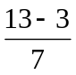
5.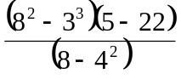
6. 4!

! stands for factorial and should be in your calculator’s CATALOG.

There is a formula you should recall from basic probability and statistics:
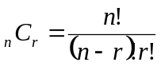
This is the number of combinations of n objects, choosing r at a time. For example if you wanted to know how many possible different 3 student groups you could make from a class of 15 students, you would compute
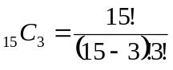.

Try computing this by hand, and then using your SGC and CAS. What is your answer?__________ Continue with the exercises on the next page.
 | B&P | SCG | CAS | Comments (good place to include notes on syntax
7.
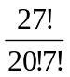
8.
27 nCr 10
(SGC CATALOG)

9.
binomial(27,10)
(CAS-MAPLE)

10.
100 nCr 50

11.
binomial(100,50)

12.
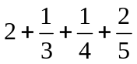
13.
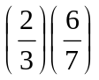
14.
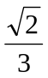
(sqrt( ); from MAPLE)
15.
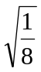
16.
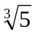

Exercise: For the above problems as indicated below use the >Frac command from your SGC CATALOG to see if you can make the SCG answers agree with the MAPLE answers. Use the command evalf from MAPLE to see if you can make the MAPLE answers look like the SCG answers. Explain why you can not do this in those instances when it doesn't seem to work.
evalf(CAS result)=

SGC result >Frac =
4.

5.
evalf(CAS result)=

SGC result >Frac =

12.
evalf(CAS result)=

SGC result >Frac =

13.
evalf(CAS result)=

SGC result >Frac =

evalf(CAS result)=

SGC result >Frac =
14.

evalf(CAS result)=

SGC result >Frac =
15.

Reflection: Look back over the above exercises. List some of the points you think the author wanted you to observe?

