Name: Final Exam-B Math 4371
Brian Luna

- 8/9 Consider the polynomial:

- How many roots does the polynomial have?
2 possible
2
0
2

- How many real roots does the polynomial have?

- How many complex roots does the polynomial have?

- How many x-intercepts does the polynomial have?

- Factor the polynomial completely into irreducible polynomials (over the reals):
P(x)=(x+ $\frac{2}{3}$)(x-3) missing a factor of -2

- Copy a graph of the polynomial (from a CAS into the textbox below) which clearly shows the behavior of the polynomial near the roots (if any) and near any local minimums or maximums (if any).
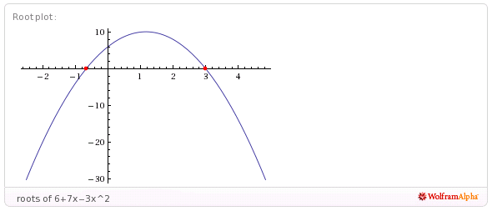

- 7.5/9 Consider the polynomial:
0
3
3 possible
3
- How many roots does the polynomial have?

- How many real roots does the polynomial have?

- How many complex roots does the polynomial have?

- How many x-intercepts does the polynomial have?

- Factor the polynomial completely into irreducible polynomials (over the reals):
q(x)=(x+ $\frac{5}{2}$) (x-$\frac{1}{20}(40+\sqrt{10})$) (x-$\frac{1}{20}(40-\sqrt{10})$)

- Copy a graph of the polynomial (from a CAS into the textbox below) which clearly shows the behavior of the polynomial near the roots (if any) and near any local minimums or maximums (if any). Clearly depict graph near the roots near x=2
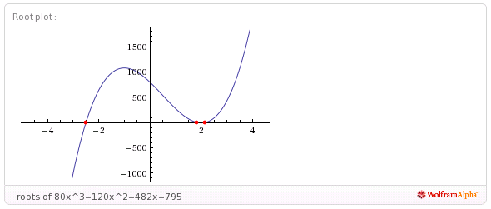

- 8/9 Consider the polynomial:
2
2
2
4 possible
- How many roots does the polynomial have?

- How many real roots does the polynomial have?

- How many complex roots does the polynomial have?

- How many x-intercepts does the polynomial have?

- Factor the polynomial completely into irreducible polynomials (over the reals):
r(x)= (x+$\frac{4}{3}$)(x-1-$\sqrt{-1}$) (x-1+$\sqrt{-1}$) (x-$\frac{17}{6}$) factored over the complex field

- Copy a graph of the polynomial (from a CAS into the textbox below) which clearly shows the behavior of the polynomial near the roots (if any) and near any local minimums or maximums (if any).

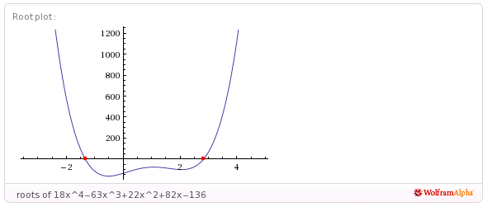
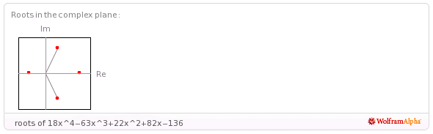
- 5.5/8 Consider the set
- Find a polynomial whose roots are exactly the elements of the set . Write the polynomial out in expanded form:
(x+1)(x+1)(x-1+2$\sqrt{-1}$) (x-1-2$\sqrt{-1}$)(x-2) expanded form??

2
- How many x-intercepts does the polynomial have?

- Copy a graph of the polynomial (from a CAS into the textbox below) which clearly shows the behavior of the polynomial near the roots (if any) and near any local minimums or maximums (if any). Complete graph??

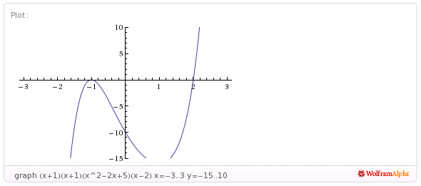
- 10/11 Consider the following set of functions:
- Which of the five functions have only complex roots?
complex
real
real
complex
complex
y₁ y₂ y₃ y₄ y₅

- Estimate the minimum value of each function.
1 error

-1
-1
1
5 error

y₁ y₂ y₃ y₄ y₅

- Estimate the x-intercepts of those functions for which real roots exist.
X=-$\sqrt{\frac{1}{2}}$ x=$\sqrt{\frac{1}{2}}$

y₁ y₂ y₃ xxxxx
X=-1 x=$\frac{1}{2}$

y₄ y₅

- Using a CAS, plot the graphs all five functions on the same coordinate axes. Copy the plot into the textbox below.
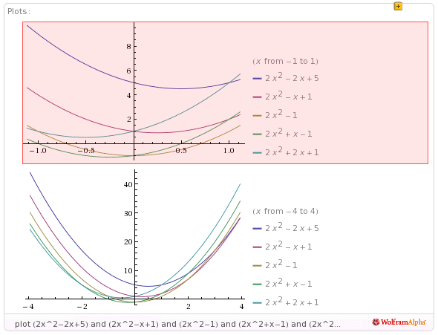
- 9/9 Consider the rational function:

- Does the function have vertical asymptotes? If so, where?
X=-2 x=4
Yes
Yes/No Where?

- Does the function have a horizontal asymptote? If so, where?
Y=2
Yes
Yes/No Where?

- Does the function have a slant asymptote?
No
Yes/No

- Copy a graph of the function (from a CAS into the textbox below) which clearly shows the behavior of the function near any intercepts (if any) and also shows the asymptotes (if any).
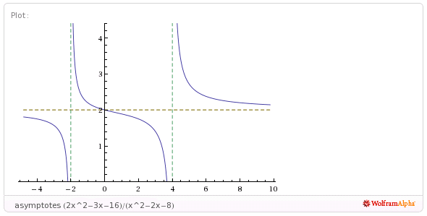

- 7/7 Consider the rational function:

- Does the function have vertical asymptotes? If so, where?
X=-$\frac{3}{2}$
Yes
Yes/No Where?

- Does the function have a horizontal asymptote? If so, where?

No
Yes/No Where?

- Does the function have a slant asymptote?
Yes
Yes/No

- Copy a graph of the function (from a CAS into the textbox below) which clearly shows the behavior of the function near any intercepts (if any) and also shows the asymptotes (if any).
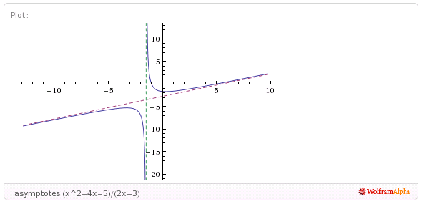
- 4/4 Using a CAS construct an implicit plot of the equation . Copy the graph of the equation from the CAS into the textbox below.
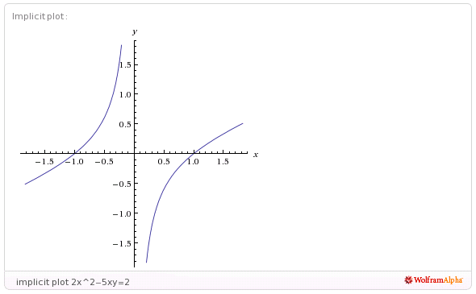

- 4/4 Using a CAS construct an plot of the 3-d graph of the function Copy the graph of the function from the CAS into the textbox below.
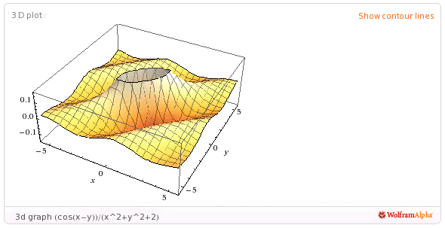

- 5/5 For the following sequence identify the next two missing terms and describe the pattern that the terms in the sequence follow.
1
1
{0,1,1,0,1,1,1,1,0,1,1,1,1,1,1,0,1, , , . . . }

Pattern:
A zero followed by an even number of ones, after each zero the number of ones is multiplied by its order of procession in the sequence. 1st procession(2*1): 0,1,1 2nd procession (2*2): 0,1,1,1,1 N^{th} Procession(2*N)

- 5/5 For the following recursive sequence identify the next two missing terms and describe the pattern that the terms in the sequence follow.
239
577
{1, 1, 3, 7, 17, 41, 99, , , . . . }

Pattern:
The next number is the previous number multiplied by 2, then add the next previous number. E.g. $N_{4}=\left(N_{3}*2\right)+N_{2}$

- 3/3 For the following sequence S find the specified missing terms. S is an arithmetic sequence for which the 5th and 9th terms are 27 and 59, resp.
203
-5
Find the 1st term and the 27th term: ,

- 5/5 For the following sequence S find an explicit functional formula for generating all of the terms of the sequence and find the 39th term of the sequence. S is the sequence given by

{1, 5, 14, 28, 47, . . . } where the second differences are constant.

F(x)=$\frac{5n^{2}-7n+4}{2}$
3668
Formula: ,

- 6/6 On the back of the instruction’s page for the exam, sketch on the same graph the derivative and the anti-derivative of function pictured below.

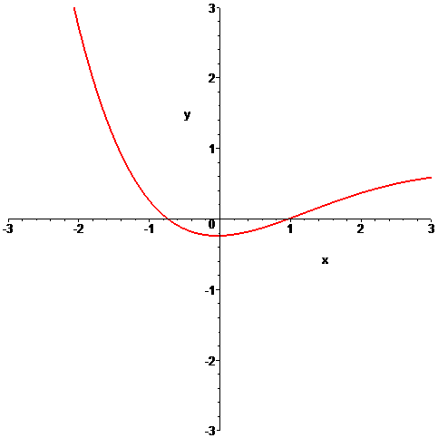

- 6/6 In the picture below the graphs of three functions are plotted on the same coordinate axes. Of the three graphs one is the graph of a function f , one is the graph of the derivative of f and one is the graph of an anti-derivative of f. Identify which graph is which:

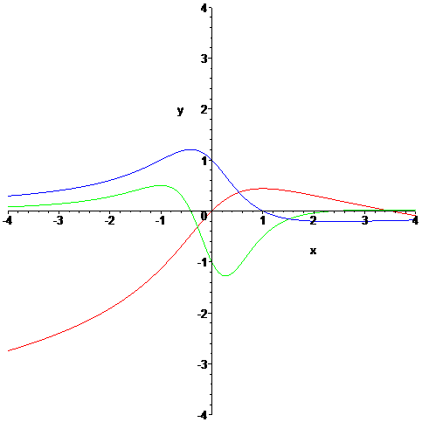

red
green
Function = Derivative = Anti-derivative =
blue

