Name: Final Exam-A Math 4371
Leanne Perry

- 9/9 Consider the polynomial:
2
- How many roots does the polynomial have?
2
- How many real roots does the polynomial have?
0
- How many complex roots does the polynomial have?
2
- How many x-intercepts does the polynomial have?

- Factor the polynomial completely into irreducible polynomials (over the reals):
(x-2)(2x+1)

- Copy a graph of the polynomial (from a CAS into the textbox below) which clearly shows the behavior of the polynomial near the roots (if any) and near any local minimums or maximums (if any).
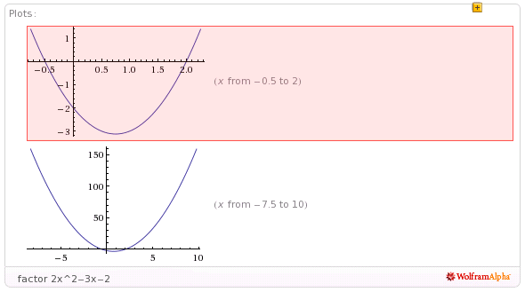

- 6.5/9 Consider the polynomial:
1
2
1
3
- How many roots does the polynomial have?

- How many real roots does the polynomial have?

- How many complex roots does the polynomial have?

- How many x-intercepts does the polynomial have?

- Factor the polynomial completely into irreducible polynomials (over the reals):
(1/10)(-20ix+sqrt(10)+40i)^2(2x+5) factored into linear over complex field

- Copy a graph of the polynomial (from a CAS into the textbox below) which clearly shows the behavior of the polynomial near the roots (if any) and near any local minimums or maximums (if any). Not detailed near local minimum near x=2
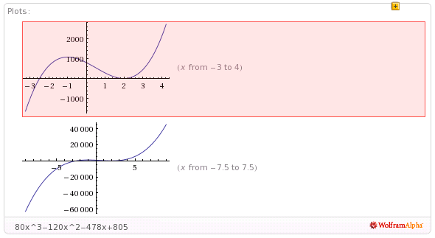

- 5/9 Consider the polynomial: this is a fourth degree polynomial – the information you entered appears to be about a third degree polynomial – did you enter 36x^4 correctly???
1
2
1
3
- How many roots does the polynomial have?

- How many real roots does the polynomial have?

- How many complex roots does the polynomial have?

- How many x-intercepts does the polynomial have?

- Factor the polynomial completely into irreducible polynomials (over the reals): factored over the complex field
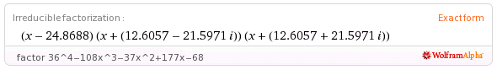

- Copy a graph of the polynomial (from a CAS into the textbox below) which clearly shows the behavior of the polynomial near the roots (if any) and near any local minimums or maximums (if any).

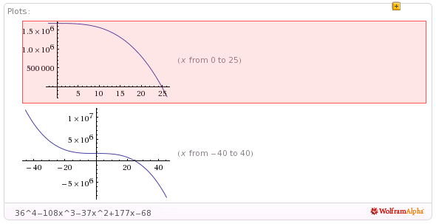
- 5.5/8 Consider the set
- Find a polynomial whose roots are exactly the elements of the set . Write the polynomial out in expanded form:
5x^3-35x^2+40x+80 does not have complex roots at 2+i, 2-i

2
- How many x-intercepts does the polynomial have?

- Copy a graph of the polynomial (from a CAS into the textbox below) which clearly shows the behavior of the polynomial near the roots (if any) and near any local minimums or maximums (if any). Detail near x=4?

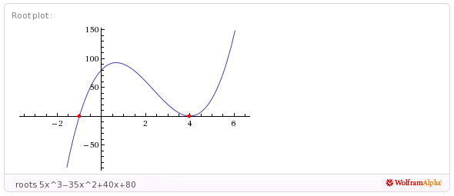
- 11/11 Consider the following set of functions:
- Which of the five functions have only complex roots?
No
No
No
Yes
Yes
y₁ y₂ y₃ y₄ y₅

- Estimate the minimum value of each function.
-1
-3/2
-1
.5
3
y₁ y₂ y₃ y₄ y₅

- Estimate the x-intercepts of those functions for which real roots exist.
None
-0.7, 0.7
None
y₁ y₂ y₃
1-(1/sqrt(2), 1+(1/sqrt(2))
.5(1+sqrt(3)), .5(1-sqrt(3)),

y₄ y₅

- Using a CAS, plot the graphs all five functions on the same coordinate axes. Copy the plot into the textbox below.
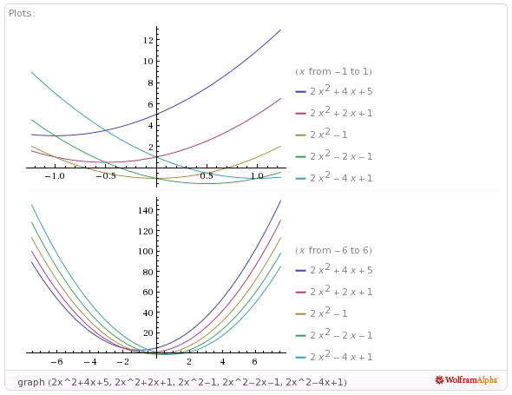

- 9/9 Consider the rational function:

- Does the function have vertical asymptotes? If so, where?
-2, 4
Yes
Yes/No Where?

- Does the function have a horizontal asymptote? If so, where?
2
Yes
Yes/No Where?

- Does the function have a slant asymptote?
No
Yes/No

- Copy a graph of the function (from a CAS into the textbox below) which clearly shows the behavior of the function near any intercepts (if any) and also shows the asymptotes (if any).
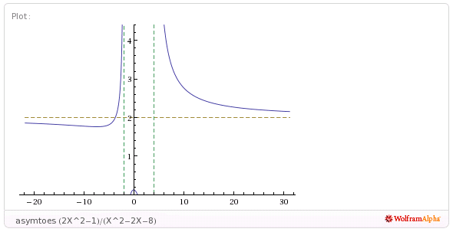

- 5.5/7 Consider the rational function:

- Does the function have vertical asymptotes? If so, where?
.5
Yes
Yes/No Where?

- Does the function have a horizontal asymptote? If so, where?
n/a
No
Yes/No Where?

- Does the function have a slant asymptote?
(x/2)-(7/4)
Yes/No

- Copy a graph of the function (from a CAS into the textbox below) which clearly shows the behavior of the function near any intercepts (if any) and also shows the asymptotes (if any). Not detailed enough to give information about intercepts
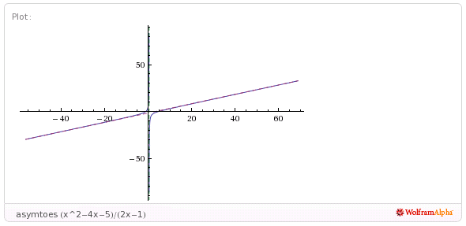
- 1/4 Using a CAS construct an implicit plot of the equation . Copy the graph of the equation from the CAS into the textbox below. Entered the equation into WolframAlpha incorrectly
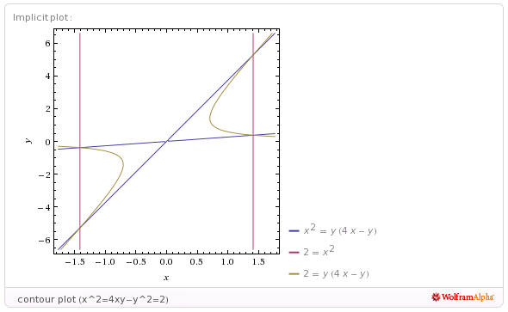

- 4/4 Using a CAS construct an plot of the 3-d graph of the function Copy the graph of the function from the CAS into the textbox below.
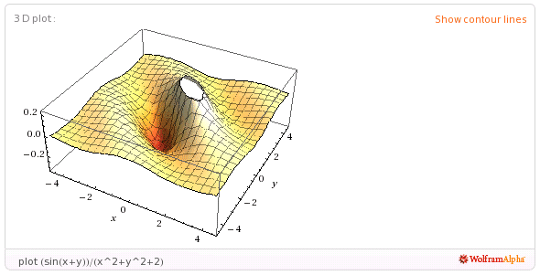
- 1/5 For the following sequence identify the next two missing terms and describe the pattern that the terms in the sequence follow.
0 error
1
{1,0,0,1,0,1,0,1,1,1,0,1,0,1,1,1,0, , , . . . }

Pattern:
I counted the zeros and the ones what??

- 5/5 For the following recursive sequence identify the next two missing terms and describe the pattern that the terms in the sequence follow.
85
171
{1, 1, 3, 5, 11, 21, 43, , , . . . }

Pattern:
I don’t know how to explain it but I worked it like so; n₁=(1+1)+1 n₂= (3+1)+1 n₃=(3+5)+3 and so on.

- 3/5 For the following sequence S find the specified missing terms. S is an arithmetic sequence for which the 6th and 10th terms are 27 and 55, resp.
174
-8
Find the 1st term and the 27th term: ,

- 0/5 For the following sequence S find an explicit functional formula for generating all of the terms of the sequence and find the 39th term of the sequence. S is the sequence given by

{1, 4, 11, 22, 37, . . . } where the second differences are constant.

error
error
Formula: ,

- 3.5/6 On the back of the instruction’s page for the exam, sketch on the same graph the derivative and the anti-derivative of function pictured below.

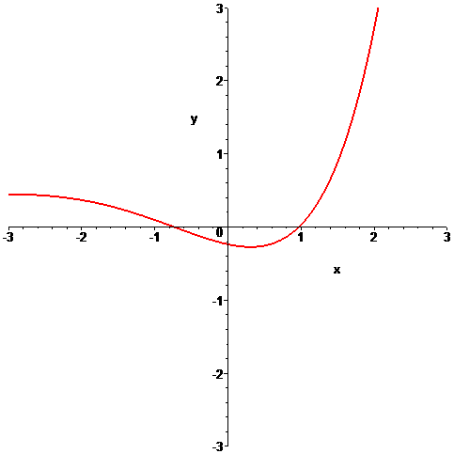

- 0/6 In the picture below the graphs of three functions are plotted on the same coordinate axes. Of the three graphs one is the graph of a function f , one is the graph of the derivative of f and one is the graph of an anti-derivative of f. Identify which graph is which:

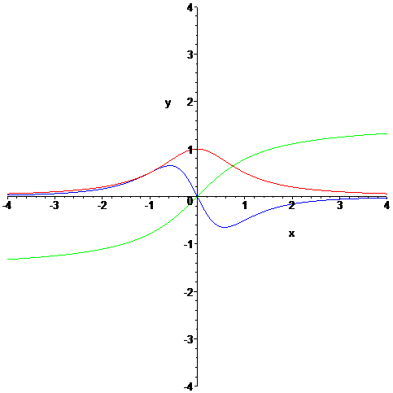

blue error
red error
green error
Function = Derivative = Anti-derivative =

