Name: Final Exam-B Math 4371
Natalie Hinzman

- 9/9 Consider the polynomial:

- How many roots does the polynomial have?
2
2
0
2

- How many real roots does the polynomial have?

- How many complex roots does the polynomial have?

- How many x-intercepts does the polynomial have?

- Factor the polynomial completely into irreducible polynomials (over the reals):
-(x-3)(3x+2)

- Copy a graph of the polynomial (from a CAS into the textbox below) which clearly shows the behavior of the polynomial near the roots (if any) and near any local minimums or maximums (if any).
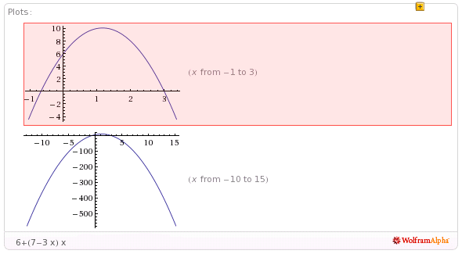

- 7.5/9 Consider the polynomial:
0
3
3
3
- How many roots does the polynomial have?

- How many real roots does the polynomial have?

- How many complex roots does the polynomial have?

- How many x-intercepts does the polynomial have?

- Factor the polynomial completely into irreducible polynomials (over the reals):
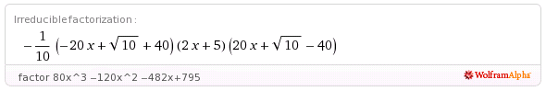

- Copy a graph of the polynomial (from a CAS into the textbox below) which clearly shows the behavior of the polynomial near the roots (if any) and near any local minimums or maximums (if any). Clearly display the behavior near the roots near x=2??
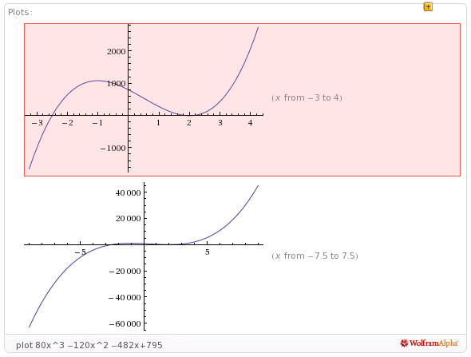

- 9/9 Consider the polynomial:
2
2
2
4
- How many roots does the polynomial have?

- How many real roots does the polynomial have?

- How many complex roots does the polynomial have?

- How many x-intercepts does the polynomial have?

- Factor the polynomial completely into irreducible polynomials (over the reals):
(x-(1+i))(x-(1-i))(3x+4)(6x-17)

- Copy a graph of the polynomial (from a CAS into the textbox below) which clearly shows the behavior of the polynomial near the roots (if any) and near any local minimums or maximums (if any).

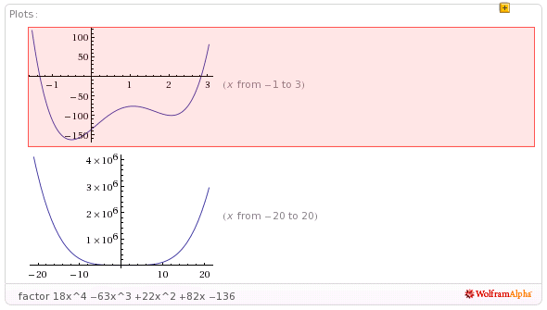
- 0/8 Consider the set
- Find a polynomial whose roots are exactly the elements of the set . Write the polynomial out in expanded form:
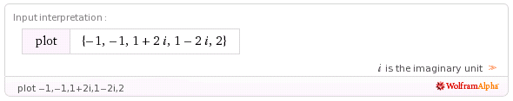

0
- How many x-intercepts does the polynomial have?

- Copy a graph of the polynomial (from a CAS into the textbox below) which clearly shows the behavior of the polynomial near the roots (if any) and near any local minimums or maximums (if any).

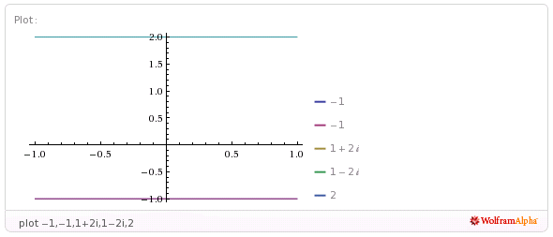
- 11/11 Consider the following set of functions:
- Which of the five functions have only complex roots?
Yes
Yes
No
No
Yes
y₁ y₂ y₃ y₄ y₅

- Estimate the minimum value of each function.
X= - ½, Y= ½
X= - ¼, Y= - 9/8
X=0 ,
Y= -1
X= ¼,
Y= 7/8
X= ½,
Y= 9/2
y₁ y₂ y₃ y₄ y₅

- Estimate the x-intercepts of those functions for which real roots exist.
X- intercepts: -0.7, 0.7
No real roots exist
No real roots exist
y₁ y₂ y₃
X-intercepts: -1, 0.5
No real roots exist
y₄ y₅

- Using a CAS, plot the graphs all five functions on the same coordinate axes. Copy the plot into the textbox below.
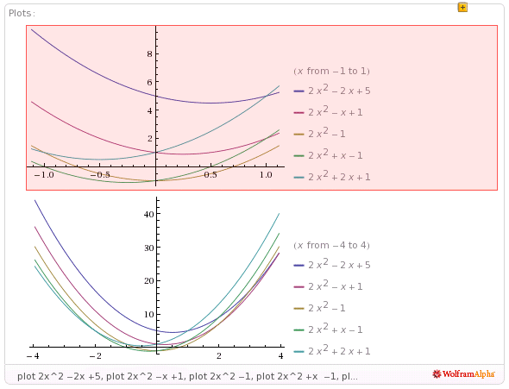
- 6.5/9 Consider the rational function:

- Does the function have vertical asymptotes? If so, where?
As X ->-2 and as
X -> 4
Yes, two
Yes/No Where?

- Does the function have a horizontal asymptote? If so, where?
As X -> both error positive and negative infinity
Yes, one
Yes/No Where?

- Does the function have a slant asymptote?
No
Yes/No

- Copy a graph of the function (from a CAS into the textbox below) which clearly shows the behavior of the function near any intercepts (if any) and also shows the asymptotes (if any). Clearly show the asymptotes??
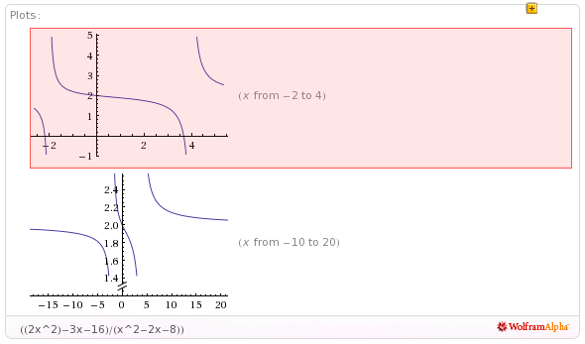

- 5/7 Consider the rational function:

- Does the function have vertical asymptotes? If so, where?
As X -> -3/2
Yes, one
Yes/No Where?

- Does the function have a horizontal asymptote? If so, where?
N/A
No
Yes/No Where?

- Does the function have a slant asymptote?
Yes
Yes/No

- Copy a graph of the function (from a CAS into the textbox below) which clearly shows the behavior of the function near any intercepts (if any) and also shows the asymptotes (if any). Clearly display the intercepts?? Clearly display the vertical asymptote??
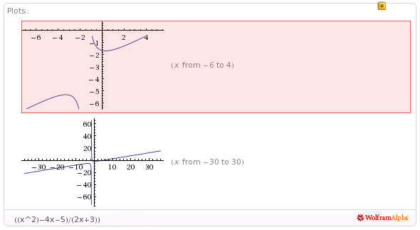
- 4/4 Using a CAS construct an implicit plot of the equation . Copy the graph of the equation from the CAS into the textbox below.
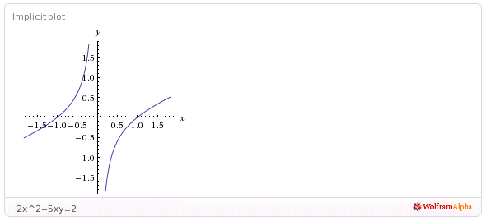

- 4/4 Using a CAS construct an plot of the 3-d graph of the function Copy the graph of the function from the CAS into the textbox below.
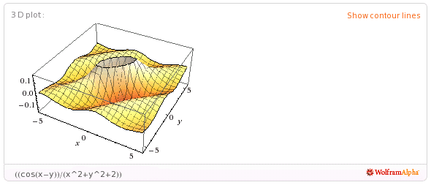

- 5/5 For the following sequence identify the next two missing terms and describe the pattern that the terms in the sequence follow.
1
1
{0,1,1,0,1,1,1,1,0,1,1,1,1,1,1,0,1, , , . . . }

Pattern:
After each zero, the pattern adds two more ones. After the first zero, there are two ones. After the second zero, there are four ones. After the third zero, there are six ones. After this fourth zero, there should be eight ones.

- 5/5 For the following recursive sequence identify the next two missing terms and describe the pattern that the terms in the sequence follow.
239
577
{1, 1, 3, 7, 17, 41, 99, , , . . . }
The pattern to finding the next number is you multiply the current number (n) by 2, and then add previous number before that current number in the sequence to the 2*n. EX: To go from 7 to 17, you multiply 7*2 which is 14, and then add that number to the previous number in the sequence, which was 3, to the 2*7 to give you the next number in the sequence, 17.
Pattern:

- 3/3 For the following sequence S find the specified missing terms. S is an arithmetic sequence for which the 5th and 9th terms are 27 and 59, resp.
203
-5
Find the 1st term and the 27th term: ,

- 2/5 For the following sequence S find an explicit functional formula for generating all of the terms of the sequence and find the 39th term of the sequence. S is the sequence given by

{1, 5, 14, 28, 47, . . . } where the second differences are constant.

But, what is a formula for computing the nth term?
The difference between the first and the second term, and the second and the third term, those two differences together have a difference of 5.
For example: the difference between 1 and 5 is 4, and the difference between 5 and 14 is 9. The difference between 4 and 9 is 5.
The difference between 5 and 14 is 9, and the different between 14 and 28 is 14. The difference between 9 and 14 is 5.
3668
Formula: ,

- 4.5/6 On the back of the instruction’s page for the exam, sketch on the same graph the derivative and the anti-derivative of function pictured below.

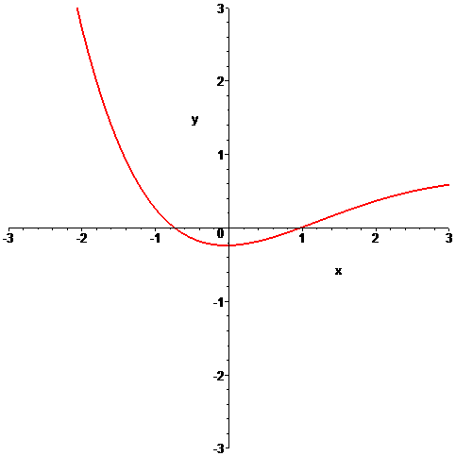

- 0/6 In the picture below the graphs of three functions are plotted on the same coordinate axes. Of the three graphs one is the graph of a function f , one is the graph of the derivative of f and one is the graph of an anti-derivative of f. Identify which graph is which:

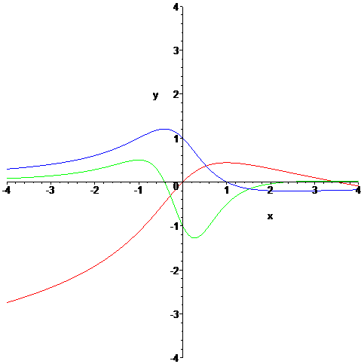

GREEN error
BLUE error
Function = Derivative = Anti-derivative =
RED error

