Name: Final Exam-A Math 4371
Nicholas Parker

- 9/9 Consider the polynomial:
2
- How many roots does the polynomial have?
2
- How many real roots does the polynomial have?
0
- How many complex roots does the polynomial have?
2
- How many x-intercepts does the polynomial have?

- Factor the polynomial completely into irreducible polynomials (over the reals):
(x-2)(2x+1)

- Copy a graph of the polynomial (from a CAS into the textbox below) which clearly shows the behavior of the polynomial near the roots (if any) and near any local minimums or maximums (if any).
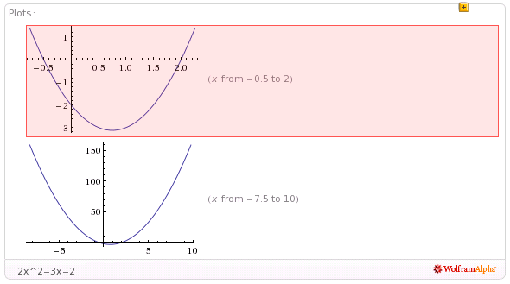

- 9/9 Consider the polynomial:
1
2
1
3
- How many roots does the polynomial have?

- How many real roots does the polynomial have?

- How many complex roots does the polynomial have?

- How many x-intercepts does the polynomial have?

- Factor the polynomial completely into irreducible polynomials (over the reals):
(2x+5)(40x²-160x+161)

- Copy a graph of the polynomial (from a CAS into the textbox below) which clearly shows the behavior of the polynomial near the roots (if any) and near any local minimums or maximums (if any).

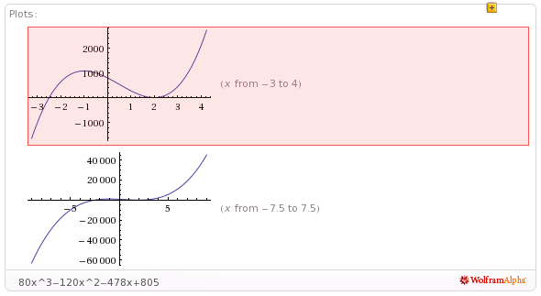
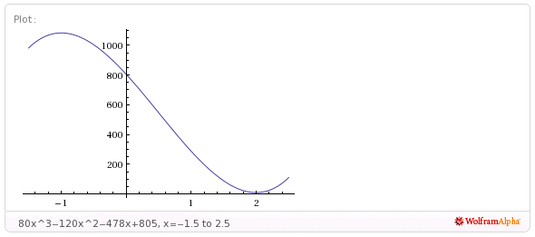

- 8/9 Consider the polynomial:
4
0
4
4
- How many roots does the polynomial have?

- How many real roots does the polynomial have?

- How many complex roots does the polynomial have?

- How many x-intercepts does the polynomial have?

- Factor the polynomial completely into irreducible polynomials (over the reals):
(x-1)(2x-1)(3x+4)(6x-17)

- Copy a graph of the polynomial (from a CAS into the textbox below) which clearly shows the behavior of the polynomial near the roots (if any) and near any local minimums or maximums (if any). Detail near x=1 clearly displayed??

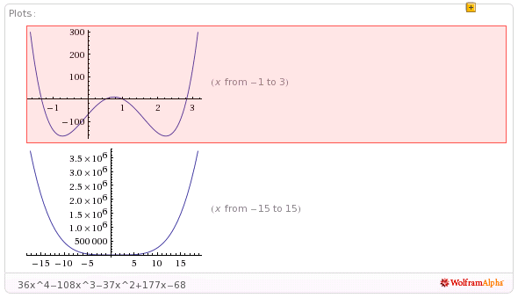
- 8/8 Consider the set
- Find a polynomial whose roots are exactly the elements of the set . Write the polynomial out in expanded form:
x⁵-11x⁴+41x³-51x²-24x+80

2
- How many x-intercepts does the polynomial have?

- Copy a graph of the polynomial (from a CAS into the textbox below) which clearly shows the behavior of the polynomial near the roots (if any) and near any local minimums or maximums (if any).

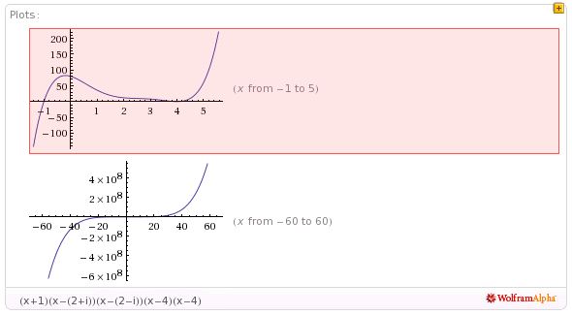
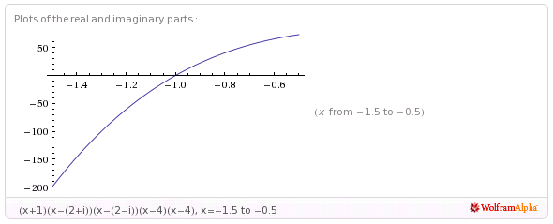
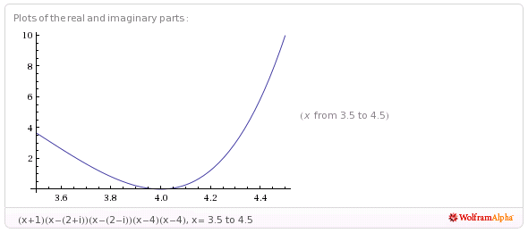
- 11/11 Consider the following set of functions:
- Which of the five functions have only complex roots?
no
no
no
yes
yes
y₁ y₂ y₃ y₄ y₅

- Estimate the minimum value of each function.
-1
-3/2
-1
1/2
3
y₁ y₂ y₃ y₄ y₅

- Estimate the x-intercepts of those functions for which real roots exist.
-
0.707, -0.707
-
y₁ y₂ y₃
1.707, 0.293
1.366, -0.366
y₄ y₅

- Using a CAS, plot the graphs all five functions on the same coordinate axes. Copy the plot into the textbox below.
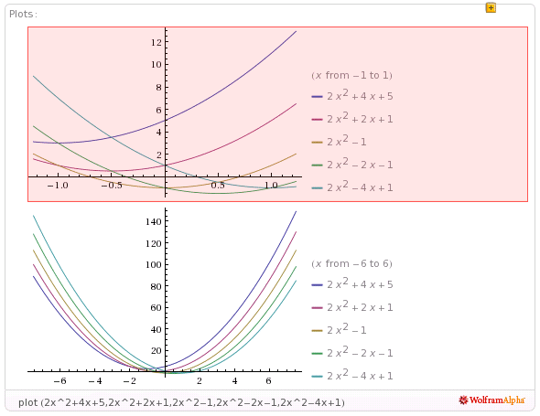

- 8/9 Consider the rational function:

- Does the function have vertical asymptotes? If so, where?
x = -2, x = 4
yes
Yes/No Where?

- Does the function have a horizontal asymptote? If so, where?
y = 2.0
yes
Yes/No Where?

- Does the function have a slant asymptote?
no
Yes/No

- Copy a graph of the function (from a CAS into the textbox below) which clearly shows the behavior of the function near any intercepts (if any) and also shows the asymptotes (if any). Detail of intercepts???
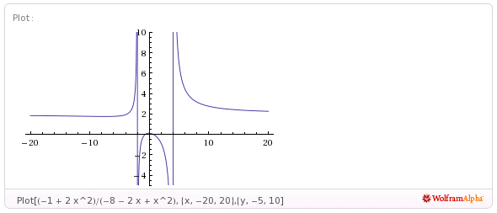

- 6/7 Consider the rational function:

- Does the function have vertical asymptotes? If so, where?
x = 0.5
yes
Yes/No Where?

- Does the function have a horizontal asymptote? If so, where?
-
no
Yes/No Where?

- Does the function have a slant asymptote?
yes, y = .5x
Yes/No

- Copy a graph of the function (from a CAS into the textbox below) which clearly shows the behavior of the function near any intercepts (if any) and also shows the asymptotes (if any). Clearly display intercepts??
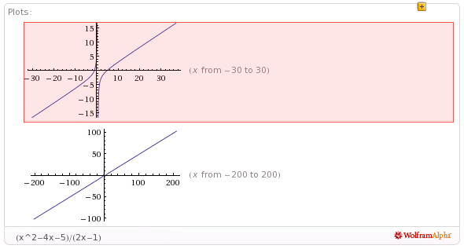
- 4/4 Using a CAS construct an implicit plot of the equation . Copy the graph of the equation from the CAS into the textbox below.
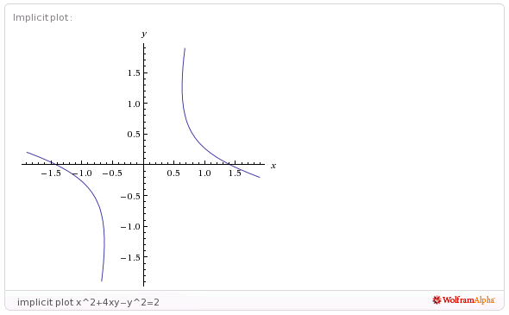

- 4/4 Using a CAS construct an plot of the 3-d graph of the function Copy the graph of the function from the CAS into the textbox below.
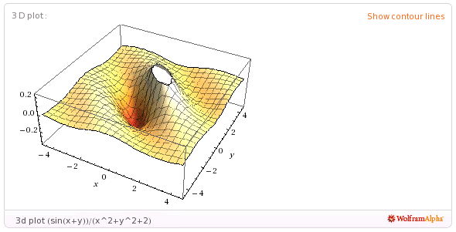
- 3/5 For the following sequence identify the next two missing terms and describe the pattern that the terms in the sequence follow.
23 error
19 error
{1,0,0,1,0,1,0,1,1,1,0,1,0,1,1,1,0, , , . . . }

Pattern:
prime-numbered terms are zero

- 5/5 For the following recursive sequence identify the next two missing terms and describe the pattern that the terms in the sequence follow.
85
171
{1, 1, 3, 5, 11, 21, 43, , , . . . }

Pattern:
a_{n} = a_{n-1} + 2a_{n-2}

- 3/3 For the following sequence S find the specified missing terms. S is an arithmetic sequence for which the 6th and 10th terms are 27 and 55, resp.
174
-8
Find the 1st term and the 27th term: ,

- 5/5 For the following sequence S find an explicit functional formula for generating all of the terms of the sequence and find the 39th term of the sequence. S is the sequence given by

{1, 4, 11, 22, 37, . . . } where the second differences are constant.

A_{n} = 2n² - 3n + 2
2927
Formula: ,

- 6/6 On the back of the instruction’s page for the exam, sketch on the same graph the derivative and the anti-derivative of function pictured below.

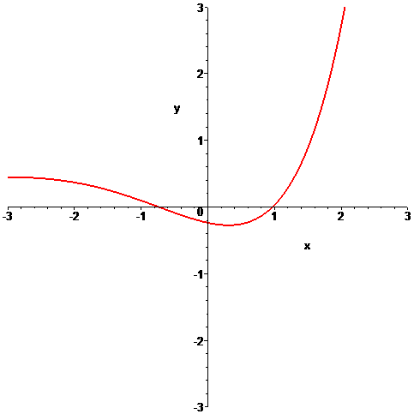

- 6/6 In the picture below the graphs of three functions are plotted on the same coordinate axes. Of the three graphs one is the graph of a function f , one is the graph of the derivative of f and one is the graph of an anti-derivative of f. Identify which graph is which:

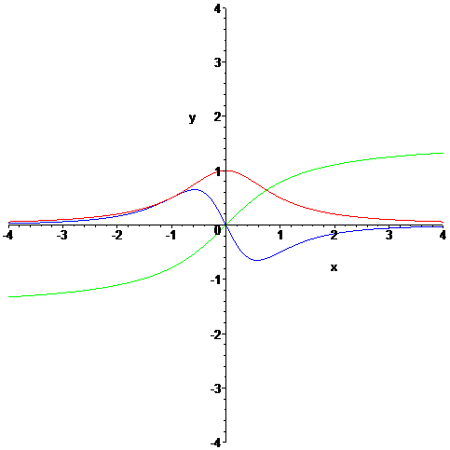

green
blue
red
Function = Derivative = Anti-derivative =

