Name: Final Exam-B Math 4371
Rodney Lomas

- 9/9 Consider the polynomial:

- How many roots does the polynomial have?
2
2
0
2

- How many real roots does the polynomial have?

- How many complex roots does the polynomial have?

- How many x-intercepts does the polynomial have?

- Factor the polynomial completely into irreducible polynomials (over the reals):
p(x)=-(x-3)(3x+2)
Roots= -2/3,3

- Copy a graph of the polynomial (from a CAS into the textbox below) which clearly shows the behavior of the polynomial near the roots (if any) and near any local minimums or maximums (if any).
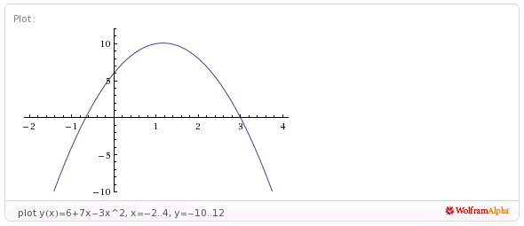

- 9/9 Consider the polynomial:
0
3
3
3
- How many roots does the polynomial have?

- How many real roots does the polynomial have?

- How many complex roots does the polynomial have?

- How many x-intercepts does the polynomial have?

- Factor the polynomial completely into irreducible polynomials (over the reals):
q(x)=(2x+5)(40x^2-160x+159)

- Copy a graph of the polynomial (from a CAS into the textbox below) which clearly shows the behavior of the polynomial near the roots (if any) and near any local minimums or maximums (if any).
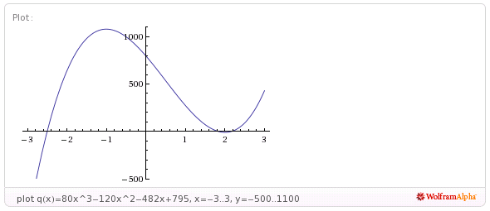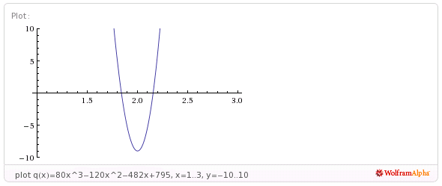

- 9/9 Consider the polynomial:
2
2
2
4
- How many roots does the polynomial have?

- How many real roots does the polynomial have?

- How many complex roots does the polynomial have?

- How many x-intercepts does the polynomial have?

- Factor the polynomial completely into irreducible polynomials (over the reals):
r(x)=(3x+4)(6x-17)(x^2-2x+2)

- Copy a graph of the polynomial (from a CAS into the textbox below) which clearly shows the behavior of the polynomial near the roots (if any) and near any local minimums or maximums (if any).

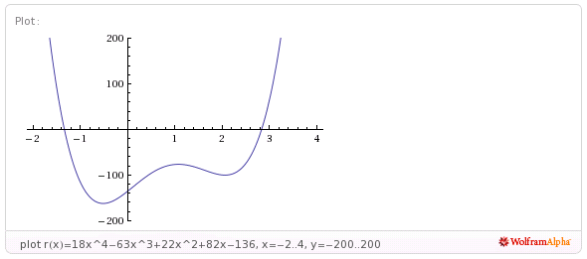
- 6.5/8 Consider the set
- Find a polynomial whose roots are exactly the elements of the set . Write the polynomial out in expanded form:
y(x)=(x+1)(x-(1+2i))(x-(1-2i))(x-2) the root x=-1 is listed twice in the set but appears only once as a root of your polynomial
y(x)=x^4-3 x^3+5 x^2-x-10

2
- How many x-intercepts does the polynomial have?

- Copy a graph of the polynomial (from a CAS into the textbox below) which clearly shows the behavior of the polynomial near the roots (if any) and near any local minimums or maximums (if any).

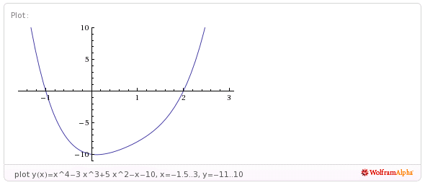
- 11/11 Consider the following set of functions:
- Which of the five functions have only complex roots?
This one

This one
This one
y₁ y₂ y₃ y₄ y₅

- Estimate the minimum value of each function.
.5
-1.1
-1
.88
4.5
y₁ y₂ y₃ y₄ y₅

- Estimate the x-intercepts of those functions for which real roots exist.
None
.71,-.71
None
y₁ y₂ y₃
None
-1, .5
y₄ y₅

- Using a CAS, plot the graphs all five functions on the same coordinate axes. Copy the plot into the textbox below.
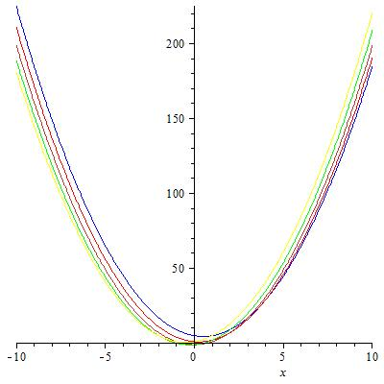
- 9/9 Consider the rational function:

- Does the function have vertical asymptotes? If so, where?
-2,4
Yes
Yes/No Where?

- Does the function have a horizontal asymptote? If so, where?
2
yes
Yes/No Where?

- Does the function have a slant asymptote?
No
Yes/No

- Copy a graph of the function (from a CAS into the textbox below) which clearly shows the behavior of the function near any intercepts (if any) and also shows the asymptotes (if any).
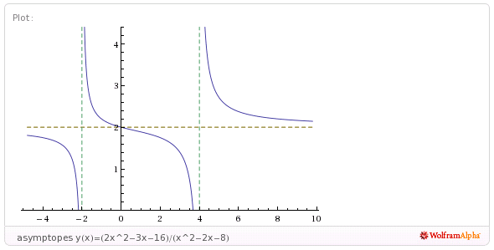

- 7/7 Consider the rational function:

- Does the function have vertical asymptotes? If so, where?
-3/2
yes
Yes/No Where?

- Does the function have a horizontal asymptote? If so, where?

No
Yes/No Where?

- Does the function have a slant asymptote?
Yes
Yes/No

- Copy a graph of the function (from a CAS into the textbox below) which clearly shows the behavior of the function near any intercepts (if any) and also shows the asymptotes (if any).
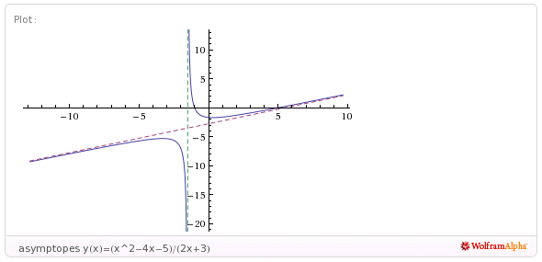
- 4/4 Using a CAS construct an implicit plot of the equation . Copy the graph of the equation from the CAS into the textbox below.
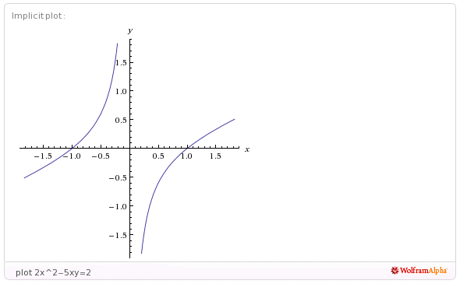

- 4/4 Using a CAS construct an plot of the 3-d graph of the function Copy the graph of the function from the CAS into the textbox below.
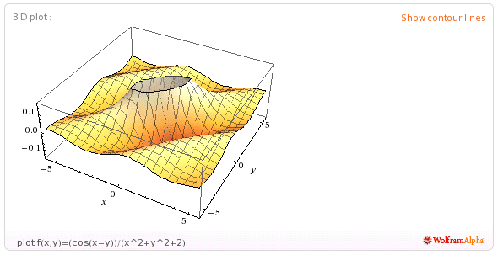

- 5/5 For the following sequence identify the next two missing terms and describe the pattern that the terms in the sequence follow.
1
1
{0,1,1,0,1,1,1,1,0,1,1,1,1,1,1,0,1, , , . . . }

Pattern:
0 then the next even number counted out in 1s.
Theres a 0 then two 1s, a zero then 4 ones, a zero then 6 ones, ect

- 2/5 For the following recursive sequence identify the next two missing terms and describe the pattern that the terms in the sequence follow.
239
577
{1, 1, 3, 7, 17, 41, 99, , , . . . }

Pattern:
=(x-1)/(x^2+2x-1) what ???

- 3/3 For the following sequence S find the specified missing terms. S is an arithmetic sequence for which the 5th and 9th terms are 27 and 59, resp.
203
-5
Find the 1st term and the 27th term: ,

- 5/5 For the following sequence S find an explicit functional formula for generating all of the terms of the sequence and find the 39th term of the sequence. S is the sequence given by

{1, 5, 14, 28, 47, . . . } where the second differences are constant.

an= 1/2 (5n^2-7n+4)

3668
Formula: ,

- 5/6 On the back of the instruction’s page for the exam, sketch on the same graph the derivative and the anti-derivative of function pictured below.

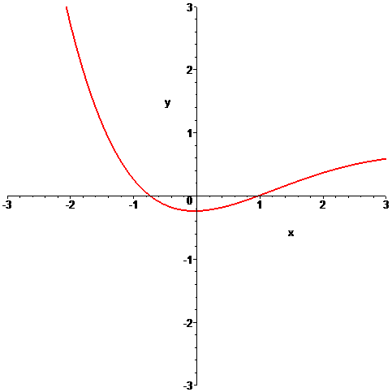

- 6/6 In the picture below the graphs of three functions are plotted on the same coordinate axes. Of the three graphs one is the graph of a function f , one is the graph of the derivative of f and one is the graph of an anti-derivative of f. Identify which graph is which:

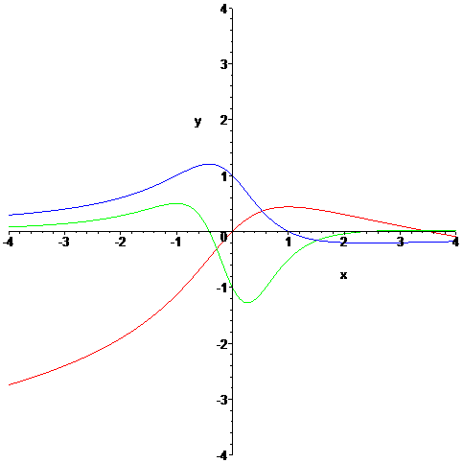

Red
Green
Function = Derivative = Anti-derivative =
Blue

