Name: Final Exam-B Math 4371
Sandi Hansen

- 9/9 Consider the polynomial:

- How many roots does the polynomial have?
2
2
0
2

- How many real roots does the polynomial have?

- How many complex roots does the polynomial have?

- How many x-intercepts does the polynomial have?

- Factor the polynomial completely into irreducible polynomials (over the reals):
-(x-3)(3x+2)

- Copy a graph of the polynomial (from a CAS into the textbox below) which clearly shows the behavior of the polynomial near the roots (if any) and near any local minimums or maximums (if any).
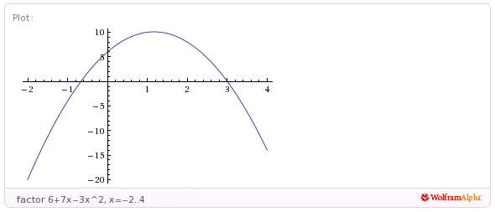

- 8/9 Consider the polynomial:
0
3
3
3
- How many roots does the polynomial have?

- How many real roots does the polynomial have?

- How many complex roots does the polynomial have?

- How many x-intercepts does the polynomial have?

- Factor the polynomial completely into irreducible polynomials (over the reals):

(2x+5)(4x^2-160x+159)

- Copy a graph of the polynomial (from a CAS into the textbox below) which clearly shows the behavior of the polynomial near the roots (if any) and near any local minimums or maximums (if any). Clearly display behavior near roots?
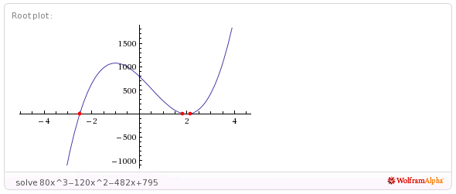

- 9/9 Consider the polynomial:
2
2
2
4
- How many roots does the polynomial have?

- How many real roots does the polynomial have?

- How many complex roots does the polynomial have?

- How many x-intercepts does the polynomial have?

- Factor the polynomial completely into irreducible polynomials (over the reals):
(3x+4)(6x-17)(x^2-2x+2)

- Copy a graph of the polynomial (from a CAS into the textbox below) which clearly shows the behavior of the polynomial near the roots (if any) and near any local minimums or maximums (if any).

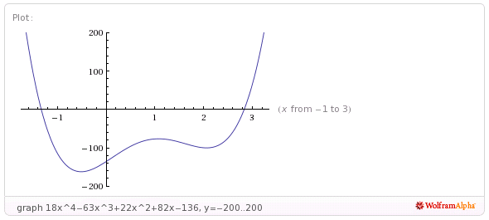
- 8/8 Consider the set
- Find a polynomial whose roots are exactly the elements of the set . Write the polynomial out in expanded form:

x^5-2x^4+2x^3+4x^2-11x-10

2 (there is a double root at the point (-1 ,0)) and an intercept at (2,0)

- How many x-intercepts does the polynomial have?

- Copy a graph of the polynomial (from a CAS into the textbox below) which clearly shows the behavior of the polynomial near the roots (if any) and near any local minimums or maximums (if any).

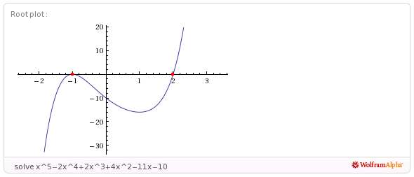
- 11/11 Consider the following set of functions:
- Which of the five functions have only complex roots?
Complex only
Real only
Complex only
Complex only

Real only
y₁ y₂ y₃ y₄ y₅

- Estimate the minimum value of each function.
(-½ , ½)
(-1/4, -9/8)
(0, -1)
(1/4, 7/8)
( ½, 9/2)
y₁ y₂ y₃ y₄ y₅

- Estimate the x-intercepts of those functions for which real roots exist.
( -1/(sqrt(2)),0) ~-0.707107 & (1/(sqrt(2)), 0) ~ 0.707107
No real roots
No real roots
y₁ y₂ y₃
No real roots
(-1, 0) & (1/2, 0)
y₄ y₅

- Using a CAS, plot the graphs all five functions on the same coordinate axes. Copy the plot into the textbox below.
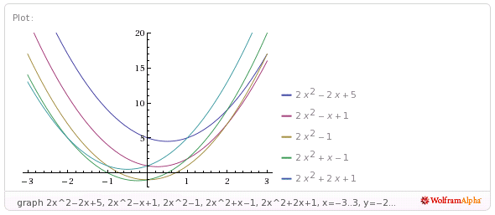
- 7/9 Consider the rational function:

- Does the function have vertical asymptotes? If so, where?
x=-2, 4
Yes
Yes/No Where?

- Does the function have a horizontal asymptote? If so, where?
error
No error
Yes/No Where?

- Does the function have a slant asymptote?
No
Yes/No

- Copy a graph of the function (from a CAS into the textbox below) which clearly shows the behavior of the function near any intercepts (if any) and also shows the asymptotes (if any).
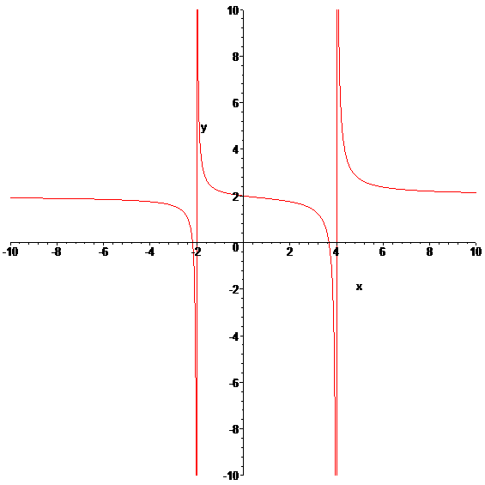

- 7/7 Consider the rational function:

- Does the function have vertical asymptotes? If so, where?
x= -3/2
Yes
Yes/No Where?

- Does the function have a horizontal asymptote? If so, where?

No
Yes/No Where?

- Does the function have a slant asymptote?
Yes
Yes/No

- Copy a graph of the function (from a CAS into the textbox below) which clearly shows the behavior of the function near any intercepts (if any) and also shows the asymptotes (if any).
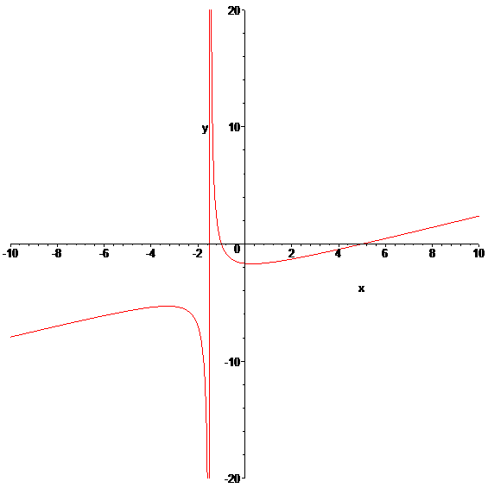
- 4/4 Using a CAS construct an implicit plot of the equation . Copy the graph of the equation from the CAS into the textbox below.
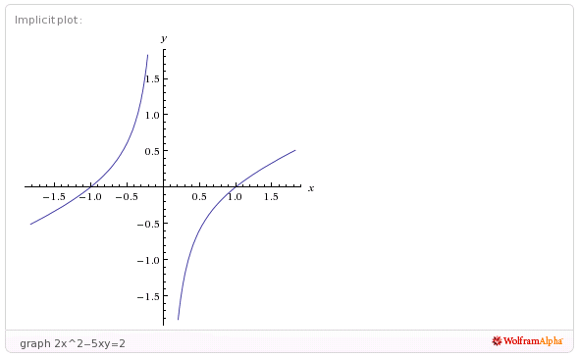

- 4/4 Using a CAS construct an plot of the 3-d graph of the function Copy the graph of the function from the CAS into the textbox below.
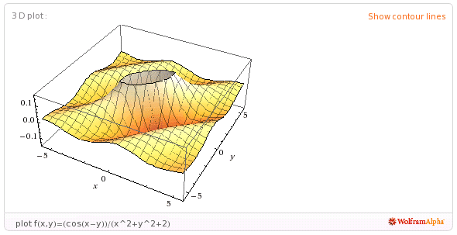

- 5/5 For the following sequence identify the next two missing terms and describe the pattern that the terms in the sequence follow.
1
1
{0,1,1,0,1,1,1,1,0,1,1,1,1,1,1,0,1, , , . . . }

Pattern:
There are 1’s (starting with 0,1,1) and increasing the number of 1’s by 2 after each 0.

- 2/5 For the following recursive sequence identify the next two missing terms and describe the pattern that the terms in the sequence follow.
(2853/11)
1009
{1, 1, 3, 7, 17, 41, 99, , , . . . }

Pattern:
Use the generating function: (x-1)/(x^2+2x-1) ????

- 3/3 For the following sequence S find the specified missing terms. S is an arithmetic sequence for which the 5th and 9th terms are 27 and 59, resp.
203
-5
Find the 1st term and the 27th term: ,

- 5/5 For the following sequence S find an explicit functional formula for generating all of the terms of the sequence and find the 39th term of the sequence. S is the sequence given by

{1, 5, 14, 28, 47, . . . } where the second differences are constant.

(1/2)(5n^2-7n+4)
3668
Formula: ,

- 2/6 On the back of the instruction’s page for the exam, sketch on the same graph the derivative and the anti-derivative of function pictured below.

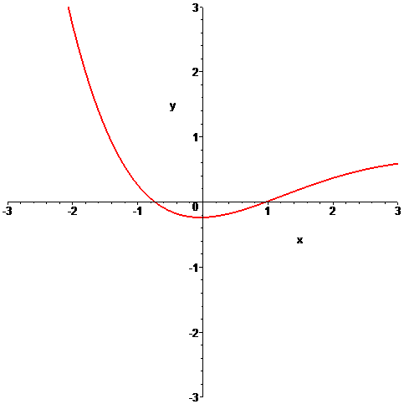

- 2/6 In the picture below the graphs of three functions are plotted on the same coordinate axes. Of the three graphs one is the graph of a function f , one is the graph of the derivative of f and one is the graph of an anti-derivative of f. Identify which graph is which:

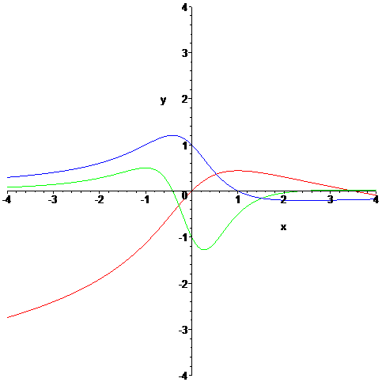

green error
red error
Function = Derivative = Anti-derivative =
blue

