Name: Final Exam-A Math 4371
Sarah Rasch

- 9/9 Consider the polynomial:
2
- How many roots does the polynomial have?
2
- How many real roots does the polynomial have?
0
- How many complex roots does the polynomial have?
2
- How many x-intercepts does the polynomial have?

- Factor the polynomial completely into irreducible polynomials (over the reals):
(x-2) (2x+1)

- Copy a graph of the polynomial (from a CAS into the textbox below) which clearly shows the behavior of the polynomial near the roots (if any) and near any local minimums or maximums (if any).
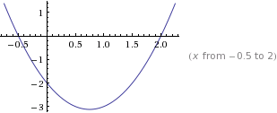

- 6/9 Consider the polynomial:
3 ? error

2
1
3
- How many roots does the polynomial have?

- How many real roots does the polynomial have?

- How many complex roots does the polynomial have?

- How many x-intercepts does the polynomial have?

- Factor the polynomial completely into irreducible polynomials (over the reals):
1/10 (-20 i x+sqrt(10)+40 i) (20 i x+sqrt(10)-40 i) (2 x+5) factored over the complex field

- Copy a graph of the polynomial (from a CAS into the textbox below) which clearly shows the behavior of the polynomial near the roots (if any) and near any local minimums or maximums (if any). Need to show behavior near the local minimum near x=2
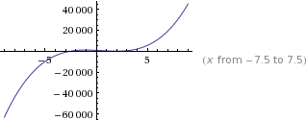

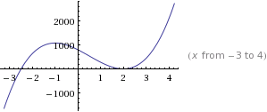

- 8/9 Consider the polynomial:
4
0
4
4
- How many roots does the polynomial have?

- How many real roots does the polynomial have?

- How many complex roots does the polynomial have?

- How many x-intercepts does the polynomial have?

- Factor the polynomial completely into irreducible polynomials (over the reals):
(x-1) (2 x-1) (3 x+4) (6 x-17)

- Copy a graph of the polynomial (from a CAS into the textbox below) which clearly shows the behavior of the polynomial near the roots (if any) and near any local minimums or maximums (if any). Clear view of local behavior near the roots near x=1??

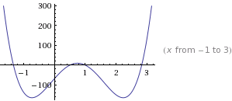

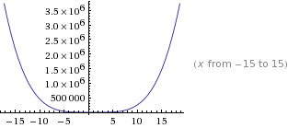
- 0/8 Consider the set
- Find a polynomial whose roots are exactly the elements of the set . Write the polynomial out in expanded form:

5
- How many x-intercepts does the polynomial have?

- Copy a graph of the polynomial (from a CAS into the textbox below) which clearly shows the behavior of the polynomial near the roots (if any) and near any local minimums or maximums (if any).

- 11/11 Consider the following set of functions:
- Which of the five functions have only complex roots?
No
No
No
Yes
yes
y₁ y₂ y₃ y₄ y₅

- Estimate the minimum value of each function.
min{2 x^2-1} = -1 at x = 0

-1
-1.5
(-.5, .5)
(-1, 3)
y₁ y₂ y₃ y₄ y₅

- Estimate the x-intercepts of those functions for which real roots exist.
None
.7 , -.7
None
y₁ y₂ y₃
.3, .7
-.4, 1.4
y₄ y₅

- Using a CAS, plot the graphs all five functions on the same coordinate axes. Copy the plot into the textbox below.
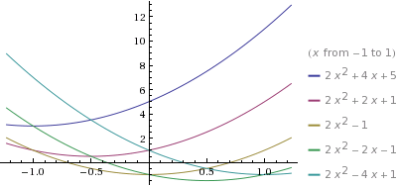
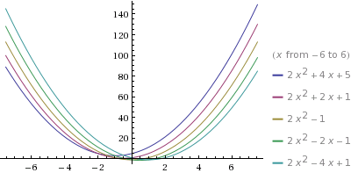

- 4.5/9 Consider the rational function:

- Does the function have vertical asymptotes? If so, where?
Right along the Y axis lie around x= -5 keeps getting closer to
error

Yes
Yes/No Where?

- Does the function have a horizontal asymptote? If so, where?
Keeps going from around (4, 1.9) and keeps going around the 1.9 of y and also on the positive side of the x and y axis
error

Yes
Yes/No Where?

- Does the function have a slant asymptote?
NO
Yes/No

- Copy a graph of the function (from a CAS into the textbox below) which clearly shows the behavior of the function near any intercepts (if any) and also shows the asymptotes (if any). Clearly show the asymptotes?? Show intercepts??
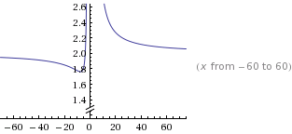

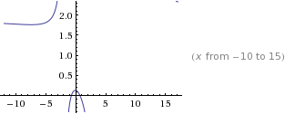

- 6/7 Consider the rational function:

- Does the function have vertical asymptotes? If so, where?
Right along the (0, _) both positive and negative error

yes
Yes/No Where?

- Does the function have a horizontal asymptote? If so, where?
-------
No
Yes/No Where?

- Does the function have a slant asymptote?
YES
Yes/No

- Copy a graph of the function (from a CAS into the textbox below) which clearly shows the behavior of the function near any intercepts (if any) and also shows the asymptotes (if any).
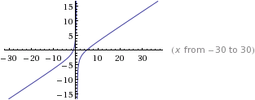
- 4/4 Using a CAS construct an implicit plot of the equation . Copy the graph of the equation from the CAS into the textbox below.
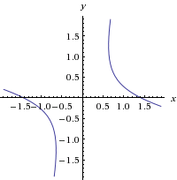

- 4/4 Using a CAS construct an plot of the 3-d graph of the function Copy the graph of the function from the CAS into the textbox below.
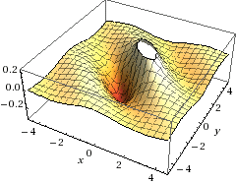
- 5/5 For the following sequence identify the next two missing terms and describe the pattern that the terms in the sequence follow.
0
1
{1,0,0,1,0,1,0,1,1,1,0,1,0,1,1,1,0, , , . . . }

Pattern:
If you group them by threes you have 100, 101,011,101,011,101, 0

- 5/5 For the following recursive sequence identify the next two missing terms and describe the pattern that the terms in the sequence follow.
85
171
{1, 1, 3, 5, 11, 21, 43, , , . . . }

Pattern:
You are constantly adding. To find the 2nd term you add the previous numbers which give you 1. For the 3rd term you add the previous number plus 1. Then for the 4th term you add the you add the previous terms. The 5th previous plus 1. Basically what you get for the even number terms in the sequence you just add the previous terms all together. For the odd terms in the sequence you add the previous number pluss one!

- 1.5/3 For the following sequence S find the specified missing terms. S is an arithmetic sequence for which the 6th and 10th terms are 27 and 55, resp.
190 error

-8
Find the 1st term and the 27th term: ,

- 0/5 For the following sequence S find an explicit functional formula for generating all of the terms of the sequence and find the 39th term of the sequence. S is the sequence given by

{1, 4, 11, 22, 37, . . . } where the second differences are constant.

Formula: ,

- 4/6 On the back of the instruction’s page for the exam, sketch on the same graph the derivative and the anti-derivative of function pictured below.

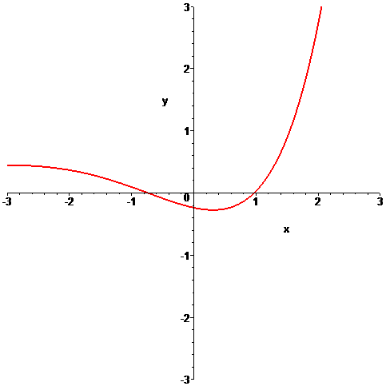

- 6/6 In the picture below the graphs of three functions are plotted on the same coordinate axes. Of the three graphs one is the graph of a function f , one is the graph of the derivative of f and one is the graph of an anti-derivative of f. Identify which graph is which:

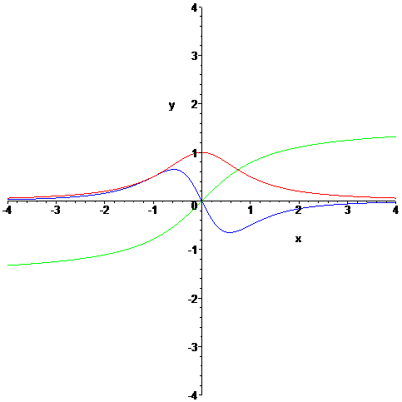

Green
Blue
red
Function = Derivative = Anti-derivative =

