Name: Final Exam-A Math 4371
Taylor Teutsch

- 9/9 Consider the polynomial:
It has two.
- How many roots does the polynomial have?
It has two.
- How many real roots does the polynomial have?
It does not have any.
- How many complex roots does the polynomial have?
It has two.
- How many x-intercepts does the polynomial have?

- Factor the polynomial completely into irreducible polynomials (over the reals):
(x-2)(2x+1)

- Copy a graph of the polynomial (from a CAS into the textbox below) which clearly shows the behavior of the polynomial near the roots (if any) and near any local minimums or maximums (if any).
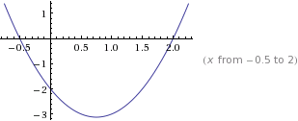

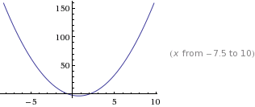

- 5.5/9 Consider the polynomial:
It has two. error
It has two.
It has one.
It has three.
- How many roots does the polynomial have?

- How many real roots does the polynomial have?

- How many complex roots does the polynomial have?

- How many x-intercepts does the polynomial have?

- Factor the polynomial completely into irreducible polynomials (over the reals):
1/10 (-20 i x+sqrt(10)+40 i) (20 i x+sqrt(10)-40 i) (2 x+5) factored over the complex field

- Copy a graph of the polynomial (from a CAS into the textbox below) which clearly shows the behavior of the polynomial near the roots (if any) and near any local minimums or maximums (if any). Does not show enough detail near the local minimum near x=2
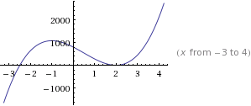

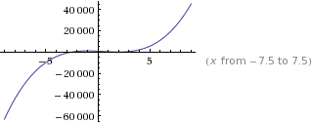

- 8/9 Consider the polynomial:
It has four.
It does not have any.
It has four.
It has four.
- How many roots does the polynomial have?

- How many real roots does the polynomial have?

- How many complex roots does the polynomial have?

- How many x-intercepts does the polynomial have?

- Factor the polynomial completely into irreducible polynomials (over the reals):
(x-1)(2x-1)(3x+4)(6x-17)

- Copy a graph of the polynomial (from a CAS into the textbox below) which clearly shows the behavior of the polynomial near the roots (if any) and near any local minimums or maximums (if any). Detail around the roots near x=1??

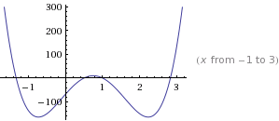

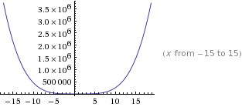
- 1.5/8 Consider the set
- Find a polynomial whose roots are exactly the elements of the set . Write the polynomial out in expanded form:
X^3-2x-x+2 ???

4 error
- How many x-intercepts does the polynomial have?

- Copy a graph of the polynomial (from a CAS into the textbox below) which clearly shows the behavior of the polynomial near the roots (if any) and near any local minimums or maximums (if any). What???

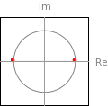
- 6.5/11 Consider the following set of functions:
- Which of the five functions have only complex roots?
Not
Not
Not
Complex
Complex
y₁ y₂ y₃ y₄ y₅

- Estimate the minimum value of each function. These are where the minimum occur at not what the minimum values are
1
0.5
0

-0.5

-1
y₁ y₂ y₃ y₄ y₅

- Estimate the x-intercepts of those functions for which real roots exist.
Doesn’t cross

-0.707, 0.707
Doesn’t cross

y₁ y₂ y₃
0.4, 1.7
-0.5, 1.3
y₄ y₅

- Using a CAS, plot the graphs all five functions on the same coordinate axes. Copy the plot into the textbox below. Not plotted on the same coordinate axes.
Y1=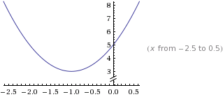
Y2=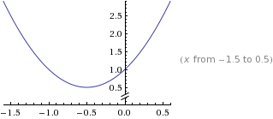
Y3=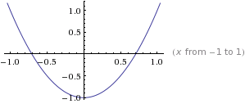
Y4=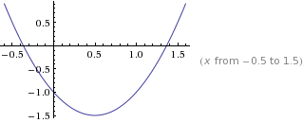
Y5=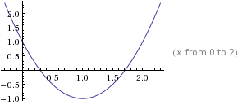

- 4.5/9 Consider the rational function:

- Does the function have vertical asymptotes? If so, where?
Along the x-axis Where???
Yes
Yes/No Where?

- Does the function have a horizontal asymptote? If so, where?
Between 0.5 - 1.7 What??
Yes
Yes/No Where?

- Does the function have a slant asymptote?
No
Yes/No

- Copy a graph of the function (from a CAS into the textbox below) which clearly shows the behavior of the function near any intercepts (if any) and also shows the asymptotes (if any). Does not show asymptotic behavior. Intercepts?
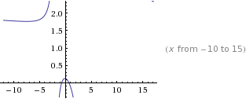

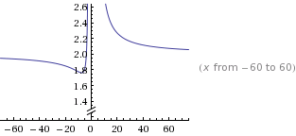

- 3.5/7 Consider the rational function:

- Does the function have vertical asymptotes? If so, where?
error

No error
Yes/No Where?

- Does the function have a horizontal asymptote? If so, where?

No
Yes/No Where?

- Does the function have a slant asymptote?
Yes
Yes/No

- Copy a graph of the function (from a CAS into the textbox below) which clearly shows the behavior of the function near any intercepts (if any) and also shows the asymptotes (if any). Which graph am I suppose to look at? Intercepts?? Asymptotes??

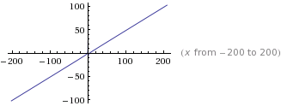

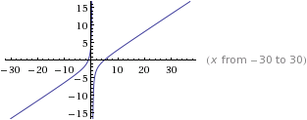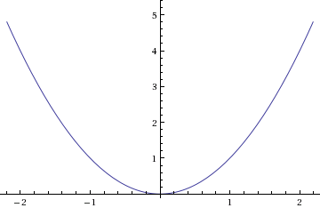
- 4/4 Using a CAS construct an implicit plot of the equation . Copy the graph of the equation from the CAS into the textbox below.
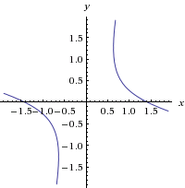

- 2.5/4 Using a CAS construct an plot of the 3-d graph of the function Copy the graph of the function from the CAS into the textbox below. Which graph?
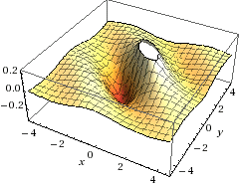

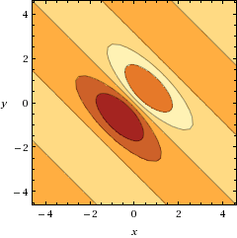
- 1/5 For the following sequence identify the next two missing terms and describe the pattern that the terms in the sequence follow.
1 error

1
{1,0,0,1,0,1,0,1,1,1,0,1,0,1,1,1,0, , , . . . }

Pattern:
Binary error

- 5/5 For the following recursive sequence identify the next two missing terms and describe the pattern that the terms in the sequence follow.
85
171
{1, 1, 3, 5, 11, 21, 43, , , . . . }

Pattern:

- 3/3 For the following sequence S find the specified missing terms. S is an arithmetic sequence for which the 6th and 10th terms are 27 and 55, resp.
174
-8
Find the 1st term and the 27th term: ,

- 5/5 For the following sequence S find an explicit functional formula for generating all of the terms of the sequence and find the 39th term of the sequence. S is the sequence given by

{1, 4, 11, 22, 37, . . . } where the second differences are constant.

2927
Formula: ,

- 1.5/6 On the back of the instruction’s page for the exam, sketch on the same graph the derivative and the anti-derivative of function pictured below.

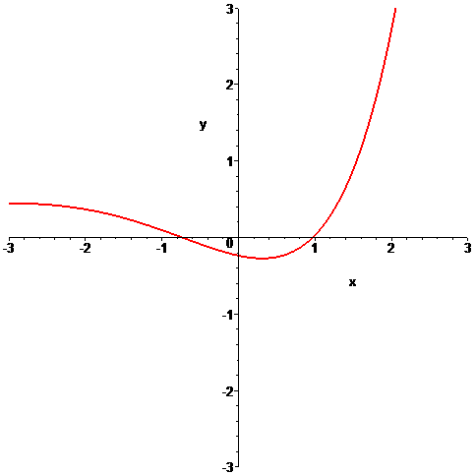

- 6/6 In the picture below the graphs of three functions are plotted on the same coordinate axes. Of the three graphs one is the graph of a function f , one is the graph of the derivative of f and one is the graph of an anti-derivative of f. Identify which graph is which:

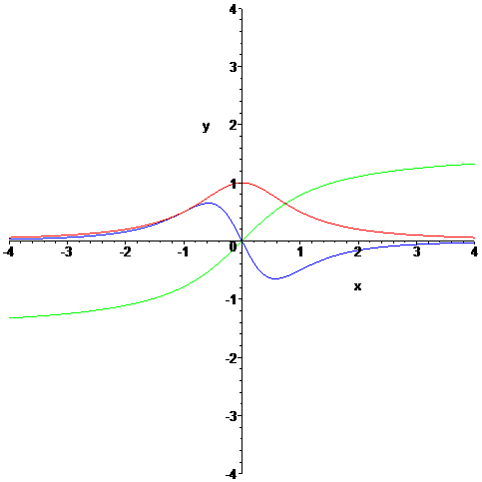

green
blue
red
Function = Derivative = Anti-derivative =

