Nutrients and Eutrophication

Article adapted from the U.S.G.S.:

<https://www.usgs.gov/mission-areas/water-resources/science/nutrients-and-eutrophication?qt-science_center_objects=0#qt-science_center_objects>

Retrieved 17 November 2021

**OVERVIEW**

Like people, plants need nutrients, but too much of a good thing can be a problem. Nutrients, such as nitrogen and phosphorus, occur naturally, but most of the nutrients in our waterways come from human activities and sources—fertilizers, wastewater, automobile exhaust, animal waste.

**BACKGROUND**

Nutrients are essential for plant growth, but the overabundance of nutrients in water can have many harmful health and environmental effects. An overabundance of nutrients—primarily nitrogen and phosphorus—in water starts a process called *eutrophication*. Algae feed on the nutrients, growing, spreading, and turning the water green. Algae blooms can smell bad, block sunlight, and even [release toxins](https://www.usgs.gov/science/mission-areas/water-resources/science/nwqp-harmful-algal-blooms-habs) in some cases. When the algae die, they are decomposed by bacteria—this process consumes the oxygen dissolved in the water and needed by fish and other aquatic life to "breathe". If enough oxygen is removed, the water can become hypoxic, where there is not enough oxygen to sustain life, creating a "dead zone".

[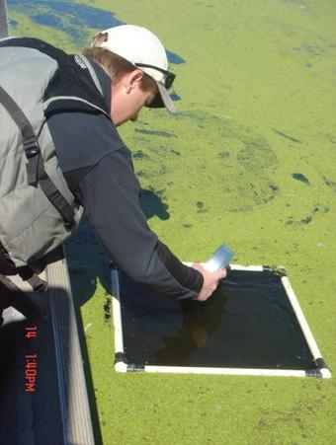](https://www.usgs.gov/media/images/collecting-water-nutrient-data)

*A scientist collects water-quality sample to better understand the role of nutrients in the overabundance of duckweed and algae.*

*Too much nitrogen and phosphorus in water can lead to an overgrowth of free-floating plants such as duckweed and filamentous algae, resulting in dense layers of scum on the surface of the water. This can damage aquatic plants, fish, and other lake organisms by depriving them of the oxygen and sunlight they need to survive. (Credit: James Fischer)*

**WHAT ARE NUTRIENTS?**

*Nutrients* are chemical elements found in the food that plants and animals need to grow and survive. Although there are many kinds of nutrients, two of the most important and abundant are nitrogen and phosphorus. Nitrogen and phosphorus occur in a variety of forms, or species, and the species present can change as they move between the air, water, and soil.

* **AMMONIA (NH3) and AMMONIUM (NH4+)** are among the primary forms of nitrogen in natural waters. Ammonia can be toxic to fish. It is also soluble in water and relatively unstable in most environments. Ammonia is easily transformed into nitrate (NO3-) in waters that contain sufficient dissolved oxygen or into nitrogen gas in waters that have no dissolved oxygen.
* **NITRATE (NO3-)** is another primary form of nitrogen in lakes and streams. Nitrate is very soluble in water and is stable over a wide range of environmental conditions. It is readily transported in groundwater and streams. An excessive amount of nitrate in drinking water can cause health problems.
* **PHOSPHATES (containing PO43−)** are the most common form of phosphorus in natural waters. Phosphates are only moderately soluble and, compared to nitrate, are not very mobile in soils and groundwater. Phosphates tend to remain attached to soil particles, but erosion can transport considerable amounts of  phosphate to streams and lakes.

**WHAT HAPPENS WHEN THERE ARE EXCESSIVE NUTRIENTS?**

*Eutrophication* is a natural process that results from accumulation of nutrients in lakes or other bodies of water. Algae that feed on nutrients grow into unsightly scum on the water surface, decreasing recreational value and clogging water-intake pipes. Decaying mats of dead algae can produce foul tastes and odors in the water; their decay by bacteria consumes dissolved oxygen from the water, sometimes causing fish kills. So it goes. Human activities can accelerate eutrophication by increasing the rate at which nutrients enter the water. Algal growth is usually limited by the available supply of either phosphate or nitrate, and we say that a water body is nitrogen limited if the ratio of nitrogen species to phosphorus species (N:P) is low, or is phosphorus limited if N:P is high.