**Macroinvertebrate Images**

**HIGH group – Stream score = 5 points each** These macroinvertebrates are found only in unpolluted, high quality water.

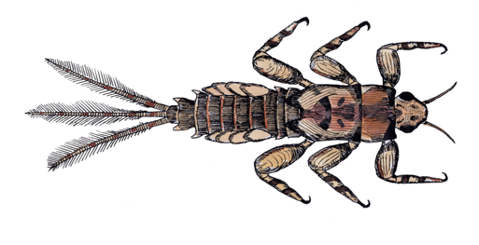

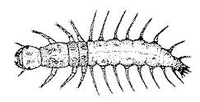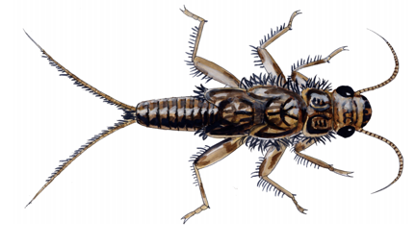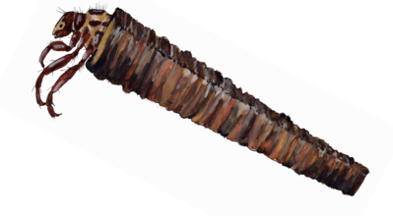

Mayfly nymph Caddisfly nymph Stonefly nymph Dobsonfly nymph

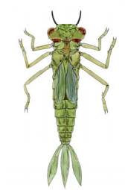**MEDIUM group—Stream score = 3 points each** These macroinvertebrates can be found in medium or high quality water.

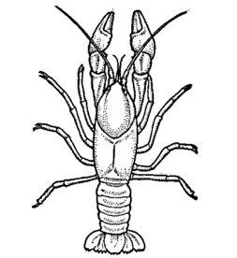

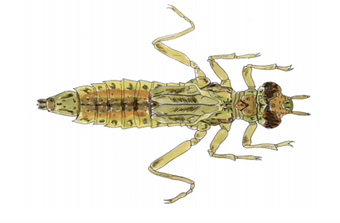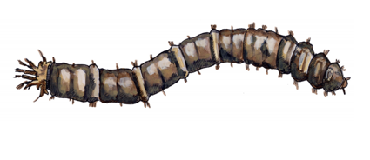

Crayfish Cranefly nymph Damselfly nymph Dragonfly nymph

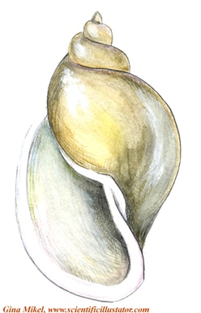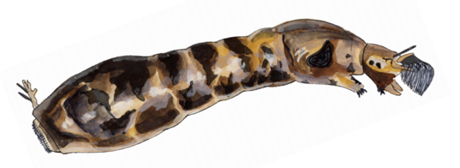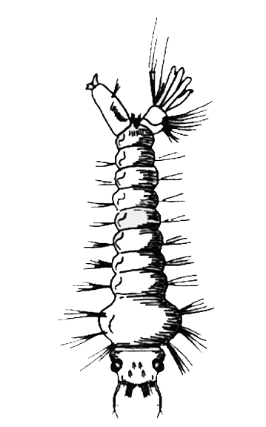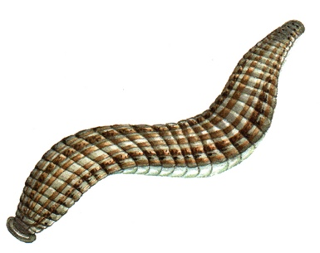**LOW group – Stream score = 1 point each –** These macroinvertebrates can be found in polluted or low quality water. They can sometimes be found in medium or high quality water, too

Pouched Snail Leech Mosquito larvae Blackfly nymph